**Lab manual**

**Name: Akifa Shahzad.**

**Bisma Zulfiqar.**

**Ajwa**

**Roll no:19205,19114,19143.**

**Reg no:2019-GCWUF-3022**

**2019-GCWUF-2988**

**2019-GCWUF-3012**

**Semester:6**

**Subject: Computer Graphics.**

**Program: BSCS(MA).**

**Submitted To: Mam Uzma parveen.**



**Government College Women University FSD.**

**Program:1**

**Draw a pixel.**

#include<graphics.h>

#include<stdio.h>

#include<conio.h>

void main()

{

int cdrive=DETECT,cmode;

initgraph(&cdrive,&cmode,"C:\\turboc3\\bgi");

putpixel(300,300,RED);

getch();

closegraph();

}

**Output:**

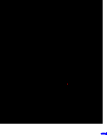

**Program:2**

**Draw a line.**

#include<graphics.h>

#include<stdio.h>

#include<conio.h>

void main()

{

int cdrive=DETECT,cdrive;

initgraph(&cdrive,&cmode,"c:\\turboc3\\bgi");

line(300,300,150,150);

getch();

closegraph();

}

**Output:**



**Program:3**

**Draw a Rectangle.**

#include<graphics.h>

#include<stdio.h>

#include<conio.h>

void main()

{

int cdrive=DETECT,cdrive;

initgraph(&cdrive,&cmode,"c:\\turboc3\\bgi");

Rectangle(100,100,200,200);

getch();

closegraph();

}

**Output:**

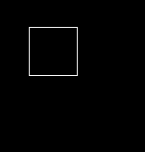

**Program:4**

**Draw a circle.**

#include<graphics.h>

#include<stdio.h>

#include<conio.h>

void main()

{

int cdrive=DETECT,cdrive;

initgraph(&cdrive,&cmode,"c:\\turboc3\\bgi");

circle(100,100,10);

getch();

closegraph();

}

**Output:**

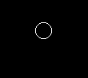

**Program:5**

**Draw an ellipse.**

#include<graphics.h>

#include<stdio.h>

#include<conio.h>

void main()

{

int cdrive=DETECT,cdrive;

initgraph(&cdrive,&cmode,"c:\\turboc3\\bgi");

ellipse(100,100,0,360,20,10);

getch();

closegraph();

}

**Output:**

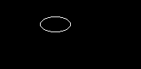

**Program:6**

**Draw an arc.**

#include<graphics.h>

#include<stdio.h>

#include<conio.h>

void main()

{

int cdrive=DETECT,cdrive;

initgraph(&cdrive,&cmode,"c:\\turboc3\\bgi");

arc(100,100,90,280,10);

getch();

closegraph();

}

**Output:**

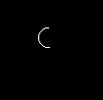

**Program:7**

**Draw a bar.**

#include<graphics.h>

#include<stdio.h>

#include<conio.h>

void main()

{

int cdrive=DETECT,cdrive;

initgraph(&cdrive,&cmode,"c:\\turboc3\\bgi");

bar(100,100,200,200);

getch();

closegraph();

}

**Output:**

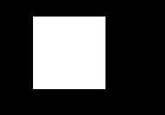

**Program:8**

**Draw a 3D bar.**

#include<graphics.h>

#include<stdio.h>

#include<conio.h>

void main()

{

int cdrive=DETECT,cdrive;

initgraph(&cdrive,&cmode,"c:\\turboc3\\bgi");

bar 3d(100,100,200,200,10,1);

getch();

closegraph();

}

**Output:**

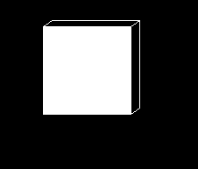

**Program:09**

**Draw a face.**

#include<stdio.h>

#include<conio.h>

#include<graphics.h>

#include<dos.h>

int main()

{

int cdrive=DETECT, cmode;

initgraph(&cdrive,&cmode,"C:\\turboc3\\bgi");

setcolor(YELLOW);

circle(300,100,40);

setfillstyle(SOLID_FILL,YELLOW);

floodfill(300,100,YELLOW);

setcolor(BLACK);

setfillstyle(SOLID_FILL,BLACK);

fillellipse(310,85,2,6);

fillellipse(290,85,2,6);

ellipse(300,100,205,335,20,9);

ellipse(300,100,205,335,20,10);

ellipse(300,100,205,335,20,11);

getch();

closegraph();

return 0;

}

**Output:**



**Program:10**

**Write a program to draw a square.**

#include<stdio.h>

#include<conio.h>

#include<graphics.h>

main()

{

int cdrive=DETECT, cmode;

initgraph(&cd, &cm, "C:\\TC\\BGI");

clrscr();

setbkcolor(LIGHTGRAY);

setcolor(RED);

lineto(50+s,50);

lineto(50+s,50+s);

lineto(50,50+s);

lineto(50,50);

getch();

closegraph();

**}**

**Output:**

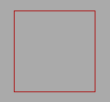

**Program:11**

**Write a program to draw a rainbow.**

#include<stdio.h>

#include<graphics.h>

#include<dos.h>

void rainbow()

{

int cdrive=DETECT, cmode;

int x,y,i;

initgraph(&cdrive, &cmode,"C:\\turboc3\\BGI");

printf("\n this is a rainbow");

setbkcolor(BLUE+WHITE);

x=getmaxx()/2;

y=getmaxy()/2;

for(i=30;i<200;i++)

{

delay(100);

setcolor(1/10);

arc(x,y,0,180,i-10);

}

}

int main()

{

rainbow();

return 0;

}

Output:

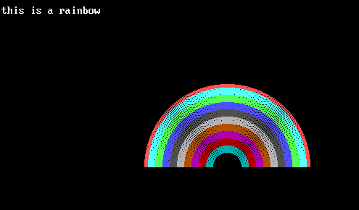

**Program:12**

**Write a program for moving car.**

#include <stdio.h>

#include <graphics.h>

#include <conio.h>

#include <dos.h>

int main() {

int cd = DETECT, cm;

int i, maxx, midy;

initgraph(&cdrive,&cmode,"C:\\turboc3\\bgi");

maxx = getmaxx();

midy=getmaxy()/2;

for (i=0; i < maxx-150; i=i+5) {

cleardevice();

setcolor(WHITE);

line(0, midy + 37, maxx, midy + 37);

setcolor(YELLOW);

setfillstyle(SOLID_FILL, RED);

line(i, midy + 23, i, midy);

line(i, midy, 40 + i, midy - 20);

line(40 + i, midy - 20, 80 + i, midy - 20);

line(80 + i, midy - 20, 100 + i, midy);

line(100 + i, midy, 120 + i, midy);

line(120 + i, midy, 120 + i, midy + 23);

line(0 + i, midy + 23, 18 + i, midy + 23);

arc(30 + i, midy + 23, 0, 180, 12);

line(42 + i, midy + 23, 78 + i, midy + 23);

arc(90 + i, midy + 23, 0, 180, 12);

line(102 + i, midy + 23, 120 + i, midy + 23);

line(28 + i, midy, 43 + i, midy - 15);

line(43 + i, midy - 15, 57 + i, midy - 15);

line(57 + i, midy - 15, 57 + i, midy);

line(57 + i, midy, 28 + i, midy);

line(62 + i, midy - 15, 77 + i, midy - 15);

line(77 + i, midy - 15, 92 + i, midy);

line(92 + i, midy, 62 + i, midy);

line(62 + i, midy, 62 + i, midy - 15);

floodfill(5 + i, midy + 22, YELLOW);

setcolor(BLUE);

setfillstyle(SOLID_FILL, DARKGRAY);

circle(30 + i, midy + 25, 9);

circle(90 + i, midy + 25, 9);

floodfill(30 + i, midy + 25, BLUE);

floodfill(90 + i, midy + 25, BLUE);

delay(100);

}

getch();

closegraph();

return 0;

}

**Output:**

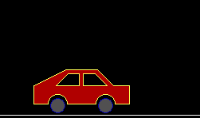

**Program:13**

**Write a program to draw a moving kite.**

#include<stdio.h>

#include<time.h>

#include<conio.h>

#include<graphics.h>

#include<stdlib.h>

#include<dos.h>

void main()

{

int cdrive=DETECT,cmode;

int x=10,y=480;

initgraph(&cdrive,&cmode,"C:\\turboc3\\bgi");

while(!kbhit())

{

cleardevice();

if(y==0)

{

y=random(480);

x=random(640);

}

else

{

y=y-1;

x=x+1;

line(x-50,y,x,y-70);

line(x,y-70,x+50,y);

line(x+50,y,x,y+70);

line(x,y+70,x-50,y);

line(x,y-70,x,y+70);

line(x,y+70,x+10,y+140);

line(x,y+70,x-10,y+140);

line(x-50,y,x+50,y);

line(x,y,x+130,y+640);

}

delay(20);

}

closegraph();

getch();

}

Output:

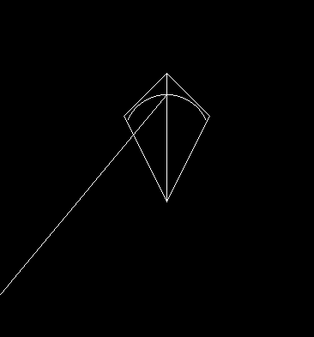

**Program:14**

**Write a program to draw a house.**

#include<conio.h>

#include<graphics.h>

#include<stdio.h>

void main()

{

int cdrive=DETECT, cmode;

initgraph(&cdrive, &cmode,"C:\\turboc3\\bgi");

line(100, 100, 150, 50);

line(150, 50, 350, 100);

line(150, 50, 350, 50);

line(350, 50, 400, 100);

rectangle(100, 100, 200, 200);

rectangle(200, 100, 400, 200);

rectangle(130, 130, 170, 200);

rectangle(250,120, 350, 180);

setfillstyle(2,3);

floodfill(131,131,WHITE);

floodfill(201,101,WHITE);

setfillstyle(11,7);

floodfill(101, 101,WHITE);

floodfill(150, 52,WHITE);

floodfill(163, 55,WHITE);

floodfill(251, 121,WHITE);

getch();

closegraph();

}

**Output:**

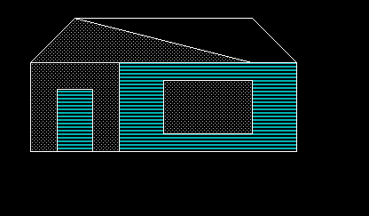

**Program:15**

**Write a program to draw a clock.**

#include<conio.h>

#include<graphics.h>

#include<dos.h>

#include<process.h>

#include<iostream.h>

int calculatehrs(int h)

{

int x;

switch(h)

{

case 0: x=90;

break;

case 1:

case 13: x=60;

break;

case 2:

case 14: x=30;

break;

case 3:

case 15: x=0;

break;

case 4:

case 16: x=330;

break;

case 5:

case 17: x=300;

break;

case 6:

case 18: x=270;

break;

case 7:

case 19: x=240;

break;

case 8:

case 20: x=210;

break;

case 9:

case 21: x=180;

break;

case 10:

case 22: x=150;

break;

case 11:

case 23: x=120;

break;

case 12:

case 24: x=90;

break;

}

return(x);

}

int calculatemin(int m)

{

int x;

if(m%5==0)

{

switch(m)

{

case 0: x=90;

break;

case 5: x=60;

break;

case 10: x=30;

break;

case 15: x=360;

break;

case 20: x=330;

break;

case 25: x=300;

break;

case 30: x=270;

break;

case 35: x=240;

break;

case 40: x=210;

break;

case 45: x=180;

break;

case 50: x=150;

break;

case 55: x=120;

break;

case 60: x=90;

break;

}

}

else

{

if(m>0&&m<15)

{

switch(m)

{

case 1: x=84;

break;

case 2: x=78;

break;

case 3: x=72;

break;

case 4: x=66;

break;

case 6: x=54;

break;

case 7: x=48;

break;

case 8: x=42;

break;

case 9: x=36;

break;

case 11: x=24;

break;

case 12: x=18;

break;

case 13: x=12;

break;

case 14: x=6;

break;

}

}

if(m>15&&m<30)

{

switch(m)

{

case 16: x=354;

break;

case 17: x=348;

break;

case 18: x=342;

break;

case 19: x=336;

break;

case 21: x=324;

break;

case 22: x=318;

break;

case 23: x=312;

break;

case 24: x=306;

break;

case 26: x=294;

break;

case 27: x=288;

break;

case 28: x=282;

break;

case 29: x=276;

break;

}

}

if(m>30&&m<45)

{

switch(m)

{

case 31: x=264;

break;

case 32: x=258;

break;

case 33: x=252;

break;

case 34: x=246;

break;

case 36: x=234;

break;

case 37: x=228;

break;

case 38: x=222;

break;

case 39: x=216;

break;

case 41: x=204;

break;

case 42: x=198;

break;

case 43: x=192;

break;

case 44: x=186;

break;

}

}

if(m>45&&m<60)

{

switch(m)

{

case 46: x=174;

break;

case 47: x=168;

break;

case 48: x=162;

break;

case 49: x=156;

break;

case 51: x=144;

break;

case 52: x=138;

break;

case 53: x=132;

break;

case 54: x=126;

break;

case 56: x=114;

break;

case 57: x=108;

break;

case 58: x=102;

break;

case 59: x=96;

break;

}

}

}

return(x);

}

int changehrs(int m,int a)

{

if(m>15&&m<=30)

a-=12;

if(m>30&&m<=45)

a-=18;

if(m>45&&m<60)

a-=24;

return (a);

}

void main()

{

int cdrive=DETECT,cmode,h,m,s,a,b,c;

initgraph(&cdrive,&cmode,"C:\turboc3\bgi");

struct time t;

gettime(&t);

h=t.ti_hour;

m=t.ti_min;

s=t.ti_sec;

a=calculatehrs(h);

b=calculatemin(m);

c=calculatemin(s);

a=changehrs(m,a);

for(int i=a;i>0;i-=6)

for(int j=b;j>0;j-=6)

for(int k=c;k>0;k-=6)

{

setbkcolor(7);

settextstyle(1,HORIZ_DIR,5);

setcolor(BLUE);

outtextxy(190,20,"Analog Clock");

settextstyle(8,HORIZ_DIR,2);

setcolor(BLUE);

circle(300,200,102);

setcolor(YELLOW);

circle(300,200,100);

outtextxy(385,185,"3");

outtextxy(288,98,"12");

outtextxy(207,185,"9");

outtextxy(295,270,"6");

circle(345,123,2);

circle(378,155,2);

circle(378,245,2);

circle(345,280,2);

circle(253,278,2);

circle(223,245,2);

circle(223,155,2);

circle(253,123,2);

setcolor(RED);

pieslice(300,200,i-1,i,75);

setcolor(WHITE);

pieslice(300,200,j-1,j,85);

setcolor(BLUE);

pieslice(300,200,k-1,k,95);

setcolor(RED);

settextstyle(3,HORIZ_DIR,1);

outtextxy(360,400,"Press any key to exit!!");

sleep(1);

clearviewport();

if(i==6)

a=360;

if(j==6)

b=360;

if(k==6)

c=360;

if(kbhit())

{

setcolor(YELLOW);

setbkcolor(BLUE);

settextstyle(1,HORIZ_DIR,8);

outtextxy(130,150,"Thank You");

sleep(3);

exit(0);

}

}

}

**Output:**

