The IDL-ENVI implementation of the HANTS algorithm

Allard de Wit, 19 April 2004
Updated: 20 July 2005
Updated: August 2013

What's new in version IDL-HANTS v1.3
The following features have been added:
- Logging has been implemented in the IDL-HANTS package. A log file describing detailed processing results is now written to disk as 'hants_log.txt'.
- Error handlers have been added to the code to avoid algorithm crashes often caused by poor input data. When an algorithm crash occurrs on a certain pixel, this will be written to the log file and the status map will have the value '-1'.
- Input and Output files can now be specified on the commandline through keyword variables. Setting an output keyword variable to an empty string (“”) will avoid output being written to disk. Usefull for example if you only want smoothed results and do not care about FFT frequencies and interpolated results.
- Starting HANTS without any keywords will produce detailed information about the available keyword variables. Handy if you just forgot what that particular keyword was.

Bug fixes:
- FFT components were not properly written to disk. If you would reconstruct the signal from the FFT components then the amplitudes would be a factor 2 too small. This is now corrected. Update (Aug 2013: post-processing of the FFT output is now in a separate function ‘prepare_fft_output.pro’)
- Better error handling in the code
- Various minor things

Cosmetic changes:
- All routines are now starting with the prefix 'CGI_'. This was done to avoid namespace conflicts between our own code in our IDL library and external code from various open source libraries on the web.

Introduction
The HANTS algorithm (Harmonic Analysis of NDVI Time-Series) was originally developed by Wout Verhoef from NLR in the Netherlands. The idea behind the algorithm was to have a fast method for smoothing and reconstructing NDVI time-series at continental scales. This effort has led to a first version of the HANTS algorithm which is a very fast implementation (FORTRAN) but difficult to use (can still be downloaded at: http://remotesensing.nlr.nl/upload/verhoef@nlr.nl/Hants.zip).

Therefore, for various purposes it was desirable to have a version of HANTS which was easy to use but with similar functionality. This has led to the implementation of HANTS using IDL-ENVI.

Basic concept
The basis concept behind the algorithm is that the vegetation development as indicated by the NDVI has a strong seasonal effect in most parts of the world (apart from the tropics) which can be described using a series of low frequency sine functions with different phases, frequencies and amplitudes. Cloud cover and other disturbing effects are usually more or less randomly occuring “spikes” in the NDVI time-series and can be considered as high frequency “noise”. The working of the HANTS algorithm is therefore based on a Fourier analyses.

In contrast to the standard fast Fourier transform (FFT), the HANTS algorithm works in an iterative manner (see next figure). The algorithm starts in the upper left block with the raw NDVI time series. These are used as input in the FFT and the relevant frequencies (usually mean, annual and half-year signal) are selected from the fourier spectrum. The inverse FFT (iFFT) then transforms the spectrum back into a filtered NDVI time-series. Next, a comparison is made between the filtered NDVI time-series and the original NDVI time-series. The difference is calculated between the filtered and the original NDVI time-series. Any points in the original NDVI time-series that are below a user-defined treshold are considered ‘cloudy’ and are replaced with the value of the filtered NDVI time-series.
However, by replacing values in the NDVI time-series the average of the entire profile change (becomes larger). Therefore a next iteration is needed and again the NDVI time-series is searched for possible cloud contaminated NDVI observations. This process continues until no new points are being found.
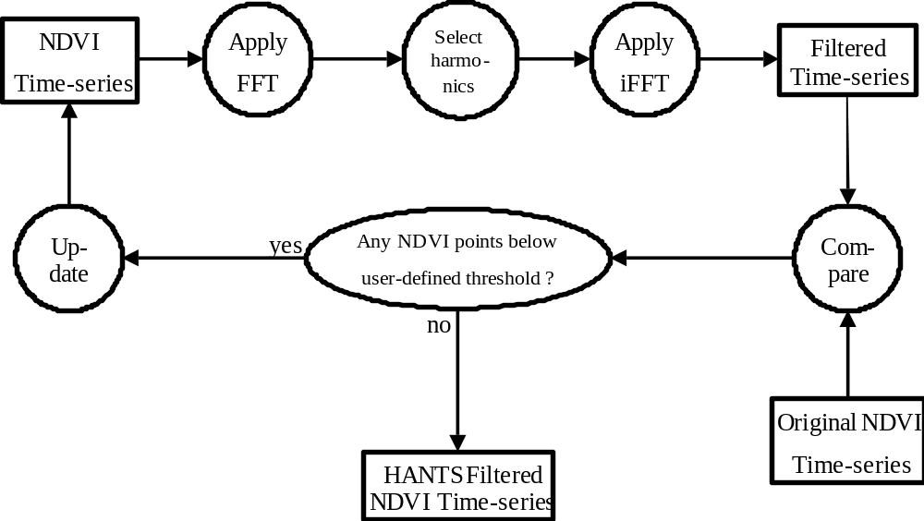

Internal workings
The internal workings of the algorithm itself (implemented in fftndvi.pro) consists of three main parts:
- Initial FFT / iFFT and replacement of no-data values;
- First loop for searching for cloudy NDVI estimates;
- Second loop for stabilising the NDVI profile.

The initial step replaces no-data values with an initial estimate of the NDVI. The first loop is the actual loop described in the figure above. The second loop is necessary for stabilising the profile because after each iteration the average value of the profile changes. This loop will continue until the difference between the current and previous NDVI profile is smaller than 1% of the average NDVI value.

Implementation of the HANTS algorithm using IDL-ENVI
The HANTS package consists of four routines:
- CGI_HANTS.pro: This is the main routine which handles input/output and integration with ENVI. This is the routine to be called from the ENVI command line.
- CGI_FFTNDVI.pro: This is the routine which implements the filtering.
- CGI_MAKE_FFT_FILTER.pro: This small routine creates a filter based on the specified frequencies
- CGI_LOGGER__DEFINE.pro: This small routine implements a logger object which is needed for logging during HANTS execution

Input/Output of IDL-HANTS Routines

CALLING SEQUENCE:
CGI_HANTS, FET=<value>, FREQS=[f1,f2,f3,..], RANGE=[min,max], $
TAT=<value>, iMAX=<value>, /PLOT, DATA_IF=<data input file>,$
MASK_IF=<mask input file>, $
HANTS_OF=<output file for FFT components>, $
STATUS_OF=<output file with status information>, $
SMOOTH_OF=<output file with smoothed results>, $
INTERP_OF=<output file with interpolated results>

INPUTS:
- An ENVI file with NDVI data.
- An ENVI file containing a mask (0/1), only pixels with value 1 will be processed. This is practical for excluding water bodies, etc.

OUTPUTS:
Will produce 4 output files (default behaviour):
- File for the Fourier components as DCOMPLEX. Number of layers will equal the number of frequencies you specified.
- File for the status map as INT. This consists of tree layers: layer 1: contains the number of NDVI values retained after HANTS processing. This is usually larger than the number of points in your time-series minus the value of TAT. Occasionally it can become less if the algorithm already throws out more points than TAT during the first iteration cycle. Layer 2&3: the number of iterations in the 1st and 2nd loop. This should be lower than iMAX. If there are many pixels with values equal to iMAX, then you should increase iMAX for better convergence.
- File for smoothed NDVI values as FLOAT. This is basically the fitted curve of sine waves.
- File for interpolated NDVI values as FLOAT. This is basically the original NDVI data, but with cloud contaminated values interpolated.

KEYWORD VARIABLES

PROCESSING KEYWORDS (OBLIGATORY):
FET: Fit Error Tolerance, is maximum tolerable downward deviation between fourier fit and NDVI data values (in DN values)

FREQS: 1D array with frequencies that should be selected from the fourier spectrum. i.e. freqs=[0,1,2,3] to use the fourier compoments 0 (mean), 1 (1 sine wave), 2 (2 sine waves) and 3. If you want to process 5 years of data you should use freqs=[0,5,10,15]

RANGE: Array of size 2 to specify the minimum and maximum valid data values. i.e. range=[1,254]

TAT: Throw Away Treshold, is maximum number of NDVI observations that can be discarded in the fitting process.

iMAX: Maximum nr. of iterations to be performed during processing, usually 10 should be sufficient.

I/O KEYWORDS (OPTIONAL):
DATA_IF: (full path to) Filename used as input for processing (NDVI), will ask for filename if not specified

MASK_IF: (full path to) Filename used as mask. A dialog box will ask for filename if not specified

HANTS_OF: (full path to) Filename used to write FFT components, set this to an empty string ("") to avoid output being written to disk. A dialog box will ask for filename if not specified

STATUS_OF: (full path to) Filename used to write processing status info set this to an empty string ("") to avoid output being written to disk. A dialog box will ask for filename if not specified

SMOOTH_OF: (full path to) Filename used to write smoothed results set this to an empty string ("") to avoid output being written to disk. A dialog box will ask for filename if not specified

INTERP_OF: (full path to) Filename used to write interpolated results set this to an empty string ("") to avoid output being written to disk. A dialog box will ask for filename if not specified

OTHER KEYWORDS (OPTIONAL):
LOG_FILE: (full path to) Filename used to write the log to. If not specified 'hants_log.txt' is used as default.

PLOT: Visualise the optimisation & fitting process. Only applied for debugging because it is very slow!

Documentation for the other routines can be found in the header of the source code.

Limitations
- Unlike the original version of HANTS, this version cannot handle non-equally time-spaced data. So even if you don’t have a value, you still need to give the algorithm a no-data value and hope for the best.
- Unlike the original version of HANTS, this version cannot ‘ignore’ no-data values because the IDL FFT has no way of ignoring values (setting values to !values.f_nan doesn’t work btw.).

Tips
-Which frequencies should I use?
Usually you will need the mean, annual signal and half-year signal, so freqs=[0,1,2] if you process one year of data. If you suspect you need more frequencies, then specify a larger number and look at the output Fourier coefficients. If the image becomes noisy without any spatial structure then you don’t need that frequency and you can leave it out.

-Large data gaps
If you have large gaps in your data with a no-date value of ‘0’, there is a risk that the algorithm will actual regard these as ‘signal’ rather than ‘noise’. In that case it is better to use alternating values of high and low no-data values (i.e. 0,255,0,255,etc.)so that the algorithm will ‘recognise’ them as high-frequency noise.

License
This software is licenced under the GNU General Public License. See: http://www.gnu.org/licenses/gpl.html

References

Roerink, Menenti, Soepboer and Su, 2003. Assessment of climate impact on vegetation dynamics by using remote sensing. Physics and chemistry of the earth 28, 103-109

Roerink, Menenti, Verhoef, 2000. Reconstructing cloudfree NDVI composites using Fourier analysis of time series. Int. J. of Rem. Sens. 21(9) 1911-1917.

Contact
You can contact me with comments, improvements, errors, etc at:
Centre for Geo-information
Droevendaalsesteeg 3
6708 GA Wageningen, The Netherlands
allard.dewit@wur.nl
T: +31-317-481914
F: +31-317-419000

