**Security Requirements**

Username: For our subsystem, users will be using their own individual email to sign in. As user, will be required to confirm that the email is theirs before they can start shopping. An email checker will be used to confirm that the emails are valid and legit emails.

Password: To ensure that the password is strong enough the password requirements are as follow:

* There must be at least a minimum of 8 digits/letters.
* There must at least one uppercase and one lowercase letter.
* There must be at least 1 digit.
* Special characters/symbols can be used
* Words inside the user’s profile cannot be used
* World found in a password blacklist cannot be used.
* Password are required to change every 6 months.

Password suggestion (not compulsory)

* Please do not use birthday as a password
* Avoid using words, slang, jargons as a password
* Use complex phrases that you will remember
* Do not write the password down

**Security Requirement for private information**

* Credit Card Details – If users are to store their credit card details, then we are required to ensure that we meet the PCI DSS (Payment Card Industry Data Security Standard). This is used to help prevent credit card fraud. We will be accessed by 3rd party either by an QSA (Qualified Security Assessor) or an ISA (Internal Security Assessor).

The diagram Figure 1 present the 6-control objective (Left hand side) and the 12 PCI DSS requirements that any business is required to follow.

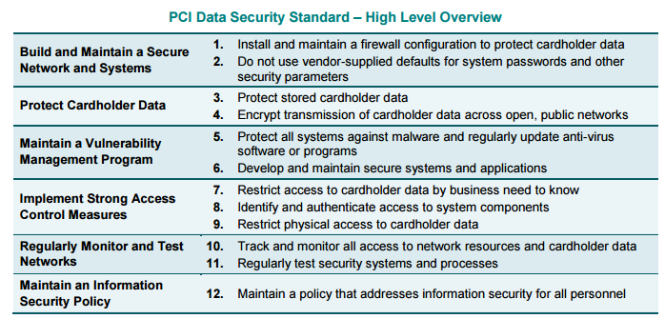

Figure 1 – This image was taken from PCI DSS v3.2 from the PCI Security Standards Council

* Personal Details - The information of personal details must be protected, especially if the company is Australian based. Therefore, we are obliged to follow the 13 Australian Privacy Principles.

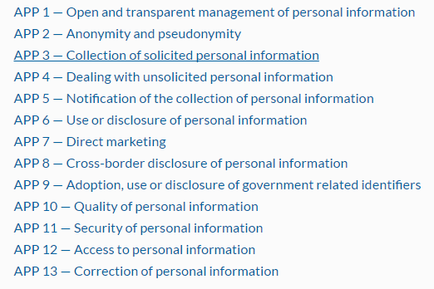

Figure 2 Images taken from the Australian Government Office of the Australia Information Commissioner

The company must take great care especially regarding APP 11 (Security of personal Information) where personal information of the user are required to be store on our database when they are registering for the website.