Anthony J. Wilhelm

110 Cherry St.

Charlevoix, MI

49720

Anthony Wilhelm/EX2

START

Integer x

Integer y

Integer z

Put “How old are you? “ to output

X = Gen next input

Y = 31536000

Put “\n” to output

Z = x \* y

Put “\n” to output

Put “You are “ to output

Put z to output

Put “ seconds old!” to output

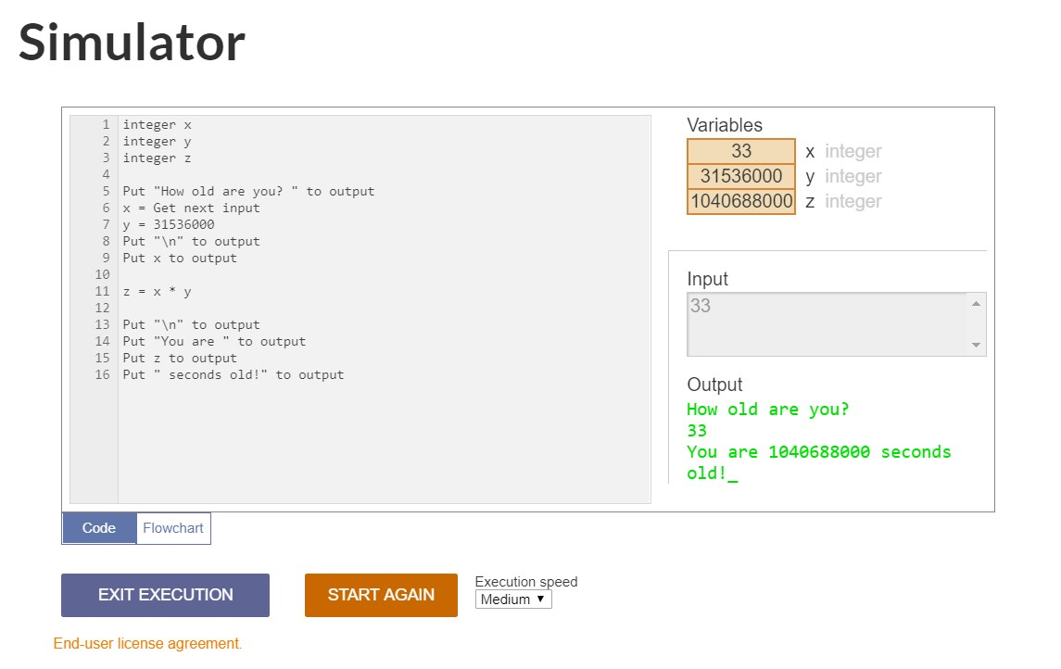END