Categorization
and
The “Ratio Rule”
Background
Formal models of categorization have tended to concentrate on two aspects of the categorization process:
1) Input representations- Are categorical decisions made on the basis of features, configural cues, memorized instances?
2) Calculation of magnitude terms - A magntiude term is a number representing the subjective level of evidence that item x is an member of category c . The vast majority of formal models of categorization employ evidence terms.
We also need to know how magnitude terms result in observable action. Consider the situation below...

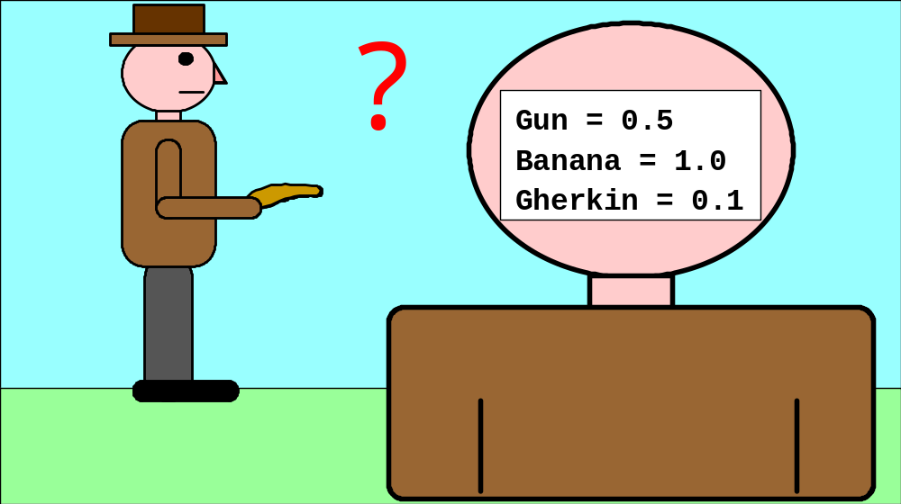

Evidence terms are shown on our hero’s head. The object being held is probably a banana, but it might also be a gun, or a gherkin. The resulting action rather critically depends on getting from the multiple evidence terms to a definite categorical decision.

The Ratio Rule
There is widespread agreement across different models of categorization that the step from evidence to action is adequately described by the “ratio rule”. In the above example this would be:
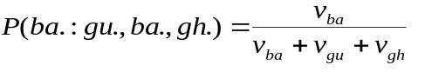

where v_{ba} is the evidence term for the banana, and so on. This choice of decision mechanism is rarley explicitly motivated, but one of the reasons is probably that it captures something of what might happen if
Andy Wills
and
Mark Suret, Ian McLaren
the different alternatives were competing with each other. For example, in the ratio rule it is when one of the terms is large relative to the others that its action is chosen with a high probability. A few years ago, we (Wills & McLaren, 1997) formulated this idea of competitive categorical decision in a simple winner-take-all connectionist network in order to allow us to make predictions about reaction time as well as choice probability.

Winner-take-all model
The system is illustrated to the right. Evidence terms are represented as input activations to a system which has fixed self-excitatory connections and fixed mutually inhbitory ones. Noise is assumed to be present in the system. Output activations are updated cyclically until one of the units wins (winning defined by one unit exceeding the activation of its nearest competitor by a threshold S.
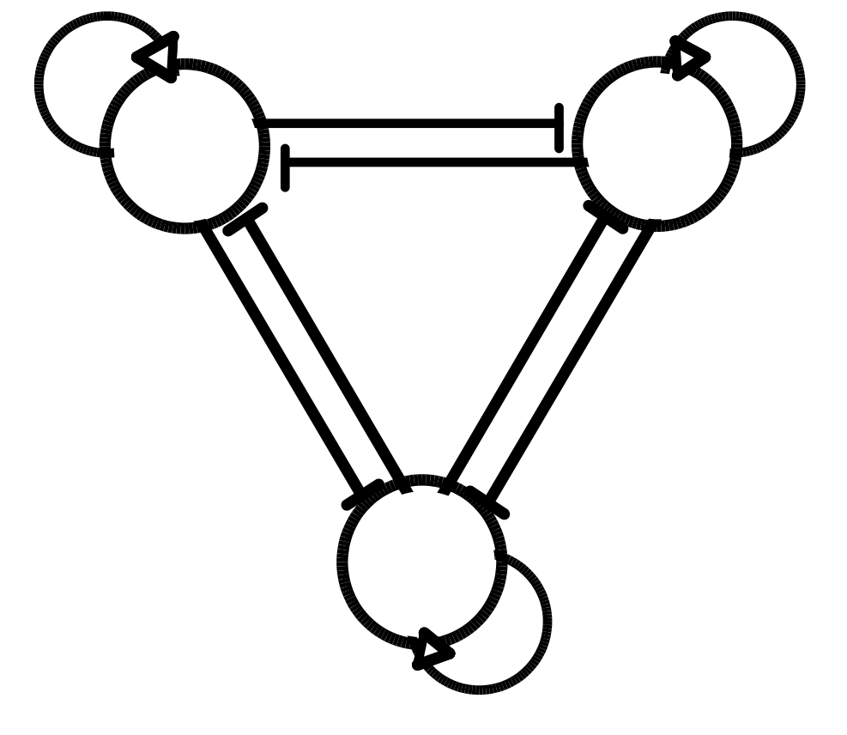
Taking competition further
In a simple two-choice task, the ratio rule and the winner-take-all system behave similarly. However, the winner-take-all system makes a number of other predictions about more complex decisions. These predictions, with an intuitive motiavtion, are given below. They are backed up by simulation later.
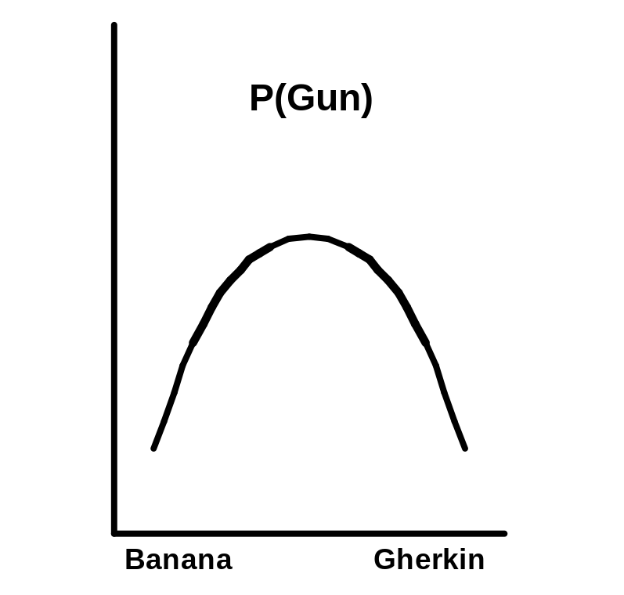
Situation OneImagine a series of situations like the one above, where the object ranges from being very like a banana, to very like a gherkin. Its similarity to a gun stays constant. When would you be most likely to decide the object is a gun? Competitive decision predicts that this will be when the object doesn’t look particularly like a banana or a gherkin.

Situation Two
The set of objects are the same as in situation one. We are comparing the probability of deciding the object is a banana when the decision that it is a gun is disallowed (2-choice), with the probability when that option is allowed (3-choice).

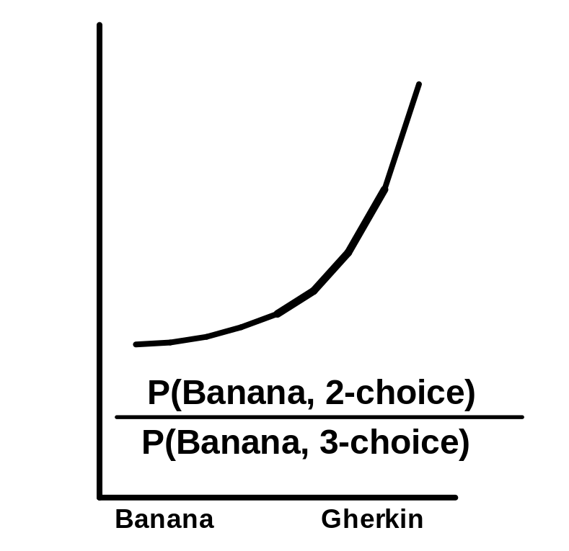
Cambridge University, U.K.
and
Exeter University, U.K.
Where the object is very much like a banana, the probabilities should be similar in both cases. However, as the object becomes more like a gherkin, the gun becomes aserious competitor to the “banana” option and so considerably reduces the probability of this response when it is allowed.

Situation Three
As situation two, except that the 2-choice condition is replaced by one where the “gun” option is not disallowed, but presented objects are so unlike a gun that it is very unlikely to be chosen.

The Ratio Rule
Whilst the ratio rule seems to capture something about competitive decision, it does not make the same predictions as a truly competitive system for the situations described above. Critically, the ratio rule predicts that the two dependent variables will show the same direction of change over any portion of the x-axis in all three situations. Details of the derivation can be found in the attached paper.
EXPERIMENT
The differing predictions of the ratio rule and a simple competitive system were put to the test in a category learning experiment. Stimuli were needed that allowed the relatively independent manipulation of similarity to three different categories. The icon array stimuli we’ve employed in a number of other experiments were used.

Stimuli
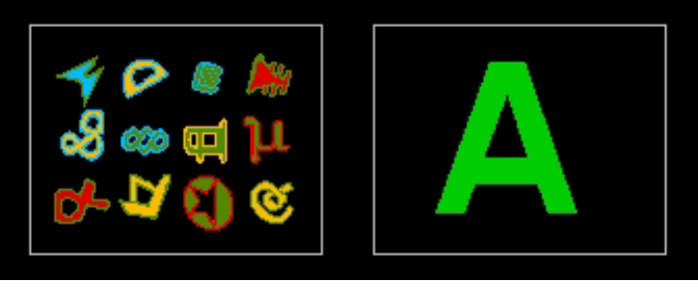
Stimuli are composed of 12 small pictures randomly placed on a grid. At the beginning of the experiment, and separately for each subject, 12 icons from a pool of 36 are randomly designated as “A”s, 12 as “B”s and 12 as “C”s. Training examples are created by starting with all 12 icons characteristic of a category (e.g. 12A), and then giving each a 10% chance of being replaced by a non-A icon.
Procedure
All participants had a training phase were 30 examples of each of categories A, B and C were shown along with a category label.

Cambridge University, U.K.
and
Exeter University, U.K.

All participants engaged in a test phase where 10 stimuli of each of the types shown below were presented for classification without feedback:

#A icons 4 4 4 4 4 4 4 4 4
#B icons 8 7 6 5 4 3 2 1 0
#C icons 0 1 2 3 4 5 6 7 8

Participants were asked to make one of two decisions ( a between-participants manipulation):
Decision One: Is the an A, a B, or a C?
Decision Two: Is this a B or a C? (Option A not allowed).
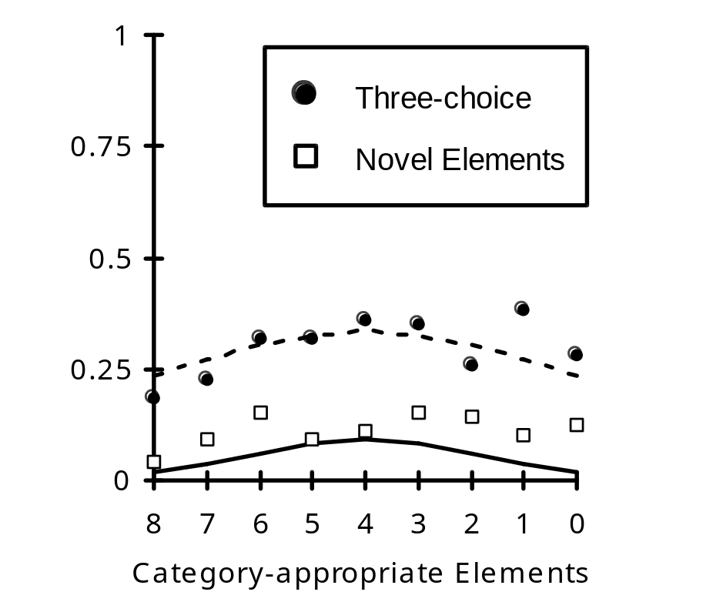
There were three between-participant groups overall. The 2-choice group was asked to make decision two, the other two groups (3-choice and novel-elements) were asked to make decision one. For the novel-elements group, the “A” icons at test were novel icons not seen in the training phase.RESULTS & DISCUSSION
The graphs show the probability of choosing category A in the three-choice and novel-elements conditions (left), and the ratio of choosing category B in two pairs of conditions (below). Inspection suggests that the four lines do not show the same direction of change, and statitiscal analysis confirms this (see paper).
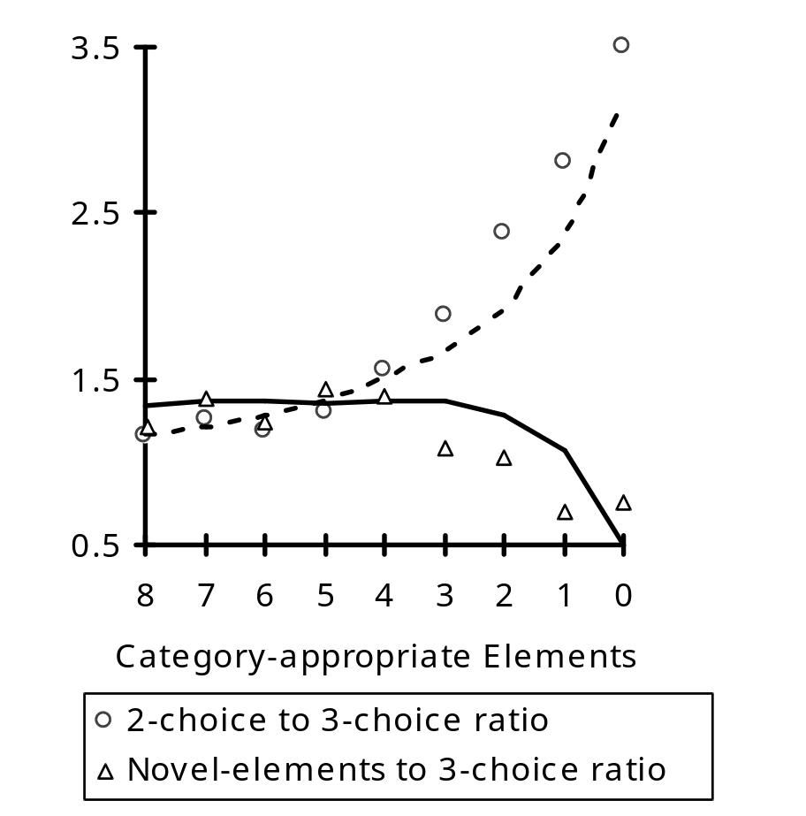
This seems to be good evidence against the Ratio Rule. The predictions of the WTA model are shown as lines, and fit the data well. The different shapes of the two lines on the second graph (right) are modelled by allowing a different threshold parameter
(S)in each experimental condition.
These results suggest that whilst the ratio rule captures some aspects of competitive categorical decision, a truly competitive system provides a better account of people’s categorical decision-making.

