Learning from failure?
No effect of errorful generation on a cued recall test

ABSTRACT

Potts and Shanks (2014) reported that making mistakes improved the encoding of novel information, compared to simply studying. Following their work, our participants attempted to learn the definitions of very rare English words. During training, participants either guessed the definition (and nearly always made an error) before the correct defintion was shown, or simply studied the words. In contrast to Potts and Shanks (who used a recognition test), we tested memory using cued recall. In our Experiment 1, memory performance was equivalent under guessing and studying conditions, with Bayesian evidence for the null. However, performance was also very low in both conditions (around 15% correct), implying that our result may have been due to a floor effect. We planned a second experiment in which we believe performance would have been higher, but it was not run due to the coronavirus pandemic. We hypothesise that errorful generation in Potts and Shanks (2014) may improve memory for definitions, rather than memory for associations.

Optimising the learning of educational materials is of critical importance to educators and students alike. Testing is one technique that has been particularly endorsed in recent years, and it is now well-established that the process of retrieving information from memory in an initial test can improve retrieval in a later test relative to simply restudying information. This effect is known as the testing effect (see Roediger & Karpicke, 2006, for a review).
Students do not always do well on tests though, which might lead educators to worry whether failed tests could do more harm than good. In this context, the results of Potts and Shanks (2014) are particularly interesting. Their first three experiments involved asking participants to learn the definitions of very rare English words (or the English translations of a foreign language). During encoding, the participants were sometimes shown the cue (the rare word, e.g., valinch) and were asked to guess the target (the definition), before the correct target (tube) was revealed. Other times, the participants simply studied the intact word pairs (e.g., valinch = tube) for the entire trial. In a subsequent multiple-choice test, the cues were presented one at a time, and the participants were asked to select the correct target, which was placed among three novel words (“foils”) that were created for each word pair. Since the cues were archaic English words, participants were very unlikely to have known the answers pre-experimentally. In line with this assumption, the participants’ guesses during encoding were almost always incorrect. Nevertheless, in a series of studies, generating errors enhanced performance on the final test compared with studying. Thus, Potts and Shanks (2014) demonstrated a benefit of generating errors over studying with novel word pairs. The implication seems to be that testing is beneficial to learning, even if students nearly always get the answers wrong.
However, one potential issue with Potts and Shanks’ (2014) work is that participants did not actually have to learn the word → meaning associations in order to perform well on the test. This is because the correct answer was always placed among three words that had not previously been seen in the experiment (novel foils). It is therefore possible to do well on the final test just by picking the only definition that seems familiar from the four available. This raises the issue of whether the benefit of errorful generation observed by Potts and Shanks (2014) would still be observed in a more challenging test that requires knowledge of the word→ definition association. In the present experiments, we investigated this question using a cued recall test.

Experiment 1

Experiment 1 was similar to the work reported by Potts and Shanks (2014), except that memory was tested via cued recall, rather than by a multiple-choice test.

Method

Participants
We tested 27 participants, drawn from those attending PSYC520 (a second-year psychological research methods module) at Plymouth University. The data from two participants were unusable due to technical errors. The sample size of 25 usable participants was determined in advance of data collection, and has sufficient power to detect medium-to-large effect sizes (d_{z}= 0.58).

Apparatus and materials
The experiment was programmed in OpenSesame (Mathôt et al., 2012), and presented on various laptop computers. Stimuli were presented in a black 16-point font on a white background, and responses were collected using the laptop’s keyboard. We used thirty word pairs of rare English words and their definitions, taken from Potts (2013). The full set are included in the Appendix

Procedure
Participants were told that they would be studying rare English words and their definitions in two formats. The order of the two encoding conditions (Study, Generate) was counterbalanced between participants. Before each encoding coding, participants read onscreen instructions stating that they would see rare English words and that they should try to remember the correct definitions, because there would be a test. The key instruction for each stage (which told the participants to either study the words or guess the meaning) was presented in red. All other text was presented in black.
Each encoding condition (Study, Generate) consisted of one presentation of each of 15 different word pairs. In the Study condition, each word pair was presented centrally for 17 seconds (e.g. gadoid = fish). The participants simply studied the words. In the Generate condition, the cue was presented alone for 10 seconds (e.g gadoid), along with the question “What do you think this word means?”. Participants were strongly encouraged to type a one-word definition, and their answer appeared below the question. The target appeared after 10 seconds, along with the cue, for a further seven seconds.
The test phase immediately followed the encoding phase. All thirty cues from the encoding phase were presented in random order. The question “What does this word mean?” was presented beneath each cue, and participants were strongly encouraged to type the correct target.
Each trial of the experiment was separated by a 3 second interval.

Results
Analysis was conducted using the BayesFactor package (Morey & Rouder, 2018) in R (R Core Team, 2019). Mean performance was 13% correct in the Generate condition, and 14% correct in the Study condition. These two conditions did not differ, with Bayesian evidence for the null, BF = 0.30. Figure 1 shows the distribution of performances across participants.

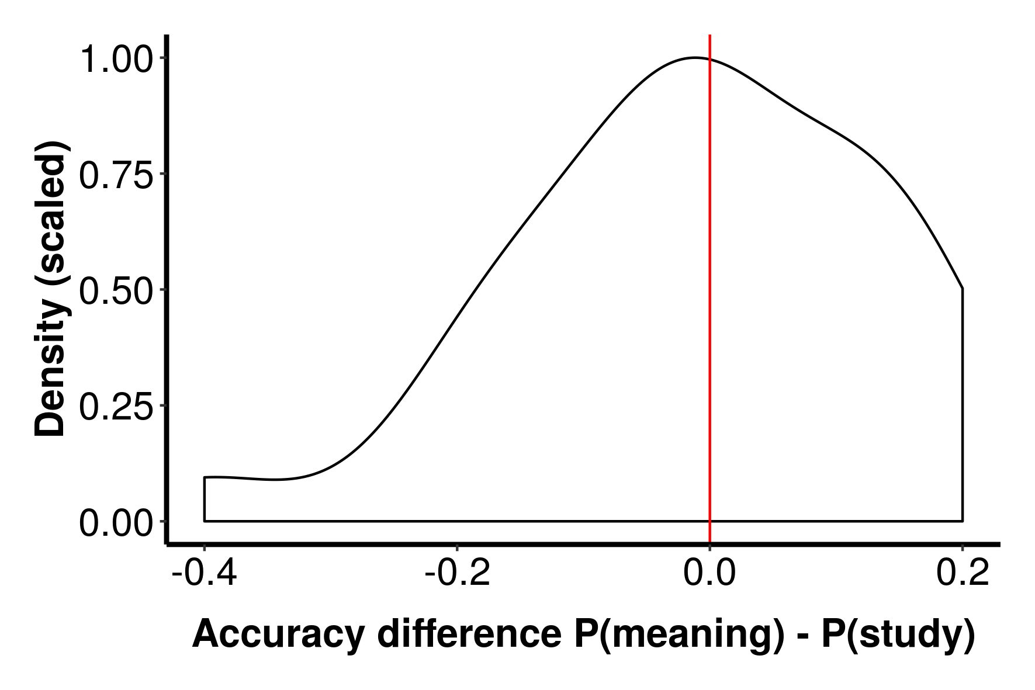

Figure 1. Distribution of difference scores in Experiment 1.

Discussion
Unlike in Potts and Shanks (2014), there was no benefit of errorful generation in this experiment. This could be because errorful generation does not improve word → definition associations, which are what is tested in a cued recall test (but not necessarily in the multiple-choice test used by Potts and Shanks). Alternatively, we may have seen no benefit of errorful generation because performance was overall rather low in our experiment – a floor effect. We planned to investigate this possibility in Experiment 2.

Experiment 2

In Experiment 2, we planned to test memory, via cued recall, at the end of each encoding condition (Generate, Study). In this way, participants were given fewer items to remember for each test, which we hypothesized would improve performance.

Method

Participants, apparatus, and materials
We planned to test a further 25 participants, from the same population as Experiment 1, using the same apparatus and materials.

Procedure
The planned procedure was the same as for Experiment 1, except that a cued- recall test followed each encoding condition (Generate, Study). Each test comprised the 15 cues presented in the immediately preceding encoding condition..

Results and Discussion
The planned experiment was not run, due to coronavirus.

General Discussion
We examined the effect of generating errors versus studying when learning the definitions of rare English words. Our experiment used cued recall as the test of performance. There was no effect of errorful generation. In Experiment 1, there was Bayesian evidence for the null but also low performance, meaning the results were possibly due to a floor effect. We planned a second experiment in which we expected performance to be higher, but the experiment was not run due to the coronavirus pandemic.
Our result stands in contrast to those of Potts and Shanks (2014), who found benefits of errorful generation across multiple experiments. Perhaps the key difference between our result and theirs is that they used a multiple-choice test as their measure of performance, while we used cue recall. This is potentially important because their multiple-choice test contained the correct definition along with three novel definitions not seen previously in the experiment. It is therefore possible to do well in their experiments using just a sense of familiarity, rather than knowledge of the word → definition association. In contrast, above-chance performance on cued recall requires a memory for the specific associations between the words and their definitions. So, it is possible that errorful generation boosts familiarity with the definitions, rather than boosting the word → definition associations. In most applied situations (e.g. foreign vocabulary learning), it is these associations, rather than overall familiarity, that are critical.
The biggest limitation of the current work is the strength of evidence for an absence of an effect of errorful generation. The results of our experiment could have been due to a floor effect, and Experiment 2, which was intended to address this shortcoming, was not run due to the coronavirus pandemic. Running Experiment 2 when conditions permit is thus the obvious next step.
Another potential limitation of our work is that participants in the Generate condition see the word pair (e.g. roke – mist) for much less time (7 seconds) than participants in the Study condition (17 seconds). This was done to equate the overall trial length across conditions (17 seconds), and followed the procedure of Potts and Shanks (2014). However, their design must be seen in the context of their result that performance in the Generate condition is better than performance in the Study condition. In this context, their result is all the more surprising given that the condition with the shorter duration of presentation for the word pair is the condition with the better performance. Given our trend for the opposite result (i.e. Study > Generate), the difference in word-pair presentation duration is a potential artifact. In future work, we could run a version of the experiment that equated word-pair presentation time across conditions. This of course would result in overall trial duration becoming unmatched, so there would be some value in running both versions of this experiment.
In conclusion, errorful generation did not improve performance in our cued recall tests. This might imply that errorful generation boosts familiarity with the definitions rather boosting knowledge of the word → definition associations. However, further research is needed.
Ethical statement
The stimuli and procedures of these experiments were innocous, and posed no risk to participants or experimenters. Participants gave informed consent, and had the right to withdraw from the study at any point. Data has been stored anonymously.

References
Mathôt, S., Schreij, D., & Theeuwes, J. (2012). OpenSesame: An open-source, graphical experiment builder for the social sciences. Behavior Research Methods, 44(2), 314-324.
Morey, R.D. & Rouder, J.N. (2018). BayesFactor: Computation of Bayes Factors for Common Designs. R package version 0.9.12-4.2. https://CRAN.R-project.org/package=BayesFactor
Potts, R. (2013). Memory interference and the benefits and costs of testing. University College London.
Potts, R., & Shanks, D. R. (2014). The benefit of generating errors during learning. Journal of Experimental Psychology: General, 143, 644–667.
R Core Team (2019). R: A language and environment for statistical computing. R Foundation for Statistical Computing, Vienna, Austria. R version 3.6.1. https://www.R-project.org/.
Roediger III, H. L., & Karpicke, J. D. (2006). The power of testing memory: Basic research and implications for educational practice. Perspectives on Psychological Science, 1, 181–210.

Appendix
The words, and defintions, we used were as follows:

