unsound: the manual
Table of Contents

unsound: the manual
A broken machine you overdrive. Everything it can do, and where to find it.
Hover over almost anything (browser entries, knobs, sliders, buttons) for a reminder of what it does, and press ? in the window for every shortcut.

1. Starting it
- Open play.scd in SuperCollider.app.
- In the first block, set ~folder to a folder of samples (subfolders count). If it’s empty or missing, it uses the macOS system sounds.
- Put the cursor in that block and press Cmd-Return. The window opens.
- Press play (or space).
Cmd-. is panic: everything stops, the sound graph rebuilds itself, and you press play again.
The default set is two bitmeisters (bytebeat), grains, and the wall, with four returns: A echo (overdriven), B space (overdriven), C freq shift, D smear.

2. The screen at a glance
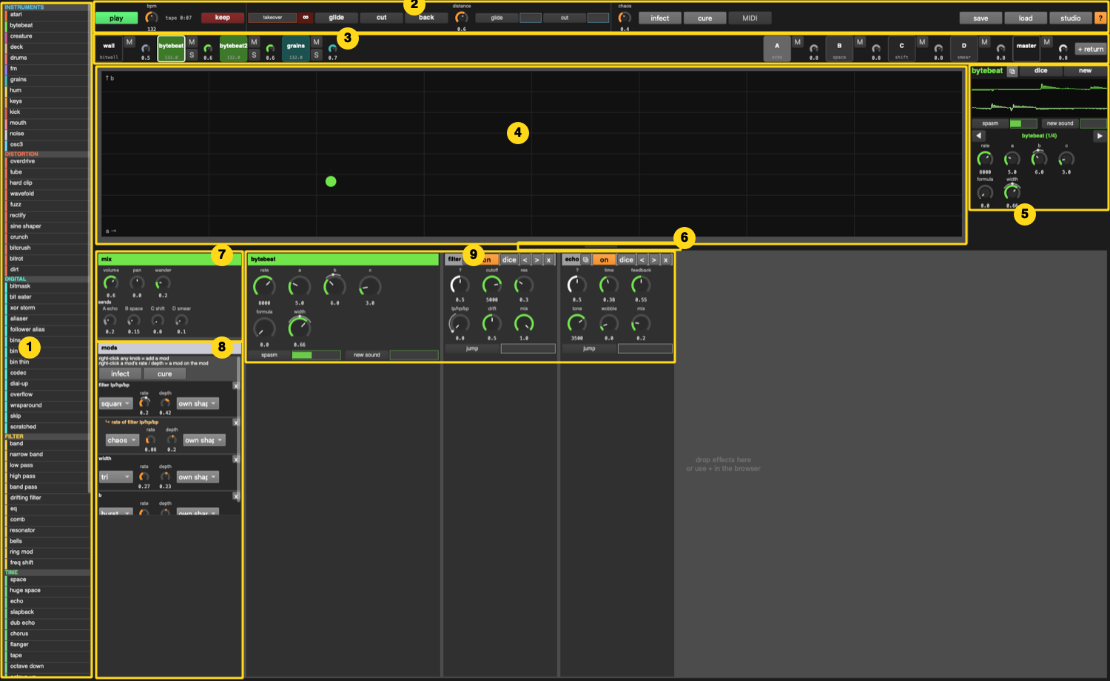
the box
# | what | how
1 | browser | everything you can add. Double-click = add to the focused track (instruments make a new track). Drag onto a pad, the chain, or onto a device to insert before it. Hover for a description.
2 | top bar | play, bpm, ● session time, tape + keep, takeover, glide / cut / back, distance, glide/cut every so often, chaos, infect / cure, MIDI learn, save / load, studio, ?
3 | pads | one per track. Click = focus. M mute, S solo, knob = volume. Returns and master on the right, then + return.
4 | screen | the focused track’s own view: XY pad, drum grid, roll, tape, the wall’s recipes…
5 | focus column | track name, ⧉ (open the track in its own window), dice, new sound, a scope, the track’s every-so-often sliders, and the 8 encoders
6 | handle | drag it up or down to trade screen space for chain space
7 | mix | volume, pan, wander, and a send knob per return (named by what’s on it)
8 | mods | every modulator on this track, as a tree. See Modulation
9 | chain | the instrument’s own panel, then every effect in order. Scrolls sideways. Drop effects here.
The old Ableton-style window is still there: press ` (backtick) or click studio. See The studio window.

3. Tracks and pads
- Focus a track: click its pad, or 1–9 (instrument tracks in order), 0 (master), ← / → (previous / next).
- Mute / solo / volume: the M, S and knob next to each pad (solo works on the wall too). M on the wall fades it in and out instead of cutting it. Keys: M mutes the focused track, ↑ / ↓ volume.
- Add an instrument: double-click (or drag) it in the browser, under INSTRUMENTS.
- Add a return: + return at the right end of the pads (it starts with a reverb; change it in its chain).
- Remove a track: in the studio window, the x at the bottom of its mixer strip.
- Tempo per track: every instrument can run at its own tempo. In the studio window’s Clip/Devices header: sync, own bpm, tempo drift, speed, resync (R). shift ↑ / ↓ nudges the focused track’s tempo (and unsyncs it).

4. The chain and its devices
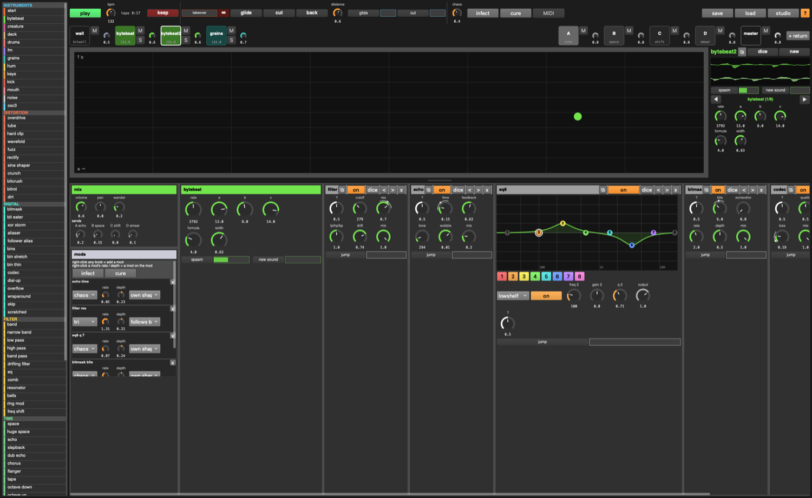
a chain with EQ Eight and digital effects
Every device box has, along its title bar:
⧉ | open this device in its own window
on | bypass
dice | random settings for this device
< > | move it left / right in the chain
x | remove it
Inside every device:
- ? the mystery knob: sweeps a hidden handful of the device’s settings between two random points. Turning it is a quick way to find something new. (Dice re-rolls which settings it moves.)
- jump: every so often, throws the mystery knob somewhere new by itself (see Every so often).
Adding effects: double-click in the browser (adds to the end of the focused track), or drag onto the chain, or onto a specific device to put it before that device. Whole chains (bottom of the browser) add several at once.
The master always ends in a limiter (it can’t be removed). Everything before it can be as broken as you like.

4½. Your own instruments and chains
Like Ableton presets: click save next to the track’s name (top of the focus column, or in the studio window’s header), type a name, save.
- An instrument keeps everything: the instrument and all its settings (patterns, drawn waves, loaded files, sends), its whole effect chain, and its mods (mods on mods too; an LFO link is kept if that LFO exists when you load it). It appears in the browser under MY INSTRUMENTS: double-click or drag it for a new track, exactly as you saved it.
- Tick just the effects to save the chain instead (from a return or the master, that’s all it can save). It appears under MY CHAINS: drop it on any track.
- Right-click one of yours: show in Finder / delete. They’re files in ~/Music/unsound/instruments/ and ~/Music/unsound/chains/.
Browser categories fold: click a header (▾ / ▸). It remembers which ones you folded.

5. Pop-out windows
Click ⧉ on any device, or ⧉ next to the track name in the focus column, and it opens in its own window, like a plugin window in a DAW. Open as many as you like and Cmd-` between them. They stay open while you focus other tracks, and close themselves if their device or track is removed.
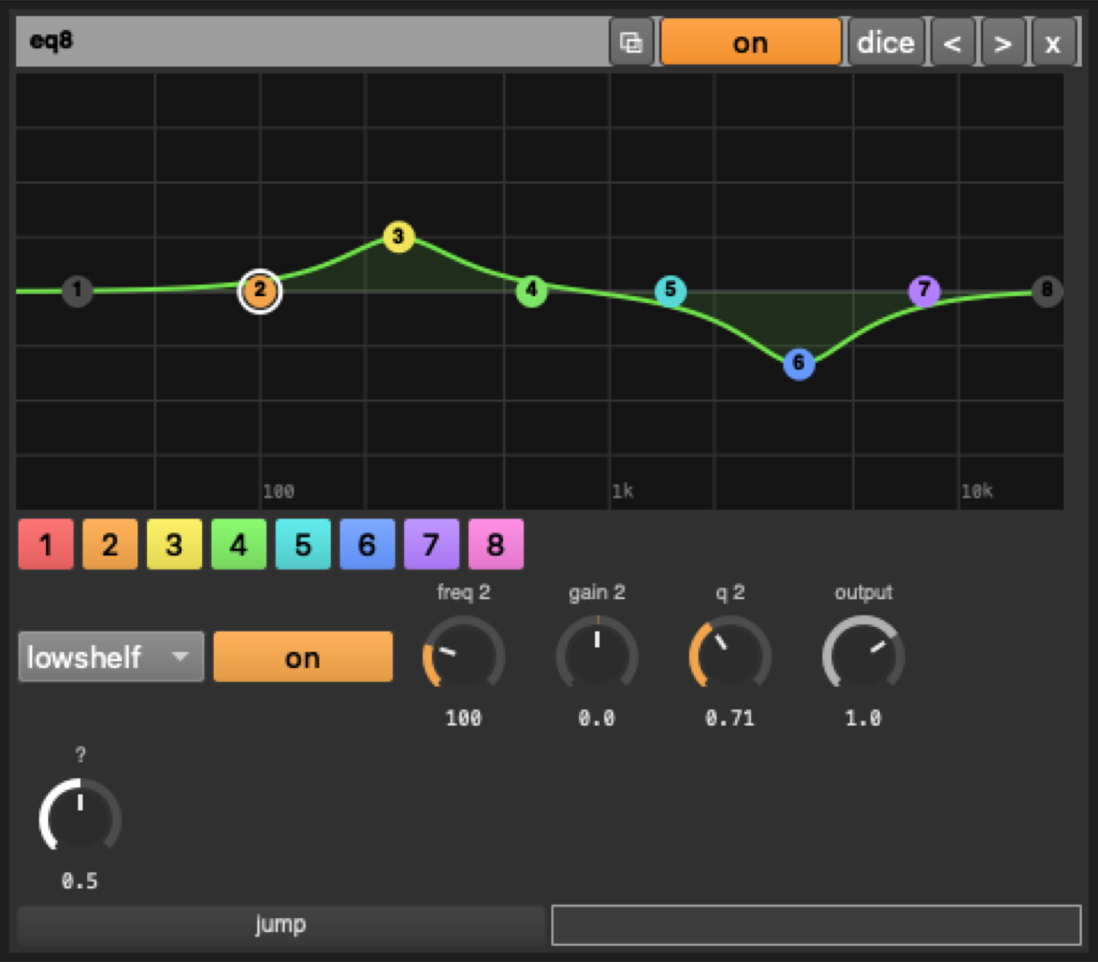
a device in its own window

6. The machine: wall, takeover, tape

The wall
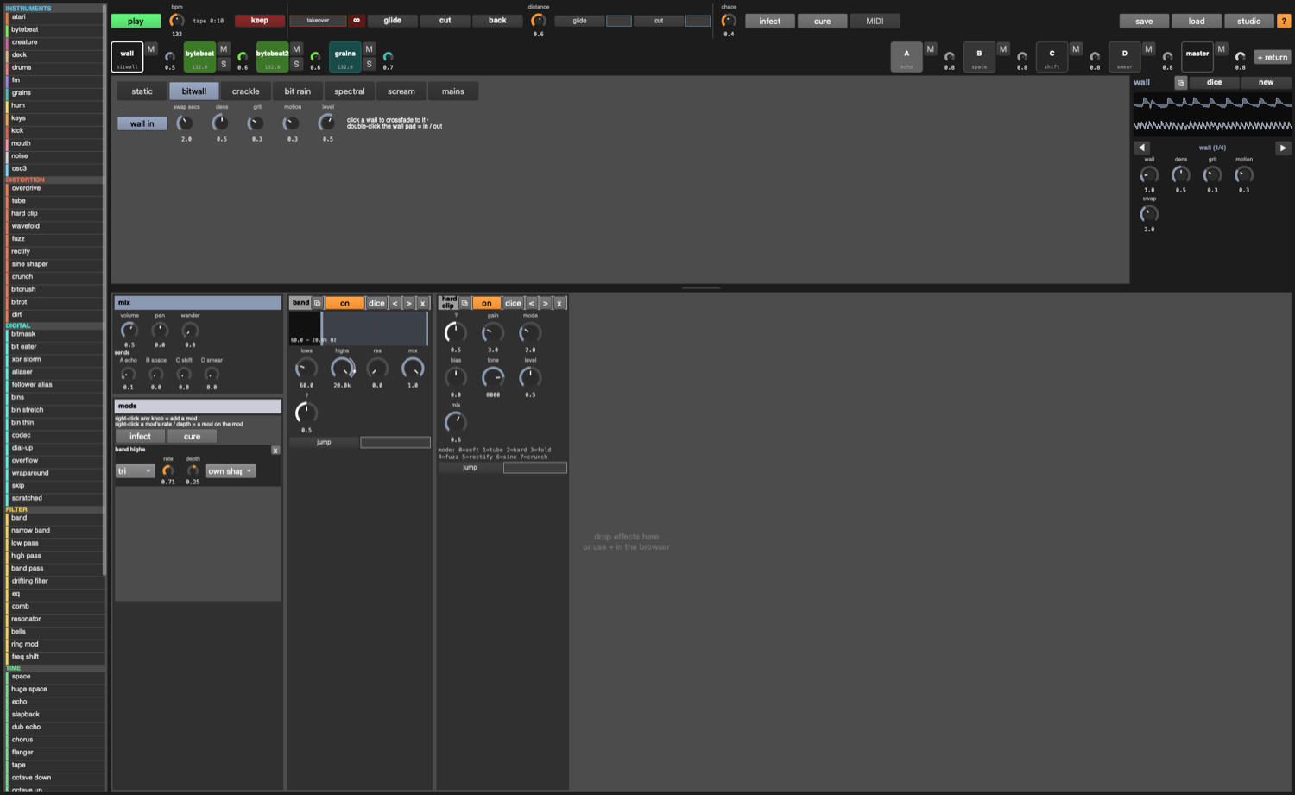
the wall
The wall is the first pad: a background noise layer to swap in and out. Focus it to see its recipes:
- static, bitwall, crackle, bit rain, spectral, scream, mains: click one and it crossfades to it over swap secs.
- wall in (or the wall pad’s M): fade the whole wall in or out.
- dens (density / rate), grit (how broken), motion (how much it moves by itself), level.
- Its chain starts with band (shape it: lows and highs) and a hard clip. Add anything else.
Solo works on it like any track (it goes quiet when you solo something else, and it has its own S). Dice and glide leave it alone: it’s yours to shape.

Takeover
In the top bar, the orange-outlined takeover slider and ∞:
- takeover (slider): pushes the focused track toward infinity (driven into digital clipping and up in level) while every other track and the wall duck under it.
- ∞ (hold) or hold the ’ key: all the way, for as long as you hold it.
Takeover follows focus: click another pad and it moves there. Returns aren’t ducked, so the taken-over track’s echoes still come through.

The session, tape and keep
Everything you play is recorded to disk, the whole time the transport runs: ~/Music/unsound/sessions/session-<date>-1.wav, -2.wav… (24-bit, about 1 GB an hour). It starts on the first play and pauses a few seconds after you stop (so tails are kept). Every 30 minutes it starts a new part, overlapping the last one by two seconds, so nothing falls in between. The ● in the top bar shows the session’s playing time; click it to open the folder.
On top of that, the last 15 minutes are always in memory (the tape), for quick clips:
- keep (or return): save what’s on the tape to ~/Music/unsound/keep-<date>.wav (24-bit), and drop a marker in the session’s notes (session-<date>.txt: which part, how far in) so you can find that moment in the long recording.
- shift-return: keep just the last minute.
So play for as long as you like without thinking about recording; nothing is lost. (~sessionOn = false in play.scd before loading turns the session recording off.) (The studio window also has the old ● record button for a classic start/stop recording.)

7. Modulation: everything moves everything
Right-click any knob (or alt-click) to give it a mod: it starts moving by itself around where you set it. Right-click again to take it away. A modulated knob shows its range as a thin outer arc; turning it moves the center the mod swings around.
Mods live in the mods panel at the start of the chain:
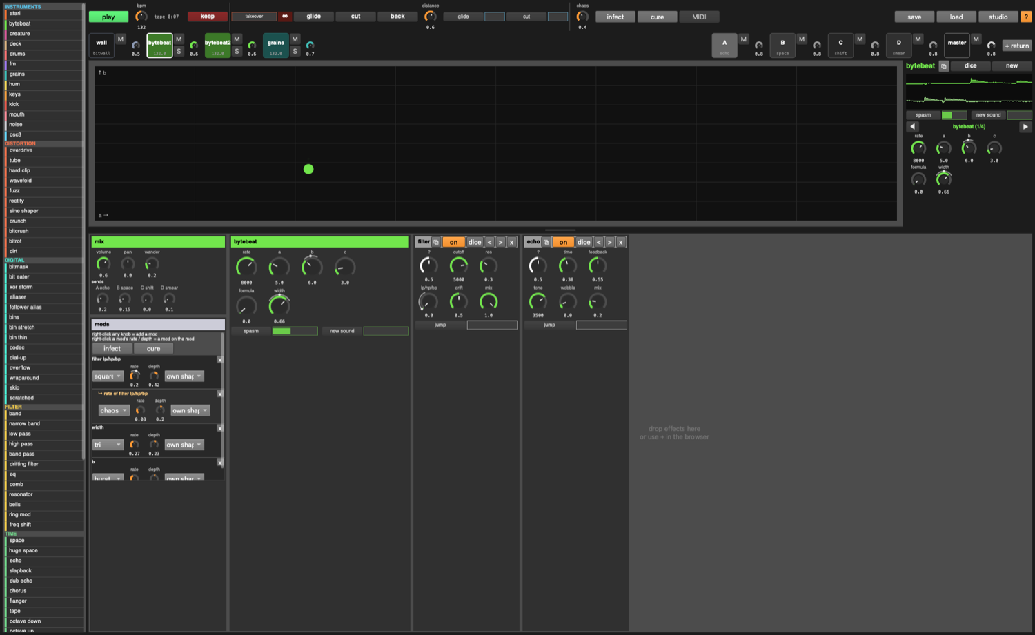
mods as a tree
Each mod has:
- shape: sine, tri, square, saw, random, drunk, chaos, burst
- rate and depth (negative depth inverts it)
- source: own shape, or follows (moves with that track’s loudness: negative depth = ducking), or driven by
- x removes it (and any mods on it)
Mods into mods: a mod’s rate and depth are knobs too. Right-click one, and the mod that moves it appears indented underneath (“↳ rate of …”). Keep going as deep as you like.
Also:
- infect (button, or I): scatters random mods (some following other tracks, some on other mods). The mods panel’s own infect only touches the focused track.
- cure (or \): removes every mod. The mods panel’s cure only touches this track.
- alive (studio window): new tracks and devices arrive already moving.
- Anything with a knob can be modulated: device settings, instrument settings, sends, pan, the every-so-often sliders, takeover, tempo…
- The master is never infected. It’s yours, by hand.
- The studio window’s mods tab shows every mod in the set at once.

7½. LFOs (Serum / Vital style)
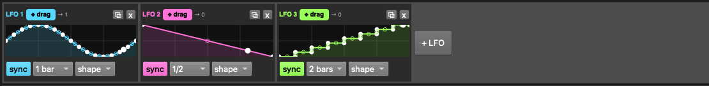
the LFO row
The row under the pads holds the LFOs: three to start, + LFO for as many as you like.
- Draw the shape: drag the white points; drag the small circle halfway along a segment to bend it (curves); double-click to add a point, double-click a point to remove it. shape… loads a preset (sine, tri, saw up / down, square, pluck, swell, steps, random).
- Speed: sync on = locked to the tempo (1/32 to 8 bars); off = free, in Hz (the small knob).
- Use it: grab the coloured ✥ drag handle and drop it on any knob (or every-so-often slider), anywhere: instruments, effects, sends, the wall, another LFO’s rate. The knob gets a ring in the LFO’s colour and a little numbered badge.
- How much: drag that knob’s outer ring up or down (or cmd-drag the knob). Drag below zero to invert it. Turning the knob normally still moves the centre it swings around.
- The → n next to the handle counts what the LFO is moving. Each of those also shows in the track’s mods panel with source “LFO n”, where you can switch it to another LFO or another source.
- ⧉ opens a big editor for the shape; x removes the LFO (and the mods it was driving).
- An LFO’s free rate is a knob too: drop another LFO on it and LFOs move LFOs.
LFOs are saved with the set.

8. Every so often
Wherever you see a small button next to a slider with no numbers: the button does it now; the slider says how often it happens by itself, at random intervals. Empty = never, full = a few times a second. Right-click the slider to modulate it.
where | what happens
every instrument | new sound (a new patch / file / formula)
noise | spasm (params jump and fall back), morph (a layer glides to another kind)
bytebeat, creature, hum | spasm
deck | skip (jumps somewhere on the tape), tape stop, reverse
drums | fill (one lane rolls), vary (one lane scrambles, then drifts home)
atari | sfx (a sound effect on channel B), glitch (wrong waveform, wrong clock)
osc3 | jump (leaps an octave or a fifth for a beat or two)
mouth | shout, hush
every device | jump (throws its mystery knob)
top bar | glide, cut (the whole set lurches somewhere new)

9. Big moves
glide (Q) | the whole set lurches toward somewhere new over the morph time
cut (=) | the same, instantly
back (-) | undo the last glide / cut / dice (50 steps of history)
distance | how far a glide or cut goes: 0 = nowhere, 1 = anywhere
dice (/) | random settings for the focused track and its devices
new sound (N) | a new patch for the focused track (keeps your pattern and settings)
chaos | the one global macro: widens every random walk, raises every probability
events (studio) | every N bars, by chance: glide, cut, back, dice, drop-outs, solos
B / V (hold) | stutter / freeze the master (if it has a stutter / freeze device)

10. Instruments

bytebeat (the bitmeister)
8-bit integer formulas on a counter. rate is the clock (keys play it chromatically), a b c are bit shifts, formula picks one of 16, width spreads it. The XY pad moves two at once.

grains
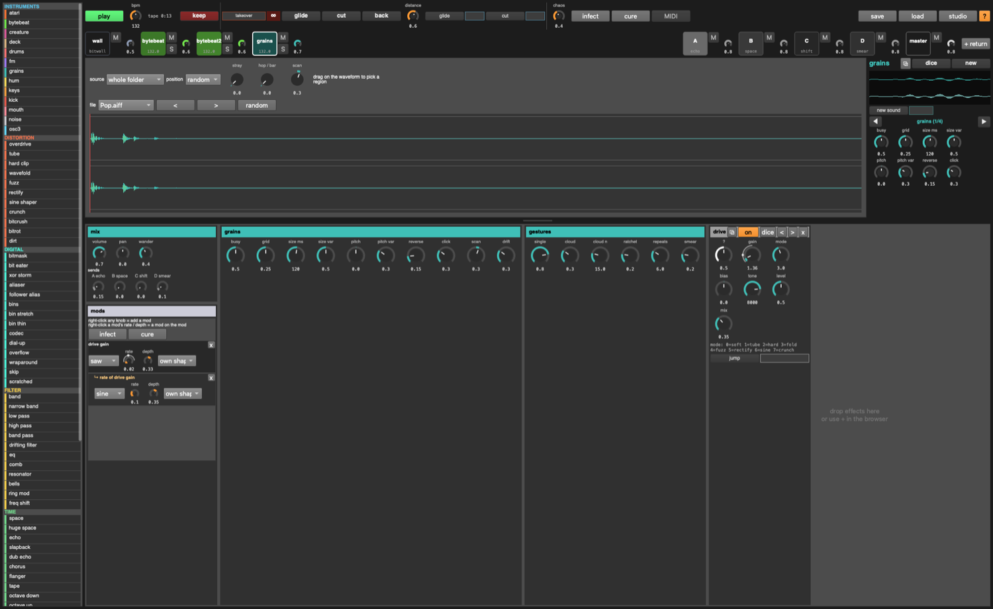 Flings little bits of your sample folder around. source: the whole folder, or stick to one file (drag on the waveform to pick a region); position random or scanning like a tape head; stray (chance of a grain from elsewhere), hop (chance per bar of jumping to a new file). Device panel: busy, grid, size, pitch and their variation, reverse, click, and the gesture weights (single, cloud, ratchet, smear).

noise
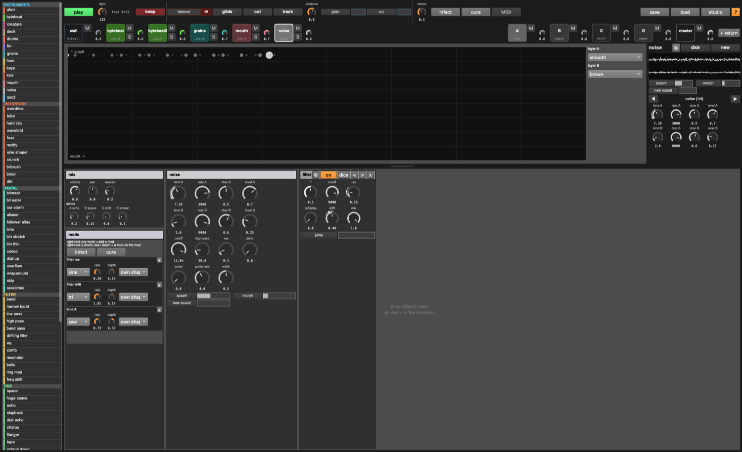 Two layers (A, B), each sweeping continuously through 20 kinds of noise: white, pink, brown, grey, bits, stepped, clipped, smooth, velvet, dust, crackle, rain, wind, radio, metal, sine fm, logistic, henon, cusp, gendy. Per layer: kind (menu, or the knob to morph between neighbours), rate, char, level. Then cutoff, high pass, res, drive, pulse (gate) and pulse rate, width. Keys set layer A’s rate (pitched noise).

mouth
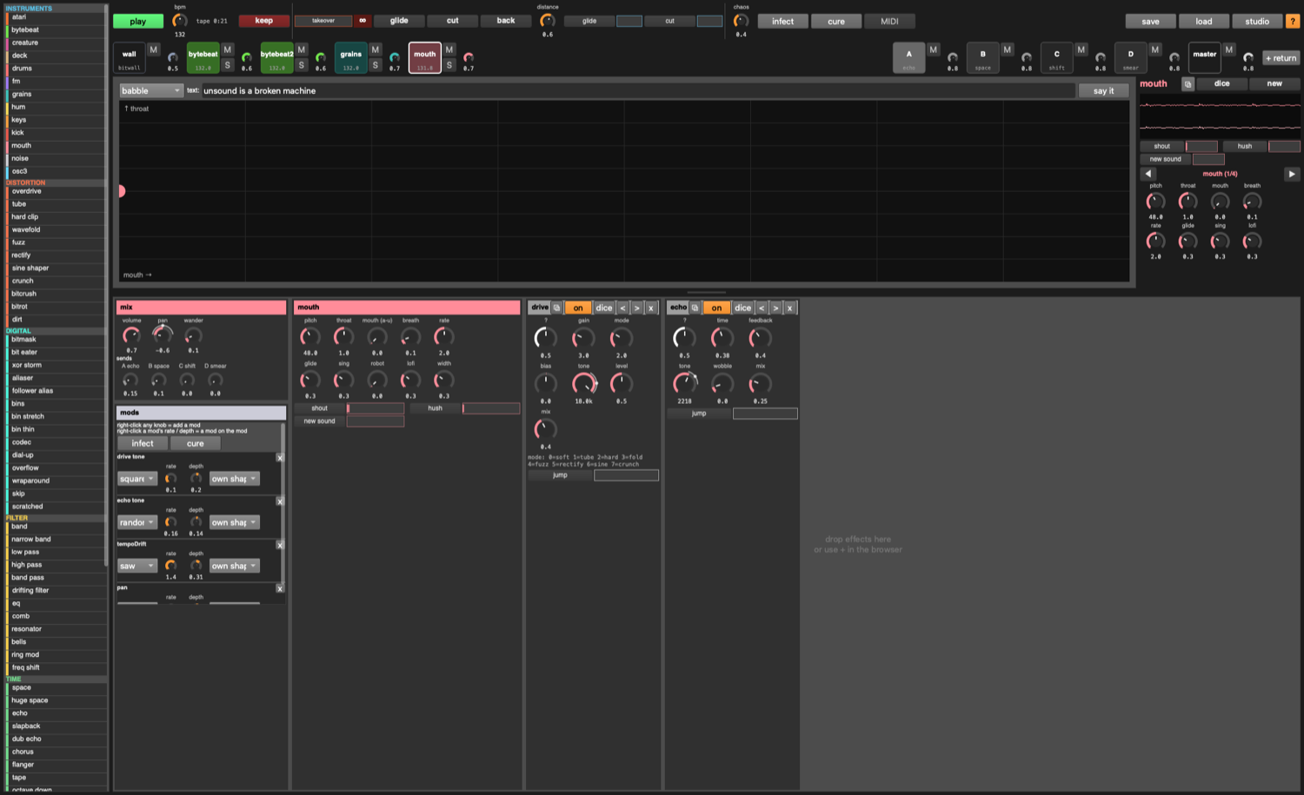 A talking machine. babble (random syllables), say the text (type into the box, it loops it), hold a vowel (sweep a → e → i → o → u on the XY pad). pitch, throat (head size), mouth, breath, rate (syllables per beat), glide, sing (0 = speech, 1 = sings the scale), robot (monotone), lofi (down to Speak & Spell). Keys: a note sets the pitch and says a syllable.

deck
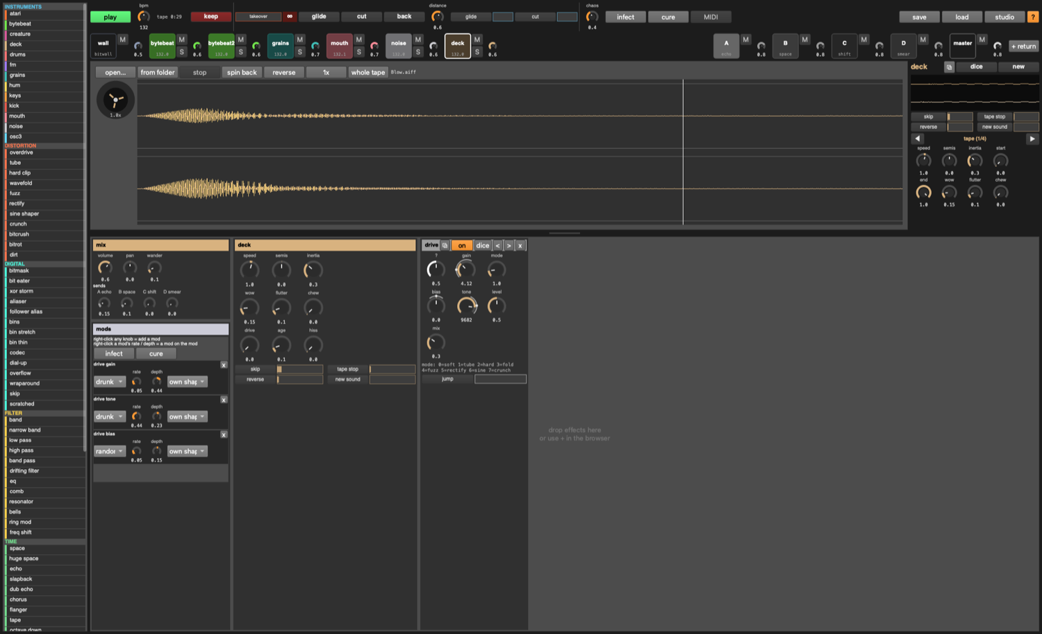 A tape player. open… any audio file, from folder for a random one. It loops the region forever: click the waveform to move the playhead, drag to pick the loop, whole tape to reset. speed −8× to 8× through a motor with inertia (so changes swoop), semis, stop, spin back, reverse, 1x. Wear: wow, flutter, chew (skips and drop-outs), drive, age, hiss. The reel shows the motor.

osc3
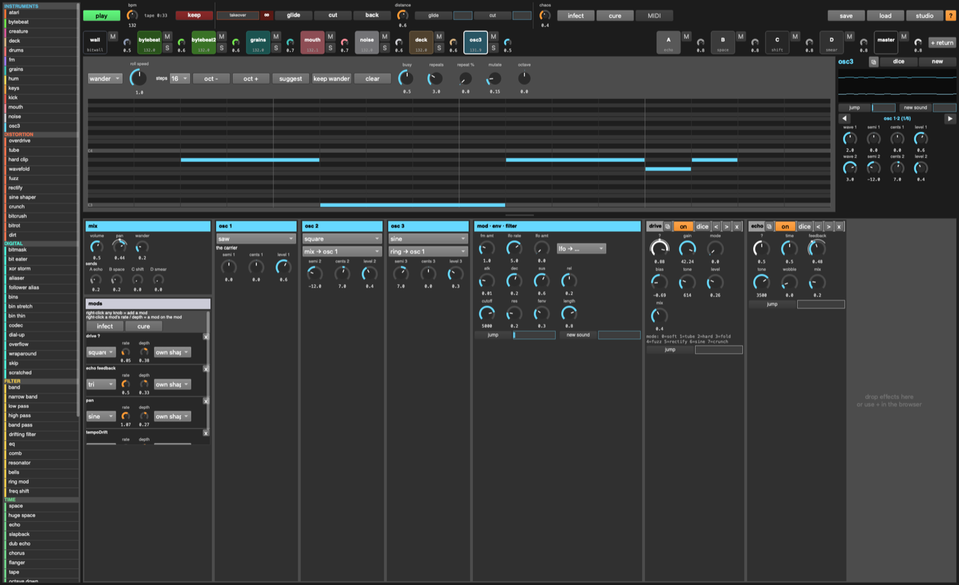 A 3xOsc. Three oscillators (sine / tri / saw / square / noise), each with semitones, cents and level. Osc 2 and 3 each mix, ring, fm or am into osc 1 (fm amt). A pitch LFO (lfo rate, lfo amt), envelope (atk dec sus rel), filter (cutoff res fenv). The lfo → … menu puts a sine mod on any of its knobs in one click. Plays the piano roll or wanders.

atari
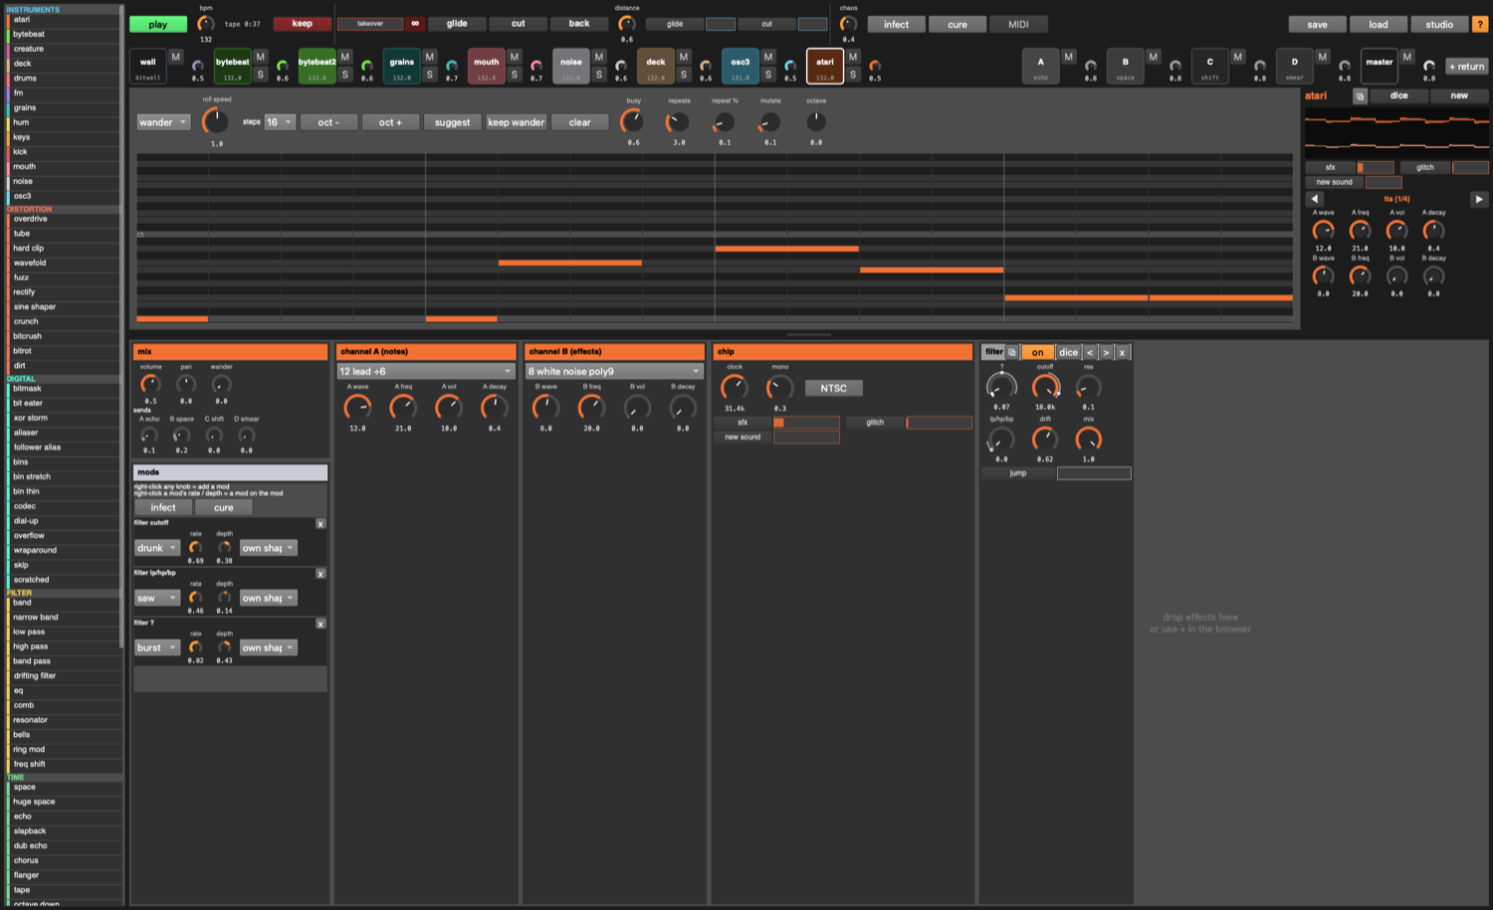 The Atari 2600’s sound chip, emulated from its counters. Two channels, each with the real registers: wave (AUDC, 16 waveforms: buzz, rumble, pure, bass, lead, white noise…), freq (AUDF, 0–31), vol (AUDV, 0–15), decay. Channel A plays the roll / wander / keys (notes snap to the nearest AUDF, so they’re out of tune like the real thing); channel B does sound effects. clock overclocks the chip (NTSC resets it).

drums
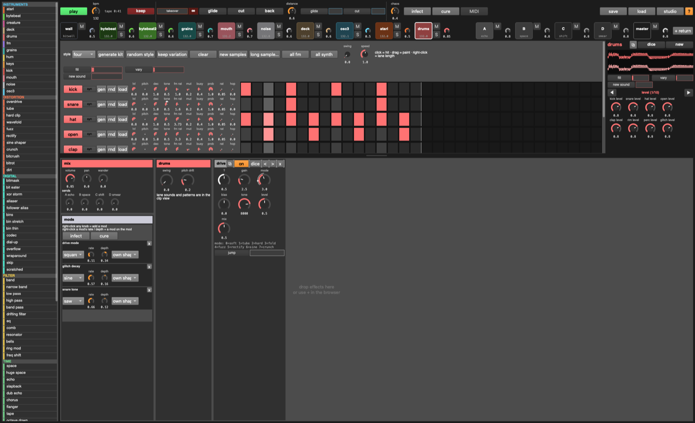 Eight lanes, each its own sequencer. click = hit, drag = paint, right-click a cell = the lane ends there (polymeter). Per lane: syn / fm / smp (click to cycle the sound), gen (new pattern), rnd (random sample slice), load (your own sample), and knobs for level, pitch, decay, tone, fm ratio, mutate, busy, probability, ratchet, hop. Kit: style, generate kit, keep variation, new samples, long sample… (one long file the whole kit slices from, at its onsets), all fm, all synth. Solid = your hit, outline = mutation added one, dot = mutation removed one.

creature, hum
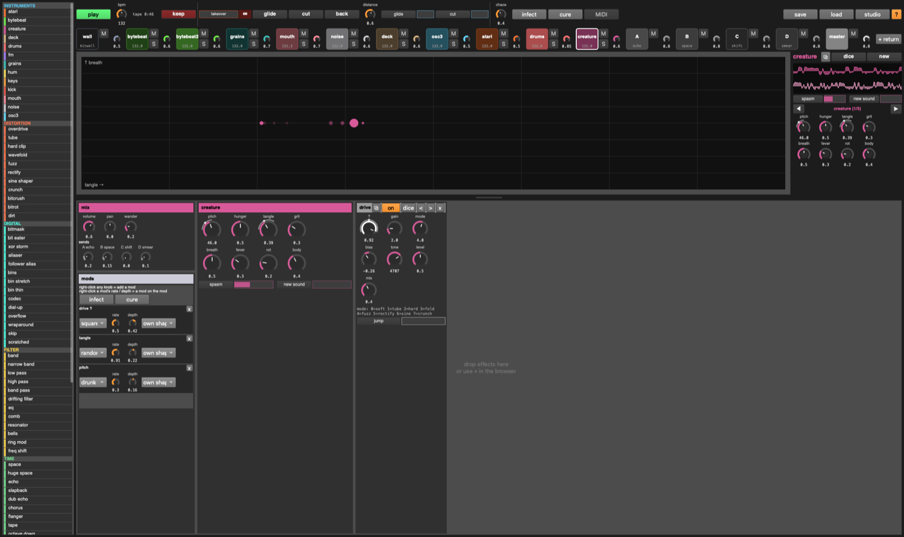 Continuous noise beasts. creature: chaotic oscillators tangled together (hunger, tangle, grit, breath, fever, rot, body). hum: a self-oscillating feedback network (tension, size, tint, unrest, swell). XY pad + knobs.

keys, fm, kick
The older instruments. keys: a region of a sample played like a synth (shot or looped as an oscillator). fm: drawable carrier / modulator waveforms. kick: a 16-step kick you draw. keys and fm play a piano roll (click to add, drag to lengthen, click a note to delete; suggest, wander, keep wander, repeats, mutate).

11. Effects
The browser’s categories (hover each for a description):
- distortion: overdrive, tube, hard clip, wavefold, fuzz, rectify, sine shaper, crunch, bitcrush, bitrot, dirt
- digital (things a pedal can’t do):
  - bitmask: the signal as 16-bit integers, XOR / AND / OR with a mask that sweeps by itself
  - aliaser: sample-and-hold with no filter; loud moments push the rate up (follow)
  - bins: stretch and shift the spectrum; thin throws bins away
  - codec: a bad stream: only spectral peaks survive (quality), frames warble, packets drop (loss)
  - overflow: integer wraparound: push it and loud turns into its opposite (fold reflects instead)
  - skip: a scratched CD, sticking on tiny chunks of the last two seconds
- filter: band (just lows and highs: drag the edges, drag the middle to move both, scroll = resonance), low / high / band pass, drifting filter, eq, EQ Eight, comb, resonator, bells, ring mod, freq shift
- time: space, echo, slapback, dub echo, chorus, flanger, tape, octave down / up, reverse, smear
- glitch: stutter, chop, freeze, scramble, blur, feedback, screamer
- dynamics: compressor, gate, width, autopan, limiter
- chains: noise wall, broken radio, tape ghost, metal, dissolve, digital rot, broken stream
EQ Eight: eight bands like Ableton’s. Drag a dot (left/right = frequency, up/down = gain), scroll on it = Q, double-click = on/off. Click a number below to pick a band: its type (low cut, low shelf, bell, notch, high shelf, high cut), on, freq, gain, Q. The curve is the real response.
stutter / freeze have a HOLD pad; on the master, hold B / V.

12. The 8 encoders and MIDI
The 8 small knobs at the bottom of the focus column are the focused track’s current page. Pages are made automatically: the instrument’s knobs, mix, then one per device. ◀ ▶ or tab / shift-tab change page. They’re mostly there for a MIDI controller:
- MIDI (top bar) = learn. Switch it on, touch something on screen, move a control on your controller. Done.
- Learning an encoder maps the encoder, not the knob under it, so 8 hardware knobs follow whatever track and page you focus.
- ◀ ▶ (pages), glide, cut, back, keep, dice, new can be learned onto pads or buttons.
- Any knob, slider or toggle anywhere can be learned directly too.
- Jog wheels (relative encoders) are detected and nudge instead of jump.
- MIDI notes play the focused track (GM drum notes work on drums).
- Mappings are saved with the set.

13. Playing it from the keyboard
key
space | play / stop
A W S E D F T G Y H U J K O L P ; | notes on the focused track (drums: one lane per white key)
Z / X | octave down / up
, / . | master tempo down / up (3%, no limits: at absurd tempos rhythm turns into pitch)
1–9 / 0 | focus instrument track 1–9 / the master
← / → | previous / next track
↑ / ↓ | volume (with shift: that track’s tempo)
tab / shift-tab | next / previous encoder page (studio: clip → devices → mods)
` | box ↔ studio window
return | keep the tape (shift: last minute)
’ (hold) | takeover: the focused track to infinity
Q / = / - | glide / cut / back
/ | dice the focused track
N | new sound
M | mute the focused track
R | resync the focused track to the master clock
I / \ | infect / cure
B / V (hold) | stutter / freeze the master
C | capture a scene
[ / ] | previous / next scene
? | the shortcuts window
The keyboard plays whenever the window is in front and you’re not typing in a text box.

14. The studio window
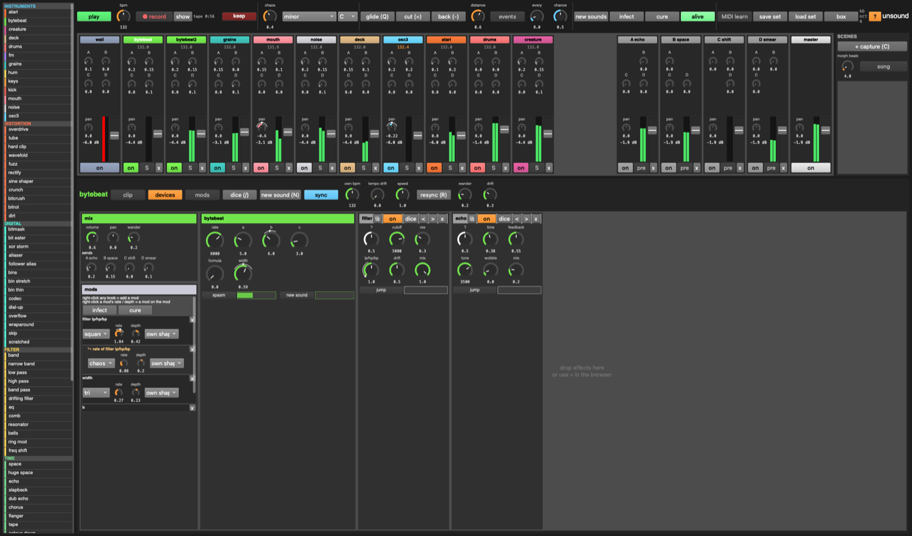
studio
Press ` or studio. The Ableton-shaped view, for when you want everything at once:
- mixer: one strip per track with sends to every return, pan, meter, fader, on / S / x (remove). Returns have pre (pre-fader sends) and can send to each other (feedback allowed). Scroll sideways with the wheel.
- scenes (right of the mixer): + capture (C) snapshots everything; click a scene to launch it, morphing over morph beats; ↻ updates it, x deletes it. song plays the list of scenes (set from code, see below).
- header of the focused track: clip / devices / mods tabs, dice, new sound, and the tempo controls (sync, own bpm, tempo drift, speed, resync), wander, drift.
- transport: record (and show it in Finder), tape + keep, chaos, scale and key, glide / cut / back, events (every / chance), new sounds, infect / cure / alive, MIDI learn, save / load set, box (back to the box).
- mods tab: every mod in the set.
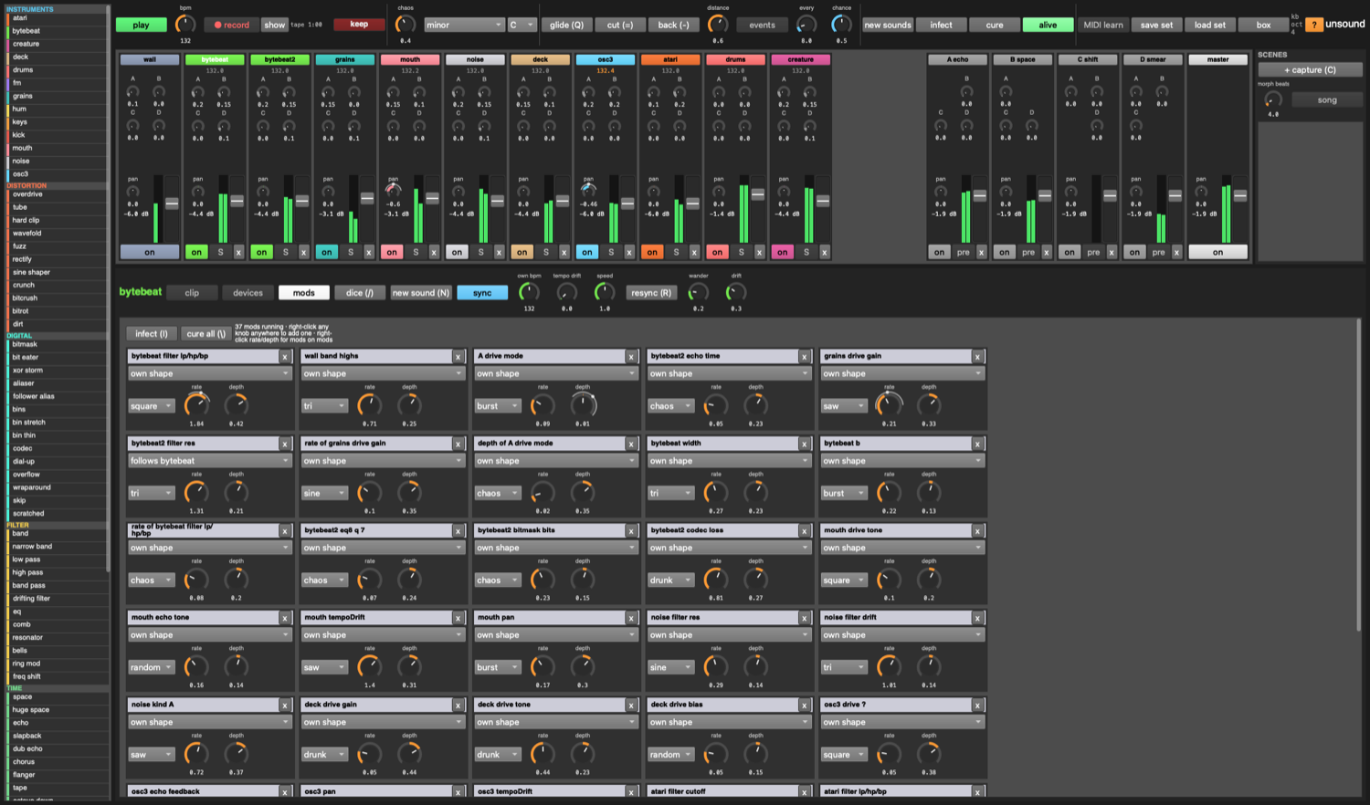
every mod in the set

15. Sets, scenes, files
- save / load (top bar): a whole set (tracks, devices, sends, mods, scenes, song, MIDI maps, the wall, loaded files’ paths) in one .unsound file. Sets go in sets/ by default.
- keeps and recordings go to ~/Music/unsound/.
- The sample folder is ~folder in play.scd; ~reload.("~/some/folder") swaps it while playing.

16. From code (play.scd)
Everything in the window can be done from code. A few favourites:
~add.(\mouth); // a new track
~dev.(\bytebeat, \overflow); // an effect on a track
~tset.(\mouth, \text, "hello"); // any track setting
~send.(\grains, \A, 0.6); // a send
~ramp.(\bytebeat, \rate, 20000, 16); // glide a setting over 16 beats
~wallPick.(5); // the scream wall
~takeover.(\bytebeat2, 1); // takeover from code
~keep.(120); // keep the last two minutes
~song = List[[0, 16], [1, 8]]; ~playSong.(); // scenes in order: [scene, bars]
Make your own: - a noise kind: one line in ~noiseKinds (lib/voices/noisegen.scd): ["name", { |rate, char| signal }] - a wall: one line in ~wallTypes (lib/wall.scd): ["name", { |dens, grit, motion| stereo signal }] - an effect: a ~deviceDef and an entry in ~deviceTypes (lib/devices.scd), plus a description in lib/descriptions.scd - an instrument: a file in lib/voices/ registering ~voiceTypes[\name] (copy one), added to the list in unsound.scd

17. When something’s wrong
- Silence: is play on? Is the track muted (M), or something else soloed (S)? Is the wall faded out? Cmd-. and play again.
- Way too loud: the master’s limiter catches it; pull the master pad’s volume down, or turn the takeover slider back to empty.
- The server won’t boot: the input and output sample rates differ (e.g. AirPods mic). unsound starts without inputs to avoid that; if it still fails, pick one output device in Audio MIDI Setup.
- Memory: the tape keeps 15 minutes in RAM (about 350 MB). Set ~tapeMinutes = 5 before loading to use less.
- A knob won’t stay where I put it: it has a mod. Right-click it to take the mod away, or turn its depth down in the mods panel.

