**Unified Calendar system**

**Objective**

Building a web application with its own database, that imports calendar data from other systems in other networks, the system shall allow logged in users to view all calendar events from different systems in layered view. Users can also add additional events directly through the web interface. Managers shall be able to view the calendars of their teams.

**Existing data sources:**

1. Microsoft exchange server
2. Gitlab

**A. middleware-server:**

* Import and synch calendar events from other systems.
* create new calendar event with local database as draft
* expose an API to allow future organization

Technologies & Tools :

runtime : Node.js

framework : Express.js

database : Mongo

unit-testing : Jest

package manager : NPM

**B. web-UI**

* manager able to view all calendar events of each team/employee
* employee able to view/ add events directly – on date/time range in UI
* multiple views of calendar – day | week | month | year
* display calendar events that are pending/confirmed differently
* web based responsive interface

Tools and Technologies :

* web tech : HTML, CSS, JavaScript
* CSS : bootstrap, font-awesome
* UI lib : React.js
* state management : Redux.js
* build tools : NPM
* unit-testing : Jest
* end-to-end : selenium, cucumber

Sample UI:

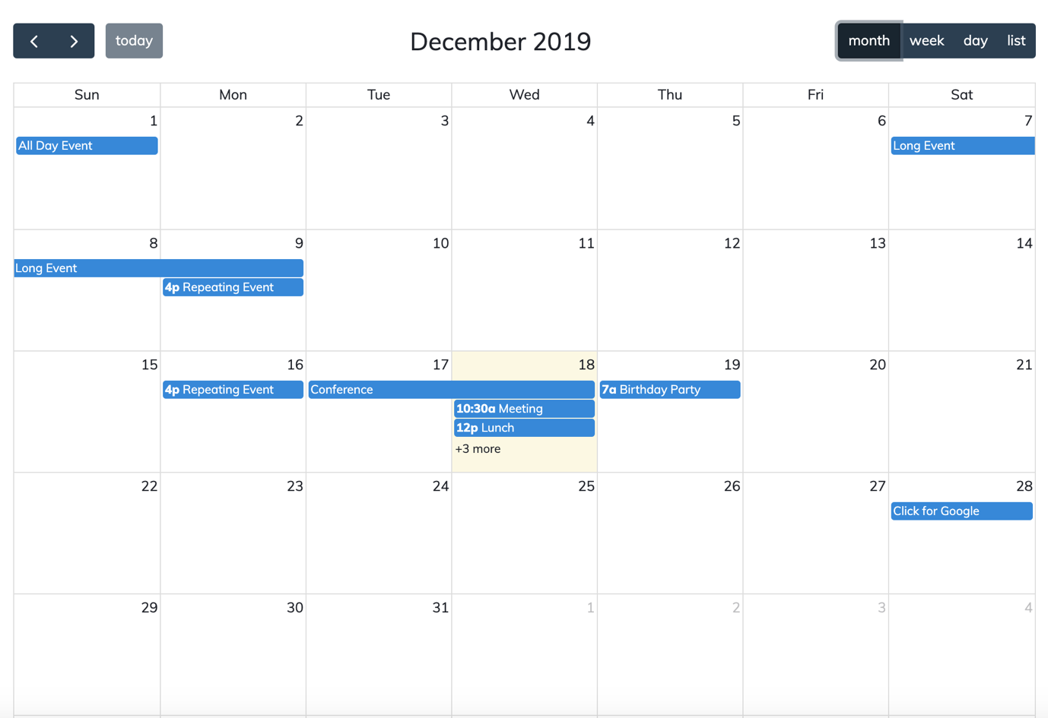

**C. Authentication/Authorization server**

* Integration with AD / LDAP

Team-1 : UI

Team-2 : Middleware development