**trial1_nomuscle_1.0anatomy_0.0brace**

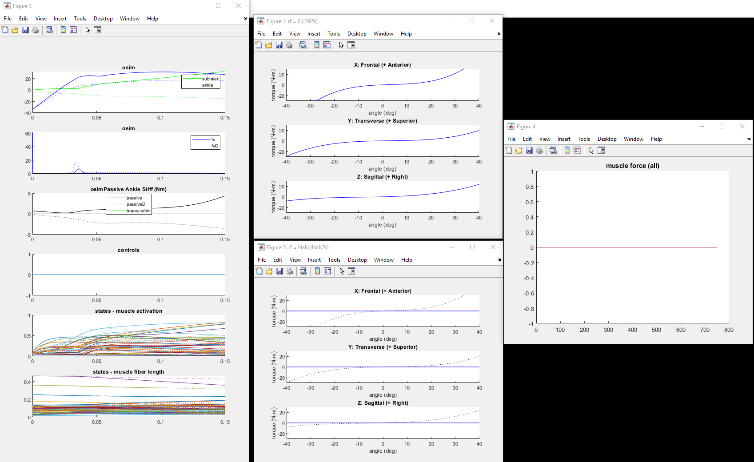

**Anatomy**

**Brace**

**Trial2_nomuscle_1.0anatomy_1.0brace *(2x stiffer than anatomy at fixed displacements)***

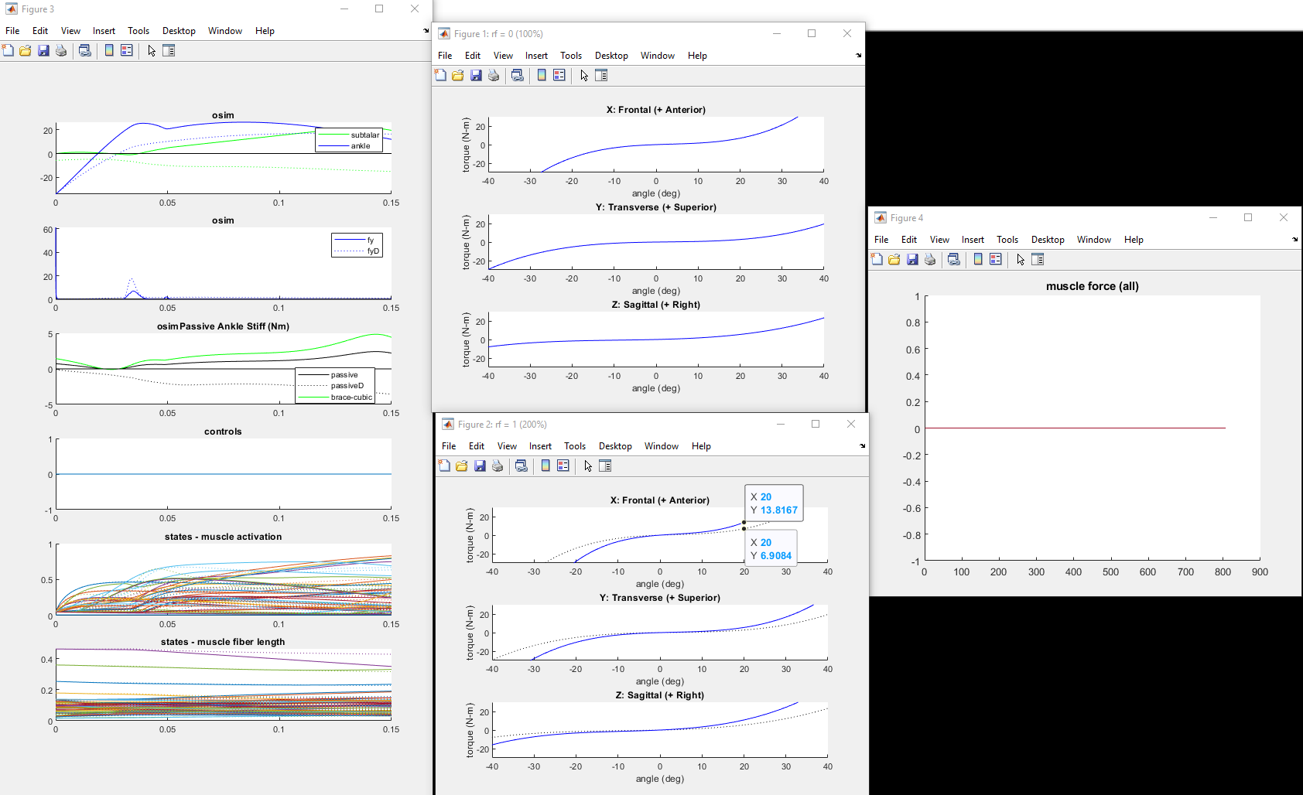

**Anatomy**

**Brace**

**Trial3_withmuscles_1.0anatomy_0.0brace**

**(used 50% Inv/Ev co-activation, and 5.0 reflex gain)**

**These should produce physiologically reasonable JCS angles and velocities w.r.t literature**

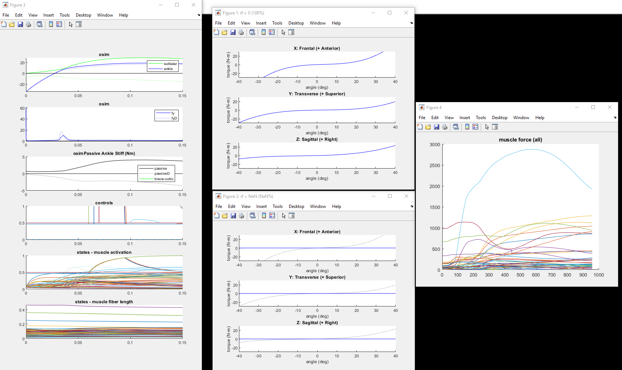

**This is soleus_r @2800N**

**Brace**

**Anatomy**