SERIAL PERIPHERAL INTERFACE (SPI)

- SPI is an interface bus commonly used to send data between microcontrollers and small peripherals such as shift registers, sensors and SD cards.

- SPI has synchrounous solution to receive data.
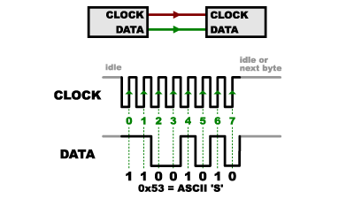

- SPI has four lines:
- SCK / CLK – generates cloock signal.
- MOSI – data sent from master to slave, Master Out Slave In
- MISO – data sent from slave to master, Master In Slave Out
- SS – used to select the required slave

- SPI generates clock in only one side i.e., master generates clock and other side is called slave.
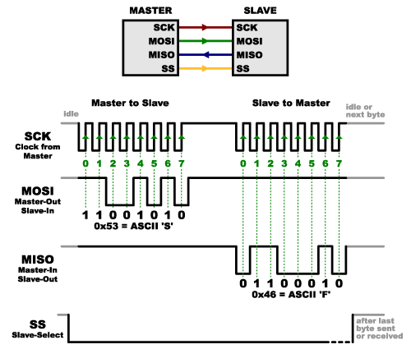

- Multiple slaves : 2 ways
  - separate slave lines:
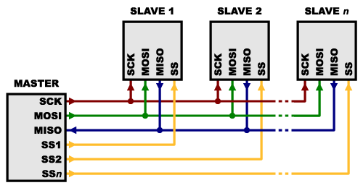
  - single SS line (daisy chain configuration):
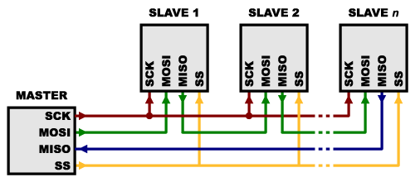
- SPI transfer example
  - when master wants to initiate transfer, it must pull SS signal low for the slave it wants to communicate with
  - once SS signal is low, that slave will be listening on the bus
  - master is free to start sending data
- There are 4 different types of SCK signal. The four modes are catagorized into two:
  - CPOL (clock polarity) – value low/high will decide the idle state of bus
  - CPHA (clock phase) – sampling of data during rising or falling edge of the clock
SPI Mode | Clock Polarity  (CPOL/CKP) | Clock Phase  (CPHA) | Clock Edge  (CKE/NCPHA)
0 | 0 | 0 | 1
1 | 0 | 1 | 0
2 | 1 | 0 | 1
3 | 1 | 1 | 0

