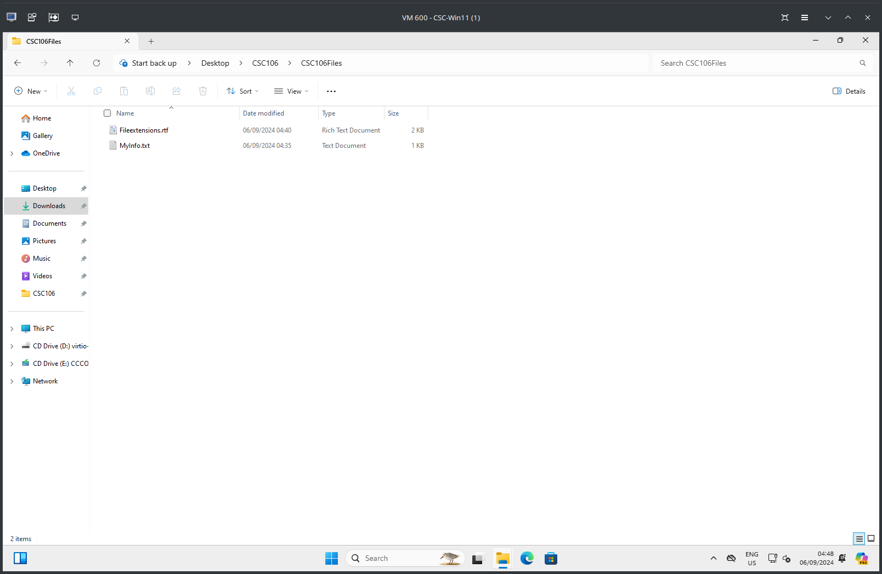
Aadhi Kumar, CSC106-IN5, File Explorer, CSC106Files folder

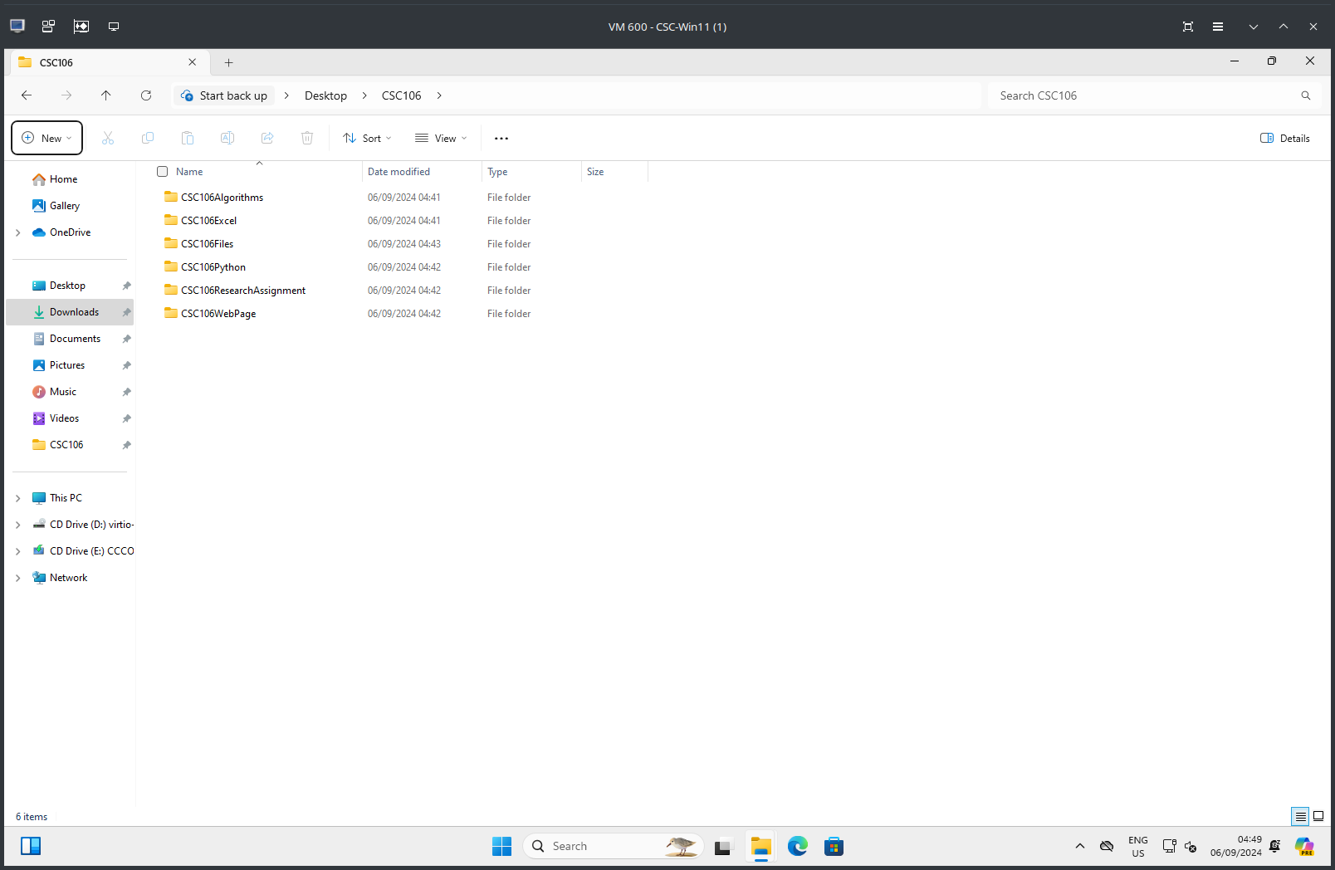
Aadhi Kumar, CSC106-IN5, File Explorer, CSC106 Folder

