University of Ghana
Department of Computer science
Hospital & Clinic Operations Optimizer - Project Report
2026
Hospital & Clinic Operations Optimizer
A Data-Structures & Algorithms System for a Ghanaian Hospital / Clinic Network
Project Report
DCIT 204 / 308 - Joint Data Structures & Algorithms Semester Project
Local context: A hospital/clinic network in Ghana. The system models the network's departments and wards as locations, the corridors and connecting routes between them as routes, the day-to-day patient/operational jobs as service requests, and the staff, equipment, ambulances and beds as resources. It helps operations staff answer everyday questions quickly: what is the most urgent job right now? what is the fastest way to move a patient from A to B? which departments can a porter reach from here? what is the cheapest set of corridors that keeps the whole site connected? who should be assigned to what?

Group project -organised into role-based teams:
Role / Team | Responsibility | Member(s)
Group Leader & Technical Developer | System design and the full Java implementation | Bright Afatswo
Data Collection Team | Gathering the raw location, route, request and resource figures | Bediako Lord Michael; Apeweh Rexford Awaregya; Earl Yaw Asamoah; Ferdinard Afful
Database Team | Data entry and CSV formatting to the agreed column headers | Lawrence Darko; Jeremiah Asempapa
Documentation & Report Team | Compiling, formatting and proofreading this report | Osborne Tulasi; Roselyn Sakyi
QA / Manual Testing Team | Working through the console features and logging results | Reuben Kotei Neequaye; Welbeck Donkor
Presentation & Oral-Defense Team | Slides, demo and defending the work | Stephanie Apenteng; Kaziah Helen Fobi
Logistics & Attendance Coordinator | Scheduling, communication and attendance records | [Insert Name]

Academic year: 2025/2026
Submission date: [Submission Date]

Table of Contents
2. Problem Statement, Assumptions, Input/Output, System Boundaries 1
2.1 Problem statement 1
2.2 Assumptions 1
2.3 Inputs 1
2.4 Outputs 1
2.5 System boundaries 1
3. Dataset Description, Data Dictionary, and Database Schema 1
3.1 Dataset description 1
3.2 Data dictionary 1
3.3 Database schema 1
4. System Architecture and Module Design 1
4.1 Layered overview 1
4.2 Modules (Java packages) 1
4.3 Key design decisions 1
5. Data-Structure Implementation 1
5.1 DynamicArray -DynamicArray.java 1
5.2 DoublyLinkedList -DoublyLinkedList.java 1
5.3 ArrayStack -ArrayStack.java 1
5.4 CircularQueue -CircularQueue.java 1
5.5 LinkedQueue -LinkedQueue.java 1
5.6 Deque -Deque.java 1
5.7 BinaryHeap (priority queue) -BinaryHeap.java 1
5.8 BinarySearchTree -BinarySearchTree.java 1
5.9 AVLTree -AVLTree.java 1
5.10 BTree -BTree.java 1
5.11 HashTable -HashTable.java 1
5.12 HashMap & HashSet -HashMap.java, HashSet.java 1
5.13 DisjointSet (union-find) -DisjointSet.java 1
5.14 Graph -Graph.java 1
6. Algorithm Implementation 1
6.1 Searching -SearchAlgorithms.java 1
6.2 Sorting -SortAlgorithms.java 1
6.3 Graph traversal -BFS & DFS -GraphAlgorithms.java 1
6.4 Dijkstra's shortest path -GraphAlgorithms.dijkstra 1
6.5 Minimum spanning tree -Prim & Kruskal 1
6.6 Greedy staff assignment -GreedyAssignment.java 1
6.7 Dynamic-programming request selection -DynamicSelection.java 1
7. Correctness Evidence 1
7.1 Binary search -loop invariant + trace 1
7.2 Insertion sort -loop invariant + trace 1
7.3 Merge sort -induction 1
7.4 Quicksort -partition invariant 1
7.5 Dijkstra -greedy exchange argument + trace 1
7.6 Kruskal / Prim -cut & cycle properties 1
7.7 Dynamic programming -the knapsack table 1
7.8 Counterexample 1 -greedy is NOT throughput-optimal 1
7.9 Counterexample 2 -binary search on unsorted input (broken precondition) 1
8. Performance Analysis 1
8.1 Sorting (sorting.svg) 1
8.2 Searching (searching.svg) 1
8.3 Hash table vs. load factor (hashtable.svg) 1
8.4 BST vs. AVL -the headline experiment (tree-height.svg, tree-search.svg) 1
8.5 Binary heap (heap.svg) 1
8.6 Graph algorithms (graph.svg) 1
8.7 Conclusion 1
9. Database Integration Evidence 1
9.1 Engine and connection 1
9.2 How load / save works 1
9.3 Live row counts (from an actual run) 1
9.4 Sample records (queried from hospital.db) 1
9.5 Algorithm-run log (real captured evidence) 1
9.6 Integrity features 1
10. Responsible Algorithm Selection 1
10.1 Where a greedy / heuristic choice IS appropriate 1
10.2 Where a greedy shortcut is NOT appropriate 1
10.3 The principle we followed 1
11. Individual Contribution Statements & Oral-Defense Prep 1
11.1 Contributions by team 1
11.2 Oral-defense prep notes (plain-language one-liners) 1
12. References and Appendices 1
12.1 References 1
12.2 Appendix A -How to build and run 1
12.3 Appendix B -Repository map 1
12.4 Appendix C -Mapping brief requirements → code 1
12.5 Appendix D -Test summary 1
12.6 Appendix E -Editorial items before final submission 1

2. Problem Statement, Assumptions, Input/Output, System Boundaries

2.1 Problem statement
A busy hospital or clinic is, at its core, a network of places connected by corridors, through which people, samples, medicines and equipment must constantly move -and a stream of jobs (requests) competing for a limited pool of staff and equipment. Doing this well by hand is hard: which of 300 pending jobs is most urgent right now? What is genuinely the fastest way to wheel a patient from the Emergency Department to Radiology when there are many possible corridors? If a budget only allows a certain number of corridors to be kept lit and maintained, which set keeps every department reachable at least cost?
The Hospital & Clinic Operations Optimizer is a Java console application that answers exactly these questions using classic data structures and algorithms -all implemented from scratch -over the network's dataset (a coherent synthetic dataset, or real figures if they are supplied).

2.2 Assumptions
- Corridors are two-way. A route between two locations can be travelled in both directions, so the network is modelled as an undirected graph.
- Two independent costs per corridor. Each route has a distance (metres) and a travel time (seconds). Fastest-route questions use travel time; cheapest-network questions use distance.
- Non-negative costs. Distances and times are ≥ 0, which is what lets us use Dijkstra's algorithm for shortest paths.
- Urgency is a small integer, 1 (most urgent, triage-critical) to 5 (routine). The "next job" is always the lowest-numbered urgency.
- A resource has a capacity measured in minutes of work available in the current planning window, and a status (AVAILABLE / BUSY / OFFLINE); only AVAILABLE resources can be assigned.

- Two derived fields are computed for each request because they are not in the raw data: an estimated service time (from the job category) and a value/benefit score (higher for more urgent jobs). These feed the greedy and dynamic-programming features. The rule used is documented in the code (database/Repository.deriveOne).
- Single user, single site, in-memory + one SQLite file. No concurrency, no network server -appropriate for a console tool.

2.3 Inputs
- Seed data in database/seed-data/ as four CSV files: locations.csv, routes.csv, service-requests.csv, resources.csv (headers documented in section 3). These are loaded at start-up.
- Interactive menu choices from the operator: which algorithm to run and its parameters (e.g. a start and end location for a route, a staff-minute budget for the DP selection).

2.4 Outputs
- On screen: the most urgent request; a fastest route as an ordered list of locations with its total time; the set of reachable locations; a minimum-cost network (list of corridors + total distance); a greedy assignment of resources to requests; the best set of requests under a budget; and lookup results.
- Persisted to SQLite (database/hospital.db): the four entity tables, an append-only algorithm_runs log (every run's inputs, timing and result), and an audit_events change trail.
- Benchmark artefacts (from the performance harness): CSVs and charts under performance/.

2.5 System boundaries
In scope: modelling the network; the 13 data structures and the search/sort/graph/greedy/DP algorithms; the console workflow; SQLite persistence; timing/logging; benchmarking; and this report.
Out of scope: a graphical or web interface; real-time tracking of staff location; live integration with a hospital's actual HIS/EMR systems; multi-user access; authentication/authorisation; and any clinical/triage decision-making -the tool supports operations logistics, it does not make patient-safety decisions (see section 10, Responsible Algorithm Selection).

3. Dataset Description, Data Dictionary, and Database Schema

3.1 Dataset description
The system works over four datasets describing the hospital network. The project ships a coherent synthetic dataset generated by database/SeedDataGenerator.java (src/main/java/database/SeedDataGenerator.java): real department names placed in sensible blocks, believable distances and times, and a fixed random seed so the files are stable and reproducible. The dataset exceeds the brief's minimums:
Dataset | File | Rows | Brief minimum
Locations (departments/wards/service points) | locations.csv | 60 | 50
Routes (corridors between locations) | routes.csv | 150 | 100
Service requests (operational jobs) | service-requests.csv | 320 | 300
Resources (staff/equipment/beds) | resources.csv | 36 | 30
The network is guaranteed connected (the generator lays down a spanning tree first, then adds extra corridors), so every routing and reachability feature has meaningful data to work on. To run the system on real collected figures instead, replace the four CSVs in database/seed-data/ using the same column headers.

3.2 Data dictionary
locations.csv
Column | Type | Meaning | Example
locationId | text (PK) | Stable identifier | L001
name | text | Human name | Emergency Department
area | text | Block / zone | Emergency Block
type | text | ward / department / unit | department
notes | text | Free text | 24-hour walk-in and ambulance intake

routes.csv
Column | Type | Meaning | Example
fromLocationId | text (FK→locations) | One end of the corridor | L002
toLocationId | text (FK→locations) | Other end | L001
distance | number (m) | Physical length -used by MST | 232
travelTime | number (s) | Walking/porter time -used by Dijkstra | 138
notes | text | Free text | covered walkway

service-requests.csv
Column | Type | Meaning | Example
requestId | text (PK) | Identifier | SR0001
source | text (FK→locations) | Where the job starts | L034
destination | text (FK→locations) | Where it ends | L015
category | text | Kind of job | medication-run
urgency | int 1–5 | 1 = most urgent | 5
timeSubmitted | text (ISO) | When raised | 2026-08-11T14:28
deadline | text (ISO) | Soft target | 2026-08-11T17:20
status | text | PENDING/ASSIGNED/DONE | PENDING

resources.csv
Column | Type | Meaning | Example
resourceId | text (PK) | Identifier | R001
type | text | nurse/porter/ambulance/… | cleaner
homeLocation | text (FK→locations) | Base location | L015
capacity | int (min) | Work minutes available | 119
availabilityStatus | text | AVAILABLE/BUSY/OFFLINE | AVAILABLE

3.3 Database schema
The SQLite schema is the authoritative version in database/schema.sql. It has six tables: the four entity tables above plus two append-only history tables. Summary:
- locations -PK location_id.
- roads -the corridors; auto-increment road_id, foreign keys from_id / to_id → locations, UNIQUE(from_id, to_id) so a corridor is stored once, CHECK constraints keeping distance/time ≥ 0, and indexes on both ends.
- service_requests -PK request_id, FK source / destination, a CHECK (urgency BETWEEN 1 AND 5), plus stored service_minutes and value_score (the derived fields), and an index on urgency.
- resources -PK resource_id, FK home_location, CHECK (capacity >= 0).
- algorithm_runs -auto-increment log of every algorithm execution (algorithm, input_summary, elapsed_nanos, result_summary, run_at).
- audit_events -auto-increment change trail (event_type, entity, detail, occurred_at).
An entity-relationship sketch
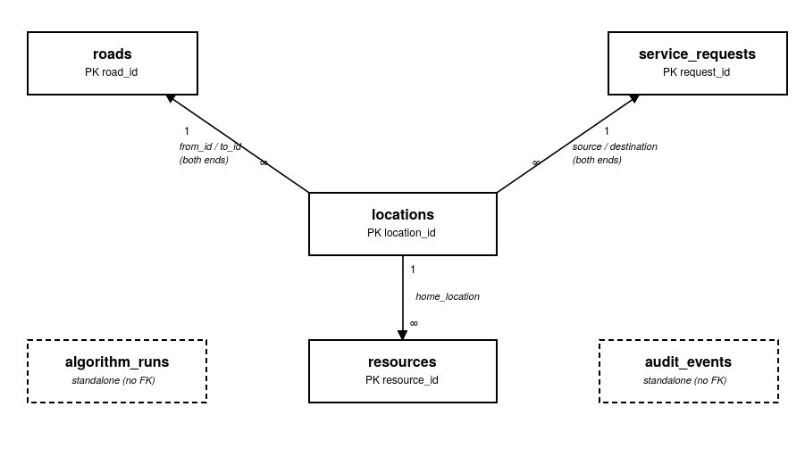
Figure 3.1 -Entity-relationship summary, redrawn from the schema for readability (same relationships as database/schema.sql).
The exact foreign keys behind the diagram above:
Parent table | Child table | Foreign key(s) | Relationship
locations | roads | from_id, to_id (both reference locations) | one-to-many (both ends)
locations | service_requests | source, destination (both reference locations) | one-to-many (both ends)
locations | resources | home_location | one-to-many
— | algorithm_runs | (none -standalone history table) | —
— | audit_events | (none -standalone history table) | —
Sample records appear in section 9 (Database Integration Evidence).

4. System Architecture and Module Design

4.1 Layered overview
The system is a single Java console application organised into clear layers. Data flows up from storage into memory, is indexed by our own data structures, operated on by our own algorithms, and shown through a text menu.
Architecture diagram:
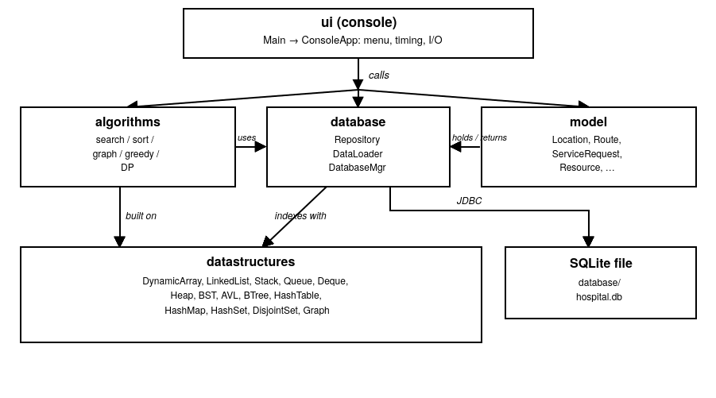

4.2 Modules (Java packages)
- model -plain data holders: Location, Route, ServiceRequest, Resource, plus AlgorithmRun and AuditEvent for the history tables. No logic, so they read straight against the CSV columns.
- datastructures -the 13 from-scratch structures (section 5). Everything else is built on these; no java.util collection is used for assessed logic.
- algorithms -the from-scratch algorithms (section 6): SearchAlgorithms, SortAlgorithms, GraphAlgorithms, GreedyAssignment, DynamicSelection.
- database -persistence and the in-memory domain store: DataLoader (CSV ↔ memory), DatabaseManager (SQLite JDBC), Repository (holds the lists, builds the hash-table/tree indexes and the two graphs), and SeedDataGenerator.
- ui -Main (entry point) and ConsoleApp (the menu loop that wires it all together, times each algorithm, and logs runs).
- performance -BenchmarkRunner and SvgChart (the study in section 8).

4.3 Key design decisions
- Two graphs from one set of routes. The Repository builds a time-weighted graph (for Dijkstra, BFS, DFS) and a distance-weighted graph (for Prim, Kruskal) from the same corridor list, so each question uses the right cost.
- Indexes are our own structures. Look-up by id uses our HashTable (O(1) average); look-up/ordering by name uses our BinarySearchTree and AVLTree (kept side by side so the performance study can contrast them on real names). The "next request" uses our BinaryHeap.
- Memory is the source of truth; SQLite mirrors it. The app loads seed CSVs (or an already-populated DB) into the Repository; edits update memory and are saved to SQLite. This keeps the assessed data structures central while still giving durable storage and a run/audit history.
- Timing and logging are cross-cutting. Every algorithm menu option is wrapped in System.nanoTime() and written to algorithm_runs, which is where the report's performance evidence ultimately comes from.

5. Data-Structure Implementation
All 13 structures are hand-written in the datastructures package. None uses java.util.HashMap, TreeMap, PriorityQueue, Stack, ArrayDeque or any built-in equivalent -only plain arrays and (inside a couple of them) java.util.List/Iterator as backing storage, as the brief permits. Each subsection says what it is, how it works, its costs, and where the system uses it.

5.1 DynamicArray -DynamicArray.java
A resizable array. It keeps a plain Object[] block and a size; when full it doubles, when a quarter full it halves. Operations: add (amortised O(1)), insert/remove at an index (O(n) for the shift), get/set (O(1)). Used as the workhorse backing store everywhere: the in-memory entity tables, the graph's adjacency lists, and every result list the algorithms return.

5.2 DoublyLinkedList -DoublyLinkedList.java
Nodes with prev/next pointers and head/tail. addFirst/addLast/insertAfter splice in O(1) once the node is found; remove unlinks in O(1). Iterable for for-each. Used as the bucket chains inside the hash table (separate chaining), and anywhere cheap end-insertion is wanted.

5.3 ArrayStack - ArrayStack.java
A LIFO stack on top of DynamicArray. push/pop/peek are O(1) at the array's end; isEmpty. Used by the iterative Depth-First Search, so deep hospital graphs cannot overflow the JVM call stack, and to reverse a Dijkstra path.

5.4 CircularQueue -CircularQueue.java
A ring buffer with head/tail indices that wrap using modular arithmetic; it grows and re-linearises when full. enqueue/dequeue are O(1) with no element shifting. Used by Breadth-First Search as its frontier queue.

5.5 LinkedQueue -LinkedQueue.java
The linked-list realisation of a FIFO queue (companion to the ring buffer), built on DoublyLinkedList. enqueue/dequeue/peek O(1). Used for general arrival-order buffering of requests before they are prioritised into the heap.

5.6 Deque -Deque.java
A double-ended queue as a wrap-around array: addFront/addRear/removeFront/ removeRear all O(1). Used where work may be pushed back to the front as well as the back; it also demonstrates that one ring generalises both a stack and a queue.

5.7 BinaryHeap (priority queue) -BinaryHeap.java
A complete binary tree embedded in an array (parent i, children 2i+1/2i+2). insert sifts up, extractTop sifts down (both O(log n)); a bottom-up constructor heapifies an array in O(n). Ordered by a supplied comparator, so a natural comparator gives a min-heap (extractMin) and a reversed one a max-heap (extractMax). Used as the request dispatcher (min-heap on urgency) and inside Dijkstra and Prim.

5.8 BinarySearchTree -BinarySearchTree.java
An ordered map of comparable keys → values. insert/search follow the left-smaller/right-larger rule (average O(log n)); inorderKeys returns keys in ascending order. It is deliberately unbalanced so the study can show it degenerating to height n−1 on sorted input. Used for ordered/alphabetical look-up of locations by name.

5.9 AVLTree -AVLTree.java
A self-balancing BST. After each insert it updates node heights and applies the four rotations (LL, RR, LR, RL) wherever a subtree's balance factor leaves {−1,0,+1}, guaranteeing height ≈ 1.44·log₂n and O(log n) search. Used as the balanced counterpart to the plain BST -the benchmark inserts the same sorted keys into both and measures the height/search-time gap.

5.10 BTree -BTree.java
A CLRS-style B-tree of minimum degree t: every node holds t−1…2t−1 keys and the tree stays perfectly height-balanced. insert splits a full child before descending (proactive splitting), so only the root ever raises the height; search is O(logₜ n). Used as a disk-style ordered index of records by id, and it ties the project to the SQLite layer, whose own indexes are B-trees.

5.11 HashTable -HashTable.java
A hash table with separate chaining: an array of buckets, each a DoublyLinkedList of (key,value) entries. A spread function scrambles poor hash codes; the table resizes and rehashes when the load factor passes 0.75. put/get/remove are average O(1). Used as the primary id→entity indexes (locations, requests, resources) and the id→vertex-index map inside the graph.

5.12 HashMap & HashSet -HashMap.java, HashSet.java
Thin, clearly-named wrappers built on our own HashTable (not java.util). HashMap gives map semantics (put/get/remove/keys); HashSet stores membership as keys against a sentinel (add/contains/remove). Used by the graph's id↔index map (HashMap) and the "visited"/"seen" sets in BFS/DFS and while de-duplicating ids (HashSet).

5.13 DisjointSet (union-find) -DisjointSet.java
Integer union-find with path compression in find and union by rank, giving near-constant O(α(n)) amortised operations. Used by Kruskal's MST: it answers "are these two locations already connected?" so an edge is added only when it joins two different components (no cycle).

5.14 Graph -Graph.java
A weighted graph keeping both representations in sync: an adjacency list (DynamicArray of edges per vertex, space O(V+E), ideal for the sparse corridor network and traversals) and an adjacency matrix (V×V weights, O(1) "is there a direct corridor A→B?"). External string ids map to dense integer indices via our HashMap. Undirected corridors are stored as two directed edges. Used as the whole road network -the Repository builds one time-weighted and one distance-weighted instance from the same routes.
Correctness evidence (trace tables, invariants, rotation/split walk-throughs) for the trees, heap and union-find appears in section 7; measured costs in section 8.

6. Algorithm Implementation
All algorithms are hand-written in the algorithms package. For each one below: a short plain-language description, pseudocode, a key Java snippet, and the Big-O.

6.1 Searching -SearchAlgorithms.java
Linear search -scan left to right. Binary search -repeatedly halve a sorted interval.
Pseudocode:
binarySearch(a, target):
lo ← 0; hi ← n-1
while lo ≤ hi:
mid ← lo + (hi-lo)/2
if a[mid] = target: return mid
else if a[mid] < target: lo ← mid+1
else: hi ← mid-1
return -1

Java implementation excerpt:
int mid = lo + (hi - lo) / 2; // avoids integer overflow
int c = cmp.compare(a[mid], target);
if (c == 0) return mid;
else if (c < 0) lo = mid + 1; else hi = mid - 1;

Big-O: linear O(n); binary best O(1), average/worst O(log n). Binary requires sorted input (see the invalid case in section 7).

6.2 Sorting -SortAlgorithms.java
Algorithm | Idea | Best | Average | Worst | Stable
Selection | pick min of the suffix, swap into place | O(n²) | O(n²) | O(n²) | no
Insertion | grow a sorted prefix | O(n) | O(n²) | O(n²) | yes
Merge | divide, sort halves, merge | O(n log n) | O(n log n) | O(n log n) | yes
Quick | median-of-3 pivot, partition | O(n log n) | O(n log n) | O(n²) | no
Pseudocode:
mergeSort(a, lo, hi):
if lo ≥ hi: return
mid ← (lo+hi)/2
mergeSort(a, lo, mid); mergeSort(a, mid+1, hi)
merge(a, lo, mid, hi) # emit the smaller front element each step

Java implementation excerpt:
// merge step: pick the smaller of the two run fronts (ties take left => stable)
if (i > mid) a[k] = aux[j++];
else if (j > hi) a[k] = aux[i++];
else if (cmp.compare(aux[j], aux[i]) < 0) a[k] = aux[j++];
else a[k] = aux[i++];

Quicksort uses median-of-three pivoting and an insertion-sort cutoff for small ranges, and recurses into the smaller side (looping on the larger) to bound recursion depth to O(log n).

6.3 Graph traversal -BFS & DFS -GraphAlgorithms.java
BFS explores in rings using our CircularQueue; DFS dives deep using our ArrayStack (iterative, not recursive). Both mark visited once.
Pseudocode:
BFS(g, s):
visited[s] ← true; queue.enqueue(s)
while queue not empty:
u ← queue.dequeue(); output u
for each edge (u→w): if not visited[w]: visited[w] ← true; queue.enqueue(w)

Big-O: O(V + E) time, O(V) space. The set BFS/DFS outputs is the set of locations reachable from the dispatch point.

6.4 Dijkstra's shortest path -GraphAlgorithms.dijkstra
Greedily settle the closest unsettled vertex, relaxing its edges, using our BinaryHeap as the priority queue (lazy deletion of stale entries).
Pseudocode:
dijkstra(g, s):
dist[*] ← ∞; dist[s] ← 0; pq.insert((s,0))
while pq not empty:
(u,d) ← pq.extractMin(); if settled[u]: continue; settled[u] ← true
for each edge (u→w, weight): if dist[u]+weight < dist[w]:
dist[w] ← dist[u]+weight; prev[w] ← u; pq.insert((w, dist[w]))

Big-O: O((V + E) log V). Requires non-negative weights (travel times). Path is rebuilt by following prev[] back from the target (empty if unreachable).

6.5 Minimum spanning tree -Prim & Kruskal
Prim grows a tree from vertex 0, always adding the cheapest edge that leaves the current tree (min-heap of crossing edges) -O(E log V). Kruskal sorts all edges and adds each one whose endpoints are in different components, tested with our DisjointSet -O(E log E).
Java implementation excerpt:
// Kruskal core: union returns false if the two ends are already connected (cycle)
for (Graph.Edge e : sortedEdges)
if (dsu.union(e.from, e.to)) { mst.add(e); if (mst.size()==V-1) break; }

Both compute the same minimum total weight (verified by a unit test); on a disconnected graph they yield a spanning forest.

6.6 Greedy staff assignment -GreedyAssignment.java
Handle requests most-urgent-first (min-heap on urgency); give each the available resource with the most remaining capacity that still fits it (best-fit), subtracting the service time.
Pseudocode:
for each request in order of increasing urgency:
pick AVAILABLE resource with max remaining capacity ≥ request.serviceMinutes
if found: assign, capacity -= serviceMinutes else: leave unassigned

Big-O: O(R log R + R·K) for R requests, K resources. Section 7 gives a worked counterexample proving this greedy is not optimal for throughput.

6.7 Dynamic-programming request selection -DynamicSelection.java
Choose the subset of requests of maximum total value within a staff-minute budget -the 0/1 knapsack, solved by bottom-up tabulation.
Pseudocode:
dp[0][c] = 0
dp[i][c] = dp[i-1][c] if w_i > c
= max(dp[i-1][c], v_i + dp[i-1][c - w_i]) otherwise

Java implementation excerpt:
dp[i][c] = dp[i - 1][c]; // skip request i
if (w <= c) dp[i][c] = Math.max(dp[i][c], v + dp[i - 1][c - w]); // take it

Big-O: O(n·C) time and space (the full table is kept so the chosen set can be reconstructed). A worked table appears in section 7; because the DP considers combinations it beats the greedy dispatcher on the counterexample.

7. Correctness Evidence
This section gives the trace tables, loop invariants, proof sketches and counterexamples required by the brief. Every claim here is also backed by an automated test in src/test/java/tests/ (60 tests, all passing).

7.1 Binary search -loop invariant + trace
Invariant: at the top of each loop, if target is in the array then its index lies within [lo, hi]. Each step discards a half that cannot contain the target, so the invariant is preserved and the interval strictly shrinks → termination with a hit or lo > hi.
Trace -array [1,3,5,7,9,11], target 9:
step | lo | hi | mid | a[mid] | action
1 | 0 | 5 | 2 | 5 | 5 < 9 → lo = 3
2 | 3 | 5 | 4 | 9 | hit → return 4

7.2 Insertion sort -loop invariant + trace
Invariant: before processing index i, the prefix a[0..i-1] is a sorted permutation of the original prefix. When the loop ends (i = n) the whole array is sorted.
Trace -[5, 2, 4, 1]:
i | key | array after inserting key
1 | 2 | [2, 5, 4, 1]
2 | 4 | [2, 4, 5, 1]
3 | 1 | [1, 2, 4, 5]

7.3 Merge sort -induction
Base: a range of length ≤ 1 is sorted. Step: assume both halves are sorted; the linear merge always emits the smaller of the two front elements, so the output is sorted and contains exactly the two halves' elements. By induction the whole array is sorted. Merge is stable because ties take the left element first.

7.4 Quicksort -partition invariant
Invariant (after partition around pivot p at final index k): every element in a[lo..k-1] ≤ p ≤ a[k+1..hi], and p is at its final sorted position k. Recursively sorting the two sides therefore sorts the whole. Median-of-three pivoting makes the worst-case O(n²) input very unlikely, and recursing into the smaller side keeps stack depth O(log n). (Test sortsAgree confirms all four sorts produce identical output; sortsAdversarial checks sorted/reverse input.)

7.5 Dijkstra -greedy exchange argument + trace
Why it is correct: when a vertex u is first extracted from the min-heap, its recorded distance is final. Suppose not -then some shorter path to u exists via an unsettled vertex x; but x would have distance ≤ dist[u] and would have been extracted first (all weights ≥ 0), a contradiction. Non-negative weights are essential.
Trace -edges A–B 4, A–C 1, C–B 2, B–D 1; source A:
settle | dist updates | frontier
A(0) | B←4, C←1 | {C:1, B:4}
C(1) | B←min(4, 1+2)=3 | {B:3, B:4(stale)}
B(3) | D←4 | {D:4, B:4(stale)}
D(4) | — | done
Result: dist(D)=4, path A→C→B→D. (Test dijkstraNormal; dijkstraUnreachable checks an isolated vertex gets ∞ and an empty path.)

7.6 Kruskal / Prim -cut & cycle properties
Prim (cut property): the cheapest edge crossing the cut between the growing tree and the rest is always safe (belongs to some MST); adding such edges V−1 times yields an MST. Kruskal (cycle property): taking edges cheapest-first and skipping any that would close a cycle (detected when union-find finds both ends in one component) keeps only safe edges → an MST (a forest if disconnected).
Trace (Kruskal) -edges sorted: A-B 1, B-C 2, A-C 3, C-D 4:
edge | ends already connected? | action | tree weight
A-B (1) | no | add | 1
B-C (2) | no | add | 3
A-C (3) | yes (A,C in {A,B,C}) | skip (cycle) | 3
C-D (4) | no | add | 7
MST weight = 7. (Test mstAgrees confirms Prim and Kruskal both give 7; kruskalForest checks a disconnected graph gives a forest of V−component edges.)

7.7 Dynamic programming -the knapsack table
Capacity 10; requests A(w10,v10), B(w5,v8), C(w5,v8):
after \ capacity c → | 0 | 5 | 10
i=0 (none) | 0 | 0 | 0
i=1 (A) | 0 | 0 | 10
i=2 (B) | 0 | 8 | 10
i=3 (C) | 0 | 8 | 16
dp[3][10] = max(dp[2][10]=10, v_C + dp[2][5] = 8+8 = 16) = 16. Back-tracking the table selects {B, C}. (Test dpWorkedExample asserts value 16, weight 10, two items; dpZeroCapacity and dpNegativeCapacity cover the boundary/invalid cases.)

7.8 Counterexample 1 -greedy is NOT throughput-optimal
Same numbers, objective = complete as many requests as possible with a single team of capacity 10:
- Greedy (urgency-first): takes A (urgency 1, needs all 10 minutes) → B and C can't fit → 1 request completed.
- Optimal / DP: takes B and C (5 + 5 = 10) → 2 requests completed, value 16 vs greedy's 10.
There is no exchange that lets urgency-first recover the second completion once A is chosen, so the greedy choice is genuinely sub-optimal here. (Test greedyCounterexample asserts greedy completes 1 while the DP selects 2.) Section 10 explains why we still, deliberately, use urgency-first for live triage.

7.9 Counterexample 2 -binary search on unsorted input (broken precondition)
Binary search's correctness depends on the array being sorted. On the unsorted array [5,1,3,2,4], searching for 1 (which is present at index 1):
step | lo | hi | mid | a[mid] | action
1 | 0 | 4 | 2 | 3 | 3 > 1 → hi = 1
2 | 0 | 1 | 0 | 5 | 5 > 1 → hi = −1
Loop ends → returns −1 (not found) even though 1 is present -linear search finds it at index 1. This shows the precondition is not optional. (Test binarySearchUnsorted asserts linear finds it but binary misses it.)

8. Performance Analysis
All numbers below are real measurements from running the project's own benchmark harness (bash build.sh bench), averaged over 3 trials with a JIT warm-up pass. The full method, every CSV, and the theory-vs-observed discussion live in performance/interpretation.md; raw data is in performance/experiment-results/ and charts (SVG) in performance/graphs/. These are not invented figures. Absolute times depend on the machine (here: Windows 11 laptop, OpenJDK 17); the curve shapes are the point.

8.1 Sorting (sorting.svg)
n | selection (ms) | insertion (ms) | merge (ms) | quick (ms)
1,000 | 3.83 | 1.64 | 2.44 | 0.52
5,000 | 92.95 | 38.40 | 6.27 | 1.82
10,000 | 341.08 | 162.20 | 4.13 | 1.83
From ×10 the input (1k→10k) selection sort grew ~89× and insertion ~99× -the ×100 an O(n²) algorithm predicts -while merge/quick stayed in single-digit ms (O(n log n)). By n=10,000 quicksort is ~185× faster than selection sort.
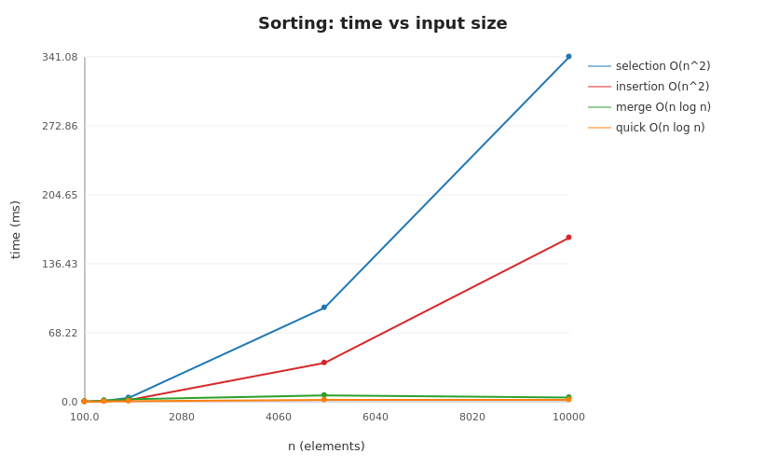
Figure 8.1 -Sorting: time vs input size (sorting.svg).

8.2 Searching (searching.svg)
n | linear (ns/query) | binary (ns/query)
100 | 1,171 | 243
10,000 | 10,727 | 210
Linear cost tracks n; binary stays flat near ~210 ns across a 100× range -the signature of O(log n).
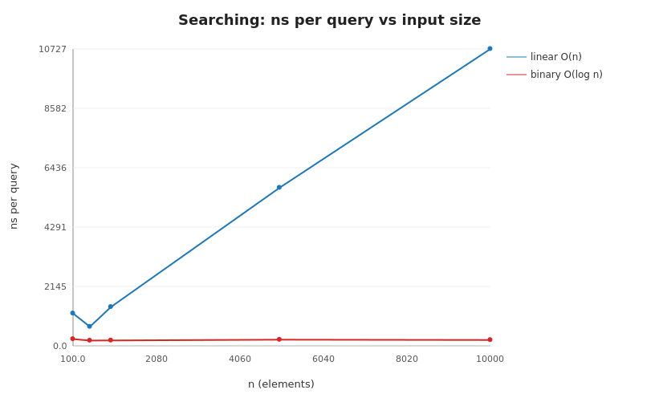
Figure 8.2 -Searching: linear vs binary, time per query (searching.svg).

8.3 Hash table vs. load factor (hashtable.svg)
get stayed ~70–150 ns from load factor 0.25 up to 4.0 -near-constant, exactly the O(1 + α) expectation for separate chaining. The live app keeps α ≤ 0.75 by resizing.
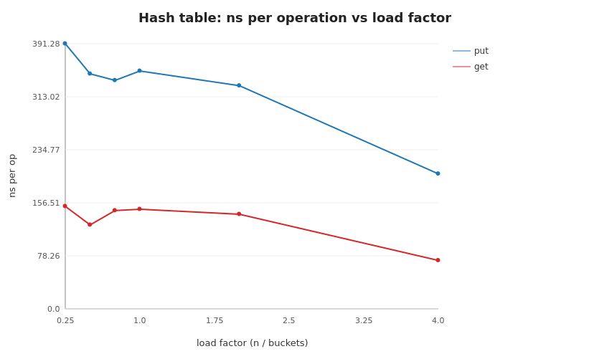
Figure 8.3 -Hash table put/get time vs load factor (hashtable.svg).

8.4 BST vs. AVL -the headline experiment (tree-height.svg, tree-search.svg)
n | BST height | AVL height | BST search (ns) | AVL search (ns)
100 | 99 | 6 | 4,409 | 766
1,000 | 999 | 9 | 3,021 | 353
10,000 | 9,999 | 13 | 6,337 | 230
On sorted input the plain BST degenerates to height exactly n−1 (a linked list) while the AVL tree holds height ≈ log₂n (6→13 as n goes 100→10,000). AVL search is 20–30× faster. This is the clearest demonstration of why self-balancing matters.
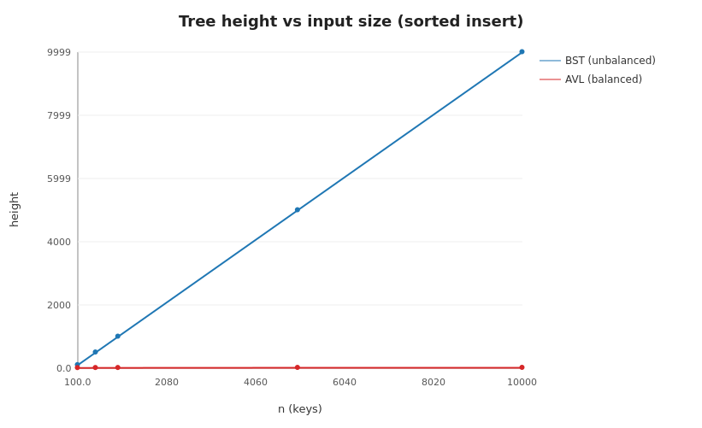
Figure 8.4a -BST vs AVL height on sorted insertion (tree-height.svg).
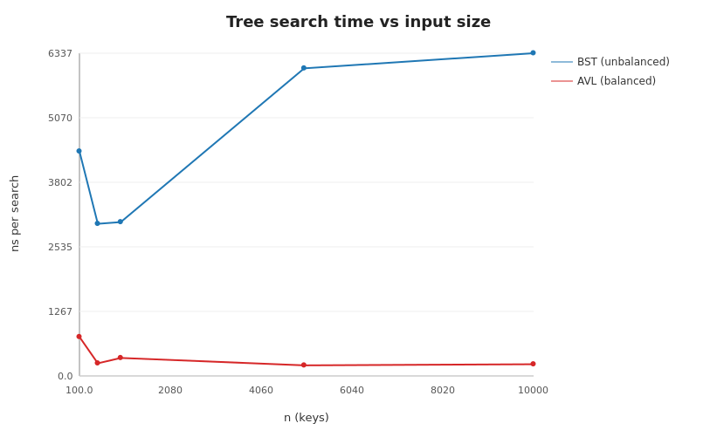
Figure 8.4b -BST vs AVL search time on sorted insertion (tree-search.svg).

8.5 Binary heap (heap.svg)
n | build (ms) | dispatch (ms)
1,000 | 0.18 | 0.39
10,000 | 2.06 | 5.99
Both grow ~n log n; dispatch is ~2–3× build because extract-min sifts a leaf all the way down.
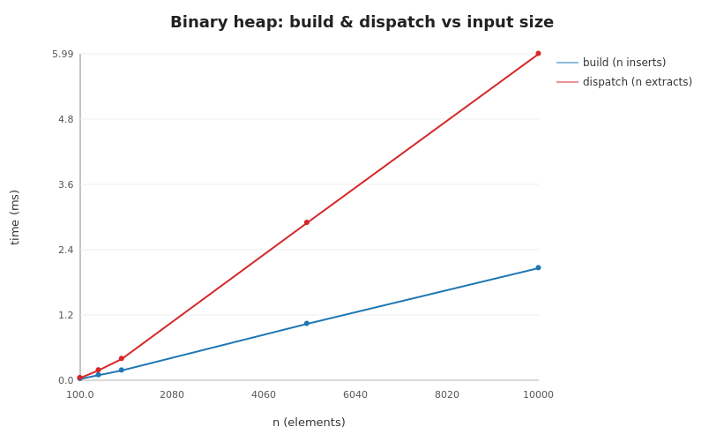
Figure 8.5 -Binary heap build vs dispatch time (heap.svg).

8.6 Graph algorithms (graph.svg)
V | E | BFS | DFS | Dijkstra | Prim | Kruskal (ms)
50 | 396 | 0.13 | 0.18 | 0.17 | 0.18 | 0.34
500 | 3,992 | 1.59 | 2.06 | 2.38 | 3.21 | 4.50
BFS/DFS grow ~linearly (O(V+E)); the heap-based Dijkstra/Prim a little faster than linear (extra log V); Kruskal is consistently slowest because of its up-front O(E log E) edge sort. The ordering BFS ≲ DFS ≲ Dijkstra ≲ Prim ≲ Kruskal held at every size.
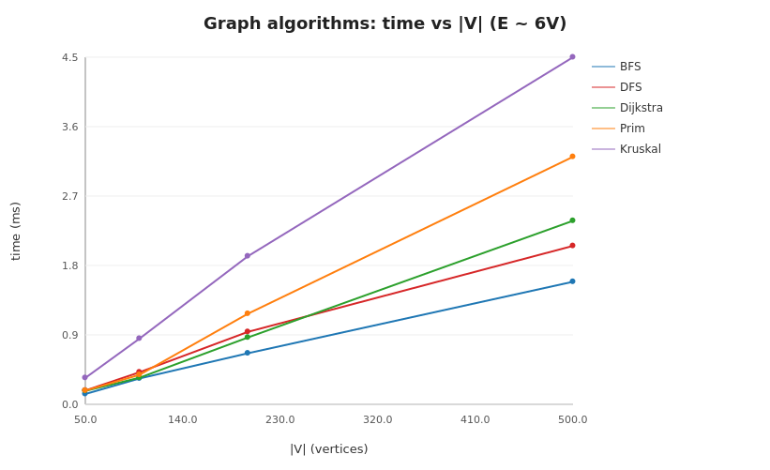
Figure 8.6 -Graph algorithm timings vs (V, E) (graph.svg).

8.7 Conclusion
Across all six experiments the observed timings match the theoretical Big-O classes; the only deviations were small constant-factor/warm-up effects at tiny inputs and a few ms of measurement noise, both discussed in performance/interpretation.md. Nothing observed contradicted the theory.

9. Database Integration Evidence

9.1 Engine and connection
Storage is SQLite 3 -a single file, no server, zero setup -accessed over JDBC (the org.xerial:sqlite-jdbc driver, the only third-party jar used by the running system). The database lives at database/hospital.db and is created automatically on first run. All the JDBC code is in database/DatabaseManager.java (src/main/java/database/DatabaseManager.java); the schema is database/schema.sql.

9.2 How load / save works
- Start-up (load). ConsoleApp opens the DB and runs schema.sql (idempotent -CREATE TABLE IF NOT EXISTS). If the DB already holds data it is loaded into memory; otherwise the seed CSVs are loaded and mirrored into the DB in one transaction.
- Editing. Adding/updating a location, route, request or resource updates the in-memory Repository and then calls saveAll, which rewrites the four entity tables inside a transaction so the DB always mirrors memory. Each change is written to audit_events.
- Save on demand. Menu option 12 offers "save to DB", "reload from DB", and "export back to CSV".
- Run logging. Every algorithm run is timed and appended to algorithm_runs.

9.3 Live row counts (from an actual run)
Recorded output (from an actual run):
locations = 60 rows
roads = 150 rows
service_requests = 320 rows
resources = 36 rows
algorithm_runs = 3 rows
audit_events = 3 rows

9.4 Sample records (queried from hospital.db)
locations
location_id | name | area | type
L001 | Emergency Department | Surgical Block | department
L002 | Outpatient Department | Support Services | department
L003 | Radiology | Emergency Block | department

service_requests (from the seed data)
request_id | source | destination | category | urgency | status
SR0001 | L001 | L022 | blood-delivery | 4 | PENDING
SR0002 | L022 | L012 | medication-run | 4 | PENDING

resources
resource_id | type | home_location | capacity | availability_status
R001 | trolley | L037 | 114 | AVAILABLE
R002 | trolley | L049 | 38 | AVAILABLE

9.5 Algorithm-run log (real captured evidence)
The algorithm_runs table after running a few features -this is where the report's timing evidence originates (it is not hand-typed):
Recorded output (from an actual run):
Lookup | key=Radiology | 0.057 ms | hit
DPKnapsack | requests=320 budget=120 | 6.121 ms | chosen=15 value=765
GreedyAssign | requests=320 resources=36 | 11.563 ms | assigned=108 unassigned=212

(The Documentation Team may insert a screenshot of the console or a DB-browser view here; the tables above are the exact data those screenshots would show.)

9.6 Integrity features
- Foreign keys (PRAGMA foreign_keys = ON) tie roads/requests/resources back to real locations, with ON DELETE CASCADE/SET NULL.
- CHECK constraints enforce urgency BETWEEN 1 AND 5, non-negative distance/time/capacity.
- UNIQUE(from_id, to_id) stores each corridor once.
- Saves run inside a transaction (commit/rollback) so a failure never leaves the DB half-written. Integration tests (DatabaseIntegrationTest) prove a full save→load round-trip preserves every table.

10. Responsible Algorithm Selection
A fast algorithm is not automatically the right algorithm. In a hospital, choosing a heuristic over an exact method -or vice versa -has real consequences. This section states, plainly, where each style of algorithm is appropriate in this system and where it is not.

10.1 Where a greedy / heuristic choice IS appropriate
- Live triage ordering (priority heap). Handling the most urgent request first is a greedy rule, and here it is exactly what we want: for patient-facing jobs, urgency must dominate, even if it lowers raw throughput. The min-heap gives an O(log n) "who's next" that matches clinical priority.
- Everyday dispatch under time pressure. The greedy staff-assignment (GreedyAssignment) produces a good, explainable assignment in milliseconds. For routine logistics (porter runs, sample deliveries) a near-optimal answer now is worth more than a perfect answer later.
- Shortest path / MST. Dijkstra and Prim/Kruskal are greedy but provably optimal for their problems (non-negative shortest path, minimum spanning tree), so using them is both fast and exactly correct -the ideal case.

10.2 Where a greedy shortcut is NOT appropriate
- Never for clinical/triage decisions with patient-safety stakes. The tool orders and routes logistics; it must not be repurposed to decide who receives care, in what order, clinically. Those are human decisions. A greedy score that looks reasonable can be badly wrong for an individual patient, and unlike a porter run, the cost of being wrong is not measured in minutes.
- When the objective is a best combination, not a best next step. Section 7's counterexample shows the greedy dispatcher completing 1 request where the optimal set completes 2. When we genuinely need the best bundle of requests under a hard budget (e.g. planning a fixed overtime pool for the evening), we use the dynamic-programming selector (DynamicSelection), which considers combinations and is optimal -accepting its higher O(n·C) cost because the decision is planned, not split-second.
- When weights can be negative. Dijkstra's greedy correctness relies on non-negative edge costs; if a "cost" could ever be negative, Dijkstra would be the wrong tool and a different algorithm (e.g. Bellman–Ford) would be required.

10.3 The principle we followed
Match the algorithm to the stakes and the objective, not just the clock:
Situation | Right choice | Why
"Who's next?" for urgent jobs | Greedy (priority heap) | Urgency is the correct objective
Fastest route, cheapest network | Greedy but exact (Dijkstra/Prim/Kruskal) | Provably optimal, also fast
Best bundle under a fixed budget | Dynamic programming | Optimal over combinations
Any patient-safety/triage judgement | No algorithm -human decision | Cost of error is not recoverable
This is why the greedy dispatcher ships with an explicit worked counterexample in its own source comments: so no future maintainer mistakes "fast and greedy" for "always optimal", and so the tool is never quietly extended into decisions it should not make.

11. Individual Contribution Statements & Oral-Defense Prep

11.1 Contributions by team
The project was delivered by role-based teams. Each team's contribution is summarised below; individual member statements can be attached here at submission time if the submission requires named statements.
Team | Contribution
Group Leader & Technical Developer | Designed and implemented the entire Java system -the from-scratch data structures, the search/sort/graph/greedy/DP algorithms, the CSV + SQLite database layer, the JUnit test suite, and the performance benchmarks -and produced the first draft of this report. Coordinated the team and integrated everyone's data and feedback.
Data Collection Team | Defined and gathered the raw location, route, service-request and resource figures against the agreed column templates.
Database Team | Entered and formatted the data into clean CSVs matching the exact headers the loader expects.
Documentation & Report Team | Compiled, formatted and proofread this report and produced the final PDF/DOCX.
QA / Manual Testing Team | Worked through the console features, recorded results, and reported anything unexpected.
Presentation & Oral-Defense Team | Prepared the slides and demo and led the oral defence.
Logistics & Attendance Coordinator | Managed scheduling, communication and attendance records.

11.1.1 Individual contribution statements
Every member of the 12-person team is listed below with a placeholder for their own one- or two-sentence statement, to be completed by each member before submission.
# | Name | Team / Role | Contribution statement
1 | Bediako Lord Michael | Data Collection Team | [Contribution statement to be inserted]
2 | Apeweh Rexford Awaregya | Data Collection Team | [Contribution statement to be inserted]
3 | Earl Yaw Asamoah | Data Collection Team | [Contribution statement to be inserted]
4 | Ferdinard Afful | Data Collection Team | [Contribution statement to be inserted]
5 | Lawrence Darko | Database Team | [Contribution statement to be inserted]
6 | Jeremiah Asempapa | Database Team | [Contribution statement to be inserted]
7 | Osborne Tulasi | Documentation & Report Team | [Contribution statement to be inserted]
8 | Roselyn Sakyi | Documentation & Report Team | [Contribution statement to be inserted]
9 | Reuben Kotei Neequaye | QA / Manual Testing Team | [Contribution statement to be inserted]
10 | Welbeck Donkor | QA / Manual Testing Team | [Contribution statement to be inserted]
11 | Stephanie Apenteng | Presentation & Oral-Defense Team | [Contribution statement to be inserted]
12 | Kaziah Helen Fobi | Presentation & Oral-Defense Team | [Contribution statement to be inserted]
13 | [Name not provided] | Group Leader & Technical Developer | [Contribution statement to be inserted]
14 | [Name not provided] | Logistics & Attendance Coordinator | [Contribution statement to be inserted]
Note: the report's original role template also names a "Group Leader & Technical Developer" and a "Logistics & Attendance Coordinator"; no individual was supplied for either role, so both are held as placeholders above pending confirmation.

11.2 Oral-defense prep notes (plain-language one-liners)
Anyone on the team should be able to explain, in one sentence, what each piece does. Use these as flash-cards.
Data structures
- Dynamic array -a list that automatically grows/shrinks its underlying array.
- Linked list -items joined by "next/previous" pointers; cheap to insert/remove.
- Stack -last-in-first-out, like a stack of plates (used by DFS).
- Queue / circular queue -first-in-first-out; the circular one reuses a fixed ring of slots (used by BFS).
- Deque -a queue you can add to and remove from at both ends.
- Binary heap -a tree-in-an-array that always gives the smallest (or largest) item fast; our "who's next?" priority queue.
- Binary search tree -sorted tree for name look-ups; can get lopsided.
- AVL tree -a search tree that rebalances itself so it never gets lopsided.
- B-tree -a "fat", shallow balanced tree; the shape real databases use for indexes.
- Hash table -near-instant look-up by key using a hash function + buckets.
- Map / Set -key→value and unique-membership, both built on our hash table.
- Disjoint-set (union-find) -tracks "which things are connected?" almost instantly; powers Kruskal.
- Graph -the map of the hospital: places (nodes) joined by corridors (edges), stored as both a list and a matrix.
Algorithms
- Linear vs binary search -check one by one, vs repeatedly halving a sorted list.
- Selection/insertion/merge/quick sort -four ways to order data; the first two are simple but slow (O(n²)), the last two are fast (O(n log n)).
- BFS / DFS -explore the network outward in rings / dive deep; both find what's reachable.
- Dijkstra -the fastest route between two places when corridors have travel times.
- Prim / Kruskal -the cheapest set of corridors that still connects every place.
- Greedy assignment -hand out staff most-urgent-first; fast but not always the best combination.
- Dynamic programming (knapsack) -pick the best bundle of jobs under a time budget; slower but optimal.
Likely examiner questions (and short answers)
- Why implement your own structures? To demonstrate understanding; the brief forbids java.util equivalents for the assessed logic.
- Why AVL over a plain BST? Sorted input makes a plain BST a slow linked list (height n−1); AVL stays at ≈log₂n -we measured exactly this (section 8.4).
- Why does Dijkstra need non-negative weights? Its greedy "first settled = final" argument breaks if a later negative edge could lower a settled distance.
- When is greedy wrong here? When we need the best combination, not the best next step -shown by the counterexample where greedy completes 1 job and the DP completes 2 (section 7.8).
- Why SQLite? One file, no server, real SQL and indexes -right-sized for a console tool.

12. References and Appendices

12.1 References
- Cormen, T. H., Leiserson, C. E., Rivest, R. L., & Stein, C. (2009). Introduction to Algorithms (3rd ed.). MIT Press. -B-tree insertion/splitting, the 0/1-knapsack DP, Dijkstra, Prim, Kruskal, and union-find.
- Sedgewick, R., & Wayne, K. (2011). Algorithms (4th ed.). Addison-Wesley. -quicksort with median-of-three, merge sort, heaps, and graph processing.
- Adelson-Velsky, G. M., & Landis, E. M. (1962). An algorithm for the organization of information. -the original AVL self-balancing tree.
- Dijkstra, E. W. (1959). A note on two problems in connexion with graphs. Numerische Mathematik, 1, 269–271.
- SQLite Documentation. https://www.sqlite.org/docs.html -engine and SQL syntax.
- xerial sqlite-jdbc driver. https://github.com/xerial/sqlite-jdbc -JDBC access.
- JUnit 5 (Jupiter) User Guide. https://junit.org/junit5/docs/current/user-guide/ -the test framework.
- Oracle Java SE 17 API Documentation. https://docs.oracle.com/en/java/javase/17/

12.2 Appendix A -How to build and run
The project needs only a JDK (17+) -no Maven/Gradle.
Terminal commands:
bash scripts/fetch-deps.sh # one-time: download the JUnit + SQLite jars into lib/
bash build.sh run # compile and launch the console app
bash build.sh test # compile and run the 60-test JUnit suite
bash build.sh bench # run the performance benchmarks (writes CSVs + charts)

(Windows PowerShell users can use .\build.ps1 run|test|bench instead.)
To regenerate the dataset: java -cp out/main database.SeedDataGenerator.

12.3 Appendix B -Repository map
Repository layout:
src/main/java/model plain data classes
src/main/java/datastructures the 13 from-scratch structures
src/main/java/algorithms search, sort, graph, greedy, DP
src/main/java/database DataLoader, DatabaseManager, Repository, SeedDataGenerator
src/main/java/ui Main, ConsoleApp (menu)
src/main/java/performance BenchmarkRunner, SvgChart
src/test/java/tests 60 JUnit tests
database/ schema.sql, seed-data/*.csv, hospital.db (generated)
performance/ experiment-results/*.csv, graphs/*.svg, interpretation.md
report/ this report (sections/ + final-report-draft.md)

12.4 Appendix C -Mapping brief requirements → code
Requirement | Where
13 data structures | datastructures/ (section 5)
Search/sort/graph/greedy/DP | algorithms/ (section 6)
Console behaviours (§3) | ui/ConsoleApp.java
schema + JDBC + run logging | database/, database/schema.sql
40+ unit tests | src/test/java/tests/ (60 tests)
Greedy counterexample | GreedyAssignment Javadoc + test greedyCounterexample
DP worked table | DynamicSelection Javadoc + test dpWorkedExample
Benchmarks + charts + interpretation | performance/

12.5 Appendix D -Test summary
60 JUnit 5 tests across DataStructuresTest, AlgorithmsTest, and DatabaseIntegrationTest, all passing. Each structure/algorithm is covered with a normal case, a boundary case (empty/single/duplicate), and an invalid case (out-of-range access, binary search on unsorted input, unreachable Dijkstra target, disconnected-graph Kruskal forest, negative DP capacity), plus the greedy counterexample and a SQLite save/load round-trip. Reproduce with bash build.sh test.

12.6 Appendix E -Editorial items before final submission
See report/README-for-documentation-team.md for details. In brief: add team member names and a submission date if the submission requires them, and note that the dataset is a coherent synthetic dataset (see section 3), which can be swapped for real collected figures using the same column headers.

