1. Write a program to find the factor of the given number.
2. Write a program to find whether the given number is prime or not.
3. Write a program to find the given number is Armstrong number or not.

|  |  |  |  |
| --- | --- | --- | --- |
| **153** |  |  |  |
| 1 | 5 | 3 |  |
| 1 | 125 | 27 | **153** |

1. Write a program to print the Armstrong numbers between 1 to 10000.
2. Write a program to count and print the number of odd and even numbers. [2,85,6,77,5]
   1. Eg: Enter The limit:5

Enter the Value: 10

Enter the Value: 25

Enter the Value: 65

Enter the Value: 12

Enter the Value: 45

Even: 2

Odd: 3

6.Write a program to find the reverse of n digit number using While loop (Clue : % //)

7.Write a program to find the binary number from given decimal number.

8. Write a program to find the decimal number from given Binary number.

9.Write a program to find the factorial of the given number.

Enter The number: 5

Factorial 5 is: 120

10.Write a program to find the Fibonacci Series of the given number.

Enter the Limit: 8

0

1

1

2

3

5

8

13

11.Write a program to find the given number is perfect number

|  |  |  |
| --- | --- | --- |
| **Prefect Number** | |  |
| **6** |  |  |
|  |  |  |
| **6** | **1** | **0** |
| **6** | **2** | **0** |
| **6** | **3** | **0** |
| 6 | 4 | 2 |
| 6 | 5 | 1 |
| 6 | 6 | 0 |
|  | =1+2+3 | **6** |

12. Write a program to print the perfect number between 1-1000

13.Write a program to find the given number is strong number

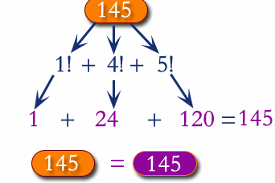

14. Two numbers are entered through the keyboard. Write a program to find the value of one number raised to the power of another.

Eg: Enter the Base: 2

Enter the Power:3 (clue 2*2*2=8)

Result: 8