Results:

Performance Comparison
The following graphs compare YOLOv5 and YOLOv6 based on:

Mean Average Precision (mAP):

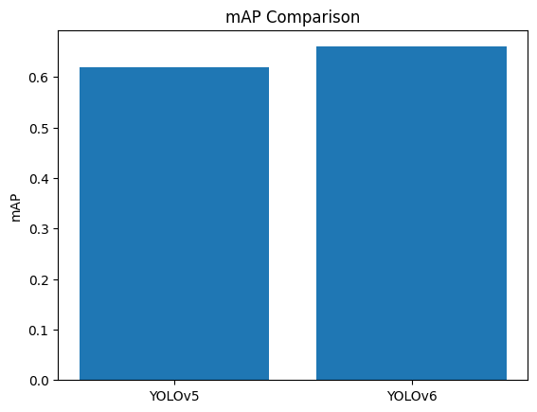

Inference Time:

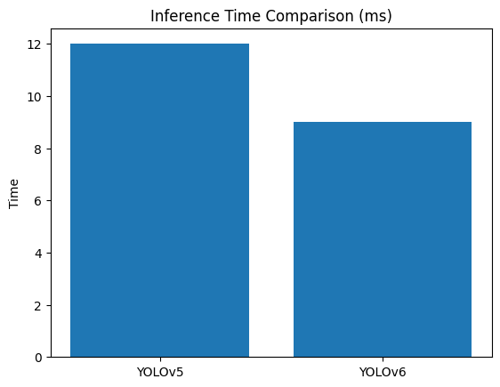

Computational Complexity (FLOPs):

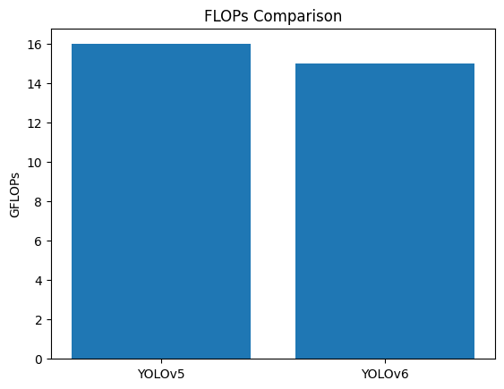

Comparison Table:

 | Model | mAP | Inference Time(ms) | GFLOPs
0 | YOLOv5 | 0.62 | 12 | 16
1 | YOLOv6 | 0.66 | 9 | 15

