Programming Exercises:

1. In spatial domain, denoising pepper&salt noises by average, median and Gaussian filters, respectively, Input noised image is as follows( noised Lena photo).

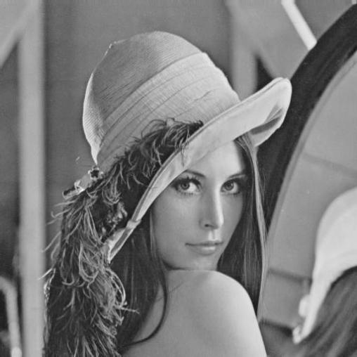 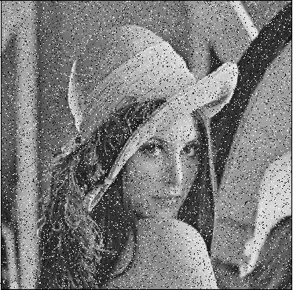

Fig. Denoising: (a) Lena photo, (b) noised Lena photo (pepper&salt).

1. Computing FT of the image given in problem1 and drawing its spectrum. And in frequency domain, denoising pepper & salt noises average, median, and Gaussian filters.
2. Give the HPF and LPF resultant images of the above denoised image given in problem1.

Notes: you can select MatLab, Python, OpenCV programming languages to writing programs to implement algorithms for the above problems.

Requirements: 1) flowchart (Block diagram) of your algorithms and their corresponding source codes. 2) output image.

Submissions: submit your programming exercises to Lexue and send to email: [homework_cgip2022@126.com](mailto:cgip2020@126.com) before May.31.