ANKIT KUMAR  BCA Student | Aspiring Web Developer  Muzaffarpur, Bihar • 7202975056 • ak0596533@gmail.com  GitHub: github.com/ak0596533-ux • LinkedIn: linkedin.com/in/ankit-kumar-90a5982a2 | 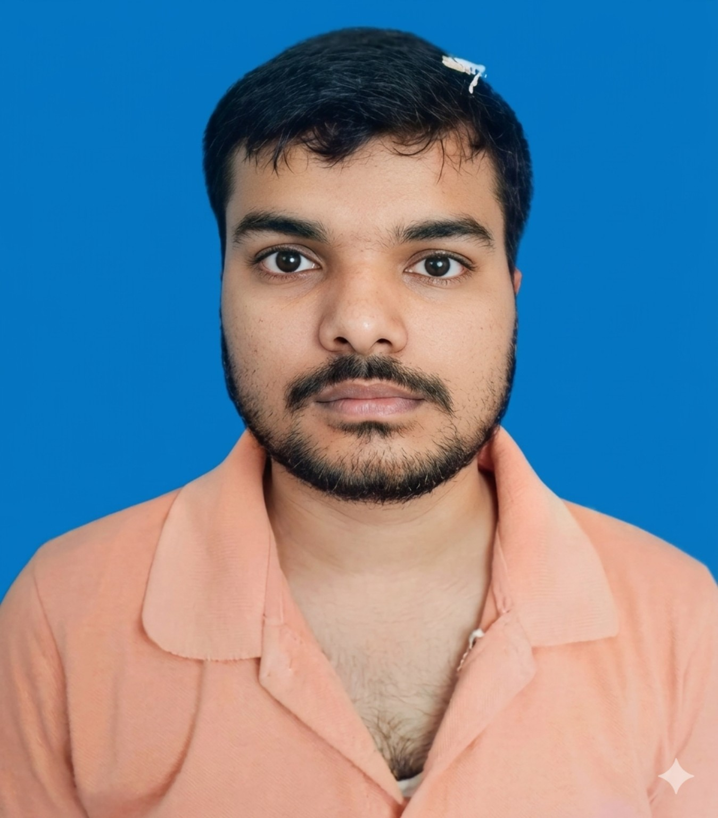
CAREER OBJECTIVE
Motivated BCA student seeking an entry-level opportunity in web development where I can apply my knowledge of HTML, CSS and JavaScript, strengthen my practical skills, and contribute to building responsive and user-friendly web experiences.
EDUCATION
Bachelor of Computer Applications (BCA) — LN Mishra College of Business Management
Baba Saheb Bhimrao Ambedkar University | 2024–2027
Class XII — 55%
Class X — 55%
TECHNICAL SKILLS
Frontend: HTML, CSS, JavaScript
Tools: Visual Studio Code (VS Code)
PROJECT
Professional Portfolio Website
Designed and developed a personal portfolio website to present profile information, technical skills and projects in a professional layout. Focused on clean structure, responsive styling and a user-friendly interface using HTML, CSS and JavaScript.
CERTIFICATION
Web Development Certificate
STRENGTHS
Quick Learner • Problem Solving • Willingness to Learn • Attention to Detail
Declaration: I hereby declare that the information provided above is true to the best of my knowledge.

