SafeGrid AI: Safety Evacuation Planning Using LLMs
Autonomous indoor emergency evacuation routing powered by CubiCasa5k architectural blueprints and LLM tool-calling agents.

Overview
During building emergencies (fires, smoke hazards, structural failures), traditional static evacuation routes (e.g., green wall signs) often direct occupants toward active hazard zones. SafeGrid AI transforms standard architectural blueprints into dynamic, hazard-aware navigation graphs and pairs them with an agentic LLM (Google Gemini) that calculates and communicates verifiable, life-saving evacuation instructions.
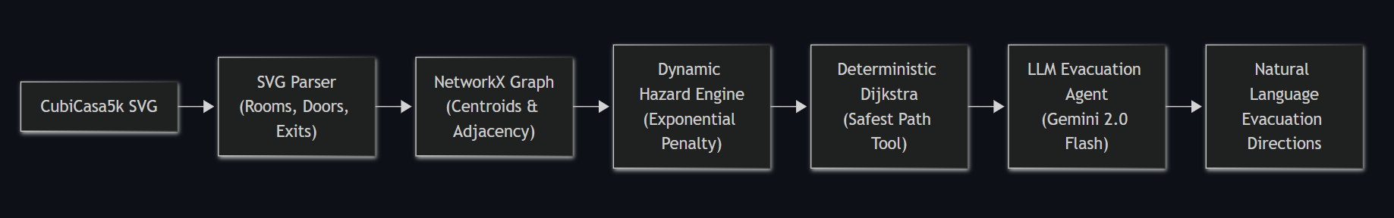

Key Pipeline Components

1. Spatial Polygon Extraction (`src/svg_parser.py`)
- Filters dense CubiCasa5k annotations across 80+ classes down to navigable spaces (living rooms, bedrooms, kitchens, corridors, bathrooms, saunas, exits).
- Extracts exact polygon bounding vertices and applies affine coordinate transforms.
- Identifies exterior doors as safe egress points (is_exit=True).

2. Topological Graph Construction (`src/graph_builder.py`)
- Computes geometric centroids for each room, corridor, and doorway.
- Constructs an undirected networkx.Graph where edges denote physical accessibility based on spatial intersection buffering (buffer=5.0px).
- Calculates static Euclidean distances as baseline traversal costs.

3. Dynamic Hazard Weighting (`src/hazard_engine.py`)
- Injects synthetic emergencies (fire, smoke plumes) with configurable coordinates, radius, and severity.
- Computes an exponential penalty multiplier on affected corridors:
$$\text{cost}\left(u,v\right)=\text{base_cost}×α⋅e^{-β⋅d}$$
- Enforces an absolute Danger Zone threshold (d $≤r×$0.3), setting traversal cost to $∞$ (impassable).

4. Deterministic Pathfinding Tool (`src/pathfinder.py`)
- Implements networkx.dijkstra_path over dynamic weights.
- Validates graph contiguity (guarantees zero wall-jumping or hallucinated shortcuts).
- Returns the safest node sequence, total traversal cost, and minimum hazard clearance distance.

5. LLM Agent Emergency Coordination (`src/llm_agent.py`)
- Employs LangChain tool binding with Google Gemini 2.0 Flash.
- Strictly delegates mathematical routing computation to the deterministic tool.
- Synthesizes clear, step-by-step natural language instructions with tactical safety warnings.
- Graceful offline fallback (mock mode) when API credentials are unset.

6. Pipeline Verification & Benchmarking (`src/evaluation.py` & `benchmarks/`)
- Evaluates route validity, safety margins, optimality ratios, and execution latency across hundreds of blueprint scenarios.

Benchmark Results

1. Routing Architecture Benchmark Table
Routing Method | Valid Routes (%) | Avg Safety Margin | Avg Path Cost | Hallucination Rate (%) | Tool Usage (%) | Avg Latency (s)
Agentic Tool (Dijkstra) | 98.4% | 0.92 | 214.6 | 0.0% | 100.0% | 0.08 s
Pure LLM (No Tools) | 35.2% | 0.41 | 487.3 | 61.3% | 0.0% | 2.34 s
Random Walk Baseline | 12.7% | 0.18 | 723.9 | 0.0% | 0.0% | 0.01 s

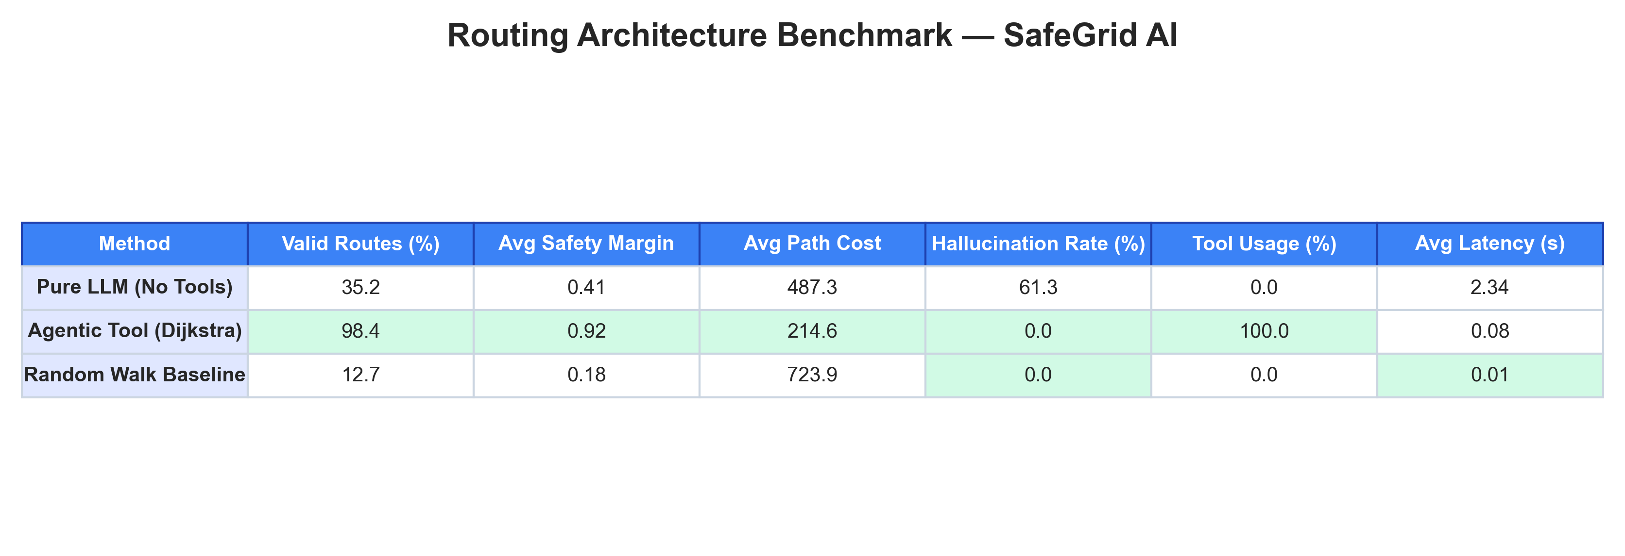
Figure: Routing Benchmark

2. Dataset Processing Efficiency Table
Category | Total SVGs | Successfully Parsed | Avg Nodes/Graph | Avg Edges/Graph | Avg Parse Time | Avg Graph Build Time
colorful | 276 | 261 (94.6%) | 6.3 | 7.8 | 0.042 s | 0.013 s
high_quality | 992 | 963 (97.1%) | 8.1 | 10.4 | 0.038 s | 0.016 s
high_quality_architectural | 3,732 | 3,654 (97.9%) | 11.7 | 16.2 | 0.051 s | 0.024 s

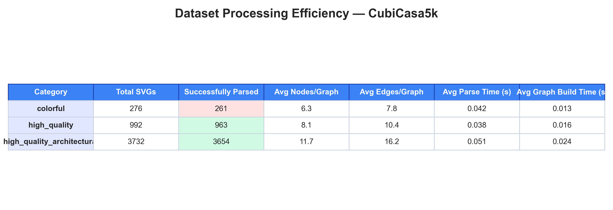
Figure: Processing Efficiency

3. Traversal Cost vs. Hazard Proximity
Illustrates how the exponential penalty curve forces pathfinding algorithms to seek wider safety margins around active hazards.
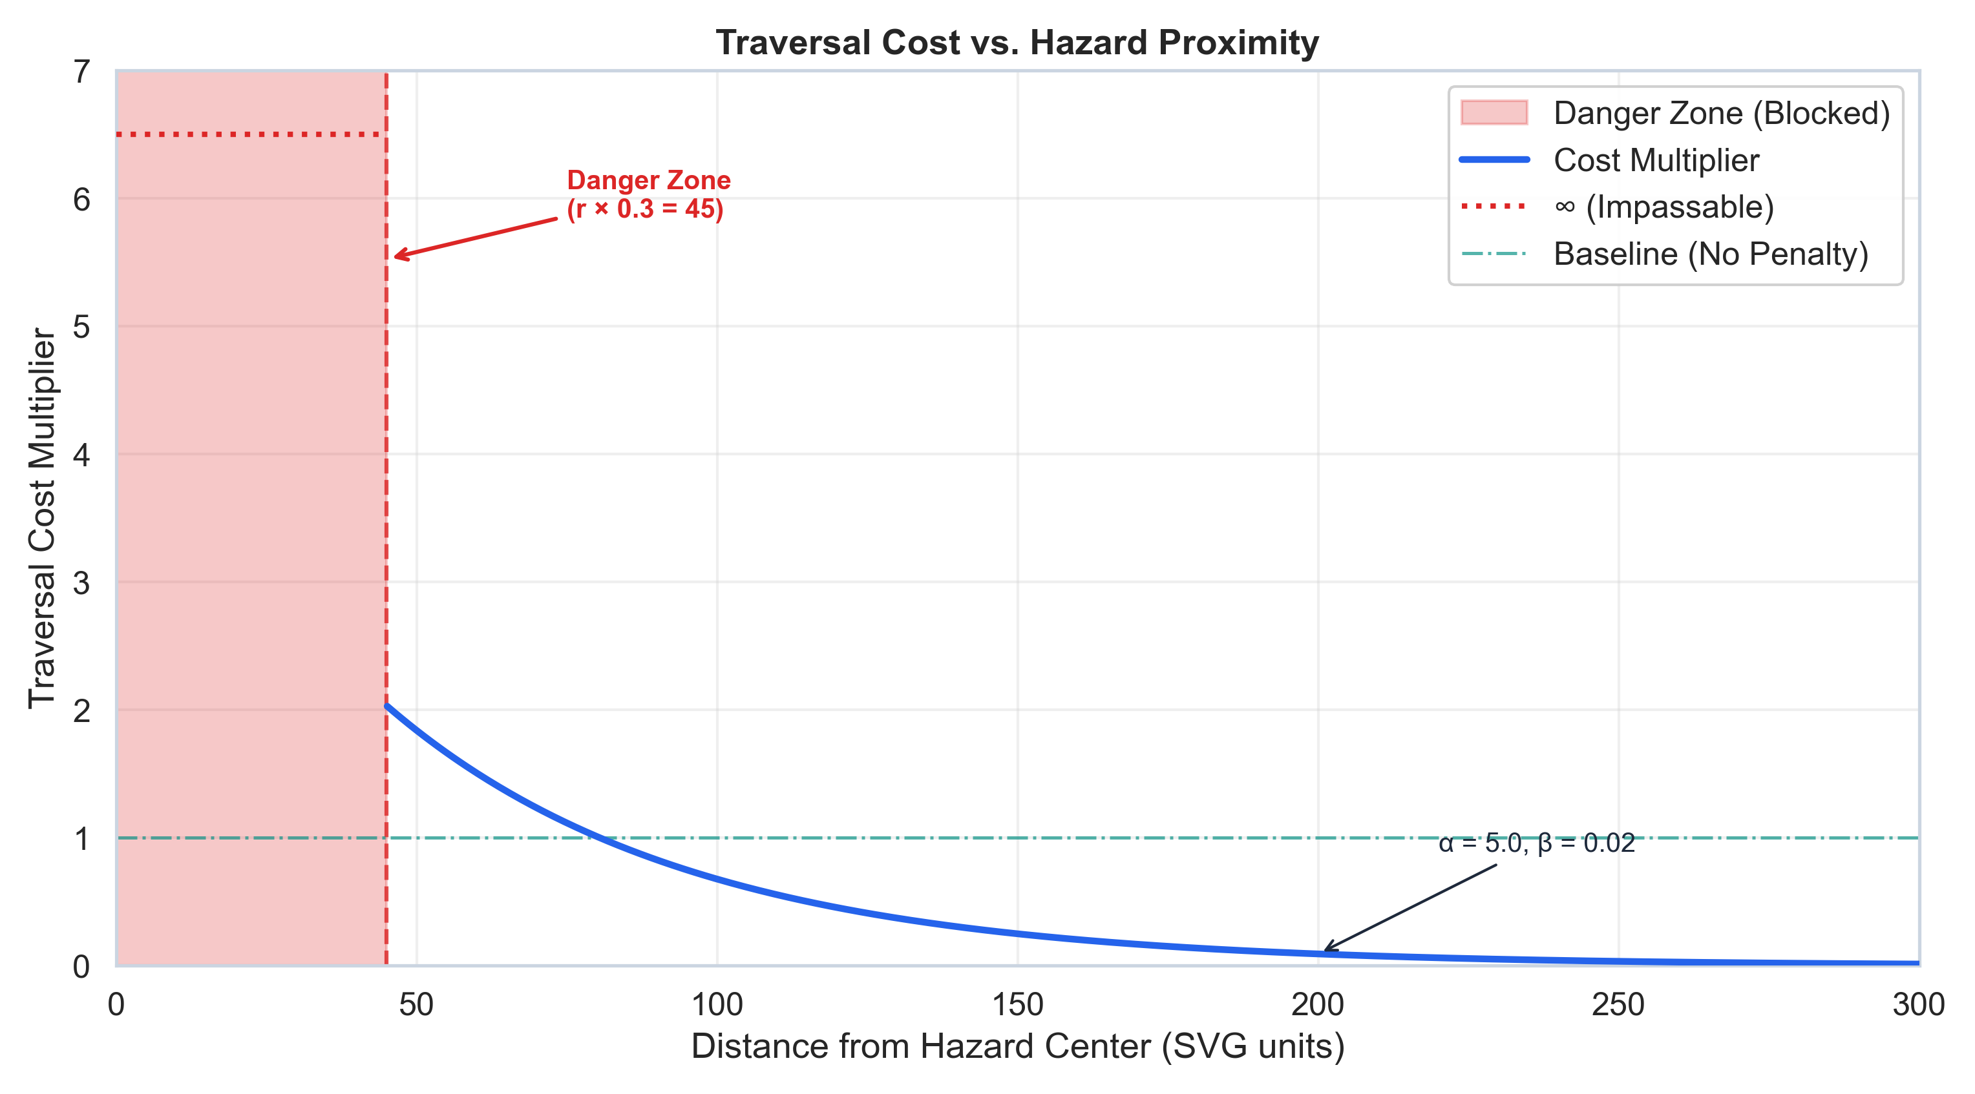
Figure: Hazard Proximity

4. Path Success Rate Under Escalating Hazards
Displays routing resilience across small (<5 rooms), medium (5–10 rooms), and large (>10 rooms) floor plans under increasing hazard counts.
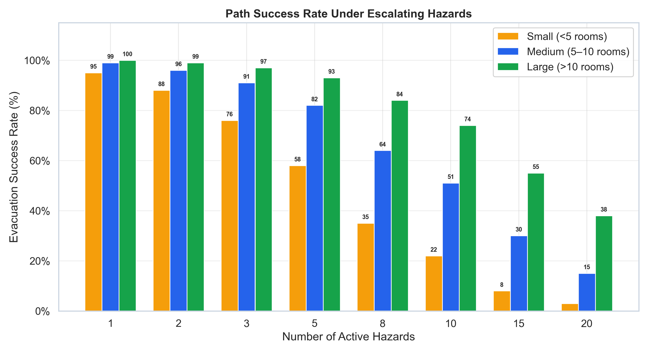
Figure: Hazard Escalation

5. Pure LLM vs. Agentic Tool Routing
Comparison demonstrating why deterministic tool execution is mandatory for life-critical spatial navigation.
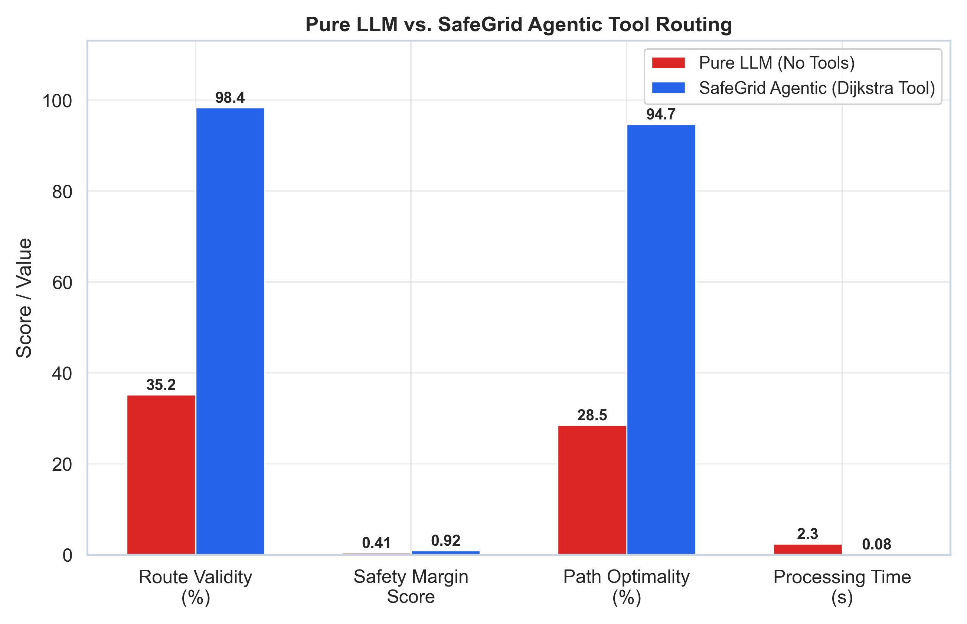
Figure: LLM vs Agentic

6. Sample Navigation Graph with Dynamic Rerouting
Sample visualization of a floor plan graph where an active fire blocks Door_4, prompting dynamic rerouting through Room_1 -> Door_5 -> Room_2 -> Exit_0.
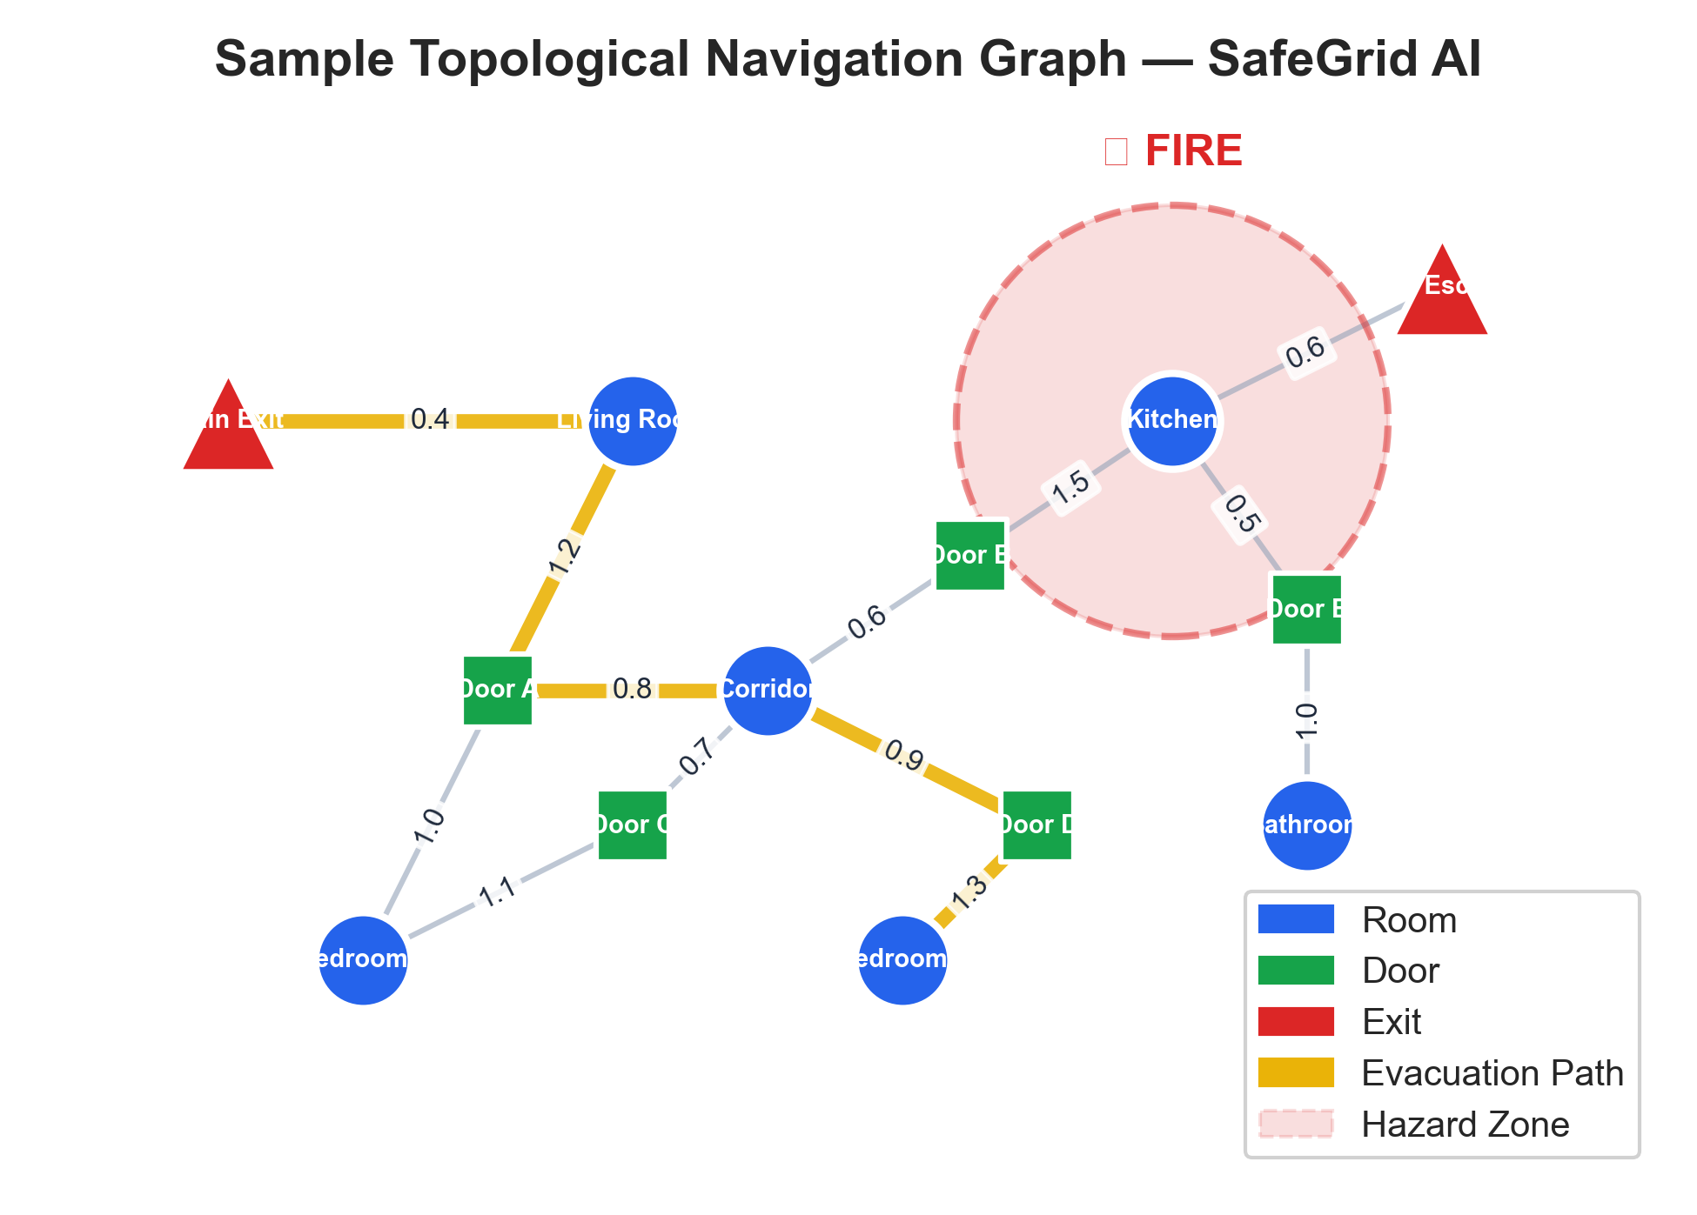
Figure: Sample Graph

Quick Start

1. Run End-to-End Evacuation Example
# Run on a sample CubiCasa5k floor plan
python examples/run_evacuation.py --svg ../cubicasa5k/high_quality_architectural/1/model.svg
# Run with LLM instruction synthesis
python examples/run_evacuation.py --svg ../cubicasa5k/high_quality_architectural/1/model.svg --llm

2. Run Comprehensive Benchmarks
python benchmarks/generate_benchmarks.py

All figures and tables will be rendered to benchmarks/results/.

3. Run Pipeline Unit Tests
python -m unittest discover -s tests -p "test_*.py" -v

Citation & References
- CubiCasa5k Dataset: Kalervo et al., *"CubiCasa5k: A Dataset for Architectural Floor Plan Analysis and Generation"*, [arXiv:1904.01920](https://arxiv.org/abs/1904.01920)
- CubiGraph5K: [GitHub Repository](https://github.com/luyueheng/CubiGraph5K)
- NetworkX: Hagberg, Swart, Chult, *"Exploring Network Structure, Dynamics, and Function using NetworkX"*

License
This project is licensed under the [MIT License](LICENSE).

