Global Air Quality: Trends, Indicators, and Insights

Akmatova K., Demina E., Moldobekova S., Raimkulova A.
TSI AUCA
SEST-2-23
Mamatov N.
01.12.25

INTRO

Abstract
As part of this project, global air quality data is analysed using Power BI. Key pollution trends, key factors influencing the main indicator, and regional differences in air quality have been identified. The dataset includes air quality index (AQI) values and concentrations of key pollutants (PM2.5, PM10, NO₂, CO, SO₂, O₃). After pre-processing the data, we visualise temporal, geographical, and pollutant-specific patterns to see the most polluted regions and the indicators that have the greatest impact on the AQI. The analysis answers research questions related to country rankings, the impact of pollutants, and seasonal trends in air quality.

Data: The Global Air Quality Dataset contains a large collection of air quality measurements from many major cities around the world. It includes important environmental indicators such as particulate matter (PM2.5 and PM10), nitrogen dioxide (NO₂), sulfur dioxide (SO₂), carbon monoxide (CO), and ozone (O₃). The dataset also provides simple weather information like temperature, humidity, and wind speed. Air quality measurements were taken from official monitoring stations located in different countries. The stations recorded data at regular time intervals. All pollutant and weather values were then gathered into a single dataset. After collection, the data was cleaned, organized, and prepared so it can be easily used for analysis and visualization.
Goal: to analyze global air quality data to identify major pollution patterns, determine the most influential pollutants affecting AQI, and compare air quality across different countries and time periods. Using Power BI and Power Query, the project aims to create clear visualizations that help understand how pollution levels change geographically and seasonally.
Relevance: Air pollution is a major global issue that affects public health, climate, and overall quality of life. Many countries experience high levels of harmful pollutants such as PM2.5 and PM10, which are linked to respiratory and cardiovascular diseases. Understanding air quality trends through data analysis is essential for governments, researchers, and communities because it helps identify high-risk regions, evaluate environmental policies, and develop strategies to reduce pollution.

Literature review
The Air Quality Index (AQI) is a common standard used to describe how clean or polluted the air is. Health organizations such as the World Health Organization (WHO) and the U.S. Environmental Protection Agency (EPA) use AQI because it converts complex pollution measurements into one clear value with categories like Good, Moderate, or Unhealthy. This makes it easier to compare air quality across different countries and cities, even when pollution levels and sources vary.
Main Pollutants and Their Health Impact
- PM2.5 – the most dangerous pollutant; very small particles that enter deep into the lungs and can reach the bloodstream.
- PM10 – larger particles that affect the respiratory system but do not penetrate as deeply as PM2.5.
- NO₂ – strongly linked to road traffic; associated with asthma and lung irritation.
- SO₂ – mainly produced by industrial activity and power plants; can trigger breathing problems.
- O₃ (ozone) – forms through chemical reactions in sunlight; affects the respiratory system, especially during hot weather.
- CO (carbon monoxide) – toxic gas resulting from incomplete fuel combustion; reduces oxygen delivery in the body.
Findings From Previous Research
Studies consistently show that PM2.5 is the strongest contributor to poor air quality and often has the largest impact on AQI. Research also notes strong seasonal patterns: many cities experience higher pollution in winter due to heating and stagnant air layers, and higher ozone levels in summer (NASA, 2022). Global datasets such as WAQI highlight that South and East Asia have the highest AQI levels worldwide, while many European and North American cities show more stable and lower pollution levels.

Data preprocessing
The entire dataset was checked for omissions, duplicates, and type correctness—no problems were found. All fields were filled in, and the data types for each column complied with the standards.
For ease of analysis, an additional conditional column was created from the source data, where each record was classified by season. This was done for additional visualisation and analysis of relationships. There is one more additional conditional column about AQI level, including three options: good, moderate and unhealthy New measures were also created to determine the average values of all pollution indicators from the dataset.
No other transformations were required, as the source dataset was already clean and structured for further visualisation and analysis.

Data Analysis
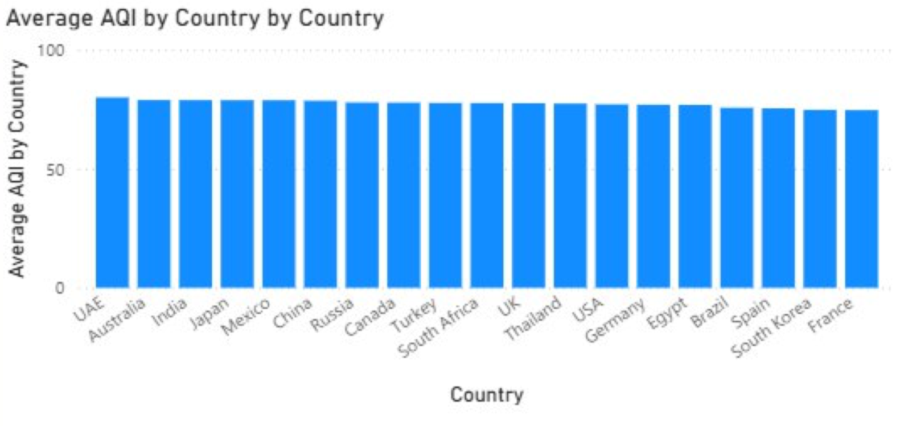
- Average AQI by Country
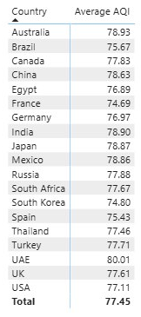 The difference in AQI levels between the UAE and France can be explained by climate, urbanisation scale and environmental policy. The Emirates has a hot desert climate with frequent dust and sand storms, which naturally increases the level of polluting particles. Added to this are intensive construction, a large number of cars, and an energy sector linked to oil and gas production.
In France, the situation is the opposite: a mild climate, less natural dust, developed public transport, strict environmental standards and a high share of nuclear energy, which reduces emissions. All this leads to a significantly lower AQI compared to the Emirates.

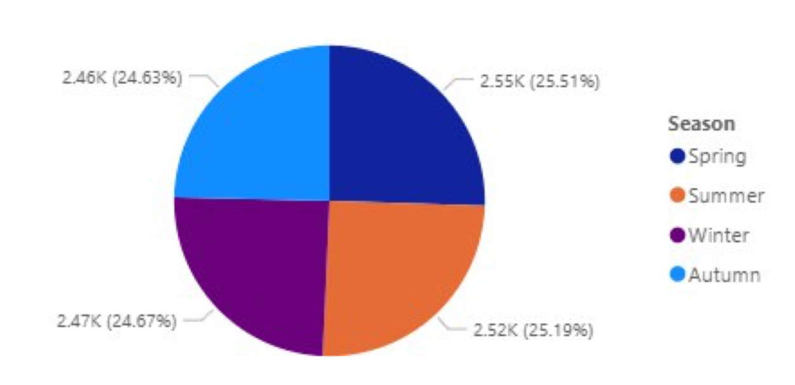
- AQI distribution by season
The distribution of AQI categories by season is almost uniform: spring, summer, autumn and winter have similar proportions.
This suggests that air quality does not depend greatly on the time of year, and pollution remains stable throughout the year without significant seasonal fluctuations.
We also conducted additional research on the internet and found that pollution is indeed more chemically reactive and irritating in the summer. This is due to increased ozone formation. Winter pollution, on the other hand, often includes heavier particles and toxic gases from heating sources that are not typically used during the summer season. Therefore, pollution does not depend greatly on the season.
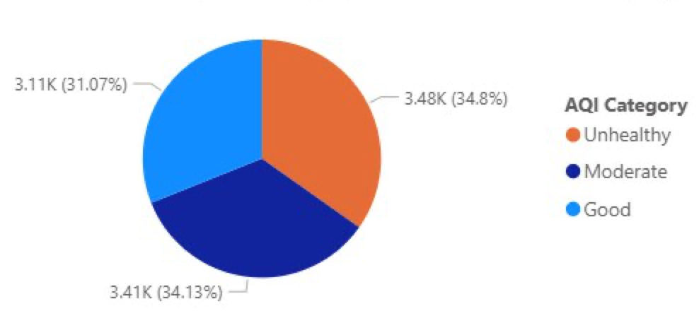
- Country distribution by AQI category
Most entries fall into the Moderate and Unhealthy categories, while the proportion of Good entries is significantly lower. This shows that in most countries, the air is more often moderate or polluted, and cases of truly good air quality are less common.
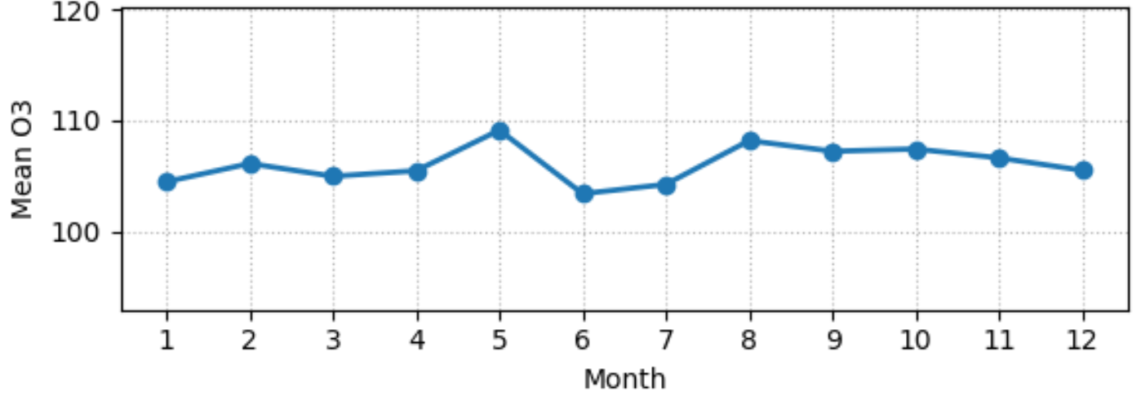
- Average 03 level by month
Average monthly O₃ values remain almost stable and fluctuate within a very narrow range, indicating the absence of pronounced seasonality. A slight increase is observed in May, followed by a slight decrease in June and then stabilisation throughout the second half of the year. Overall, O₃ concentrations vary minimally, without sharp fluctuations.

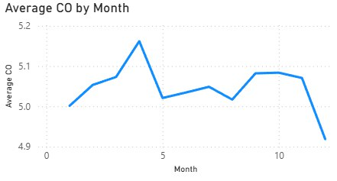
- Average CO level by month
Average CO values show a noticeable increase in April, while in other months the level remains more stable. This peak may be linked to several factors: increased traffic after winter, the start of seasonal agricultural work, including the burning of plant residues in some regions. As a result, CO concentrations temporarily increase in April, before returning to normal levels.
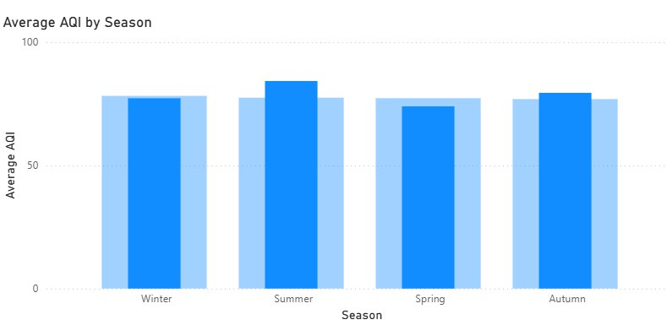
- Average AQI by Season
The highest AQI is in summer. It is possible that higher temperatures increase ozone (O₃) formation and reduce pollutant dispersion, and the number of fires increases in some regions. The lowest AQI is in spring. Air dispersion is better, heating emissions are lower, and photochemical activity is lower compared to summer. Air quality varies moderately by season, but summer consistently stands out as the most polluted period due to a combination of heat, ozone, and fire hazards.
Results
The data show moderate but consistent seasonal pollution patterns: summer is the most unfavourable period due to increased ozone, heat and possible wildfires, while spring remains the cleanest season. Individual pollutants behave differently: CO peaks in April, which may be due to increased traffic, agricultural work and local inversions; O₃ remains relatively stable throughout the year, rising slightly in May. On average, there are no noticeable extremes across countries — most states are in the AQI range of ~75–80, which indicates a comparable level of air quality and the absence of strong emissions in individual regions. Taken together, the data indicate that air quality depends simultaneously on seasonal climatic factors, human activity, and local emission sources.

References
Airly. (n.d.). Increased air pollution: Is it worse during the summer or winter? Airly. Retrieved December 3, 2025, from https://airly.org/en/increased-air-pollution-is-it-worse-during-the-summer-or-winter/#air-pollution-summer-vs-winter
NASA. (n.d.). Air quality. NASA Earthdata. Retrieved December 3, 2025, from https://earthdata.nasa.gov/learn/topics/air-quality
World Air Quality Index. (n.d.). WAQI. Retrieved December 3, 2025, from https://waqi.info
U.S. Environmental Protection Agency. (n.d.). Particulate matter (PM) pollution. EPA. Retrieved December 3, 2025, from https://www.epa.gov/pm-pollution
World Health Organization. (2021). Ambient (outdoor) air quality and health. WHO. Retrieved December 3, 2025, from https://www.who.int/news-room/fact-sheets/detail/ambient-air-quality-and-health

