MANUAL TESTING

Software Testing Concepts - Lesson #14

State Transition Testing Technique

This technique is used when features of a system are represented as states which transform into one another.

Example:

ATM system feature, where if the user enters the invalid password three times the account will be locked.

If the user enters a valid password in any of the first three attempts the user will be logged in successfully.

If the user enters the invalid password in the first or second try, the user will be asked to re-enter the password. And finally, if the user enters incorrect password 3rd time, the account will be blocked.

There are two main ways to represent or design state transition, State transition diagram, and state transition table.

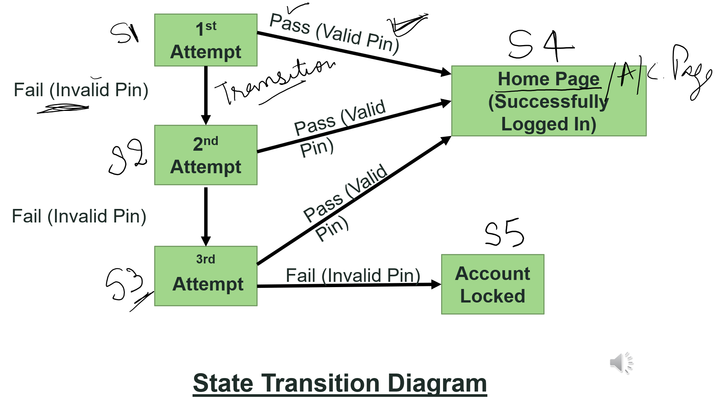

|  |  |  |  |  |  |  |
| --- | --- | --- | --- | --- | --- | --- |
| Test Case | TC1 | TC2 | TC3 | TC4 | TC5 | TC6 |
| State | S1 | S1 | S2 | S2 | S3 | S3 |
| Input | Correct Pin | Incorrect Pin | Correct Pin | Incorrect Pin | Correct Pin | Incorrect Pin |
| Output | Home Page | 2nd Attempt | Home Page | 3rd Attempt | Home Page | Account Locked |
| Finished State | S4 | S2  **State Transition Table** | S4 | S3 | S4 | S5 |

Convert above State Transition to formal test case

|  |  |  |  |
| --- | --- | --- | --- |
| TC ID | Description | Steps | Expected Result |
| TC1 | Validate that the system is able to do the transition from 1st attempt to Home Page on correct pin input | 1. Open the application 2. input correct pin | User shall be directed to Home Page |
| TC2 | Validate that the system is able to do the transition from 1st attempt to 2nd attempt on incorrect pin input | 1. Open the application 2. input incorrect pin | User shall be directed to 2nd attempt |
| TC3 |  |  |  |
| TC4 |  |  |  |
| TC5 |  |  |  |
| TC6 |  |  |  |