🌦 Weather App Project Report

# 1. Objective

The objective of this project is to develop a web-based weather application that allows users to enter a city name and retrieve real-time weather information using the OpenWeatherMap API. The app displays temperature (in Celsius), weather description, and an icon representing the weather condition.

# 2. Tools & Technologies Used

• HTML5 → Structure of the application

• CSS3 → Styling and responsive layout

• JavaScript (ES6) → Logic, interactivity, and API integration

• OpenWeatherMap API → Public API for fetching live weather data

• VS Code → Development environment

# 3. Features Implemented

✅ User can enter a city name in the input box

✅ "Submit" button fetches weather data using the API

✅ Displays: City name and country, Current temperature (°C), Weather description, Weather icon, Humidity and wind speed

✅ Error handling for invalid city, empty input, or invalid API key

✅ Responsive design for desktop and mobile

# 4. Workflow

1. User Input: User enters a city name.
2. API Call: JavaScript fetches weather data from OpenWeatherMap:
3. Response Handling: If successful → Display weather details. If error → Show appropriate error message.
4. Rendering: Weather info is displayed in a styled card with icon and details.

API Endpoint Example: https://api.openweathermap.org/data/2.5/weather?q={city}&appid={API_KEY}&units=metric

# 5. Project Structure

weather-app/

│── index.html → HTML structure

│── styles.css → Styling (CSS)

│── script.js → JavaScript (API + logic)

# 6. Sample Screenshots

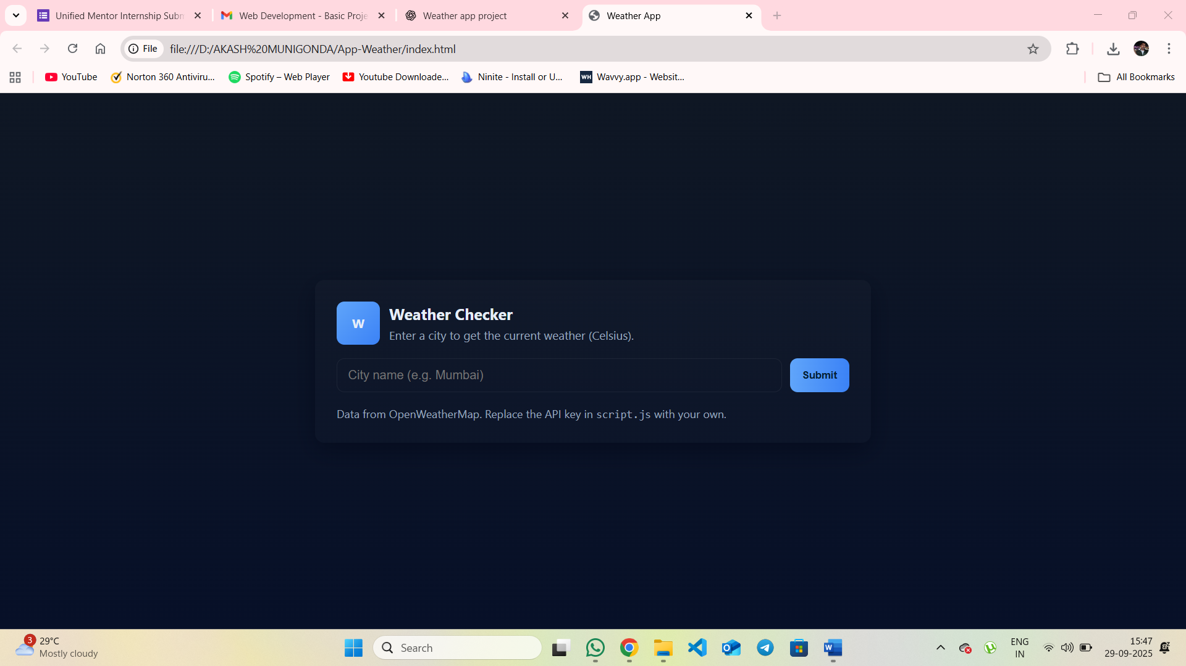

• Home page with input field

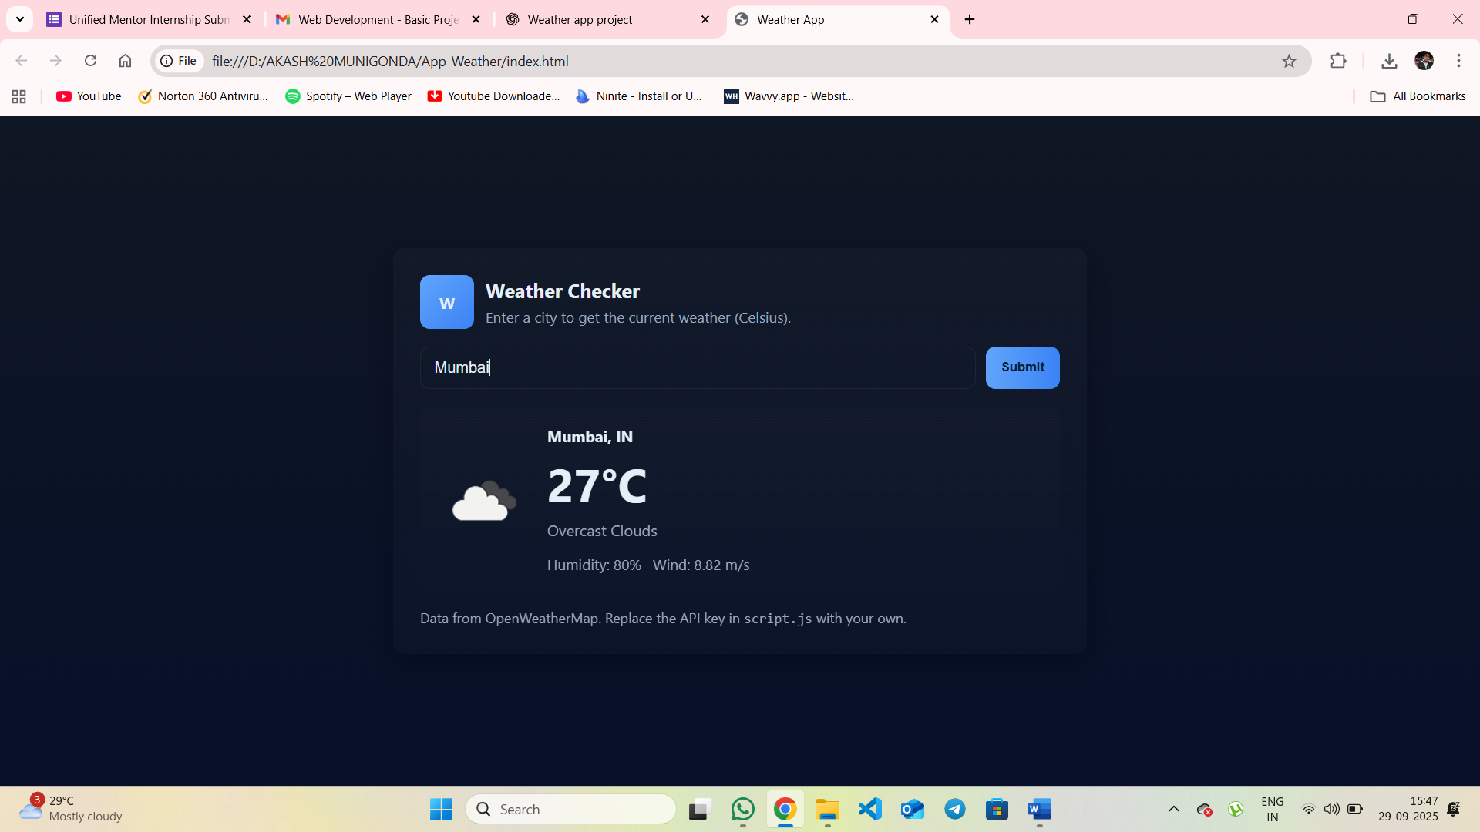

• Weather result card

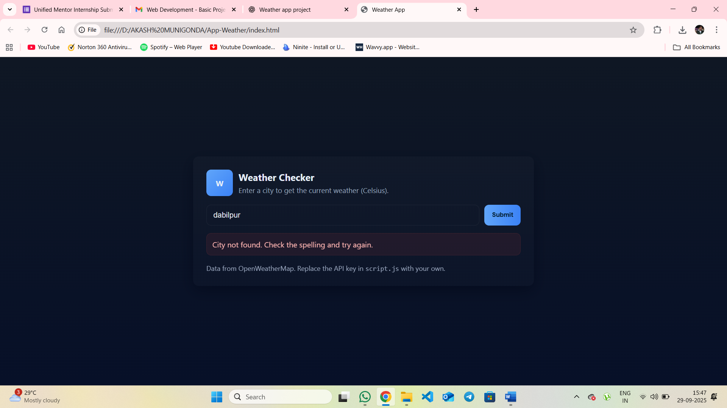

• Error message example

# 7. Future Enhancements

• Add 5day weather forecast

• Add geolocation support (auto-detect user’s location)

• Toggle between Celsius and Fahrenheit

• Dark/Light theme support

• Deploy app on GitHub Pages / Netlify

# 8. Conclusion

This project demonstrates the integration of frontend web technologies (HTML, CSS, JavaScript) with a public REST API. It improves understanding of asynchronous JavaScript (async/await, fetch API), error handling, and responsive design. The Weather App is a practical project that can be enhanced further with more features.