I was not able add screenshots in Readme.md file so created word file

Technologies Use:-

Project Name:- CreatorsLab

App Name:- app1

Models:

1)Created User model for registration and login functionality.

Templates:-

1)Login & Registration Template Name - home.html

User Password will be stored on server encrypted format.

2)If User Authenticated then User Redirect to dashboard.html Template

3)Go to File Upload, select the file and upload (authenticated user only access this functionality) and check file uploaded in fileupload folder on server

Function Created:

1)For Login & Registration created form.py file in project app1 folder and

created function name (def signup_detail for registration) and for login created (def login_detail) and also add both url in urls.py file in app1 folder.

2)For Logout user, created logout function in form.py and add url in urls.py filr in project app1

3)Upload File

Authenticate user able to upload file on server.

For Uploading File, created fileupload function in views.py file and add url in urls.py file.

ScreenShots:-

1)User Registration and Login

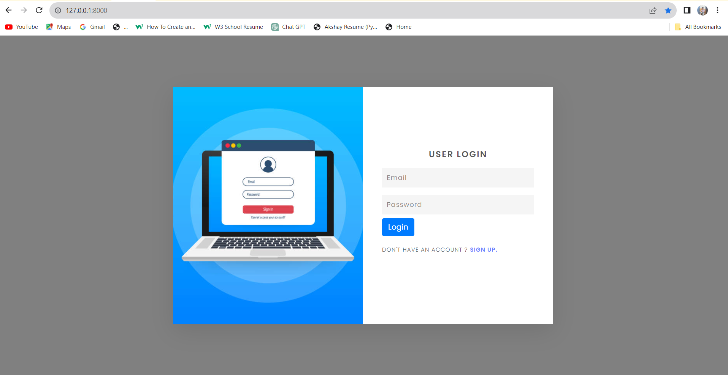

2) Authenticated User Dashboard File

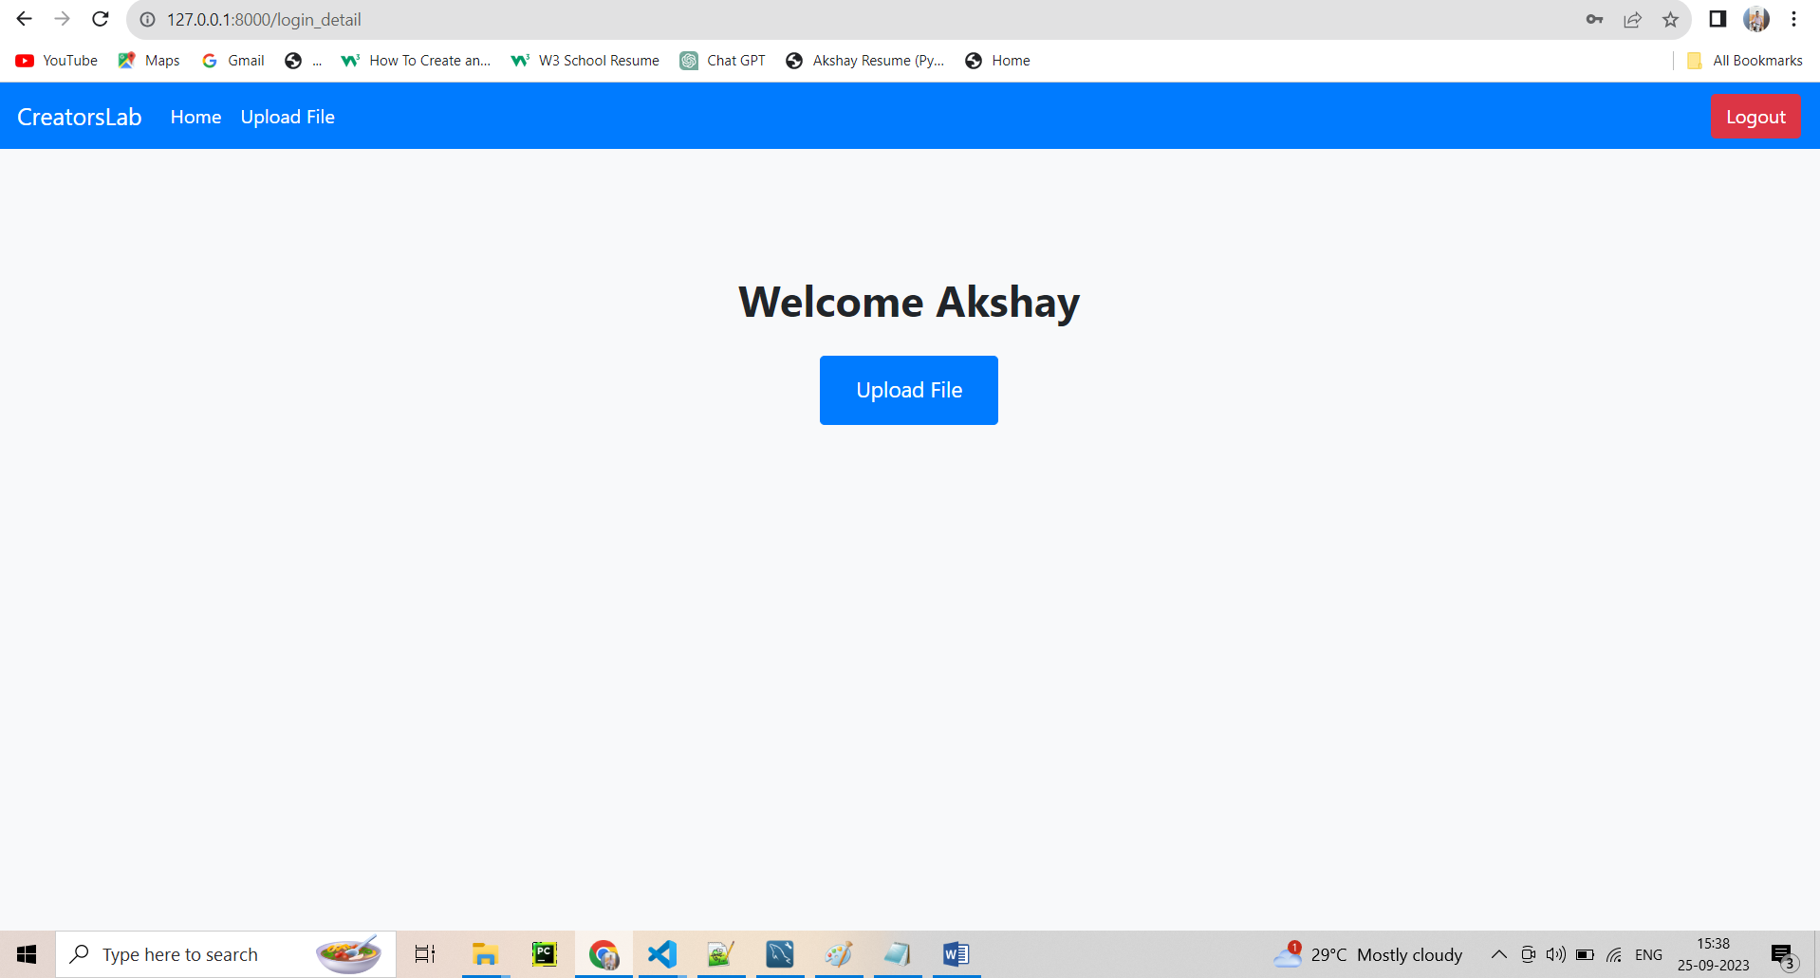

3) File Upload Page

