**Features:**

In this section, we will see the features that we can do with the Cartogram.

1. **Multiple Maps:**

There is an option in the Cartogram which enables to view two different maps to compare and view it. To enable this option, there will be a button at the dashboard. (refer the image below)



**Single** - This option will show a single cartogram map

**Compare** – This option will show to different cartogram maps, each having their own control panel.

1. **Equation for the size of the circle:**

In the filter panel, there is a feature which enables the user to configure the size of the circle based on the columns in the datasets and also the user can perform mathematical operations with the columns of the datasets. (refer the image below)

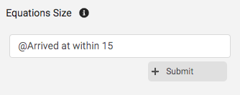

To populate this option, first you need to click on the **Filter**  button in the dashboard

To populate the columns in the dataset, type **@** as shown in the image above.

[Note: add a space before typing the @ character, why to do it? - In the background, based on the space before **@**, It will populate the column.]

**Don’t forget to press the submit button after typing the equation.**

1. **Equation for the color of the circle:**

In the filter panel, there is a feature (Equation color) which enables the user to configure the color of the circle based on the values derived from the equation that is mentioned. (refer the image below)

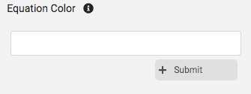

It works same as Equation of the circle.

When you submit the equation, there will be option as below:

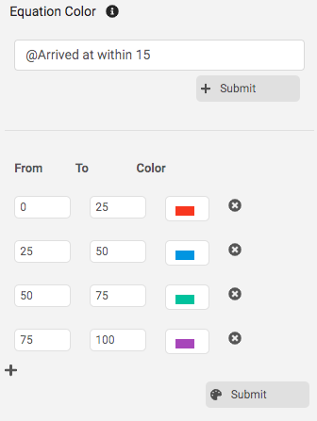

It will populate with 4 default rows of separations. The section has main components each as:

**From – To:** Here the user can specify the lower limit and the higher limit and if the value derived from the equation falls between that limit, then the color will be applied to the circle.

**Color –** The color is chosen which will be applied to the circle which falls between the mentioned limits.

** Close –** The close icon will remove the particular row from the field.

** Add –** The add icon will add a new field to the table with blank values in the From, To and Color.

**[Don’t forget to press the submit button to apply the specifications]**