TABLE OF CONTENTS

Functionality of Cartogram 2

How to add a map? 2

How to use the Options panel in the map? 2

How to use the Equation Size in the Options panel? 3

How to change the color of the bubble in the map? 4

How to filter the centroid in the map? 5

How to Delete the existing map? 6

How to save the image of the map? 6

New dataset addition #

Section 2.1 #

Section 2.2 #

Subsection 2.2.a #

Subsection 2.2.b #

Subsection 2.2.c #

Section 2.3 #

Chapter 3 #

Section 3.1 #

Section 3.2 #

Section 3.3 #

Subsection 3.3.a #

Subsection 3.3.b #

**Functionality of Cartogram:**

1. How to add a new map?

Steps to add a new map are:

1. Click on the button ‘Add a map’ which is placed at the top right corner.
2. A popup will be displayed and, in that popup, fill the Name of the map that you want to add.

[**Note: The name should be unique. It should not be the same name that has been already used by the present maps**.]

1. Select a dataset from the dropdown.
2. Then in the Centroid Column field, select the column which has the centroid in the dataset from the dropdown.
3. Click on the ‘Add’ button, so that the new map will be added to the dashboard.
4. How to use the Options panel in the map?

Once the map is added to the dashboard by the above step (How to add a new map?), there will be a panel called **Options**, (Refer the screenshot below)

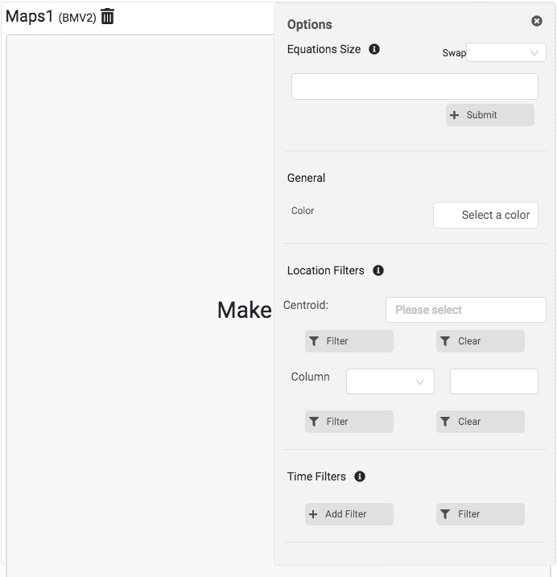

Here is the place where the major functionalities of each map present. Each map that you add has an Option panel attached with them.

1. If you want to close the Options panel, there is a Close button at the top right corner of the panel.



1. If you want to open the Options panel, then click on the Filter icon which is present in the top right corner.



1. How to use the Equation Size in the Options panel?

Equation size is the option where you can choose a column for the size of the centroid in the maps. The column that you chose should contain only numbers.

Steps to achieve the functionality:

1. The input field under the Equation Size is the place where you will add the column for the size. To add a column, press @ which will populate the columns present in the dataset.

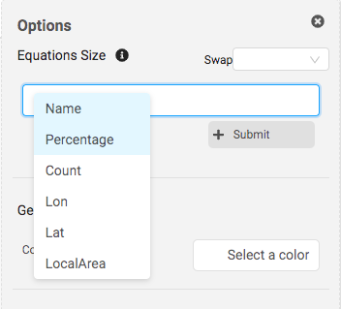

1. Select the column and press **Submit** button to apply the configurations.

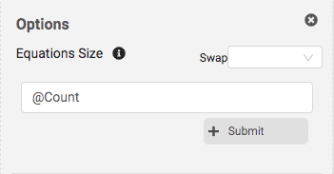

Once you submit the configuration, then the map will be created. Below is the screenshot for the above configuration.

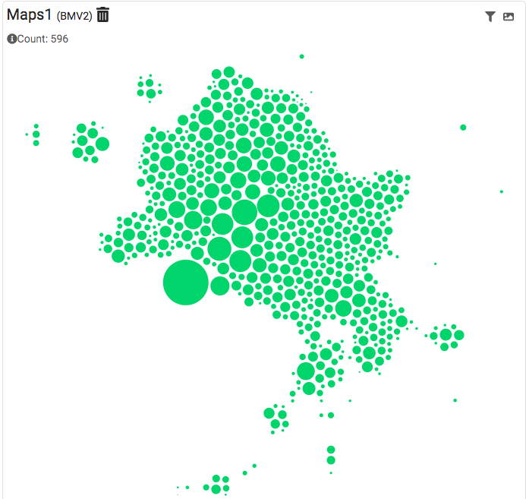

1. How to change the color of the bubble in the map?

There is an option to change the color in the **Options Panel -> General**. You can change the color of the bubble by using that option.

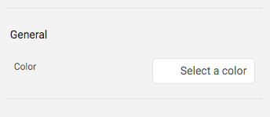

Now we will change the color of the bubble.

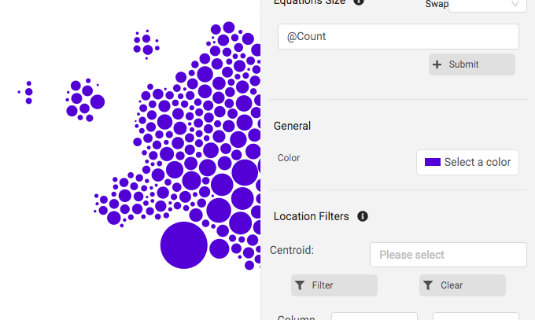

1. How to filter the centroid in the map?

To filter the centroid in the map, there is an option called **Location Filters** present inside the Options panel.

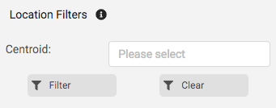

Here in the input field, select the centroid that you want to filter. After that, click on the **Filter** button.

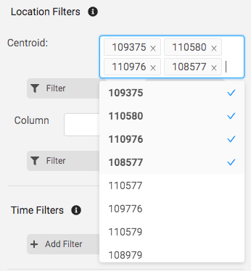

Below is the result for the configuration above.

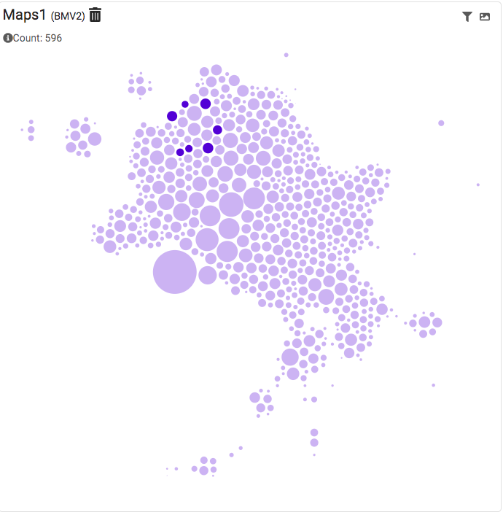

1. How to delete the existing map?

There is an option to delete the maps from the dashboard. By clicking on the Delete icon, the maps can be removed from the dashboard.

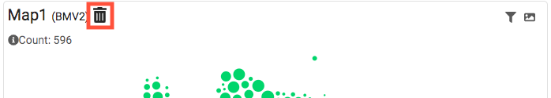

1. How to save the image of the map?

There is an icon present near the **Filter** icon at the top right corner. By clicking that icon, the map image will be saved in your **Downloads** folder.

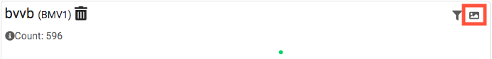

**New Dataset Addition:**

To add a new dataset in the project, there are few steps to be allowed.

1. Copy the dataset that you want to insert and paste the dataset inside the folder called **data,** which you can find inside the **ProjectFile -> src -> data**
2. After adding the dataset inside the **data** folder, Open the file called **index.js** in the text editor which is located inside the same folder (i.e., **data** folder)

The file will be look like the below screenshot:

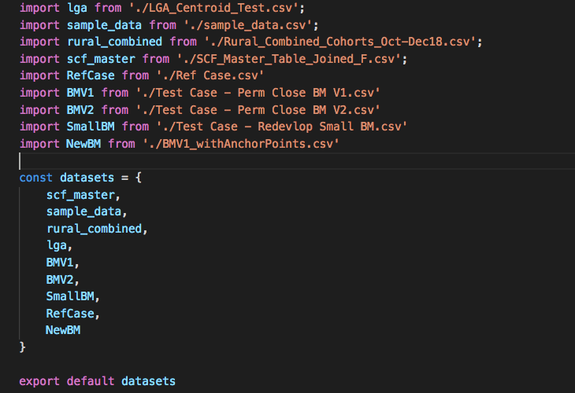

1. Now we need to link the dataset with the project. To do that, add the following line

**import** (insert_a_name_for_dataset) **from ‘./**(dataset_name)**’**

**insert_a_name_for_dataset –** The name should be unique and should not contain any space and should not start with a number or special characters.

**Dataset_name –** Type the exact name of the dataset that you added.

1. Add the name of the dataset that you gave (**insert_a_name_for_dataset**) in the **datasets** list.
2. We are at the last step of the process. Now open the file called **index.js** inside the folder **ProjectFile -> src -> default**

The file will look like the screenshot below:

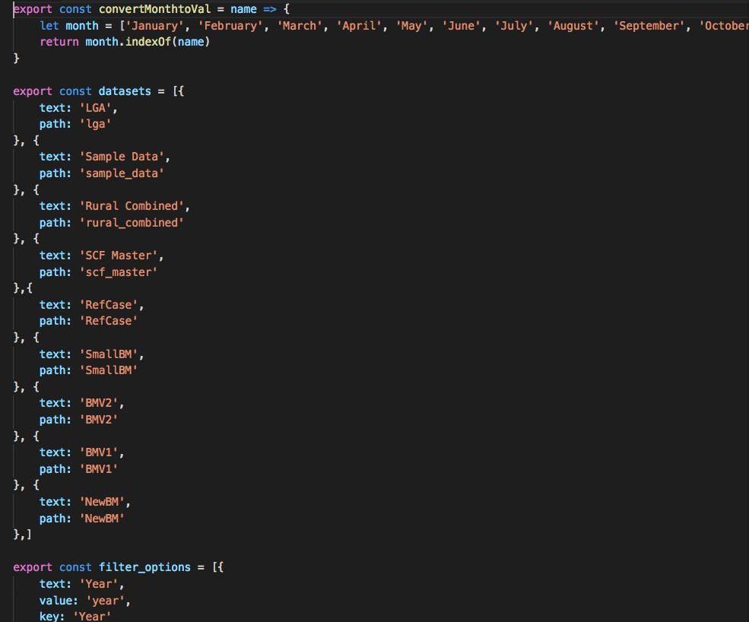

Now add the name that you gave for the dataset added (**insert_a_name_for_dataset**) inside the **datasets** in the below format

{

text: (**insert_a_name_for_dataset**),

path: (**insert_a_name_for_dataset**)

}

So, now we added the dataset to the project.

**Example for adding a new dataset:**

Let’s add a new dataset called ‘example_dataset.csv’ to the project.

1. Copy the dataset to the data folder.

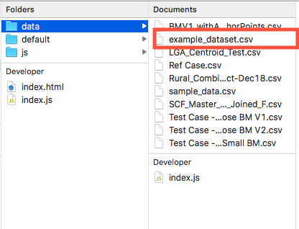

1. Open the index.js in a text editor which is located in the same folder.

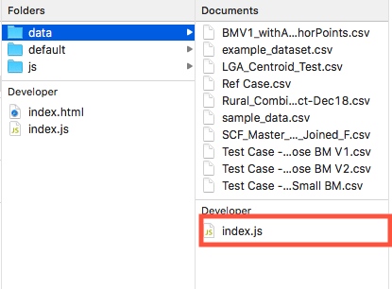

1. Add the line as mentioned in the step 3 of New Dataset Addition. I am giving the name as **Example_data** for the **example_data.csv**

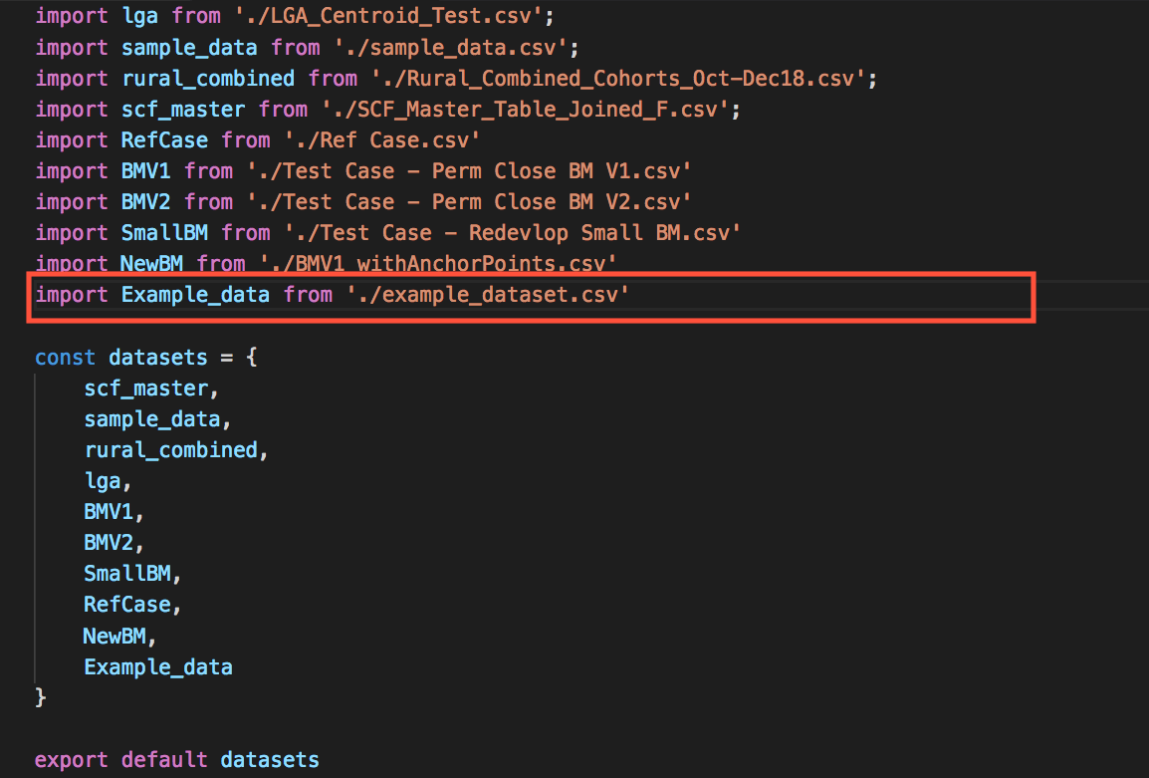

1. Add the name that you gave to the dataset to the **datasets** list

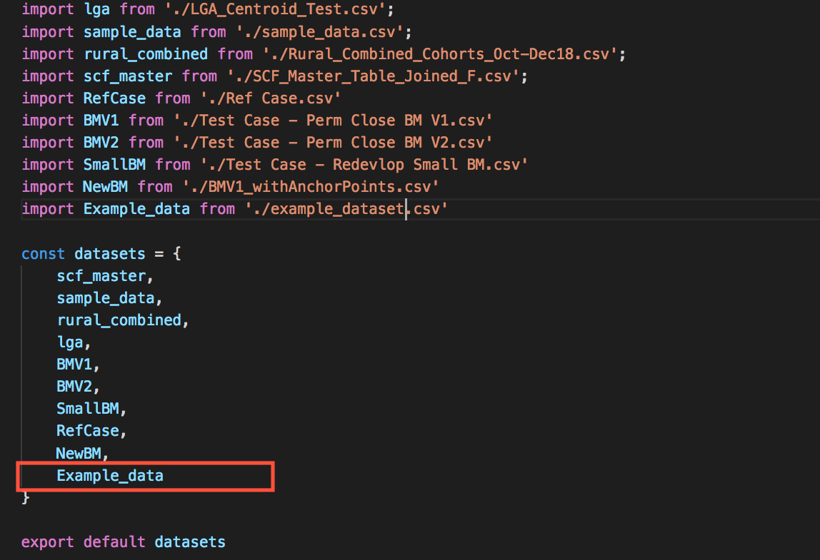

1. Last step is to open the file called **index.js** inside the folder **ProjectFile -> src -> default** and add the line mentioned in the step 5 of New Dataset Addition.

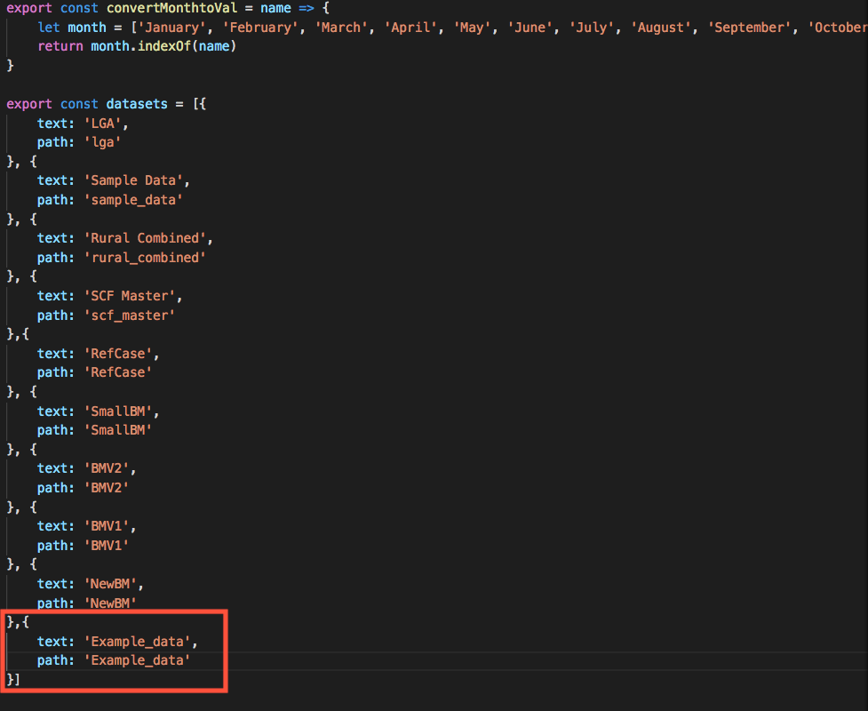

So, we added the new dataset inside the project, and you can use it in the dashboard.

