SYSEN 5381

Homework 1

Antony Klar

This shiny app contains four main components: data_api.py, economics_analyzer.py, styles.css, and main.py. When the app is running, main.py immediately calls the get_indicators() from the data_api.py file. Data_api fetches the full list of countries from the World Economic bank and loads a set of key indicators such as population, life expectancy, and co2 emissions. This populates the two drop-down menus: Country and Indicator. Then below the two drop-down menus, a ui.input_slider and ui.input_buttons are added to select year range, load the country data, and to analyze the country data. This data is all displayed using the ui.card function from Shiny.

When the user selects a country to analyze along with a year range and specific indicator, Load data, the app calls fetch_indicator() in data_api.py, which accesses the World Bank REST API at https://api.worldbank.org/v2/country/{code}/indicator/{indicator}. Using pandas, the JSON is parsed into a DataFrame with year and value columns. At the end of the list, the python script uses Matplotlib to plot out the years and corresponding indicator. This is then accessed through main via @render.table and @render.plot.

The Analyze Economic Strength button is handled by economic_analyzer.py which fetches 14 different indicators to provide a sentence summary for each category: short-term (GDP growth, inflation, unemployment), structural (productivity, demographics, innovation), and risk (debt, trade balance, governance) categories. I found these categories via asking ChatGpt and Google what people look for when analyzing a country’s economy. The summary is created by sending the data to Ollama (gemma3:4b) which runs locally, to provide a 3-sentence summary displayed in the UI as verbatim text. The whole app is then styled using CSS.

Links To Source Code

https://github.com/ak2433/AI-Reporter/blob/main/data_api.py

https://github.com/ak2433/AI-Reporter/blob/main/economic_analyzer.py

https://github.com/ak2433/AI-Reporter/blob/main/main.py

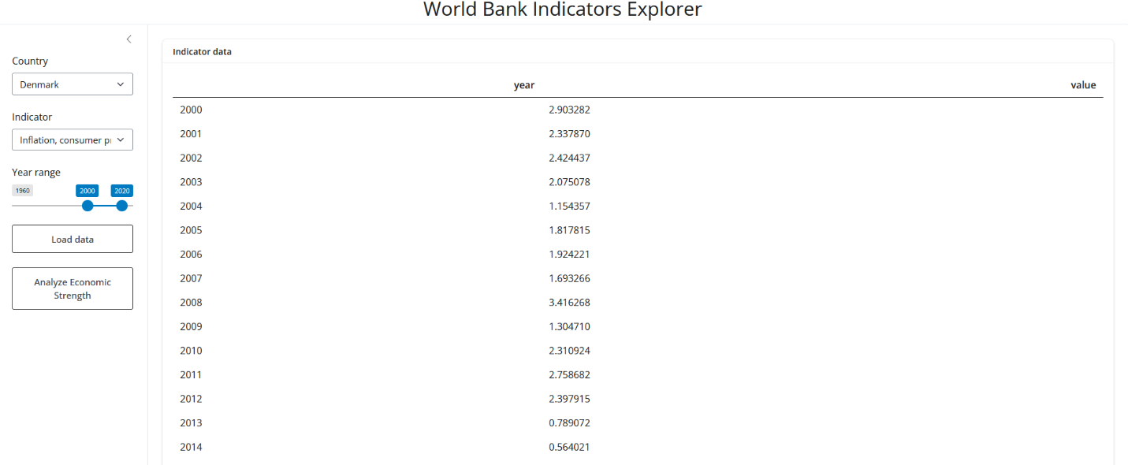

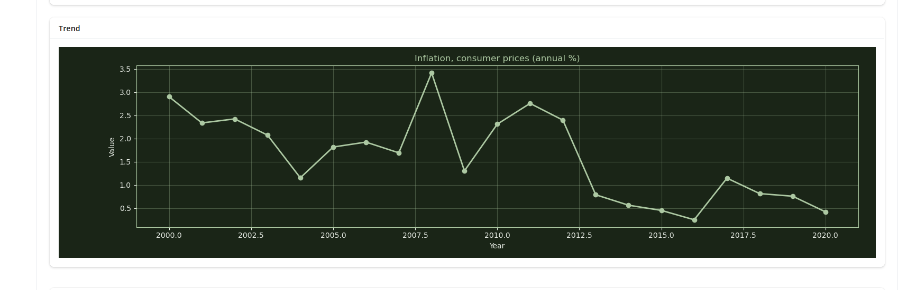

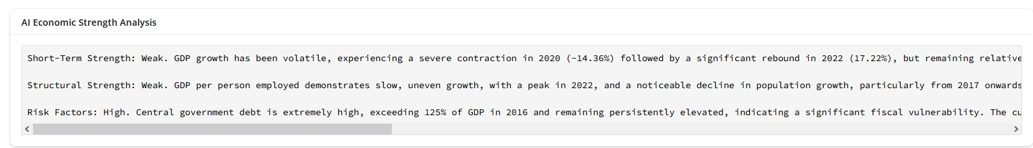

AI Reporter — World Bank Indicators Explorer
A Shiny for Python dashboard that visualizes World Bank economic indicators and generates AI-powered macroeconomic analysis using a local Ollama LLM.
Users select a country, indicator, and year range to load time-series data, view an interactive trend chart, and optionally run a structured economic strength analysis across short-term, structural, and risk dimensions.

Data Summary
All data is fetched live from the World Bank Open Data API. No local dataset is stored.

Indicator Explorer (sidebar selection)
Column | Data Type | Description
year | int | Calendar year of the observation (filtered to the user-selected range)
value | float | Numeric value of the selected indicator for that year

AI Economic Strength Analysis (fetched automatically when analysis is triggered)
The analysis button fetches 14 additional indicators organised into three categories. Each indicator produces the same year / value columns shown above.
Category | Indicator Code | Description
Short-Term | NY.GDP.MKTP.KD.ZG | GDP growth (annual %)
 | FP.CPI.TOTL.ZG | Inflation, consumer prices (annual %)
 | SL.UEM.TOTL.ZS | Unemployment (% of total labor force)
Structural | SL.GDP.PCAP.EM.KD | GDP per person employed (constant 2017 PPP $)
 | SP.POP.GROW | Population growth (annual %)
 | SP.DYN.LE00.IN | Life expectancy at birth (years)
 | GB.XPD.RSDV.GD.ZS | R&D expenditure (% of GDP)
 | IP.PAT.RESD | Patent applications (residents)
Risk | GC.DOD.TOTL.GD.ZS | Central government debt (% of GDP)
 | BN.CAB.XOKA.GD.ZS | Current account balance (% of GDP)
 | NE.EXP.GNFS.ZS | Exports of goods and services (% of GDP)
 | NE.IMP.GNFS.ZS | Imports of goods and services (% of GDP)
 | CC.EST | Control of Corruption (estimate)
 | GE.EST | Government Effectiveness (estimate)

Technical Details

API
Detail | Value
Provider | World Bank Open Data
Base URL | https://api.worldbank.org/v2/
Auth | None — the API is free and requires no key
Format | JSON (?format=json)
Key endpoints | /country (country list), /country/{code}/indicator/{indicator} (time-series data)

Local LLM (Ollama)
The AI analysis feature sends a structured data summary to a locally running Ollama instance. No data leaves your machine.
Detail | Value
Default model | gemma3:4b (configurable in economic_analyzer.py)
Connection | localhost:11434 (Ollama default)

Packages
Package | Purpose
shiny | Web application framework (Shiny for Python)
pandas | Data manipulation and DataFrames
matplotlib | Trend chart rendering
requests | HTTP requests to the World Bank API
ollama | Python client for the local Ollama LLM
tabulate | Formats indicator data into readable text tables for the LLM prompt

File Structure
AI-Reporter/
├── main.py # Shiny app UI and server logic
├── data_api.py # World Bank API helpers (countries, indicators, fetch)
├── economic_analyzer.py # Multi-indicator fetch, summary builder, Ollama integration
├── styles.css # Custom dark-theme stylesheet
├── requirements.txt # Python dependencies
└── README.md # This file

Usage Instructions

Prerequisites
- Python 3.10+
- Ollama installed and running (only required for the AI analysis feature)

1. Clone the repository
git clone <repo-url>
cd AI-Reporter

2. Create a virtual environment (recommended)
python -m venv venv
# Windows
venv\Scripts\activate
# macOS / Linux
source venv/bin/activate

3. Install dependencies
pip install -r requirements.txt

4. Set up Ollama (for AI analysis)
Install Ollama from ollama.com, then pull the default model:
ollama pull gemma3:4b
Make sure the Ollama server is running before using the analysis feature:
ollama serve
You can swap the model by changing the OLLAMA_MODEL variable at the top of economic_analyzer.py.

5. Run the app
shiny run main.py
The app will open in your browser (typically at http://127.0.0.1:8000). From there:
- Select a country and indicator from the sidebar dropdowns.
- Adjust the year range slider.
- Click Load data to fetch and display the data table and trend chart.
- Click Analyze Economic Strength to run the AI-powered macroeconomic analysis.

