The FloCard Ecosystem
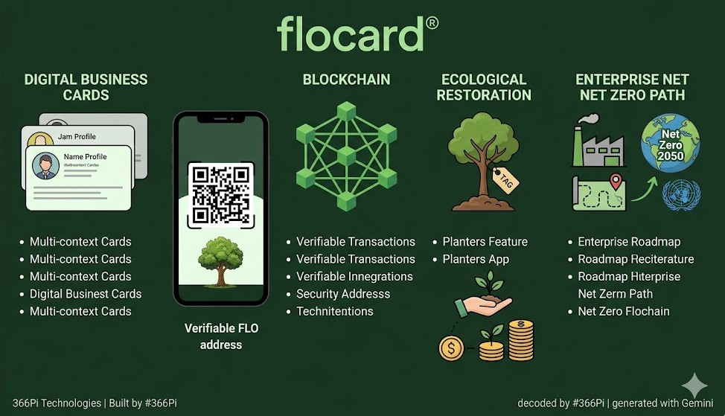

I, Ayush Kumar, an Intern at 366Pi Technologies, am sharing this as part of my Warm-up onboarding activity where I am documenting and sharing my learnings.
Starting a new role always comes with a mix of curiosity and questions. As part of my onboarding, my focus was simple but important: understanding the use cases of our flagship product and the idea it promotes.
#Goals
- To learn and understand about FloCard and the initiatives it offers towards sustainability
#Objectives
- Intended to understand the bigger picture FloCard offers
- How it aims to achieve it’s mission towards sustainable future

#Actions
- Studied use cases by visiting landing page
- Registered on the platform to experience user interface and working
- Read about the design architecture to understand the complete picture of different layer of technologies it implements

Why FloCard?
FloCard is important because it solves multiple modern business and environmental problems at once—not just networking, but sustainability, digital transformation, and climate action.
- Supports Sustainability & Climate Goals (Biggest Impact)
FloCard replaces paper business cards, reducing waste and environmental impact. Helps businesses align with Sustainable Development Goals (SDGs) and climate initiatives. Encourages eco-friendly practices and carbon footprint reduction
- Modernizes Traditional Networking
Eliminates the need to carry physical cards. Enables instant sharing via:
- QR codes
- Links
- OTP
- Builds a Sustainability Ecosystem (Not Just an App)
FloCard is more than a digital card—it’s a platform that:
- Helps track carbon footprint.
- Supports climate projects.
- Connects businesses with sustainability initiatives
It also enables climate finance access and community collaboration on environmental projects.
- Helps Businesses Become Future-Ready
- Aligns companies with ESG (Environmental, Social, Governance) trends.
- Improves brand image as a sustainable business.
- Enhances operational efficiency with digital tools.

The Ecosystem
FloCard stands out from other solutions through the intent of promoting sustainable commitment and its integration of blockchain technology.
For Individuals:
- Smart digital identity (no physical cards).
- Instant sharing via QR/link.
- Secure & verified information using blockchain.
- Multiple profiles for different audiences.
For Business/Enterprises:
- Align with ESG & sustainability goals.
- Track employee networking & engagement.
- Secure identity management.
- Integrates with internal tools (CRM, workflows)
For Communities:
- Connect members in one ecosystem.
- Collaborate on sustainability initiatives.
- Share verified impact data.
- Platform for recruitment of individuals for project contributions

Application Walkthrough
Website: https://flocard.app
Play Store:
App Store:
To sign-up we have multiple ways:
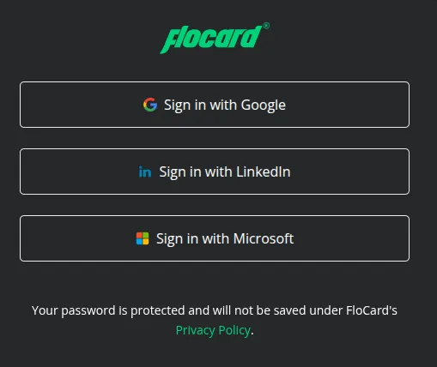
After signing up we are redirected to the dashboard page. Here the cards can be created and edited. FloCard allows to create multiple cards.

to
- Using QR generated
- Using the code generated
At the dashboard we get our own QR with FLO address that is used to digitally identify a user.
Connect with me at Flocard and let us make a commitment towards sustainability and grow together.

Conclusion
Rather than seeing sustainability as an expense, FloCard aims to help attain sustainability by making it a business opportunity. It provides a platform to make a commitment to attain sustainable development goals and help our environment grow without diminishing the business advancements and help us network to make combined contributions towards a greener future.

