Kid Care
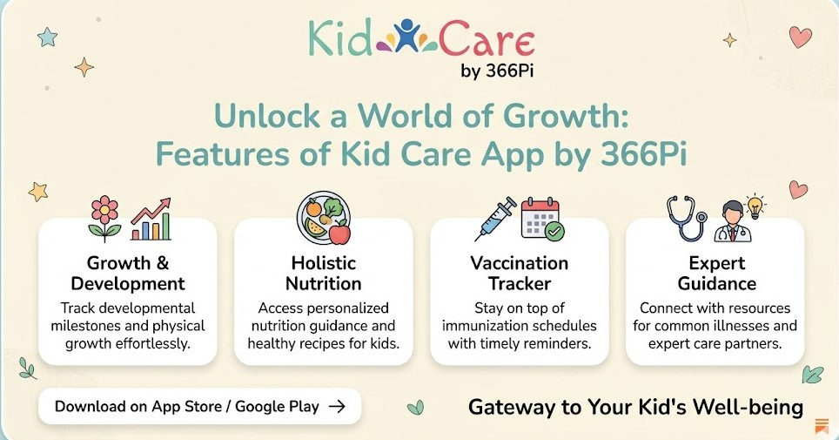
I, Ayush Kumar, an Intern at 366Pi Technologies, am sharing this as part of my Warm-up onboarding activity where I am documenting and sharing my learnings.
As I progress in my internship journey, I explored Kid Care, another product of my organisation. Kid Care is a digital child healthcare management application that helps parent manage their child’s health consult doctors and track medical data.

#Goals
- To understand the use cases, features and the flow for parent on the platform.
#Objective
- Understand the app’s vision the problem it aims to solve in real world
- How’s it is better than other apps
#Actions Taken
- Explored the landing page to understand the UI and different portals.
- Explored the patient data, dashboard for child data and doctor slot management data

Why KidCare?

The problem
The KidCare app by 366Pi addresses a major problem faced by parents in managing their child’s healthcare—lack of convenience, continuity, and organization in traditional medical systems. In the conventional approach, parents must physically visit clinics for even minor concerns, leading to long waiting times, travel effort, and limited access to doctors, especially during emergencies or odd hours. Additionally, important information such as vaccination schedules, medical history, and prescriptions is often scattered across paper records, making it difficult to track a child’s health consistently. Parents also struggle with missed vaccinations, lack of timely guidance, and poor communication with doctors between visits.

The Solution
KidCare solves these issues by providing a centralized digital platform where parents can book appointments, consult doctors online, track vaccinations, store medical records, and receive reminders—all in one place. It ensures real-time access to healthcare support, reduces dependency on physical visits for minor issues, and enables continuous monitoring of a child’s health. By combining convenience, accessibility, and data organization, KidCare transforms child healthcare from a reactive process into a proactive, efficient, and parent-friendly system.

How the user flows through the app
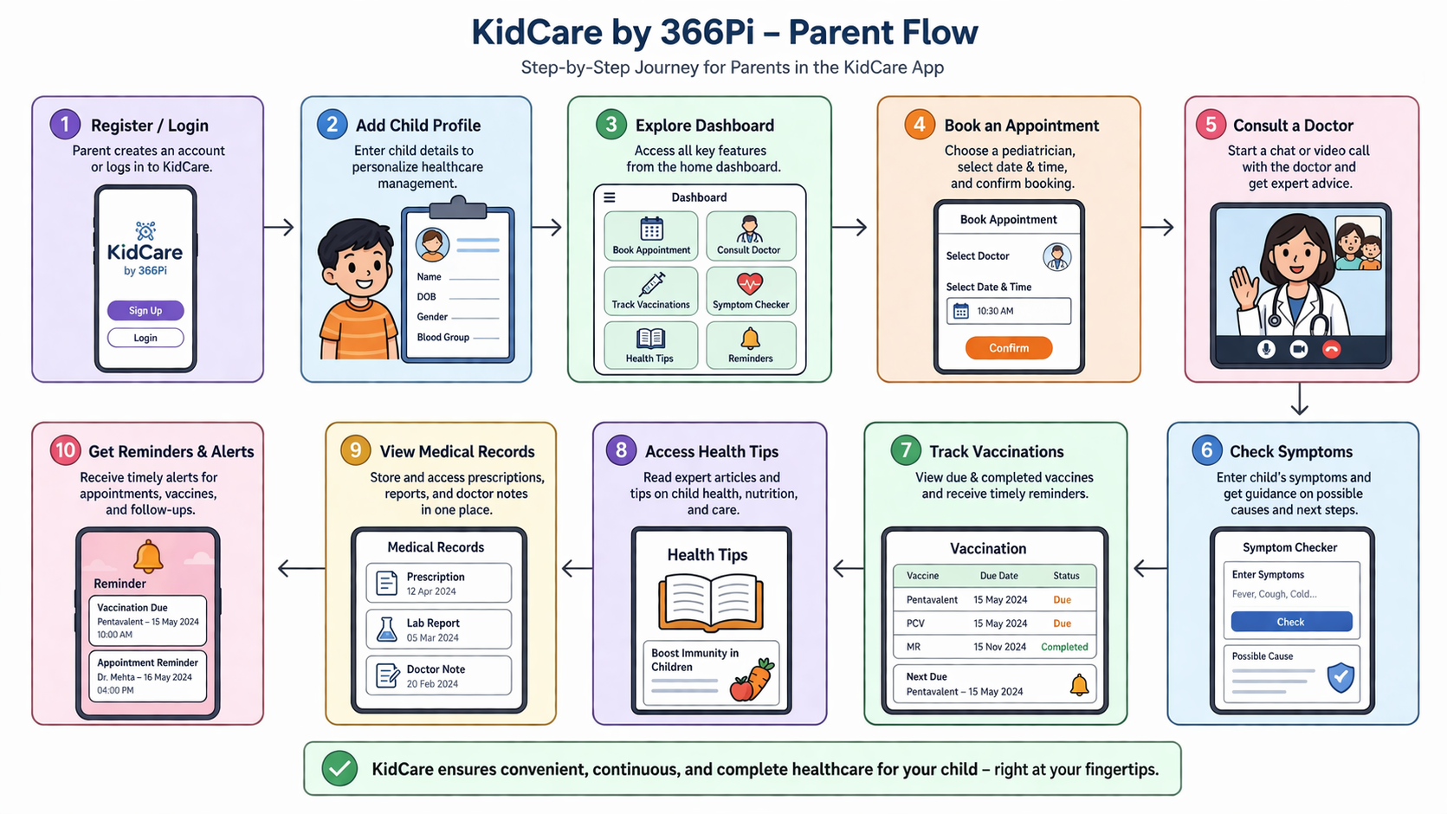
The app makes the journey for the user(parent/guardian) easy and hassle-free to input details of self and the child by providing a sooth UI experience.
Once the parent fills in the necessary details, a payment has to be made to block the appointment through the smooth billing feature on the platform. After the payment is made a confirmation code and confirmation QR is generated which is used to check pre-checkup information.

Key Features
Kid Care provides a set of essential features to ease the manual labour of physical appointment booking
- Online Appointment Booking
KidCare allows parents to book doctor appointments directly through the app without visiting hospitals physically. The system shows available doctors, time slots, and schedules.
- Access to Expert Doctors
Parents can connect with qualified pediatricians instantly via chat or video call. Doctors are available “just a tap away.”
- Vaccination Tracking System
KidCare maintains a complete vaccination schedule and sends reminders before due dates.
- Symptom Checker
Parents can enter symptoms (fever, cough, etc.), and the app provides basic guidance and recommendations
- Health Resources and Guidance
The app provides trusted health information, including nutrition tips, child care advice and disease awareness.
- Centralized Health Records
All child-related medical data such as appointments, vaccines and reports is stored digitally in one place.
- Secure Communications
KidCare offers secure communication channels between parents and doctors, ensuring privacy and confidentiality.

What makes Kid Care better?
The market offers various options for child care but KidCare stands out because it offer a platform where from booking consultation to keeping medical history records to tracking health metrics- all are offered in one place.
Real Medical Support
KidCare offers instant access to real doctors and provides a platform for the health care partners to constantly update any prescription updates or updated doctor comments.
Continuous Care
KidCare enables to ongoing chat with doctors and continuous monitoring through dashboards. Follow-up appointments are also scheduled if necessary and details of prescription and doctor comments are shared over WhatsApp to the parent.
Strong Preventive Care System
KidCare emphasizes preventive care, not just treatment. It has central repository of medical history records and vaccination details to help keep record of the previous consultations. It also sends notifications about vaccination reminders and helps track important health metrics(height, weight, BMI) through dashboard.

Summary
KidCare is not just a digital child health care management app, but a complete child health care ecosystem to book, track and keep records of all health care related data. It is a one-stop-shop for all child health care concerns which integrates constant support from the health care partners in smooth efficient manner. With the constant communication from the platform for reminders, follow-up appointments and the feature to connect with doctor

