SharePoint
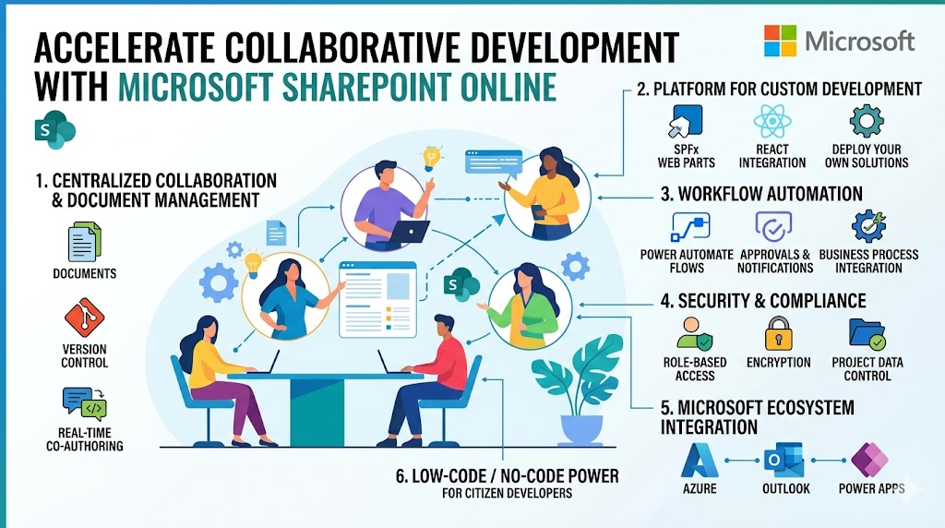
I, Ayush Kumar, an Intern at 366Pi Technologies, am sharing this as part of my Warm-up onboarding activity where I am documenting and sharing my learnings.
As I keep familiarizing myself with the tools used in my organization, the most important factor in why tools are needed is collaboration between the team members. In collaborative development environment the most important tool used in my organization is Microsoft SharePoint Online.
Microsoft SharePoint Online plays a major role in modern development environments, especially in organizations that rely on collaboration, automation, and cloud-based workflows. Its importance goes far beyond just document storage- it’s a powerful platform for building and managing solutions.
#Goals
- Understand the basics of SharePoint
- Familiarize myself with features of SharePoint
#Objective
- Understand the importance of SharePoint in managing documents, organizing information and serving as an important tool in a collaborative environment
#Actions Taken
- Read the documentation about SharePoint on the Microsoft website.
- Went through the staging area of a product of my organization hosted on SharePoint

Key Features
- Centralized Collaboration & Document Management
SharePoint Online provides a single source of truth where teams can store, organize and share documents.
- Platform for Custom Development
SharePoint Online supports custom solutions using:
- SharePoint Framework for building web parts and extensions
- Integration with JavaScript framework like React
- REST APIs and Microsoft Graph
- Workflow Automation & Business Process Integration
With tools like Microsoft Power Automate build complex workflows without heavy coding, integrate with other systems and automate repetitive tasks
- Security, Compliance & Access Control
SharePoint Online ensures role-based access control, data encryption and compliance standards and secure sharing inside and outside the organization
- Integration with the Microsoft Ecosystem
It seamlessly integrates with other Microsoft tools like Azure, Outlook, Power Apps, etc.
- Supports Low-Code / No-Code Development
Even non-developers can build apps using Power Apps, customize forms and workflows and create dashboards

The Major Problems SharePoint Solves
- Scattered Files and Knowledge Silos
SharePoint manages centralised document libraries with structured folders and metadata to help combat this problem. Everyone has access to up-to-date resources
- Version conflicts and Overwrites
In a collaborative environment multiple edits may cause conflicts. So, SharePoint provides solution to this by maintaining history of edits, real time co-authoring feature and easy rollback to previous versions
- Poor Communication and Context Loss
Since it integrates with Microsoft Teams, important discussions become hassle free which might impact business decisions. It also allows comments directly on documents and shared project spaces.
- Tool Fragmentation
Since it integrates with other Microsoft tools, it provides a unified workspace where developers can work in a connected ecosystem

Summary
SharePoint solves a major problem of communications between teams provides an ecosystem which makes the life of developers easier in collaborative environment. It serves as the most important tool in the developer workspace because of its various feature which solves major problems faced in development field. My organization’s major solutions are hosted in Microsoft SharePoint and it is most frequently used tool which serves as a developer powerhouse for solving problems and maintaining a good communication between the team.

