The following screenshot demonstrates a successful ROS 2 Jazzy installation running inside a Docker container. The ros2 topic list command confirms that the ROS 2 environment is fully operational.
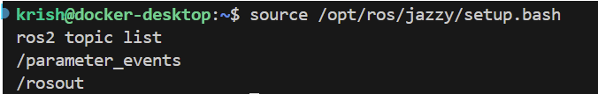

The following screenshots show the TurtleBot3 robot successfully launched in the simulated maze environment using Gazebo and RViz2.
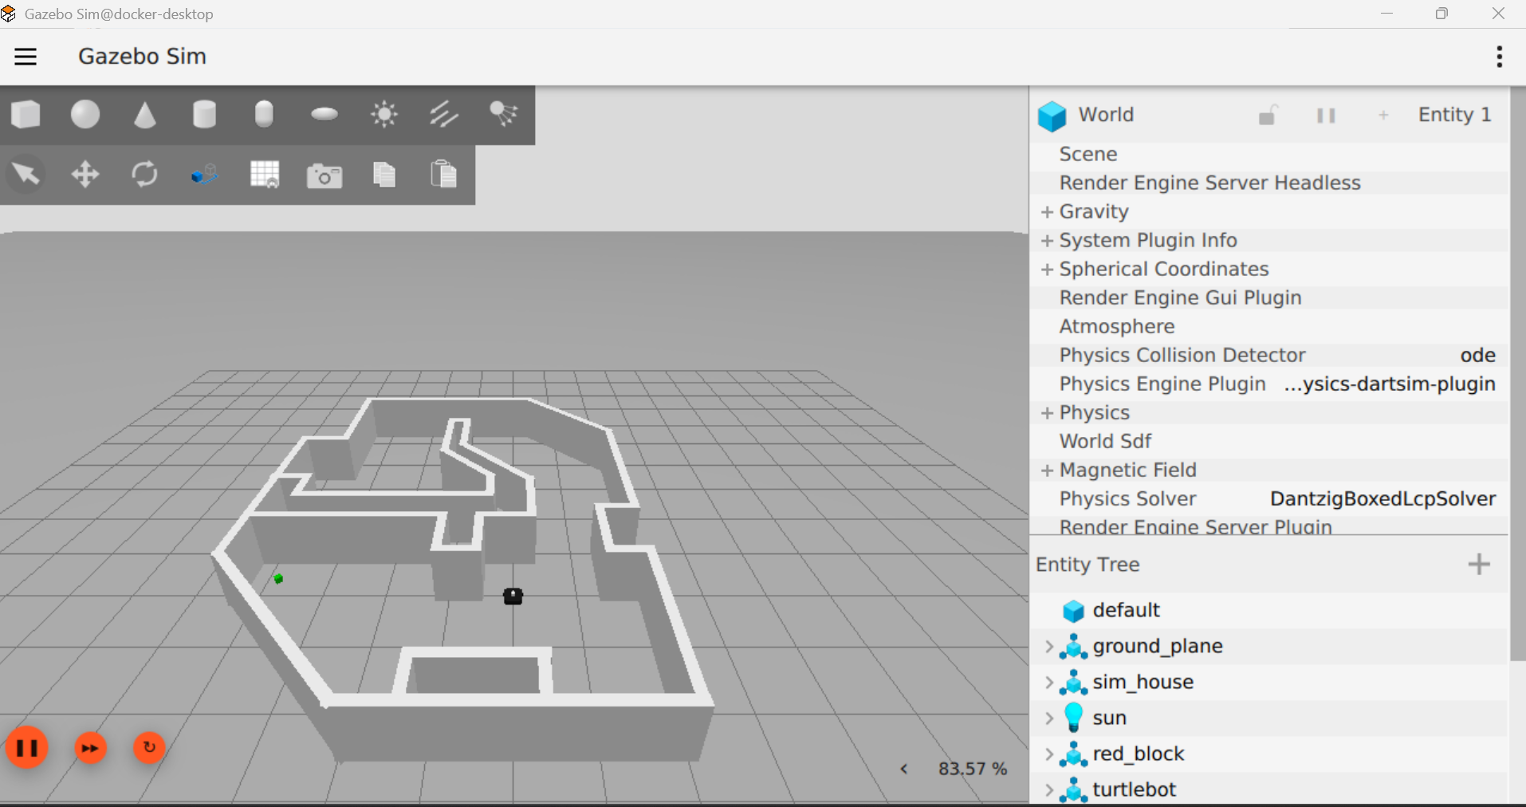

The robot was brought up using the docker compose up demo-world command, which launched both the Gazebo simulation and RViz2 visualization tools with the TurtleBot3 in the maze world.
