《JAVA EE开发技术基础》上机实验报告
实验名称 | 实验八 Spring应用基础 |  |  | 实验时间 | 2021.5.21
学生姓名 | 洪攀 | 班级 | 计算机Z1812 | 学号 | 18200135233
指导教师 | 陆悠 | 批阅教师 |  | 成绩
一、实验目的
1、 掌握Spring框架的基本结构和基本用法；
2、掌握Spring配置文件的编写方法；
3、理解并掌握Spring框架中IOC、DI、容器等核心概念，Spring事务管理与任务调度；
4、了解Spring与Struts、Hibernate集成技术（SSH）
重点：Spring控制反转IOC，Spring与Struts、Hibernate集成技术（SSH）。
二、实验内容
1、掌握Spring框架的部署和使用方法，验证Spring配置信息的作用；
2、利用Spring实现对Bean的管理；
2、基于Spring框架，将实验7的增删查改的应用进行改写，使其能够基于Spring框架运行，实现：
（1）能够将信息从数据库中取出
（2）实现基于数据库的登录成功后进入主页面
（3）实现对信息的查询、增加、删除和修改功能

三、实验步骤及实验结果记录
1、根据实验指导，各步骤及结果截图
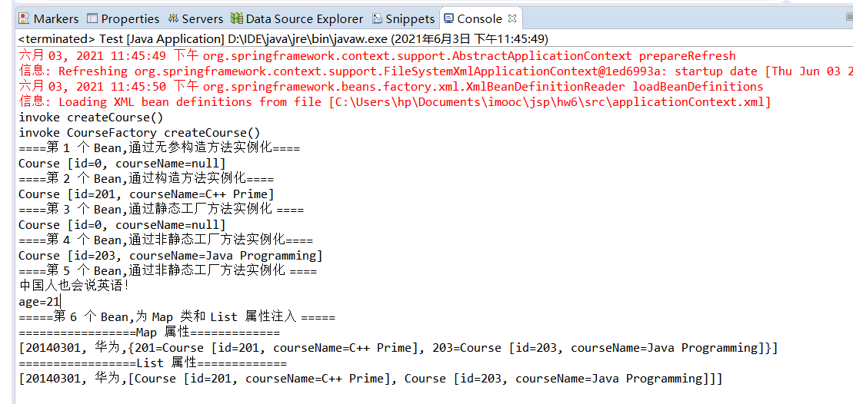

数据库中的全部书籍数据
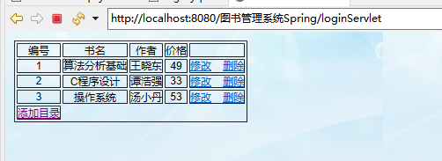
添加书籍
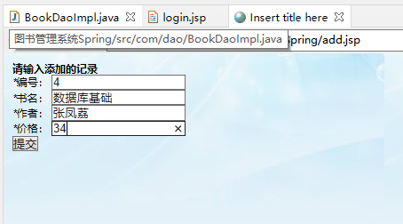
添加成功
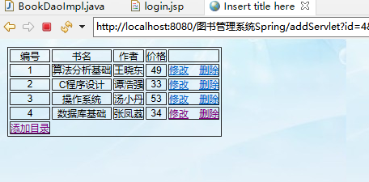
修改书籍
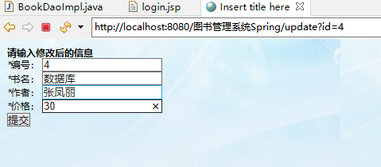
修改成功，删除书籍
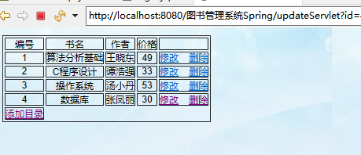
删除成功
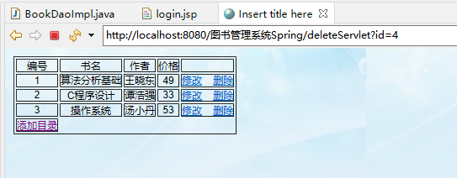

四、实验总结：
通过本次实验，我掌握了Spring框架的基本结构和基本用法，掌握了对Spring配置文件的编写，
理解并掌握了Spring框架中IOC、DI、容器等核心概念，Spring事务管理与任务调度。
五、核心源代码（详细代码见电子文档）
MyBook.java
package com.book;
public class MyBook{
private Integer book_id;//主键
private String bname;
private String wname;
private Integer price;
public MyBook() {
}
public MyBook(Integer book_id,String bname,String wname,Integer price) {
this.book_id=book_id;
this.bname=bname;
this.wname=wname;
this.price=price;
}
public Integer getBook_id() {
return book_id;
}
public void setBook_id(Integer book_id) {
this.book_id = book_id;
}
public Integer getPrice() {
return price;
}
public void setPrice(Integer price) {
this.price = price;
}
public String getBname() {
return bname;
}
public void setBname(String bname) {
this.bname = bname;
}
public String getWname() {
return wname;
}
public void setWname(String wname) {
this.wname = wname;
}
@Override
public String toString() {
return "MyBook [book_id=" + book_id + ", bname=" + bname + ", wname=" + wname + ", price=" + price + "]";
}
BookDao.java
package com.dao;
import java.util.List;

import org.springframework.stereotype.Repository;
import com.book.MyBook;

public interface BookDao {
MyBook selectBookById(Integer book_id);
List<MyBook> selectAllBook();
boolean addBook(MyBook book);
boolean updateBook(MyBook book);
boolean deleteBook(Integer book_id);
}

BookDaoImpl.java
package com.dao;

import java.util.List;
import org.springframework.beans.factory.annotation.Autowired;
import org.springframework.jdbc.core.BeanPropertyRowMapper;
import org.springframework.jdbc.core.JdbcTemplate;
import org.springframework.stereotype.Repository;

import com.book.MyBook;
@Repository
public class BookDaoImpl implements BookDao{
@Autowired
private JdbcTemplate jdbcTemplate;
private boolean flag = false;
//注入方法
public void setJdbcTemplate(JdbcTemplate jdbcTemplate) {
this.jdbcTemplate = jdbcTemplate;
}
@Override
public MyBook selectBookById(Integer book_id) {
String sql = "select * from mybook where book_id = ?";
BeanPropertyRowMapper<MyBook> rowMapper = new BeanPropertyRowMapper<>(MyBook.class);
MyBook mybook= null;
try {
mybook = jdbcTemplate.queryForObject(sql, new Object[]{book_id}, rowMapper);
}catch (Exception e){
mybook = null;
}
return mybook;
}
@Override
public List<MyBook> selectAllBook() {
String sql = "select * from mybook";
List<MyBook> bookList = jdbcTemplate.query(sql.toString(), new Object[] {},
new BeanPropertyRowMapper<MyBook>(MyBook.class));
return bookList;
}
@Override
public boolean addBook(MyBook book) {
String sql = "insert into mybook values(?,?,?,?)";
int row = jdbcTemplate.update(sql, book.getBook_id(), book.getBname(), book.getWname(),book.getPrice());
if (row>0){
flag = true;
}
return flag;
}
@Override
public boolean updateBook(MyBook book) {
String sql = "update mybook set bname = ?, wname = ?,price = ? where book_id = ? ";
int row = jdbcTemplate.update(sql, book.getBname(), book.getWname(),book.getPrice(),book.getBook_id());
if (row>0){
flag=true;
}
return flag;
}
@Override
public boolean deleteBook(Integer book_id) {
String sql = "delete from mybook where book_id =?";
int row = jdbcTemplate.update(sql, book_id);
if (row>0){
flag=true;
}
return flag;
}
Bookservice.java
package com.service;

import java.util.List;

import com.book.MyBook;

public interface BookService {
MyBook selectBookById(Integer book_id);
List<MyBook> selectAllBook();
boolean addBook(MyBook book);
boolean updateBook(MyBook book);
boolean deleteBook(Integer book_id);
}

BookServiceImpl.java
package com.service;
import java.util.List;
import org.springframework.beans.factory.annotation.Autowired;
import org.springframework.stereotype.Repository;
import org.springframework.stereotype.Service;

import com.book.MyBook;
import com.dao.BookDao;
@Service
public class BookServiceImpl implements BookService{
@Autowired
private BookDao bookdao;
@Override
public MyBook selectBookById(Integer book_id) {
return bookdao.selectBookById(book_id);
}
@Override
public List<MyBook> selectAllBook() {
return bookdao.selectAllBook();
}
@Override
public boolean addBook(MyBook book) {
// TODO Auto-generated method stub
return bookdao.addBook(book);
}
@Override
public boolean updateBook(MyBook book) {
return bookdao.updateBook(book);
}
@Override
public boolean deleteBook(Integer book_id) {
return bookdao.deleteBook(book_id);
}
}
addServlet.java
request.setCharacterEncoding("UTF-8");
response.setContentType("text/html;charset=utf-8");
ApplicationContext ac = new ClassPathXmlApplicationContext("applicationContext.xml");
BookServiceImpl bookDao = (BookServiceImpl) ac.getBean("bookServiceImpl",BookServiceImpl.class);
Integer id=Integer.parseInt(request.getParameter("id").toString());
String bname=request.getParameter("bname").toString();
String wname=request.getParameter("wname").toString();
Integer price=Integer.parseInt(request.getParameter("price").toString());
MyBook mybook=new MyBook(id,bname,wname,price);
boolean b=bookDao.addBook(mybook);
if(b) {
List<MyBook> list = bookDao.selectAllBook();
request.setAttribute("booklist", list);
request.getRequestDispatcher("main.jsp").forward(request, response);
}else {
System.out.println("添加失败");
}
deleteServlet.java
request.setCharacterEncoding("UTF-8");
response.setContentType("text/html;charset=utf-8");
ApplicationContext ac = new ClassPathXmlApplicationContext("applicationContext.xml");
BookServiceImpl bookDao = (BookServiceImpl) ac.getBean("bookServiceImpl",BookServiceImpl.class);
Integer id=Integer.parseInt(request.getParameter("id").toString());
boolean b=bookDao.deleteBook(id);
if(b) {
List<MyBook> list = bookDao.selectAllBook();
request.setAttribute("booklist", list);
request.getRequestDispatcher("main.jsp").forward(request, response);
}else {
System.out.println("删除失败");
}
}
loginServlet.java
request.setCharacterEncoding("UTF-8");
response.setContentType("text/html;charset=utf-8");
String name=request.getParameter("uname");
String password=request.getParameter("upass");
if("hxj".equals(name) && "123456".equals(password)) {
ApplicationContext ac = new ClassPathXmlApplicationContext("applicationContext.xml");
BookServiceImpl bookDao = (BookServiceImpl) ac.getBean("bookServiceImpl",BookServiceImpl.class);
List<MyBook> list = bookDao.selectAllBook();
request.setAttribute("booklist", list);
request.getRequestDispatcher("main.jsp").forward(request, response);
}else {
request.setAttribute("messageError", "用户名或密码错误");
request.getRequestDispatcher("login.jsp").forward(request, response);
}
Update.java
request.setCharacterEncoding("UTF-8");
response.setContentType("text/html;charset=utf-8");
String id=request.getParameter("id");
request.getSession().setAttribute("id", id);
request.getRequestDispatcher("update.jsp").forward(request, response);
updateServlet.java
request.setCharacterEncoding("UTF-8");
response.setContentType("text/html;charset=utf-8");
ApplicationContext ac = new ClassPathXmlApplicationContext("/applicationContext.xml");
BookServiceImpl bookDao = (BookServiceImpl) ac.getBean("bookServiceImpl",BookServiceImpl.class);
Integer id=Integer.parseInt(request.getParameter("id").toString());
String bname=request.getParameter("bname").toString();
String wname=request.getParameter("wname").toString();
Integer price=Integer.parseInt(request.getParameter("price").toString());
MyBook mybook=new MyBook(id,bname,wname,price);
boolean b=bookDao.updateBook(mybook);
if(b) {
List<MyBook> list = bookDao.selectAllBook();
request.setAttribute("booklist", list);
request.getRequestDispatcher("main.jsp").forward(request, response);
}else {
System.out.println("修改失败");
}
applicationContext.xml
<?xml version="1.0" encoding="UTF-8"?>
<beans xmlns="http://www.springframework.org/schema/beans"
xmlns:xsi="http://www.w3.org/2001/XMLSchema-instance"
xmlns:context="http://www.springframework.org/schema/context"
xsi:schemaLocation="http://www.springframework.org/schema/beans
http://www.springframework.org/schema/beans/spring-beans.xsd
http://www.springframework.org/schema/context
http://www.springframework.org/schema/context/spring-context.xsd">
<!-- 指定需要扫描的包（包括子包），使注解生效 -->
<context:component-scan base-package="com"/>
<!-- 配置数据源 -->
<bean id="dataSource"
class="org.springframework.jdbc.datasource.DriverManagerDataSource">
<property name="driverClassName" value="com.mysql.jdbc.Driver" />
<!-- 驱动类名 -->
<property name="url" value="jdbc:mysql://localhost:3306/springtest?useSSL=false" />
<!-- url访问地址 -->
<property name="username" value="root" /><!-- 链接数据库的用户名 -->
<property name="password" value="123456" /><!-- 链接数据库的密码 -->
</bean>
<!-- 3.创建JDBCTemplate对象，注入dataSource -->
<bean id="jdbcTemplate" class="org.springframework.jdbc.core.JdbcTemplate">
<property name="dataSource" ref="dataSource"/>
</bean>
<!-- 配置id为bookServiceImpl的Bena
<bean id="bookServiceImpl" class="com.service.BookServiceImpl">
<property name="jdbcTemplate" ref="jdbcTemplate"></property>
</bean> -->
</beans>
Login.jsp
<script type="text/javascript">
//确定按钮
function gogo(){
document.forms[0].submit();
}
//取消按钮
function cancel(){
document.forms[0].action = "";
}
</script>
</head>
<body>
<form action="loginServlet" method="post">
<table>
<tr>
<td colspan="2"><img src="images/login.gif"></td>
</tr>
<tr>
<td>姓名：</td>
<td><input type="text" name="uname" class="textSize"></td>
</tr>
<tr>
<td>密码：</td>
<td><input type="password" name="upass" class="textSize"></td>
</tr>
<tr>
<td colspan="2">
<input type="image" src="images/ok.gif" onclick="gogo()" >
<input type="image" src="images/cancel.gif" onclick="cancel()" >
</td>
</tr>
</table>
${messageError}
</form>
</body>
Main.jsp
<body>
<table border="1px">
<tr>
<td>编号</td>
<td>书名</td>
<td>作者</td>
<td>价格</td>
<td></td>
</tr>
<c:forEach items="${booklist}" var="book">
<tr>
<td>${book.getBook_id()}</td>
<td>${book.getBname()}</td>
<td>${book.getWname()}</td>
<td>${book.getPrice()}</td>
<td><a href="update?id=${book.getBook_id()}">修改</a>&nbsp;&nbsp;&nbsp;&nbsp;<a href="deleteServlet?id=${book.getBook_id()}">删除</a></td>
</tr>
</c:forEach>
<tr>
<td><a href="add.jsp">添加目录</a></td>
</tr>
</table>
</body>
Add.jsp
<h4>请输入添加的记录</h4>
<form action="addServlet" method="GET">
<div class="reg-input">
<label><i>*</i>编号：</label>
<input type="number" name="id" required />
</div>
<div class="reg-input">
<label><i>*</i>书名：</label>
<input type="text" name="bname" required />
</div>
<div class="reg-input">
<label><i>*</i>作者：</label>
<input type="text" name="wname" required />
</div>
<div class="reg-input">
<label><i>*</i>价格：</label>
<input type="number" name="price" required />
</div>
<div class="reg-input">
<input type="submit" value="提交" />
</div>
</form>
Update.jsp
<h4>请输入修改后的信息</h4>
<form action="updateServlet" method="GET" >
<div class="reg-input">
<label><i>*</i>编号：</label>
<input type="number" name="id" value="${sessionScope.id}"required />
</div>
<div class="reg-input">
<label><i>*</i>书名：</label>
<input type="text" name="bname" required />
</div>
<div class="reg-input">
<label><i>*</i>作者：</label>
<input type="text" name="wname" required />
</div>
<div class="reg-input">
<label><i>*</i>价格：</label>
<input type="number" name="price" required />
</div>
<div class="reg-input">
<input type="submit" value="提交" />
</div>
</form>

