

**GARIMA TUTION CENTER**

**Bhagirathi colony, Near Shiv Mandir,Jagadhri**



* **1st to 5th all subject**
* **6th to 10th all subject**
* **+1 & +2**
* **Business studies**
* **Economics**
* **Computer science**

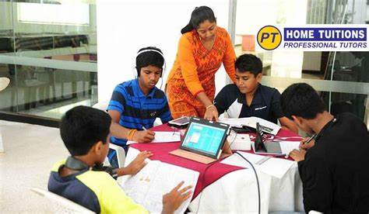

**Extra courses:**

* **Computer Networking**
* **Operating system**
* **Pc & windows software**
* **HTML & CSS**
* **Is available here**

Starting from 700rs.

**Fees start from 500 Rs.**

**Both English & Hindi Medium Available**