Client Side Inventory Management Interface

Aim :
To construct an inventory management interface using Adafruit IO.

Tools Required :
Adafruit IO,latest version of python for windows,adafruit-io python libraries,PIL(python imaging libraries).

Setting up Adafruit IO :
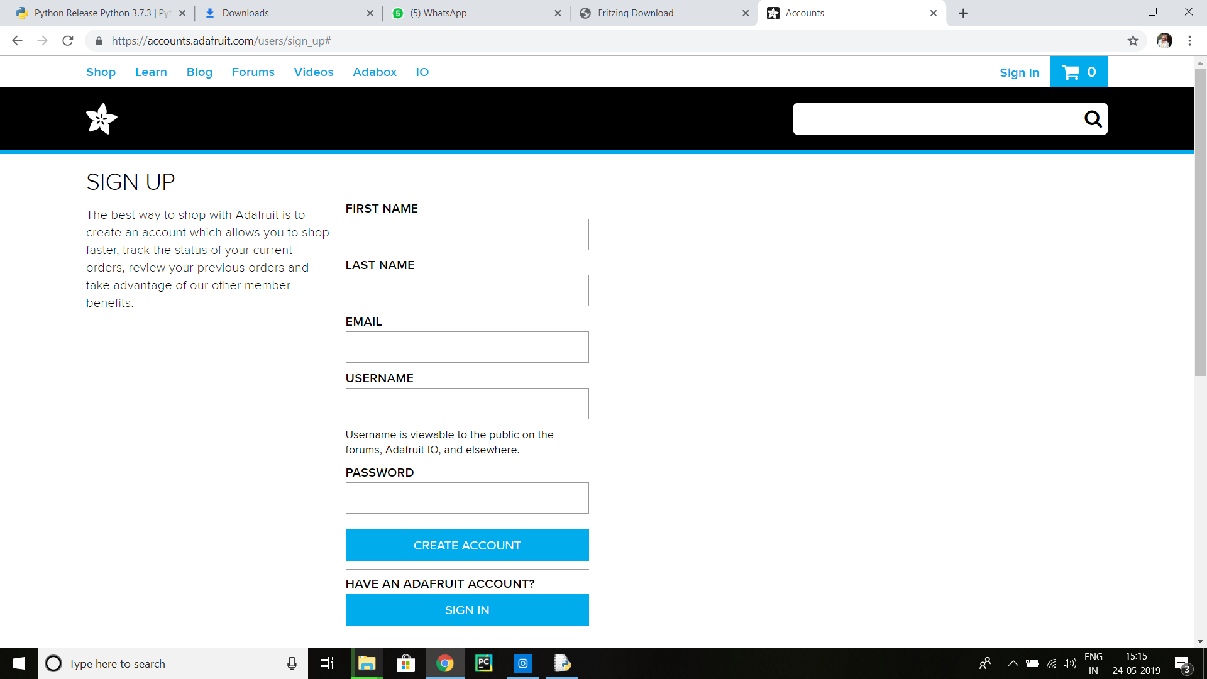
- Visit http://io.adafruit.com/ and create an account.
- Click on my dashboard and create a new dashboard.
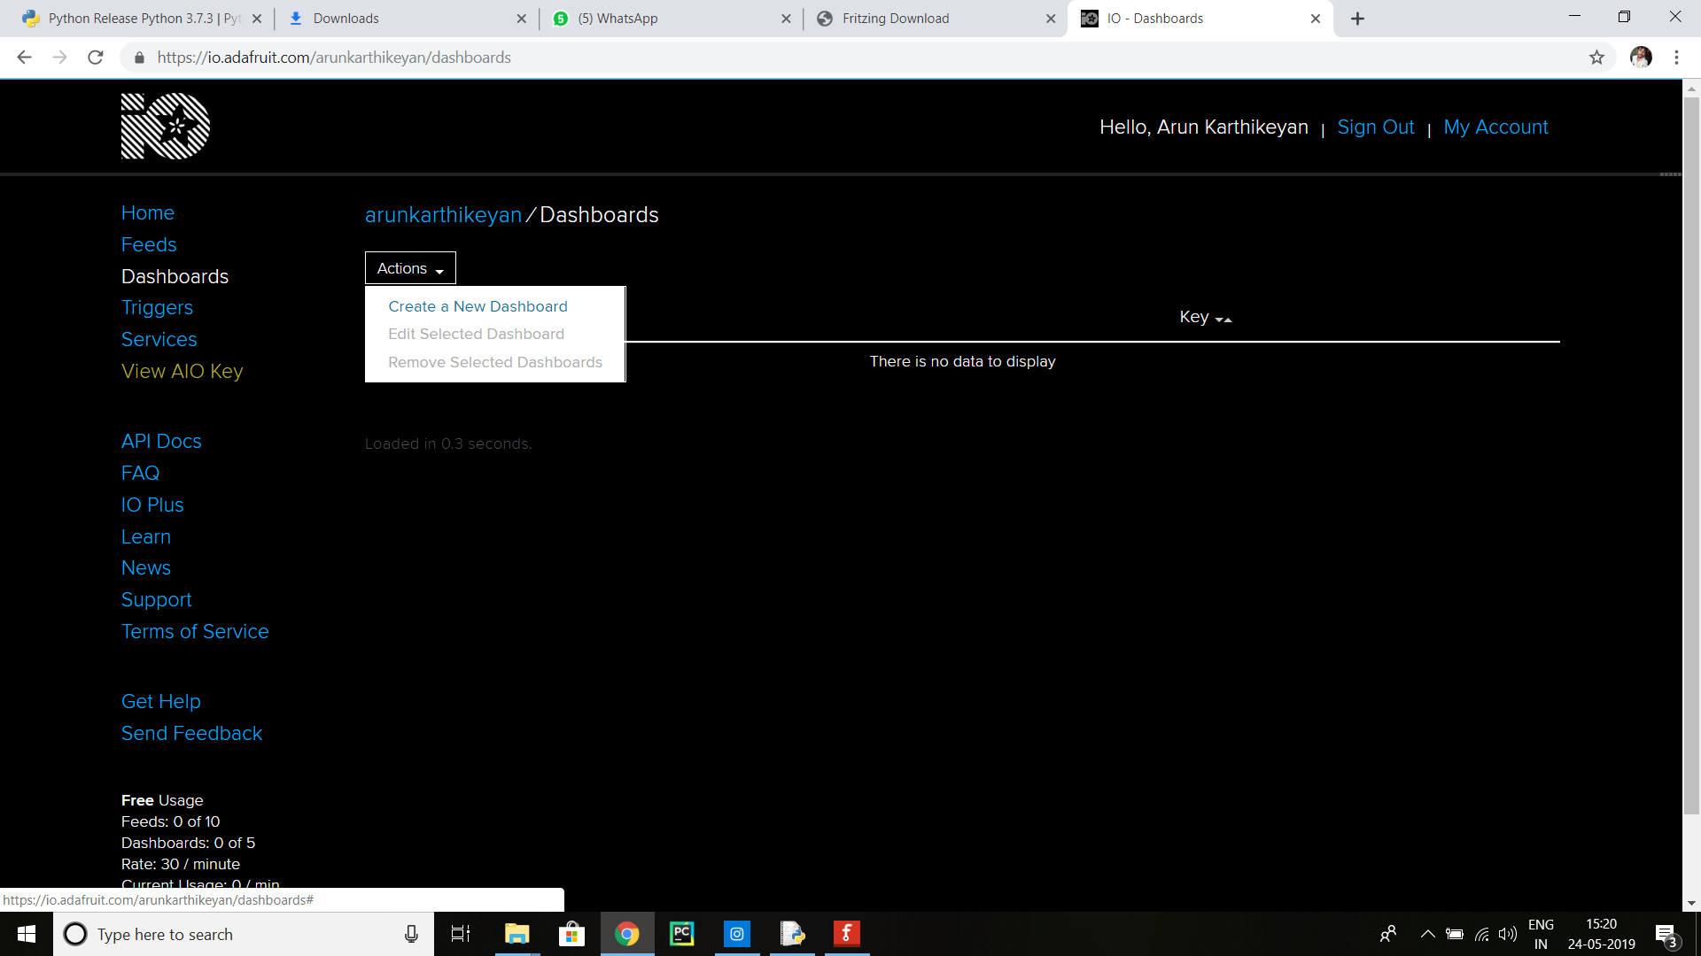

- Create a new block. As many as required.

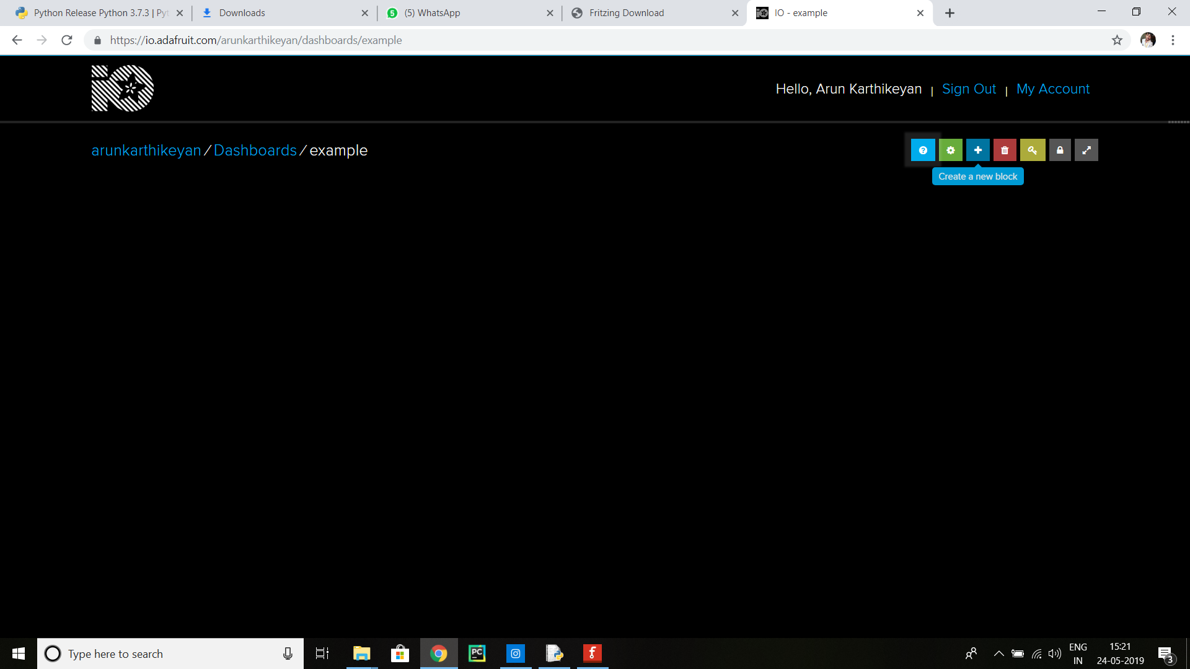

- You can find your Adafruit key where the mouse pointer is placed in the picture. Note down your AIO key from there.Here the fields are created already.
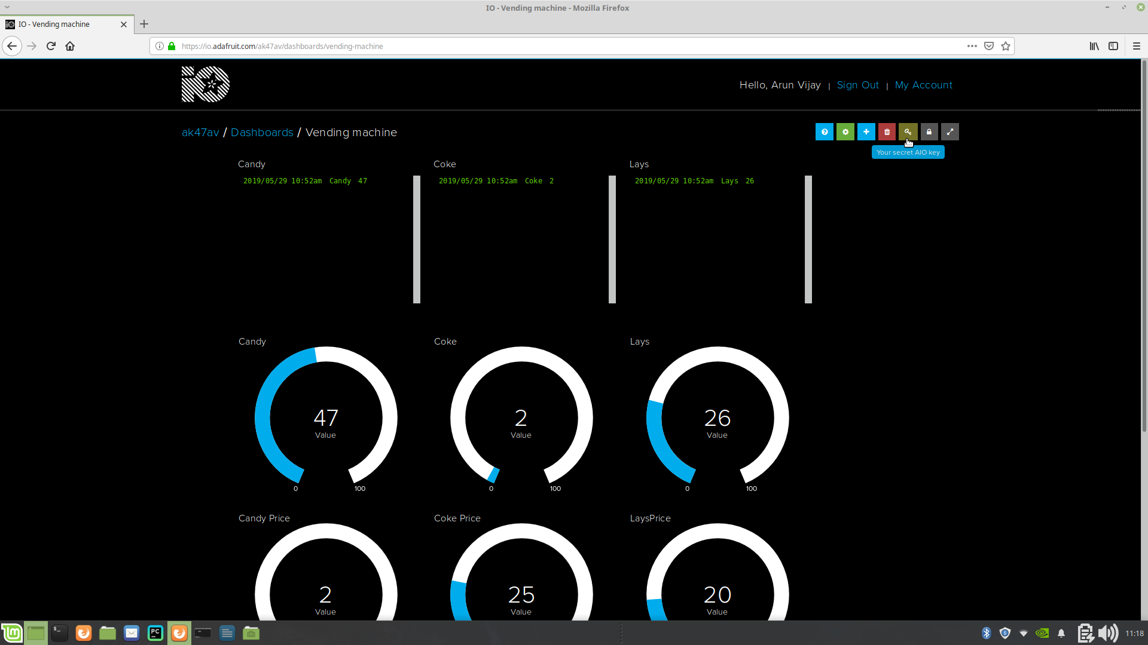
We have successfully setup Adafruit-io.

Installing python on Windows :
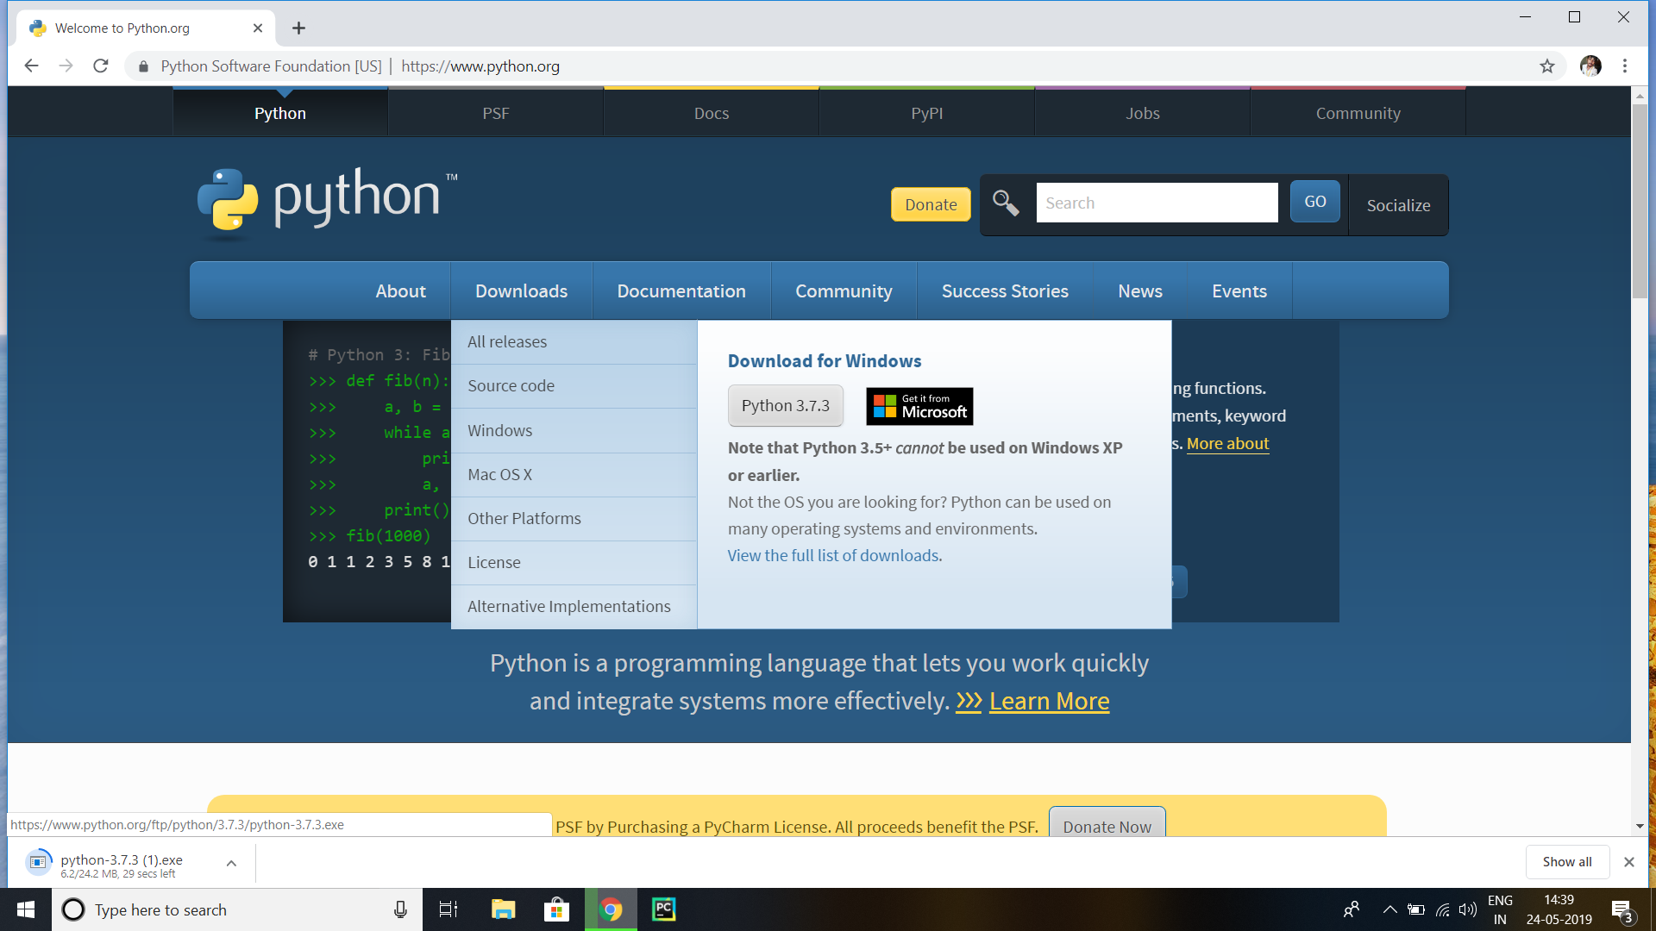
- Visit http://www.python.org/ and download the latest edition available. (this program was done on python 3.7.3).
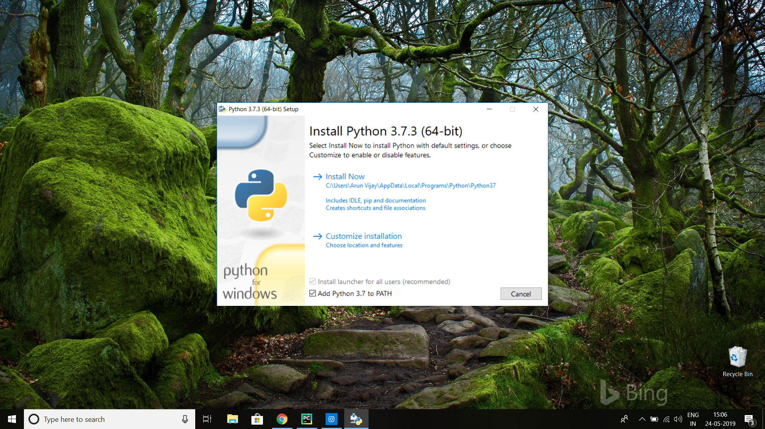
- When installing,select Add to PATH and proceed .

- After installation , open command prompt. And type the command pip install pillow . After pillow is installed, type pip install adafruit-io
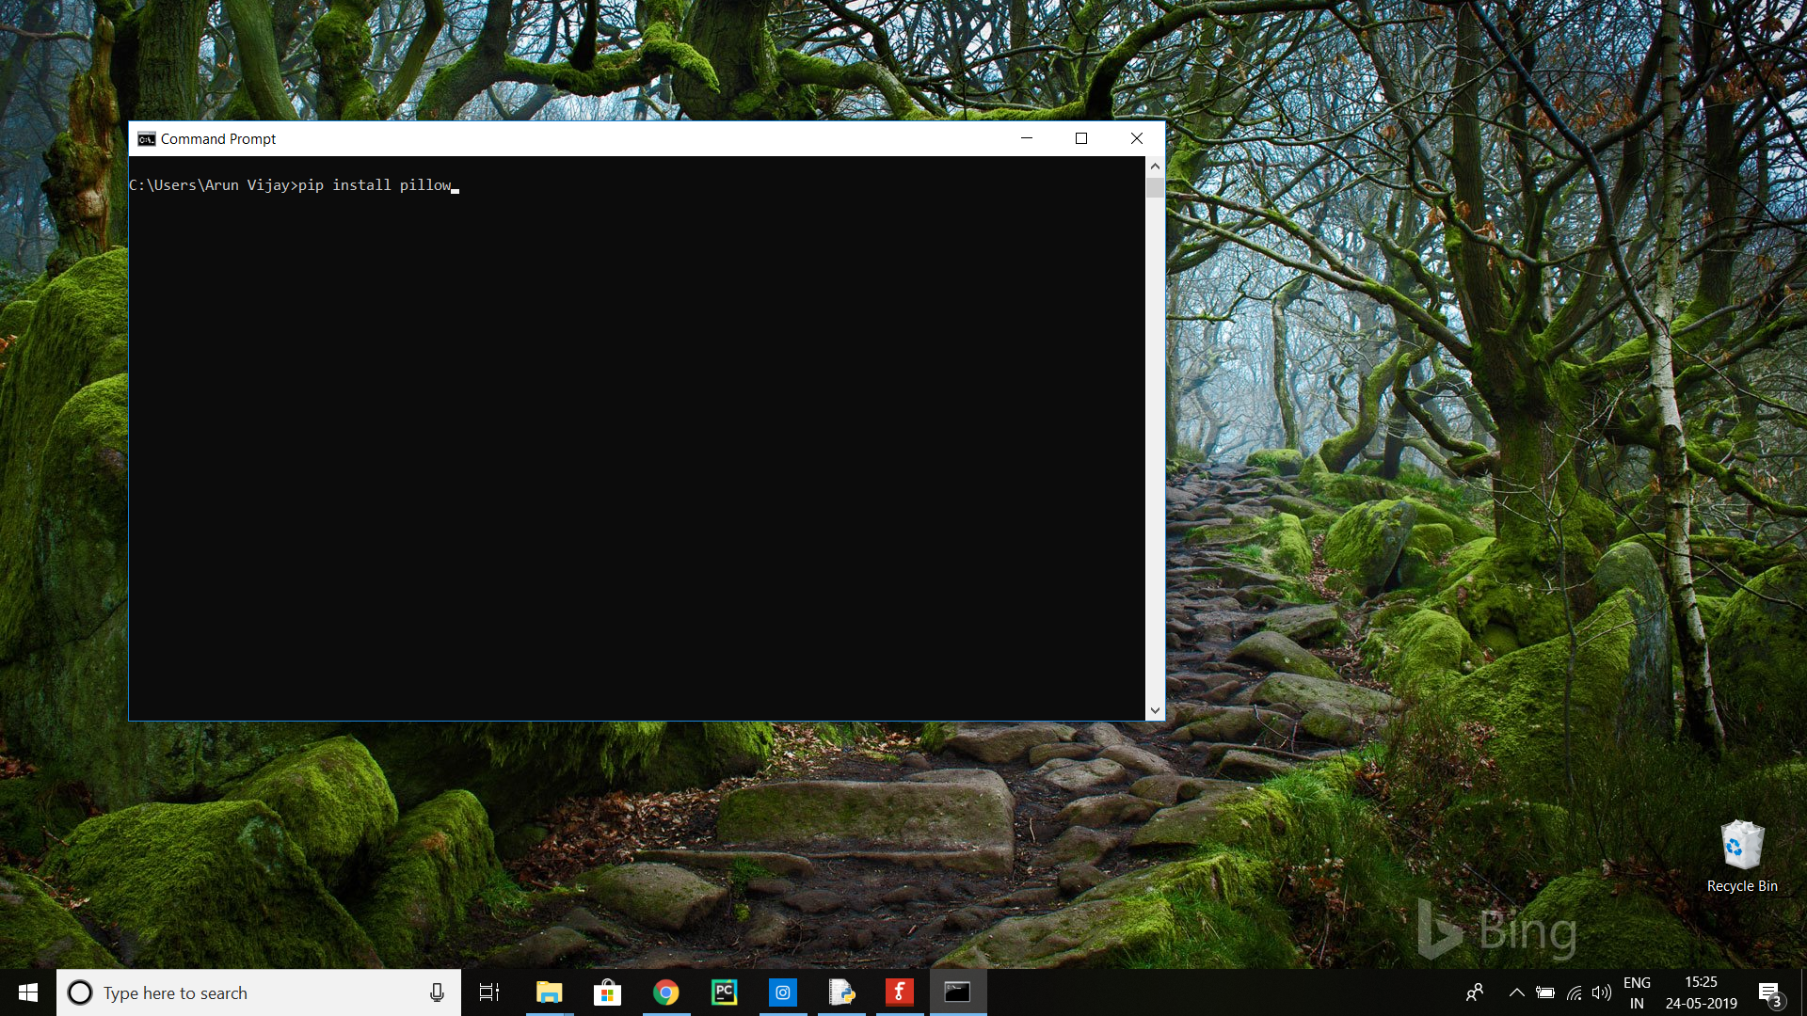
Running the code :
- Create a text file with a file extension .py and right click and edit it with python 3 IDLE .
- Copy the follwing code into the file .

from tkinter import *
from tkinter import ttk
from Adafruit_IO import Client,Data
from PIL import Image, ImageTk
aio = Client('**ID***', '**key**') #replace with user id and io key

class product:

def __init__(self, name, price, quantity):
self.price = price
self.name = name
self.quantity = quantity

def adagetdata(self):
Quantity = aio.receive(self.name)
Price = aio.receive((self.name+'price'))
self.quantity = IntVar()
self.quantity.set(Quantity.value)
self.price = IntVar()
self.price.set(Price.value)

#initialize product values
product1 = product('lays',10,10)
product2 = product('coke',25,25)
product3 = product('candy',1,50)

#initialize tkinter window
win = Tk()
win.geometry('1200x250')
win.title('Update Vending Details')

def main():

product1.adagetdata()
product2.adagetdata()
product3.adagetdata()

fr1 = Frame(win).grid(row=0,column=0)
#Display existing attributes
ttk.Separator(fr1, orient=VERTICAL).grid(row=0,column=3,rowspan=5,sticky='ns')
ttk.Separator(fr1, orient=VERTICAL).grid(row=0,column=8,rowspan=5,sticky='ns')
#display update options
prodlabel = Label(fr1,text=' Products ').grid(row=0,column=0,padx=10,pady=10)
pricelabel = Label(fr1,text=' Prices ').grid(row=0,column=1)
quantitylabel = Label(fr1,text=' Quantity Available ').grid(row=0,column=2)

p1 = Label(fr1,text=(product1.name)).grid(row=1,column=0)
price1 = Label(fr1,textvariable = str(product1.price)).grid(row=1,column=1)
q1 = Label(fr1,textvariable=str(product1.quantity)).grid(row=1,column=2)

p2 = Label(fr1, text=(product2.name)).grid(row=2, column=0)
price2 = Label(fr1, textvariable=str(product2.price)).grid(row=2, column=1)
q2 = Label(fr1, textvariable=str(product2.quantity)).grid(row=2, column=2)

p3 = Label(fr1, text=(product3.name)).grid(row=3, column=0)
price3 = Label(fr1, textvariable=str(product3.price)).grid(row=3, column=1)
q3 = Label(fr1, textvariable=str(product3.quantity)).grid(row=3, column=2)

load = Image.open('C:\\Users\\Arun Vijay\\Downloads\\Spark-Logo_Navin.png') #Here use \\ instead of \ for the file directory
load = load.resize((175,120),Image.ANTIALIAS)
spark = ImageTk.PhotoImage(load)
imageLabel = Label(fr1,image=spark)
imageLabel.image = spark
imageLabel.grid(row=0,column=9,rowspan = 5,sticky='ns')

def updateprice1():
product1.price.set(pr1.get())
data = Data(value=product1.price.get())
aio.create_data((product1.name+'price'),data)
print('Updated !')
pr1.set(0)

def updatequan1():
product1.quantity.set(product1.quantity.get()+quantity1.get())
data1 = Data(value=product1.quantity.get())
aio.create_data(product1.name,data1)
print('Updated !')
quantity1.set(0)

def updateprice2():
product2.price.set(pr2.get())
data = Data(value=product2.price.get())
aio.create_data((product2.name+'price'), data)
print('Updated !')
pr2.set(0)

def updatequan2():
product2.quantity.set(product2.quantity.get()+quantity2.get())
data1 = Data(value=product2.quantity.get())
aio.create_data(product2.name, data1)
print('Updated !')
quantity2.set(0)

def updateprice3():
product3.price.set(pr3.get())
data = Data(value=product3.price.get())
aio.create_data((product3.name+'price'), data)
print('Updated !')
pr3.set(0)

def updatequan3():
product3.quantity.set(product3.quantity.get()+quantity3.get())
data1 = Data(value=product3.quantity.get())
aio.create_data(product3.name, data1)
print('Updated !')
quantity3.set(0)

editPrice = Label(fr1,text=' Edit Prices ').grid(row=0,column=4,padx=10)
editQuantity = Label(fr1,text=' Add Quantity ').grid(row=0,column=5)

pr1 = IntVar()
pre1 = Entry(fr1,textvariable=str(pr1)).grid(row=1,column=4,padx=20)
quantity1 = IntVar()
quan1 = Entry(fr1,textvariable=str(quantity1)).grid(row=1,column=5,padx=10)
okprice1 = Button(fr1,text='Update Price',command=updateprice1).grid(row=1,column=6,padx=15)
okquan1 = Button(fr1,text='Update Quantity',command=updatequan1).grid(row=1,column=7,padx=15)

pr2 = IntVar()
pre2 = Entry(fr1,textvariable=str(pr2)).grid(row=2, column=4)
quantity2 = IntVar()
quan2 = Entry(fr1,textvariable=str(quantity2)).grid(row=2, column=5)
okprice2 = Button(fr1, text='Update Price',command=updateprice2).grid(row=2, column=6, padx=15)
okquan2 = Button(fr1, text='Update Quantity',command=updatequan2).grid(row=2, column=7, padx=15)

pr3 = IntVar()
pre3 = Entry(fr1,textvariable=str(pr3)).grid(row=3, column=4)
quantity3 = IntVar()
quan3 = Entry(fr1,textvariable=str(quantity3)).grid(row=3, column=5)
okprice3 = Button(fr1, text='Update Price',command=updateprice3).grid(row=3, column=6, padx=15)
okquan3 = Button(fr1, text='Update Quantity',command=updatequan3).grid(row=3, column=7, padx=15)

main()

win.mainloop()
- And run the module. You should see
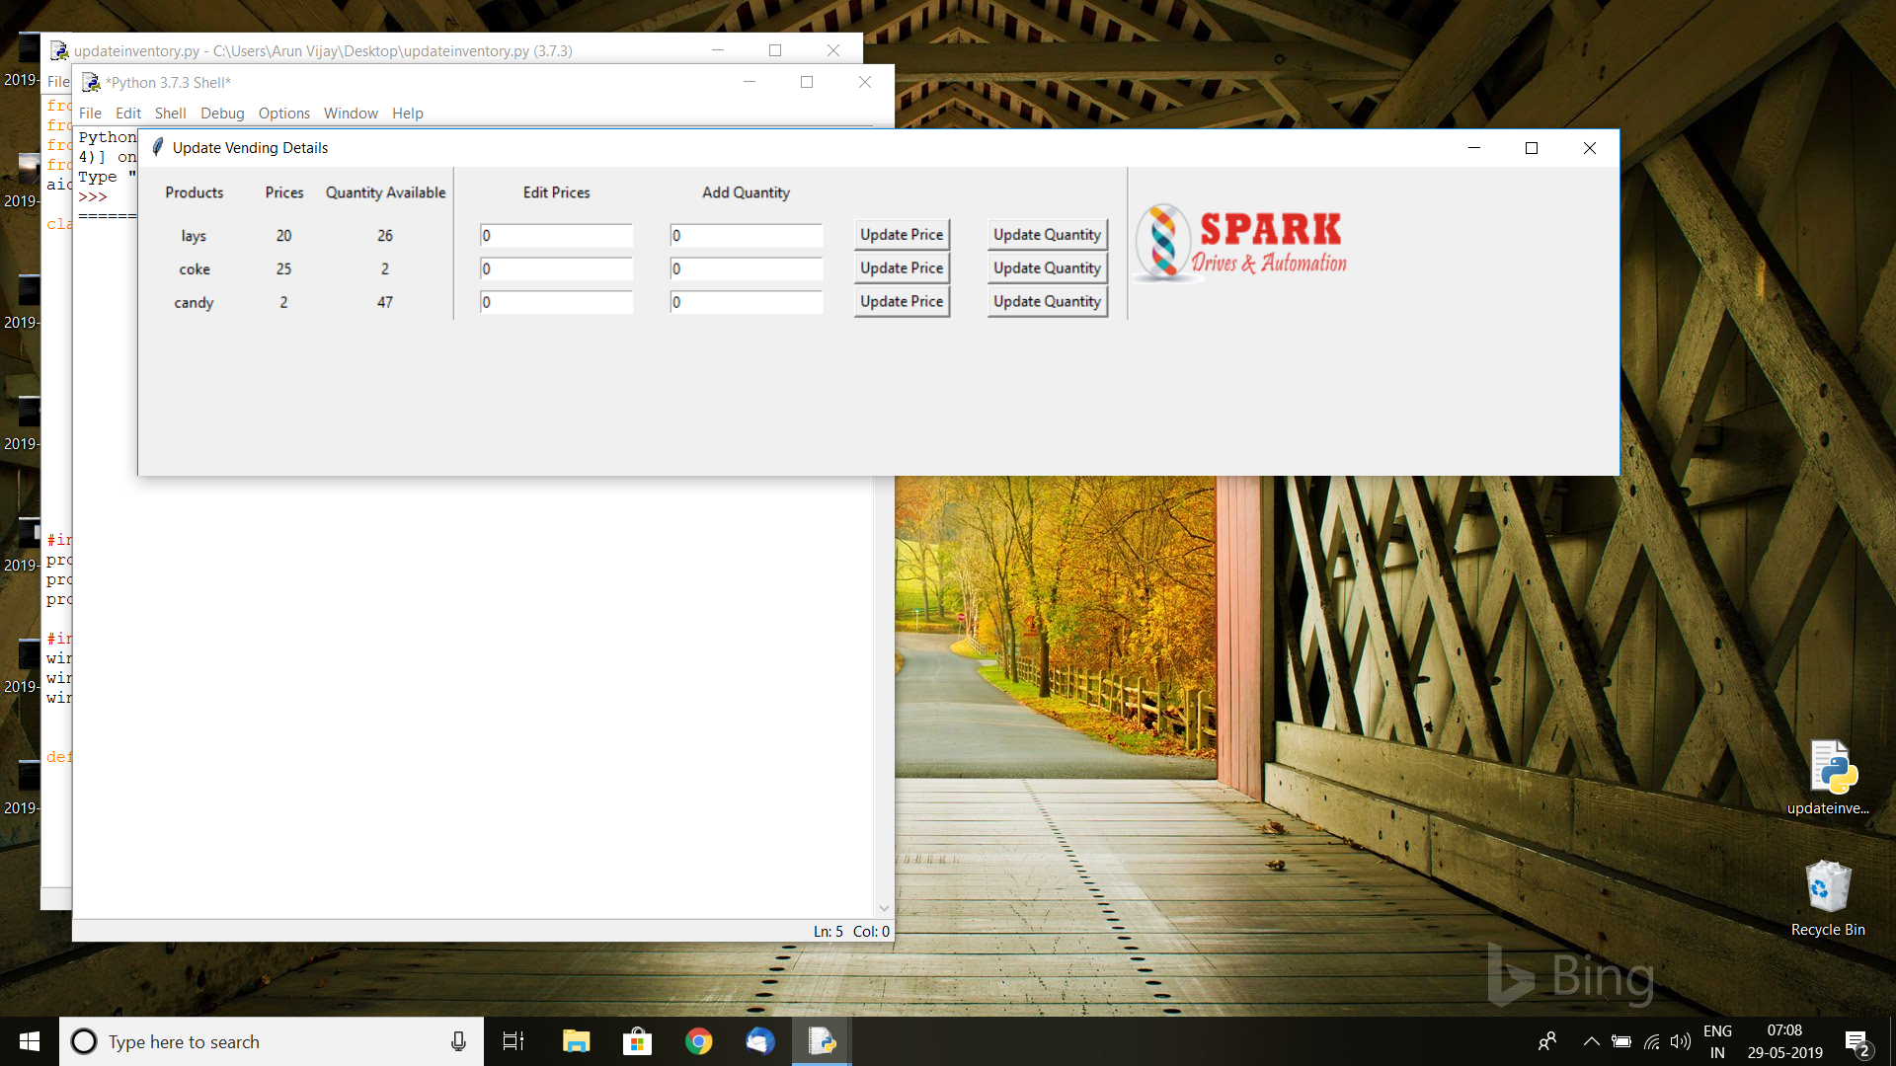
- Make sure to include the path to the image file .

