Customer vending machine interface

Aim :
To create a graphical UI to display on the vending machine,that is capable of serial communication through a FTDI chip.

Tools Required :
Adafruit-io library,FTDI232 UART TTL chip,Raspberry pi 3B+ with latest version of raspbian installed,Arduino IDE.

Installing adafruit-io library on raspberry pi :
- Raspbian comes with python preinstalled. To install python type sudo apt-get install python3
- Type pip install adafruit-io in the command line of the raspberry pi
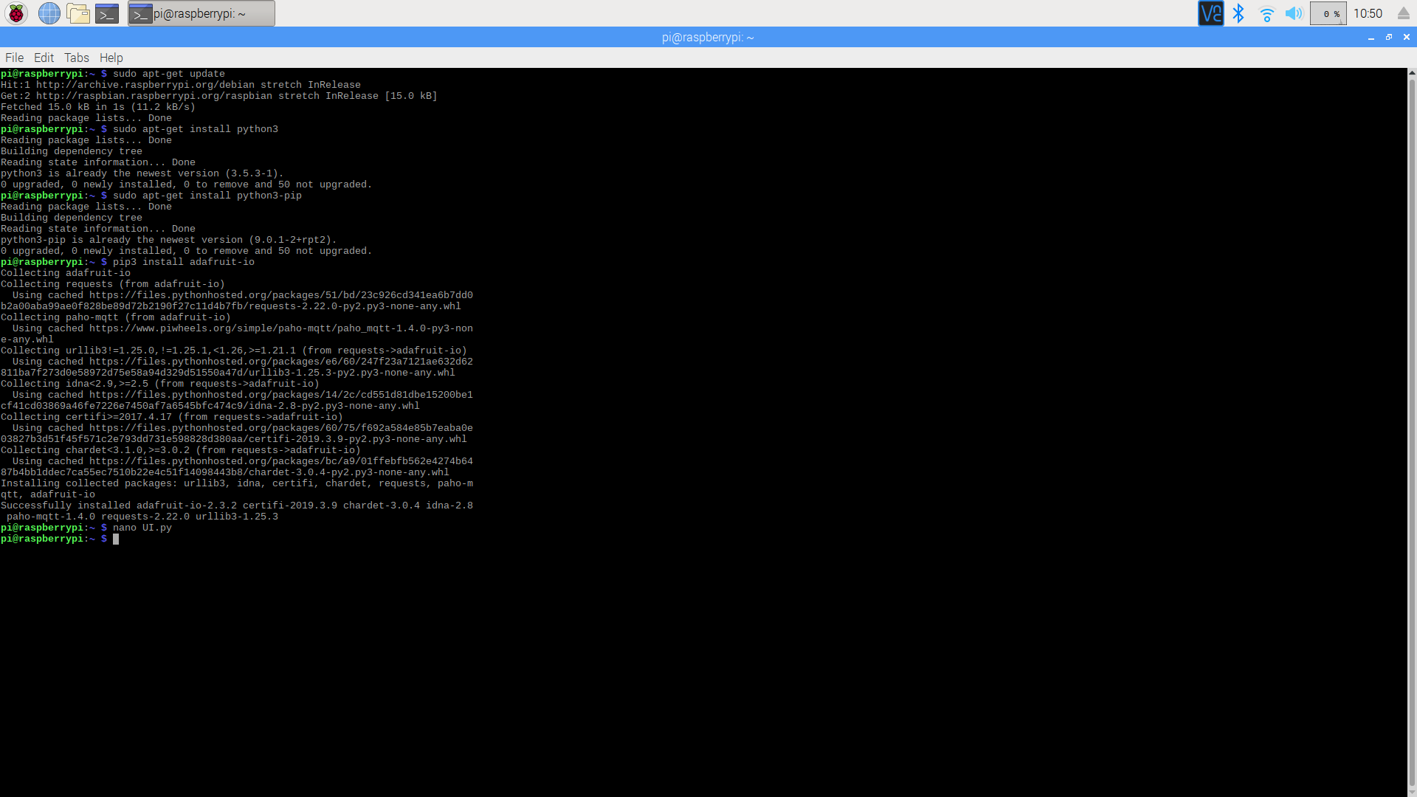
- After installation, type nano UI.py
- Copy the code below into the editor
from tkinter import *
from tkinter import messagebox
from Adafruit_IO import Client,Data
import serial
import time
#from PIL import Image, ImageTk

ser = serial.Serial(port='/dev/ttyUSB0',baudrate = 9600,bytesize = serial.EIGHTBITS,parity=serial.PARITY_NONE,stopbits=serial.STOPBITS_ONE, timeout=None)
aio = Client('ak47av', 'bda36d622b874920902764079deb0631')

class product:

def __init__(self, name, price, quantity,amount):
self.price = price
self.name = name
self.quantity = quantity
self.amount = amount

def adagetdata(self):
Quantity = aio.receive(self.name)
print(self.name)
Price = aio.receive((self.name+'price'))
print(self.name+'price')
self.quantity = IntVar()
self.quantity.set(Quantity.value)
self.price = IntVar()
self.price.set(Price.value)
print(str(Quantity.value)+' '+str(Price.value))

product1 = product('lays',10,10,0)
product2 = product('coke',25,25,0)
product3 = product('candy',1,50,0)

win = Tk()
win.title('Vending machine')
#Product Declar
frame1 = Frame(win).grid()

def main():
welcome = messagebox.showinfo('Spark Vending','Welcome to Spark drives and automation Vending services. Please wait while the interface loads')

product1.adagetdata()
product2.adagetdata()
product3.adagetdata()

def calc1():
cost1 = v1.get()*product1.price.get()
return cost1

def calc2():
cost2 = v2.get()*product2.price.get()
return cost2

def calc3():
cost3 = v3.get()*product3.price.get()
return cost3

nameofprod = Label(frame1,text=" Product avaliable ",padx=80,pady=20).grid(row=0,column=0)
quantityavailable = Label(frame1, text=' Quantity available ', padx=20).grid(row=0, column=1)
quantityrequired = Label(frame1,text =' Quantity ',padx=20).grid(row=0,column=2)
priceofprod = Label(frame1,text=' Price ',padx=20).grid(row=0,column=3)
amountdisplay = Label(frame1,text= ' Amount ',padx=20).grid(row=0,column=4)
subtotaldisplay = Label(frame1,text=' Sub Total ',padx=20).grid(row=4,columnspan=4)
taxdisplay = Label(frame1,text = ' Tax-18% ',padx=20).grid(row=5,columnspan=4)
totaldisplay = Label(frame1,text = ' Grand Total ',padx=20).grid(row=6,columnspan=4)

#load1 = Image.open("/home/akav/Downloads/lays.jpeg")
#load1 = load1.resize((150, 150), Image.ANTIALIAS)
#lays = ImageTk.PhotoImage(load1)
p1 = Label(frame1,text = product1.name)
#p1.image = lays
p1.grid(row=1,column=0,pady=30)
v1 = IntVar(frame1,value=0)
q1 = Label(frame1, textvariable=str(product1.quantity)).grid(row=1, column=1)
pricebox1 = Label(frame1,textvariable=str(product1.price)).grid(row=1,column=3)
product1.amount = IntVar()
amountbox1 = Label(frame1, textvariable=str(product1.amount)).grid(row=1, column=4)

def updateamount1():
product1.amount.set(product1.price.get() * v1.get())

optionbox1 = OptionMenu(frame1, v1, 0, 1, 2, 3, 4, 5).grid(row=1, column=2)
updateamount1()

#load2 = Image.open("/home/akav/Downloads/coke.jpg")
#load2 = load2.resize((90,150), Image.ANTIALIAS)
#coke = ImageTk.PhotoImage(load2)
p2 = Label(frame1,text=product2.name)
#p2.image = coke
p2.grid(row=2,column=0,padx=30,pady=30)
v2 = IntVar(frame1,value=0)
q2 = Label(frame1, textvariable=str(product2.quantity)).grid(row=2, column=1)
optionbox2 = OptionMenu(frame1,v2,0,1,2,3,4,5).grid(row=2,column=2)
pricebox2 = Label(frame1,textvariable=str(product2.price)).grid(row=2,column=3)
product2.amount = IntVar()
amountbox2 = Label(frame1, textvariable=str(product2.amount)).grid(row=2, column=4)

def updateamount2():

product2.amount.set(product2.price.get() * v2.get())

updateamount2()

#load3 = Image.open("/home/akav/Downloads/candy.jpg")
#load3 = load3.resize((120,150), Image.ANTIALIAS)
#candy = ImageTk.PhotoImage(load3)
p3 = Label(frame1,text = product3.name)
#p3.image = candy
p3.grid(row=3,column=0,padx=30,pady=20)
v3 = IntVar(frame1,value=0)
q3 = Label(frame1, textvariable=str(product3.quantity)).grid(row=3, column=1)
optionbox3 = OptionMenu(win,v3,0,1,2,3,4,5).grid(row=3,column=2)
pricebox3 = Label(frame1,textvariable=str(product3.price)).grid(row=3,column=3)
product3.amount = IntVar()
amountbox3 = Label(frame1, textvariable=str(product3.amount)).grid(row=3, column=4)
def updateamount3():
product3.amount.set(product3.price.get() * v3.get())
updateamount3()

subtotal = IntVar()
subtotal.set(0)
showsub = Label(frame1,textvariable=str(subtotal)).grid(row=4,column=4)
tax = DoubleVar()
tax.set(0)
showtax = Label(frame1,textvariable=str(tax)).grid(row=5,column=4)
grand =DoubleVar()
grand.set(0)
showgrand = Label(frame1,textvariable = str(grand)).grid(row=6,column=4)

def authorize():
totalcost = calc1() + calc2() + calc3()

product1.quantity.set(product1.quantity.get() - v1.get())
for i in range(0, v1.get()):
val = '1'
ser.write(val.encode())
time.sleep(1)
data1 = Data(value=product1.quantity.get())
aio.create_data('lays', data1)
product2.quantity.set(product2.quantity.get() - v2.get())
for i in range(0, v2.get()):
val = '2'
ser.write(val.encode())
time.sleep(1)
data2 = Data(value=product2.quantity.get())
aio.create_data('coke', data2)
product3.quantity.set(product3.quantity.get() - v3.get())
for i in range(0, v3.get()):
val = '3'
ser.write(val.encode())
time.sleep(1)
data3 = Data(value=product3.quantity.get())
aio.create_data('candy', data3)
data = Data(value=(totalcost*1.18))
aio.create_data('earnings', data)
return totalcost

def calc():

if ((product1.quantity.get() - v1.get()) < 0 or (product2.quantity.get() - v2.get()) < 0 or (
product3.quantity.get() - v3.get()) < 0):
messagebox.showinfo('Not enough items',
'Not enough items are available , please select a quantity lesser than the quantity available')
main()
subtotal.set(calc1() + calc2() + calc3())
tax.set(subtotal.get()*.18)
grand.set(subtotal.get()*1.18)
updateamount1()
updateamount2()
updateamount3()

def pay():

totalcost = calc1() + calc2() + calc3()
msgbox = messagebox.askquestion('Payment', 'You have to pay {0:.2f} (inclusive of tax).Click yes to pay and no to return to main screen'.format(totalcost*1.18))
if(msgbox=='yes'):
authorize()
else:
main()

calcbutton = Button(frame1,text='Evaluate bill',command = calc).grid(row=7,column=0,pady=20)
paybutton = Button(frame1,text='Pay',command = pay).grid(row=8,column=0,pady=20)

main()

win.mainloop()

- Connect jumpers from the FTDI chip to the pi’s RX and TX pins and connect the FTDI chip to a PC with Arduino IDE preinstalled.
- Select the appropriate COM port on the PC and open the serial monitor.
- To run the program type python3 UI.py on the raspberry pi command line
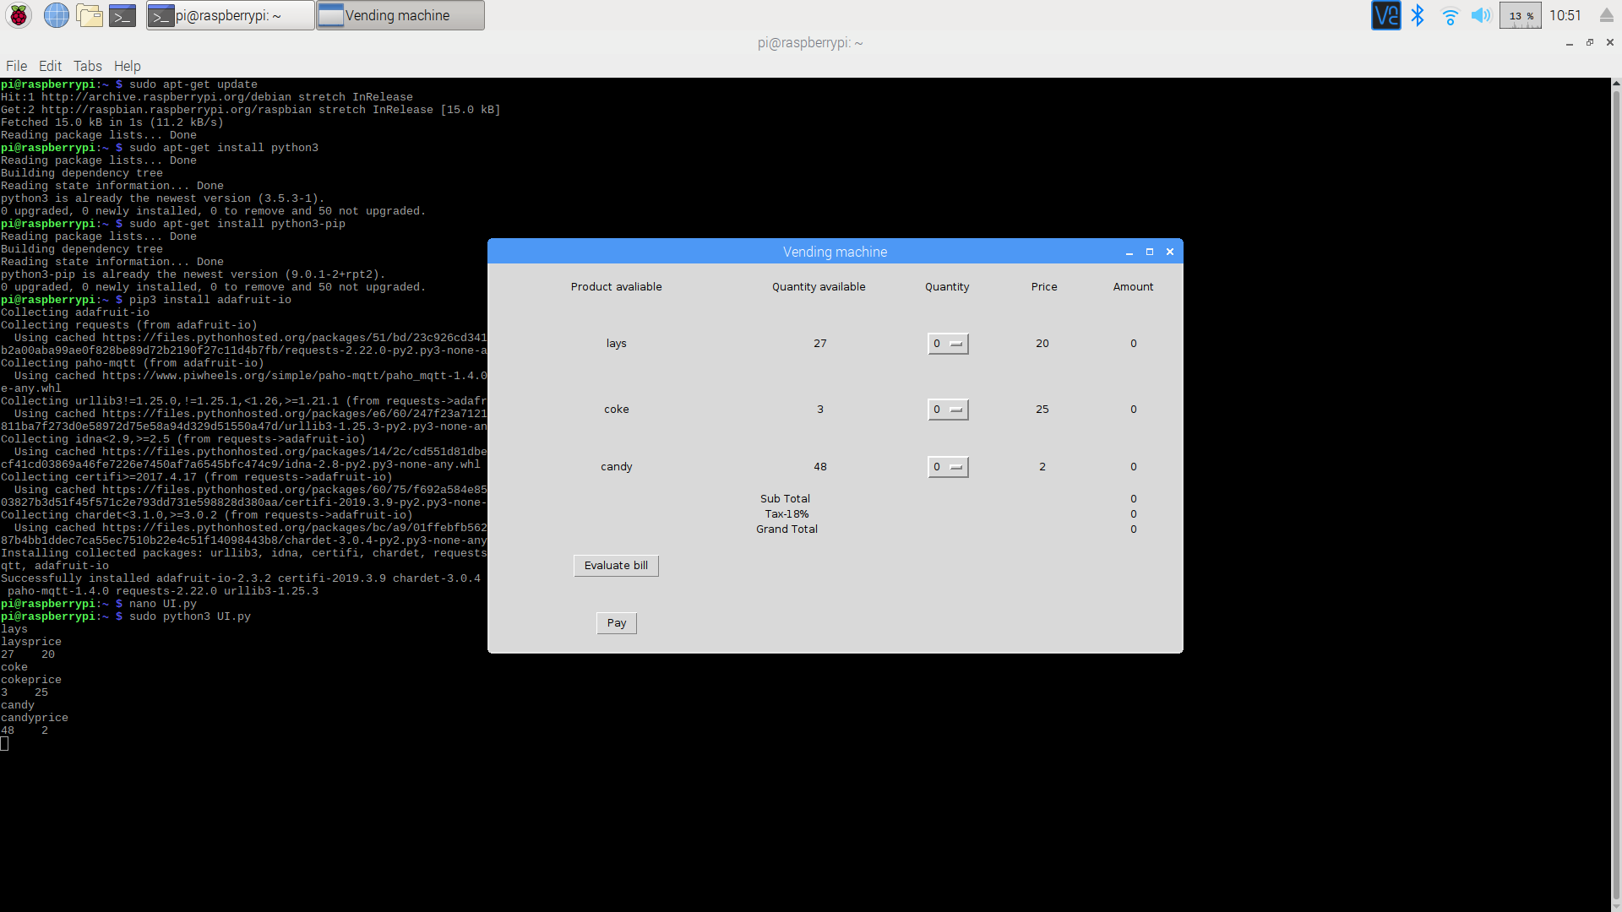
You can see the program running,the serial monitor on the PC will display the the required values on the serial monitor.

