**SVKM’s NMIMS**

**School of Technology Management & Engineering, Chandigarh**

A.Y. 2023 - 24

**Course: Database Management Systems**

**Project Report**

|  |  |  |
| --- | --- | --- |
| Program | MBA TECH (DATA SCIENCE) | |
| Semester | 4 | |
| Name of the Project: | Satellite Insights | |
|  | | |
| Details of Project Members |  |  |
| Batch | Roll No. | Name |
| J1 | S003 | Aditya Kumar |
| J1 | S006 | Anant Shukla |
| J1 | S012 | Avi Patel |
| Date of Submission: 2/4/24 | | |

**Contribution of each project Members:**

|  |  |  |
| --- | --- | --- |
| Roll No. | Name: | Contribution |
| S003 | Aditya Kumar | SQL Queries |
| S006 | Anant Shukla | Data Cleaning and helped in queries |
| S012 | Avi Patel | ER Daigram and assisted in queries |

**Github link of your project: https://github.com/ak50-ak3/Satellite**

**Project Report**

**Selected Topic**

**by**

**Aditya Kumar, S003**

**Anant Shukla, S006**

**Avi Patel, S012**

**Course: DBMS**

**AY: 2023-24**

**Table of Contents**

|  |  |  |
| --- | --- | --- |
| **Sr no.** | **Topic** | **Page no.** |
| **1** | Storyline | 3 |
| **2** | Components of Database Design | 4 |
| **3** | Entity Relationship Diagram | 5 |
| **4** | Relational Model | 6 |
| **5** | Normalization | 6-7 |
| **6** | SQL Queries | 7-18 |
| **7** | Learning from the Project | 19 |
| **8** | Project Demonstration | 19 |
| **9** | Self-learning beyond classroom | 19 |
| **10** | Learning from the project | 19 |
| **8** | Challenges faced | 19 |
| **9** | Conclusion | 19 |

**I. Storyline**

We know countless satellites orbit the Earth, each with its own unique name, purpose, and operator.

Satellites possesses an official name,country of origin and serve a specific purpose.However satellites have a lifetime after which the closer satellites burn up in the atmosphere .Here we will explore the things that are taken into consideration when a satellite is launced.and also learn about which countries had send the most satellites in the year 2023.

**II. Components of Database Design**

Entity 1: Satellite

Attributes:-

* Sat_Name(Char)
* Users(Char)
* Purpose(Char)
* SatID(int) -Primary Key-fk
* COSPAR_Number-(int)foreign Key

Description:It gives us details about the satellite such as it’s name,it’s user in sectors like military,communication ,their purpose and their unique numbers.

Entity 2: Owner

Attributes:-

* Company_Name(Char)
* Country_of_Operator(Char)
* COSPAR_Number(int)(-Primary Key
* SatID(int) - Foreign key
* Country(Char)

Description:It gives us details about the country that sent the satellite.

Entity 3: Launch_Details

Attributes:-

* Launch_Vehicle(Char)
* Date_of_Launch(Char)
* COSPAR_Number(int) -Primary Key
* Launch_Site(Char)

Description:It gives us details the satellite that are related to it’s Launching.

Entity 4: Technical_Details

Attributes:-

* Contractor(Char)
* Comments(Char)
* SatID(int) -Primary key
* Country_of_Contractor(Char)

Description:It gives us technical details about the satellite.

Entity 5: Orbit

Attributes:-

* Type_Of_Orbit(Char)
* Agopee_in_km(int)
* Perigree_in_km(int)
* COSPAR_Number (int)-Primary key

Description:It gives us details about the satellite’s oirbi Apogee:farthest distance,Perigree:.closest distance)

**III. Entity Relationship Diagram**

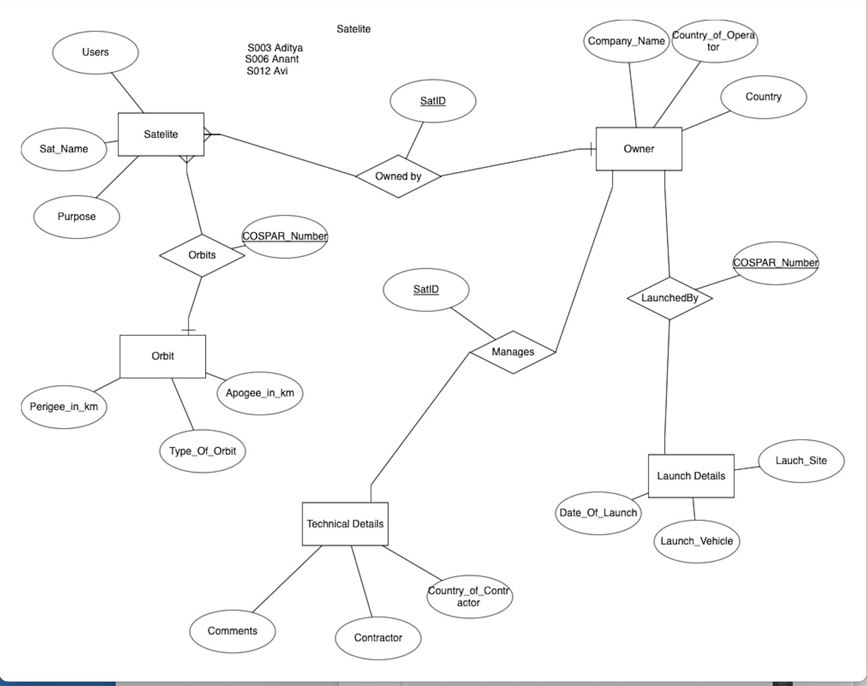

**IV. Relational Model**

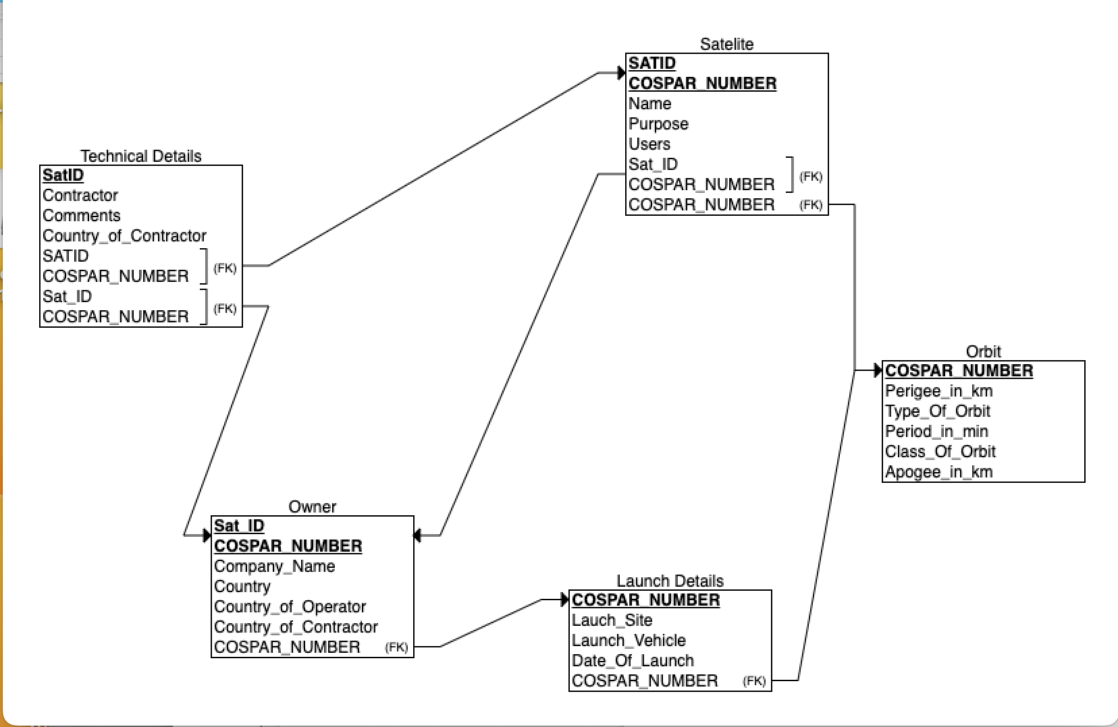

Tables obtained are Satellite,Owner,Technical_Details,Launch_Details,Orbit.

**V. Normalization**

We first drop all columns of database that had common values in their tuples and filtered them out.We also split some columns of Contractor and Country of Contractor.

In Satellite-

1NF

check for multivalued columns-There are no multivalued columns

All have atomic values.

Primary Key is SatID.

Hece,it is 1NF.

2NF

All non prime attributes depend on Sat!D.

Hence it is 2NF.

3NF

All non prime attributes do not depend on any other non prime attributes.

BCNF

SatID is a candidate key and for every (SatID->other attributes) it is a super key.

Hence Satellite table is Normalised.

Similarly for other tables Cospar_Number and SatID satisfy all the conditions .

Hence the tables were already normalized.

**VI. SQL Queries**

**Creating Tables-**

SELECT * FROM Satellite.s;

-- CREATE TABLE Satellite AS (SELECT SatID,Purpose,COSPAR_Number FROM Satellite.s);

CREATE TABLE S AS (SELECT * FROM Satellite.s);

Select * from S ;

Alter table S rename column Owner to Company_Name;

CREATE TABLE Satellite AS (SELECT SatID,Sat_Name,Users,Purpose,COSPAR_Number FROM S);

CREATE TABLE Orbit AS (SELECT Type_Of_Orbit,Perigee_in_km,Apogee_in_km,COSPAR_Number FROM S);

CREATE TABLE Technical_Details AS (SELECT SatID,Contractor,Country_of_Contractor,Comments FROM S);

CREATE TABLE Launch_Details AS (SELECT Date_of_Launch,Launch_Vehicle,Launch_Site,COSPAR_Number FROM S);

CREATE TABLE Owner AS (SELECT SatID,Company_Name,Country,Country_of_Operator,COSPAR_Number FROM S);

**QUERIES**

0.How many satellites were launced in 2023?

SELECT COUNT(*) FROM Satellite;

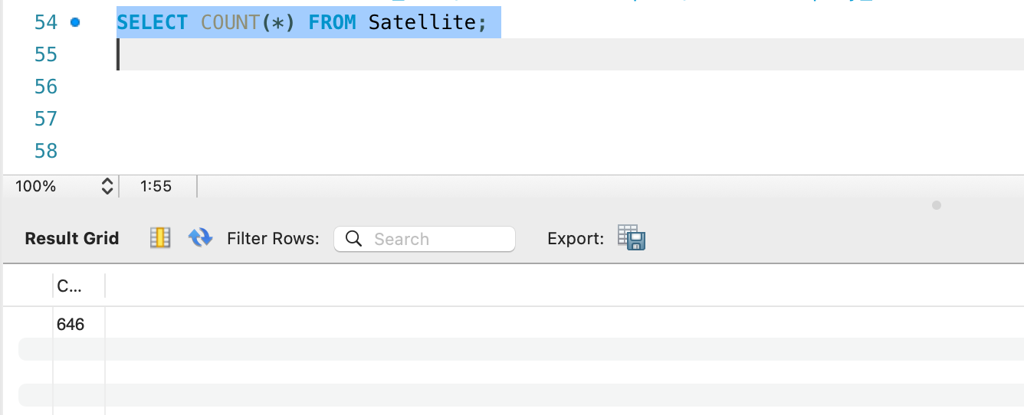

1.Show the list of furtest 10 satellites from earth.

Select SatID,Sat_Name,Users,Purpose from Satellite INNER JOIN Orbit ON Satellite.COSPAR_Number=Orbit.COSPAR_Number ORDER BY Orbit.Apogee_in_km DESC LIMIT 10;

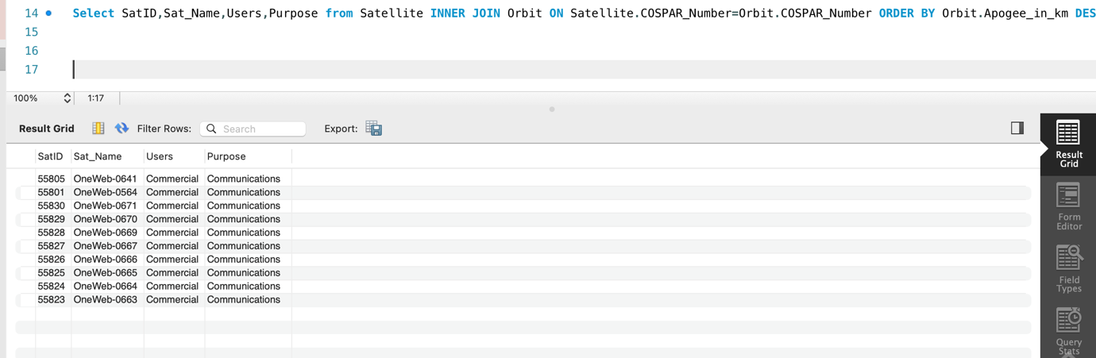

2.Show the list of nearest 10 satellites from earth.

Select SatID,Sat_Name,Users,Purpose from Satellite INNER JOIN Orbit ON Satellite.COSPAR_Number=Orbit.COSPAR_Number ORDER BY Orbit.Perigee_in_km LIMIT 10;

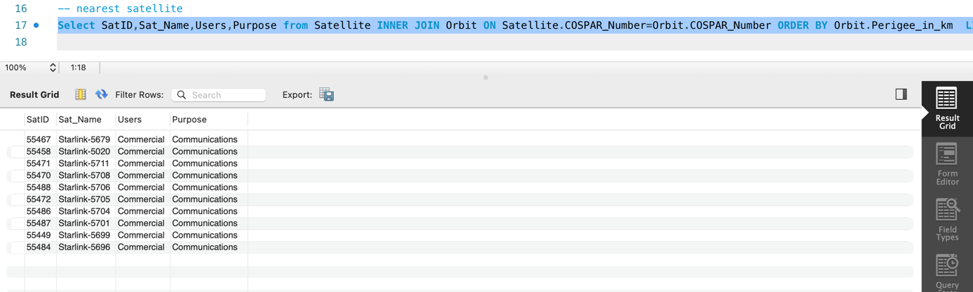

3. List the names of countries where satellite contractors are located.

Select DISTINCT Country_of_Contractor FROM Technical_Details;

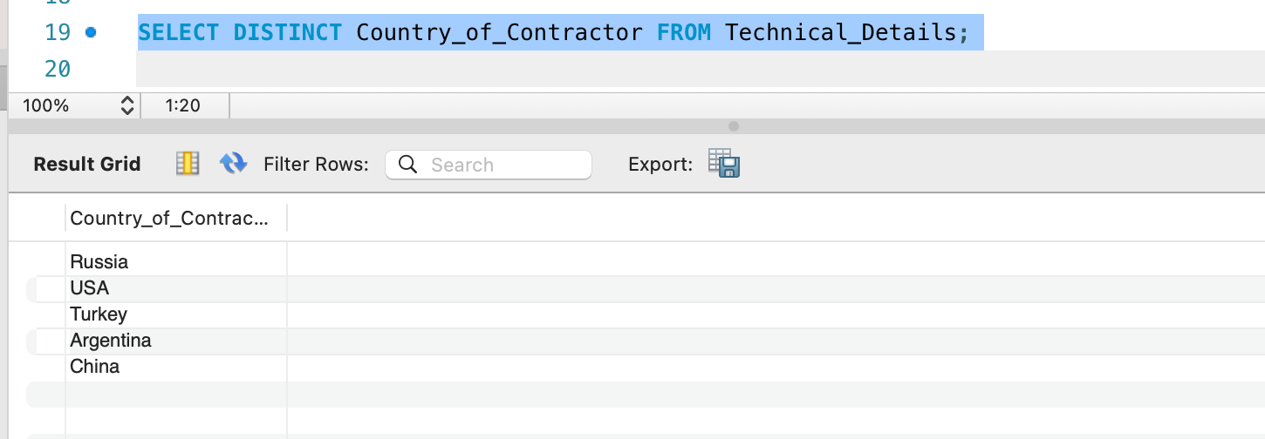

4. List the number of satellites Launced in January.

SELECT Launch_Site,COUNT(*) FROM Launch_Details where Date_of_Launch LIKE '%/01/%' ;

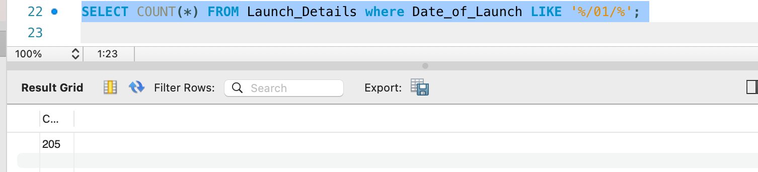

5. Count how many satellites were launced in jan ,2023 by the launch sites.

SELECT Launch_Site,COUNT(*) FROM Launch_Details where Date_of_Launch LIKE '%/01/%' GROUP BY Launch_Site;

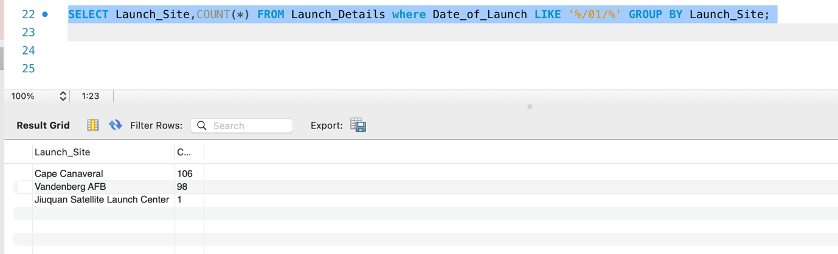

6.List the companies that launch satellites in USA.

SELECT DISTINCT Company_Name FROM Owner WHERE Country = 'USA';

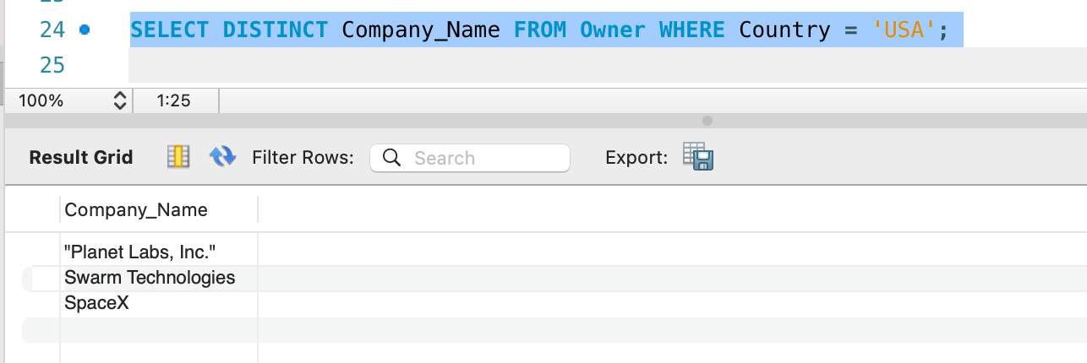

7.List the number of satellites that were sent for specific users.

SELECT Users,Count(*) FROM Satellite GROUP BY Users;

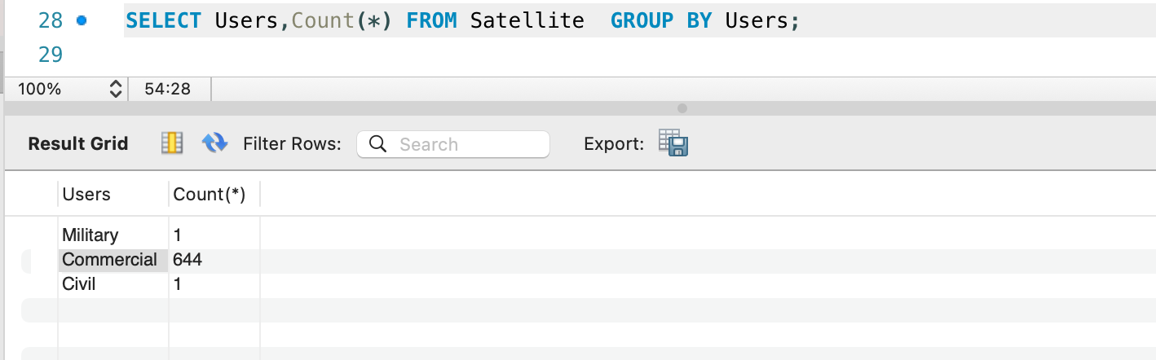

8.List the number of Satellites sent for a specific purpose.

SELECT Purpose,Count(*) FROM Satellite WHERE Users = 'Commercial' GROUP BY Purpose;

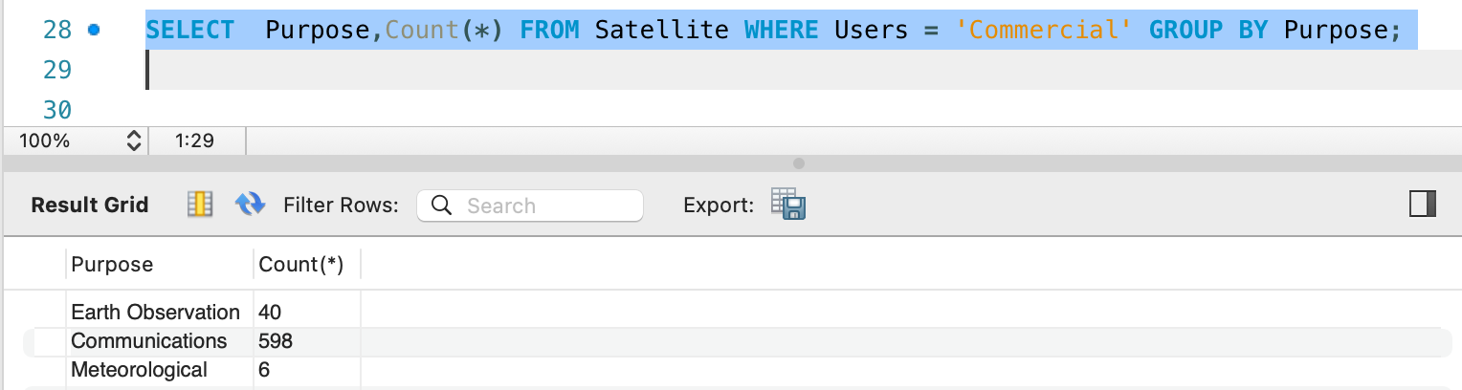

9 .What are the names of satellites and their respective contractors, including those with no technical details.Also List their purpose .

SELECT Satellite.Sat_Name,Satellite.Purpose, Technical_Details.Contractor FROM Satellite LEFT JOIN Technical_Details ON Satellite.SatID = Technical_Details.SatID;

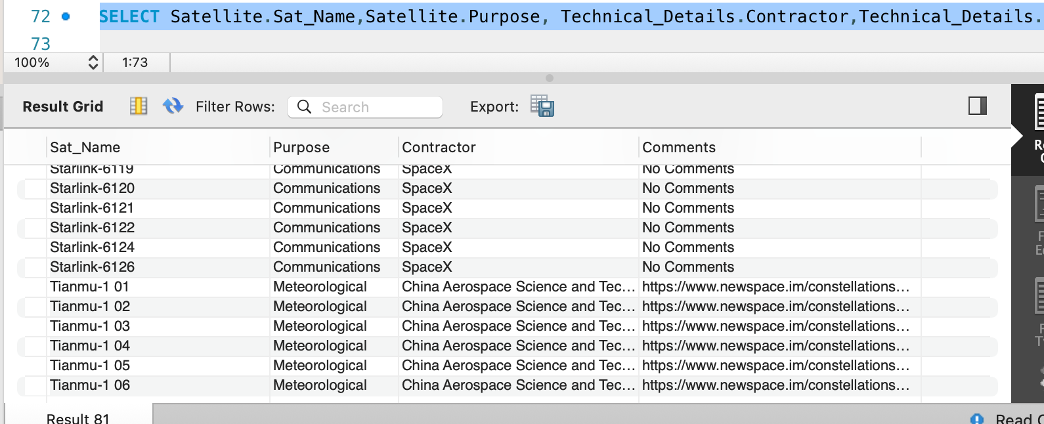

10. What are the names of satellites and their respective contractors, including those with no technical details

SELECT Satellite.Sat_Name, Technical_Details.Contractor FROM Satellite LEFT JOIN Technical_Details ON Satellite.SatID = Technical_Details.SatID;

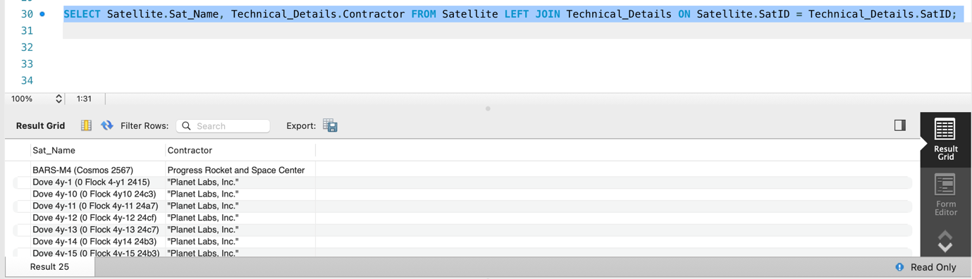

11. What is the distribution of Falcon 9 rocket launches among different companies in the satellite industry?

SELECT Company_Name, COUNT(*) FROM Owner RIGHT JOIN (SELECT * FROM Launch_Details WHERE Launch_Vehicle = 'Falcon 9') AS Launch_Details ON Owner.COSPAR_Number = Launch_Details.COSPAR_Number GROUP BY Company_Name;

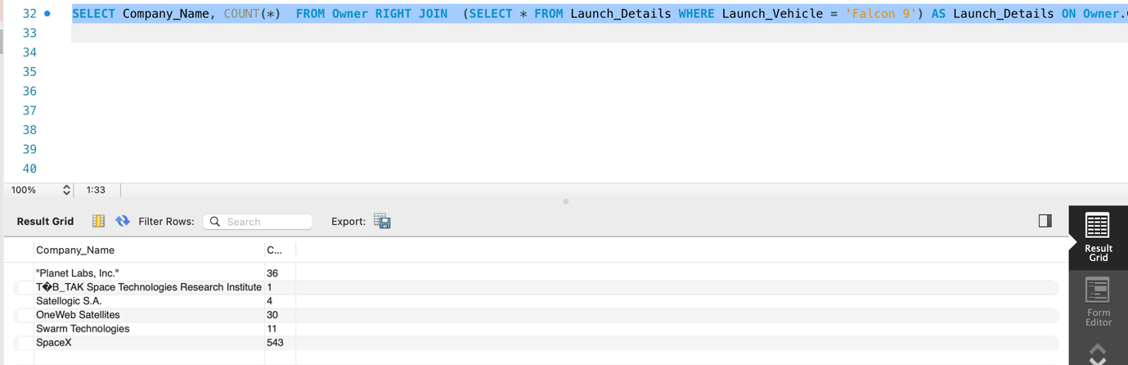

12.Find the average closest and furthest distance of satellites.

select AVG(Perigee_in_km),AVG(Apogee_in_km) from Orbit ;

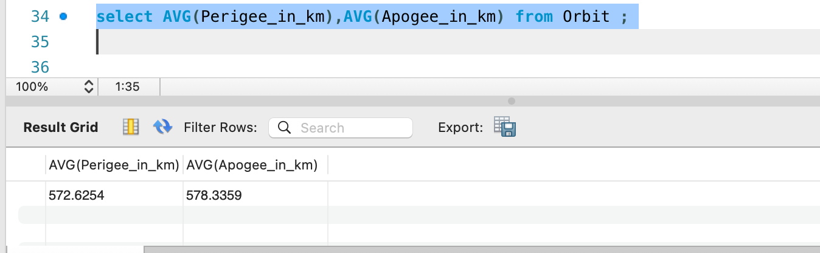

13 .Finding out the first 10 satellites Launced in 2023.

Select * from Jan_Sat;

CREATE TABLE Jan_Sat AS SELECT Satellite.Sat_Name, Launch_Details.Date_of_Launch FROM Launch_Details INNER JOIN Satellite ON Launch_Details.COSPAR_Number = Satellite.COSPAR_Number WHERE Launch_Details.Date_of_Launch LIKE '%/01/%';

SELECT * FROM Jan_Sat ORDER BY Date_of_Launch LIMIT 10;

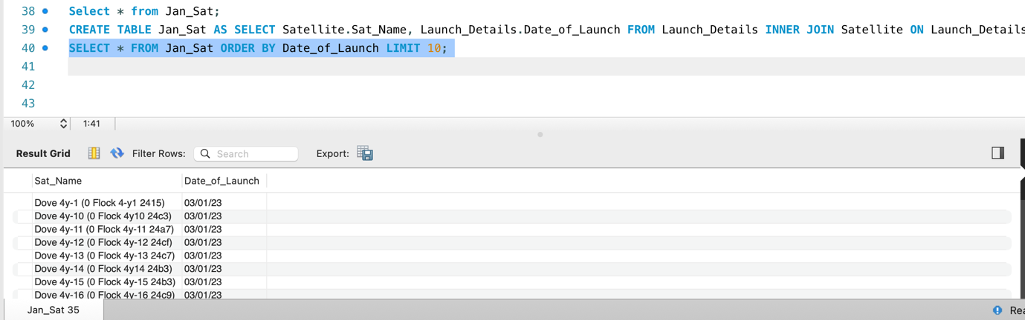

14.Which Satellites were Launced between start of February till End of March.

SELECT Sat_Name, Launch_Vehicle FROM Satellite JOIN Launch_Details ON Satellite.COSPAR_Number = Launch_Details.COSPAR_Number WHERE Date_of_Launch BETWEEN '01/2/23' AND '31/3/23';

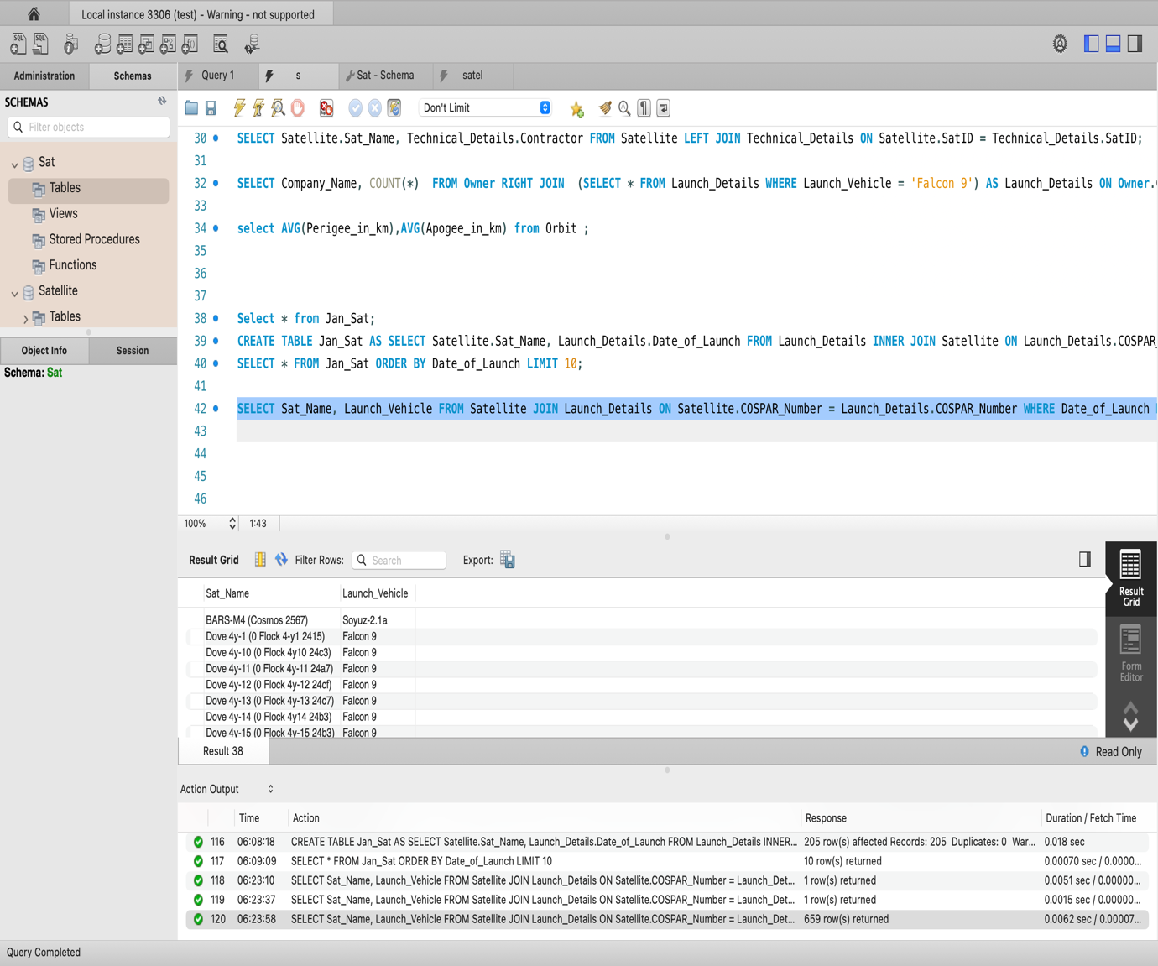

15 Which satellites are operated by companies from different countries than their registrated country .

SELECT COUNT(*) AS Total_Count,Owner.Country_of_Operator, Owner.Country, Satellite.Sat_Name FROM Owner INNER JOIN Satellite ON Owner.SatID = Satellite.SatID WHERE Owner.Country_of_Operator != Owner.Country GROUP BY Owner.Country_of_Operator, Owner.Country, Satellite.Sat_Name;

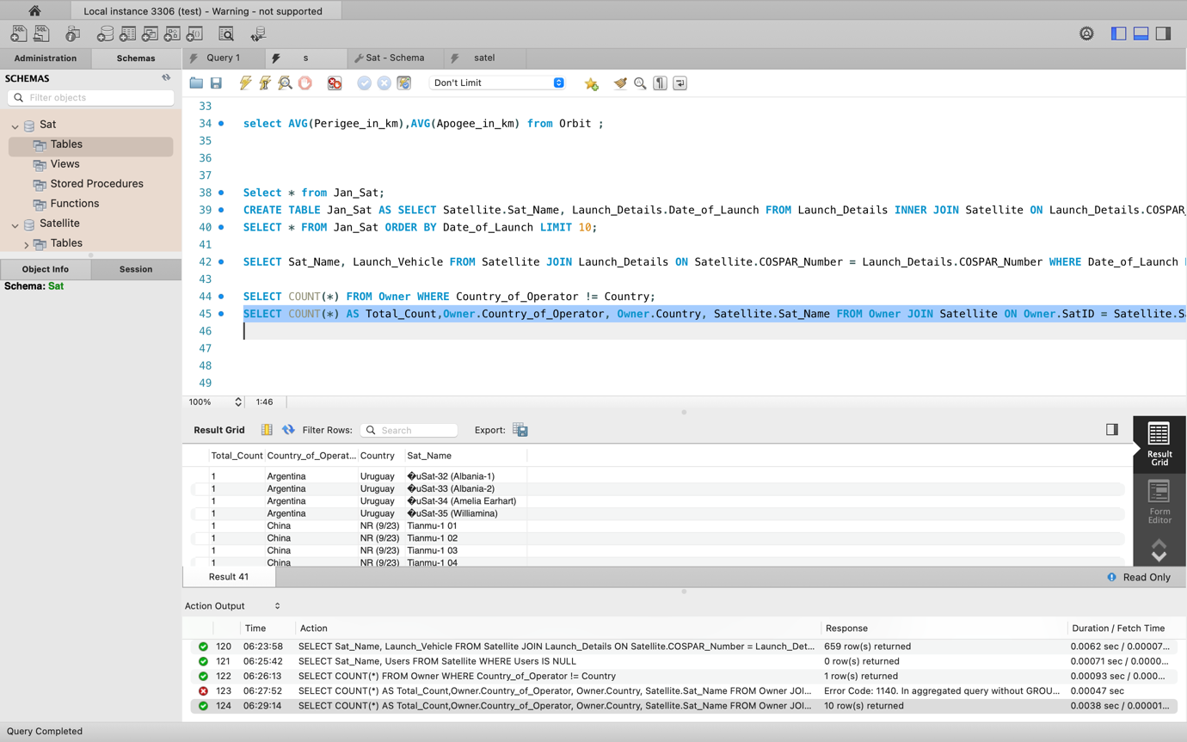

16.Which Countries have no records?

SELECT * FROM Owner WHERE Country LIKE 'NR%';

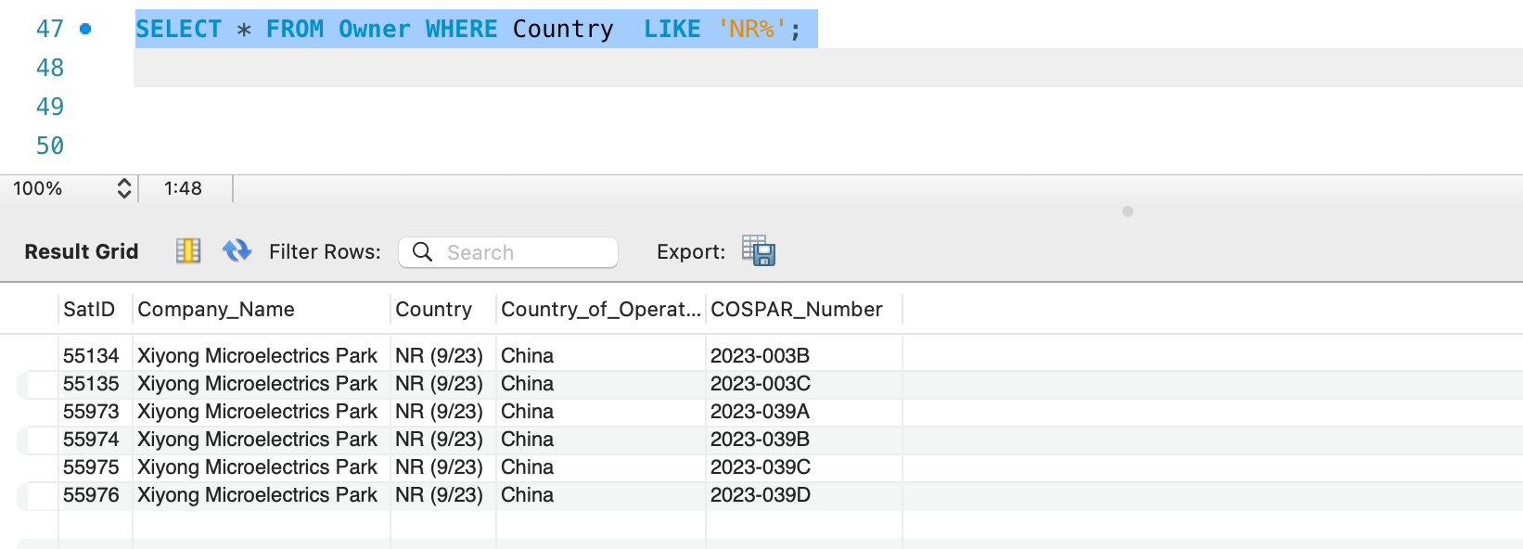

17 .Type of orbits

SELECT DISTINCT Type_Of_Orbit FROM Orbit ORDER BY Type_Of_Orbit;

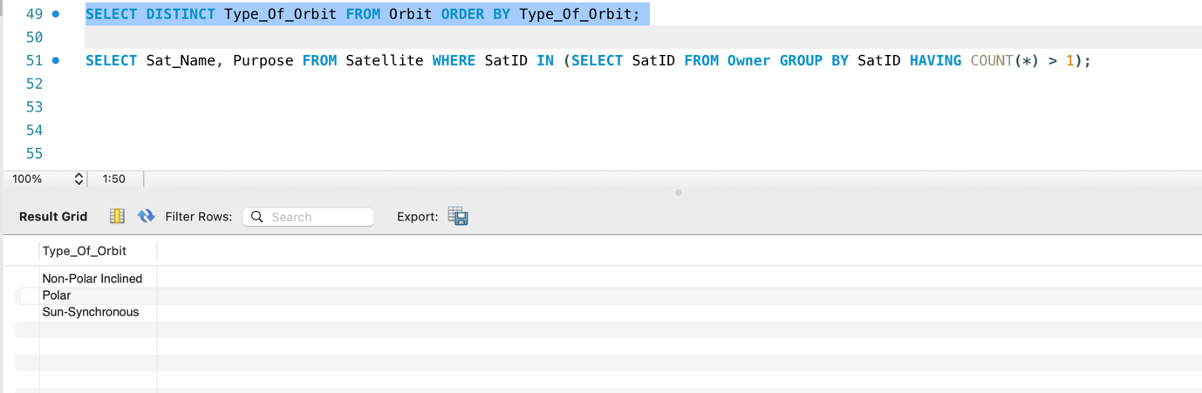

18 .What are the different contractors from Russia involved in satellite projects

SELECT DISTINCT Contractor FROM Technical_Details WHERE Country_of_Contractor = 'Russia';

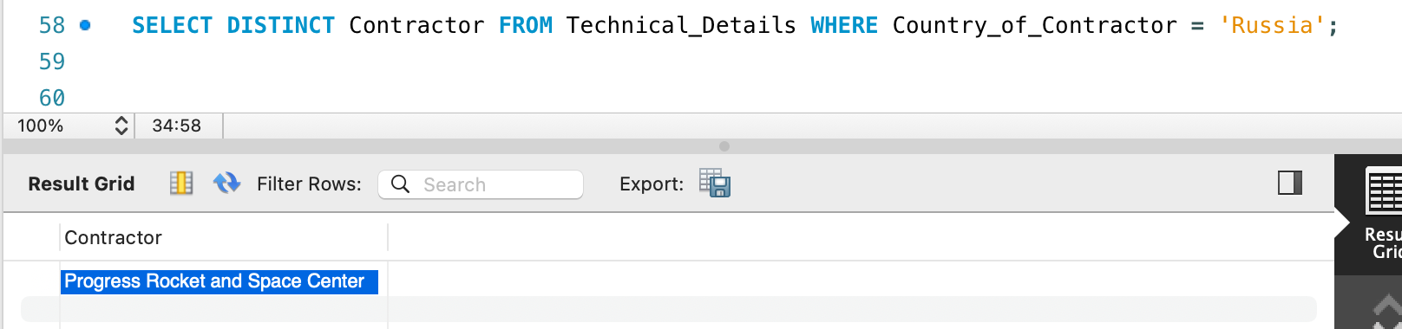

19 .How many satellites are operated by companies from the same country as their registration?

SELECT COUNT(*) FROM Owner WHERE Country = Country_of_Operator;

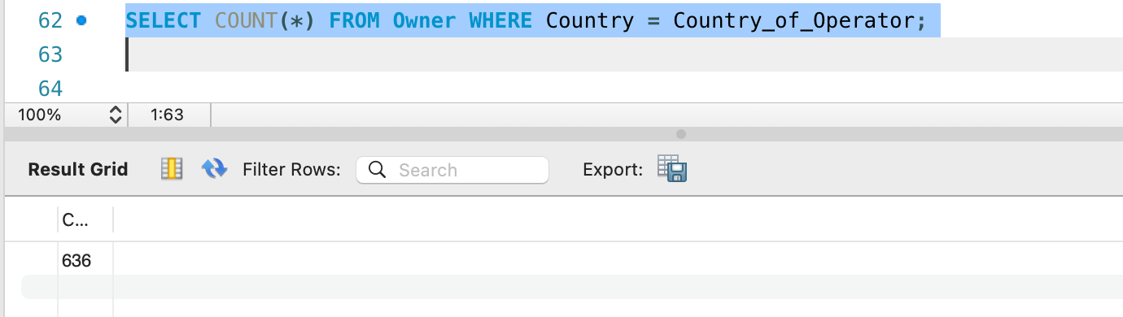

20 .Which satellites are not owned by any company?

SELECT Sat_Name, Purpose FROM Satellite WHERE SatID NOT IN (SELECT SatID FROM Owner);

Output-They are all owned by some company.

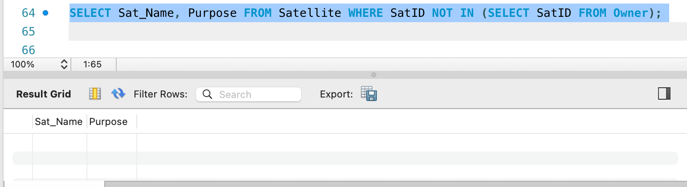

21 List the Top 5 closest Satellites that are Starlink.

SELECT Satellite.Sat_Name, Orbit.Perigee_in_km FROM Satellite JOIN Orbit ON Satellite.COSPAR_Number = Orbit.COSPAR_Number WHERE Satellite.Sat_Name LIKE 'starlink%' ORDER BY Orbit.Perigee_in_km ASC LIMIT 5;

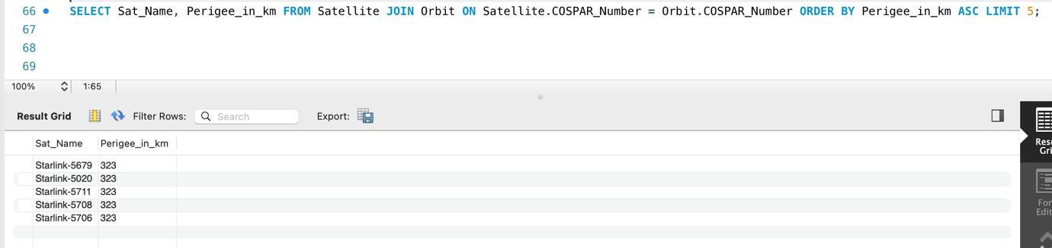

22 Which companies own the first 10 satellites in alphabetical order?

SELECT Owner.Company_Name, Satellite.Sat_Name FROM Owner RIGHT JOIN (SELECT * FROM Satellite ORDER BY Sat_Name ASC LIMIT 10) AS Satellite ON Owner.SatID = Satellite.SatID;

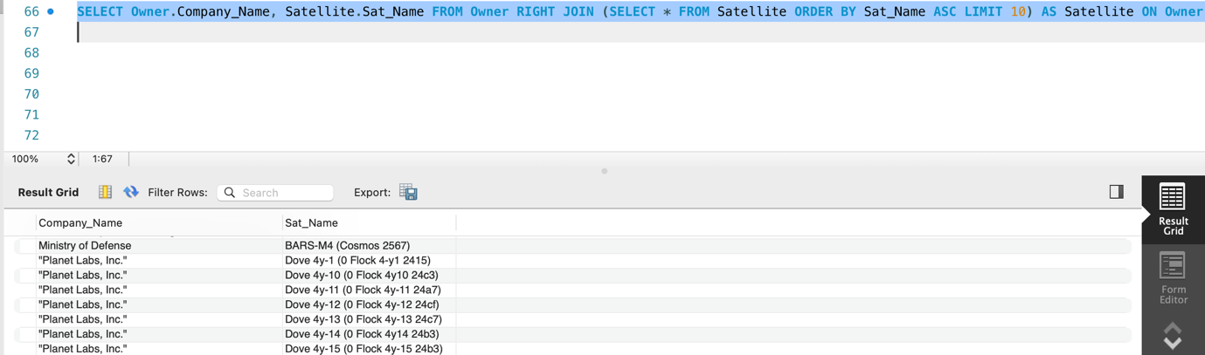

23 How many owners do each satellite from the USA have?

SELECT Satellite.Sat_Name, COUNT(Owner.SatID) AS Total_Owners FROM Satellite LEFT JOIN (SELECT * FROM Owner WHERE Country = 'USA') AS Owner ON Satellite.SatID = Owner.SatID GROUP BY Satellite.Sat_Name;

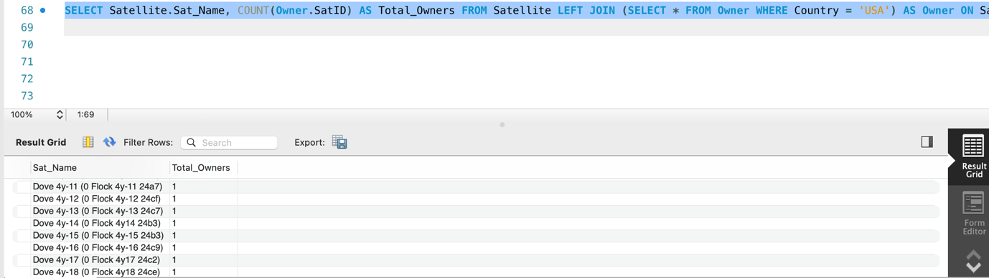

24. Names of satellites along with their respective owners and the types of orbits.

SELECT Satellite.Sat_Name,Satellite.Purpose, Technical_Details.Contractor,Technical_Details.Comments FROM Satellite LEFT JOIN Technical_Details ON Satellite.SatID = Technical_Details.SatID;

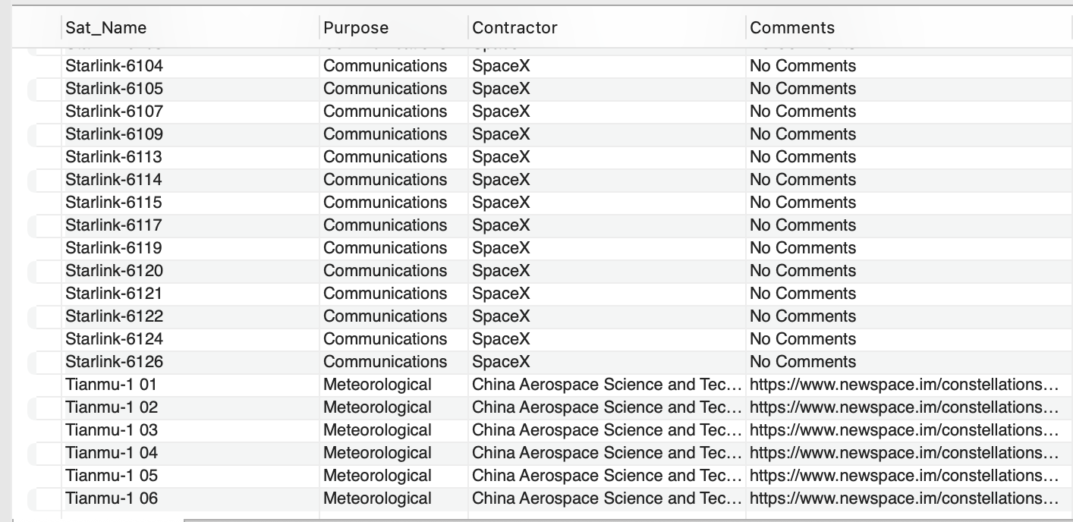

**VI. Project demonstration**

* We used ERD+ to make the ERD+ diagram and Relational Model.
* We used MySQLWorkbench to load and perform queries on the dataset.

**VII. Self -Learning beyond classroom**

:

* We learnt how to load a dataset from an excel file by converting it into json.
* We also about satellites that have been send on different purposes.

**VIII. Learning from the Project**

* This project helped us to Learn New things like uploading data from excel when data is too large to add manually
* We learnt about SQL queries.
* We learnt how to store databases.
* We learnt how to replace null values with NoData.
* We learnt about the how a lot of steps and people are involved while launching a satellite to space.

**IX. Challenges Faced**

* Loading of the project-since database was large.
* Slow Performance as it took time to load.
* Syntax and approach Errors.

**X. Conclusion**

* We learnt how to import a database into sql and make it ready for fetching queries.
* We learnt about Satellites.
* We learnt how to analyse a database , gain insights through queries and draw our conclusions from it.