Optimum DesignHomework #3 (Due May 2nd)

For problem 1 and 2, please write your own programming codes (in Matlab, C, C++, Python, or Fortran …).
Consider the following 3-variable function:
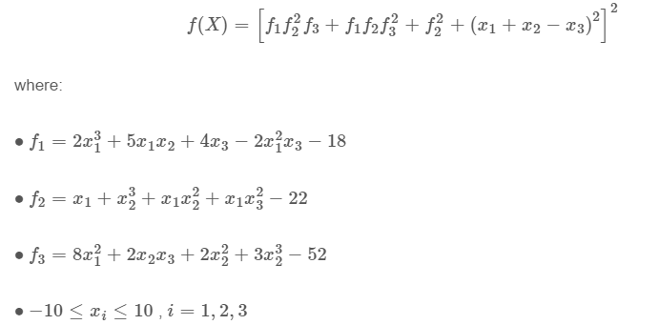
- Use Newtons’s method and a quasi-Newton (DFP or BFGS) method to find the global minimum in the range specified above. Choose a suitable set of stopping criteria (e.g., the searching process should stop if the distance between subsequent searching points becomes small enough, and/or the magnitude of gradient f becomes small enough, and/or the number of interation is too big). Note that Newton’s method may not converge. So you may need to try different starting points.

- Use Fletcher-Reeves conjugate gradient method to solve the same problem with the same starting point and stopping criteria in problem 1. Also, compare the results and number of iterations in problem 1 and 2.

- Solve the same problem by any commercial software or code you can find. For example, you can use one of the Matlab optimization functions or C codes in chapter 10 of the book: Numerical Recipes in C, or any online resources you find.

