Optimum Design
Homework #4 (Due 05/30/2017)

1. Solve the following problem by any commercial software or your own code. For example, you can use one of the Matlab optimization functions or the C code in Numerical Recipes in C. (The solution and the background idea of this problem can be found in the paper by R.T. Raikova and B.I. Prilutsky, 2001. Sensitivity of predicted muscle forces to parameters of the optimization-based human leg model revealed by analytical and numerical analyses. Journal of Biomechanics, 34, 1243-1255.)
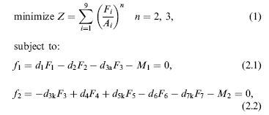

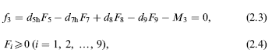

The values of the terms in the constants are given below:
M1=4; M2=33; M3=31;
d1, d2, d3a, d3k, d4, d5k, d5h, d6, d7k, d7h, d8, d9 are included in the following vector: d=[0.0298 0.044 0.044 0.0138 0.0329 0.0329 0.0279 0.025 0.025 0.0619 0.0317 0.0368];
The values of A_{i} are also included in the vector A=[11.5 92.5 44.3 98.1 20.1 6.1 45.5 31.0 44.3];

- Solve the following Linear Programming problem by any commercial software or your own code.
Maximize y₁ – 5y₂
Subject to 3y₁ – 2y₂ ≤ 12, 2y₁ + y₂ ≥ 8, y₁ + y₂ =6, and y₁ ≥ 0, y₂ is free in sign.

