QUESTION NO-1

For searching pattern line by line in linux GREP command is used.
To demonstrate grep command firstly we'll create a demo file using cat command.

SYNTAX: grep [options] pattern file_name

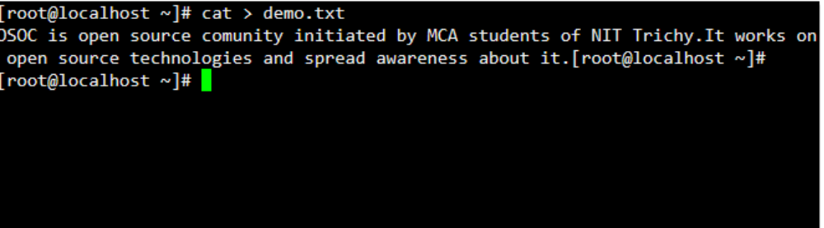
1. Basic usage of grep command is to search for a specific string in the specified file as shown below.

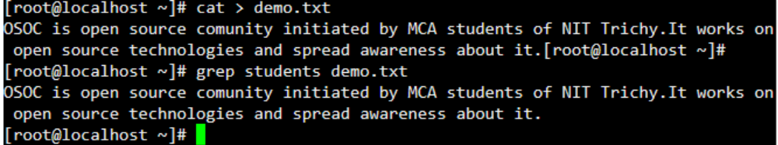
2. If we have more than one file and we want to search particular string from all of the files then also we can use grep command.

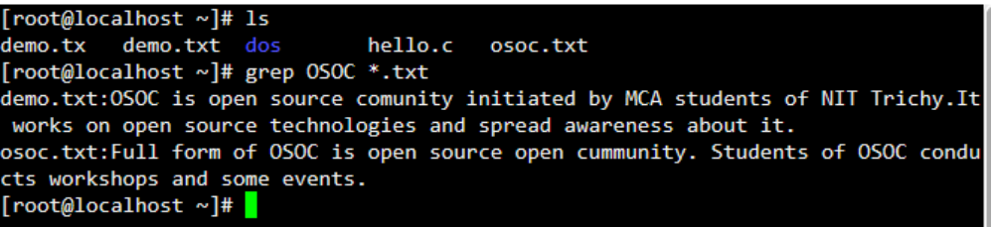
3. Using grep -i we can do case insensitive search.

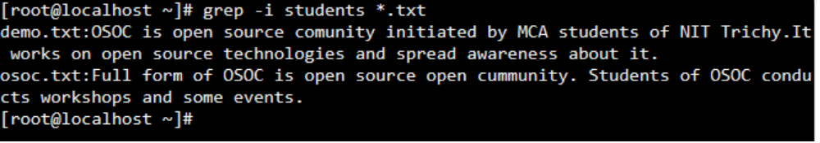
GREP Options

Option | Description
-b | Display the block number at the beginning of each line.
-c | Display the number of matched lines.
-h | Display the matched lines, but do not display the filenames.
-i | Ignore case sensitivity.
-l | Display the filenames, but do not display the matched lines.
-n | Display the matched lines and their line numbers.
-s | Silent mode.
-v | Display all lines that do NOT match.
-w | Match whole word.

QUESTION NO-2

Access to a file has three levels:
- Read permission – If authorized, the user can read the contents of the file.
- Write permission – If authorized, the user can modify the file.
- Execute permission – If authorized, the user can execute the file as a program.
Each file is associated with a set of identifiers that are used to determine who can access the file:
- User ID (UID) – Specifies the user that owns the file. By default, this is the creator of the file.
- Group ID (GID) – Specifies the user-group that the file belongs to.
Finally, there are three sets of access permissions associated with each file:
- User permission – Specifies the level of access given to the user matching the file’s UID.
- Group permission – Specifies the level of access given to users in groups matching the file’s GID.
- Others permission – Specifies the level of access given to users without a matching UID or GID.
Together, this scheme of access controls makes the Unix system extremely secure while simultaneously providing the flexibility required of a multi-user system.
The ls -l command can be used to view the permissions associated with each of the files in the current folder.
Example output of this command is given below.

ls -la command is used to check existing permissions of current file.
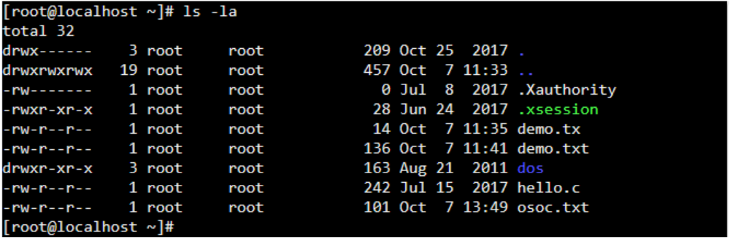
To change the existing permissions we use chmod command.

SYNTAX : chmod [options] mode[,mode] file1 [file2 …]

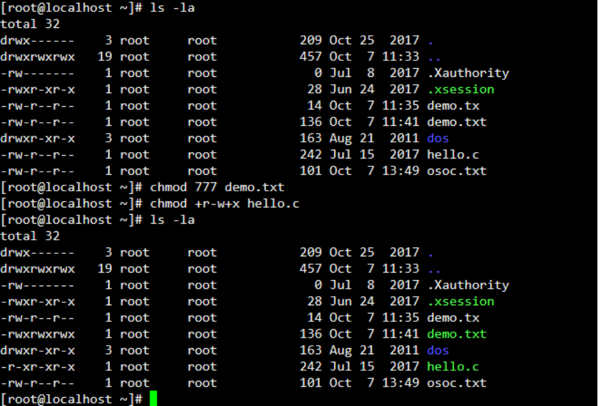

QUESTION NO-3

- To create folder I used mkdir OSOC command and created folder OSOC.
- 2Then using cd OSOC command I entered in folder OSOC.
- Then in folder OSOC using mkdir INDUCTIONS I created folder named INDUCTIONS inside OSOC.
- Using cat > task.txt I created a file.
- Now I went back to folder OSOC using cd ..
- There I created folder Workshop using mkdir Workshop .
- Now I copied file task.txt using cp command.
Cp ~/INDUCTIONS/task.txt ~/Workshop/task.txt

QUESTION NO-4

View Established Connections Only
Use following command
# netstat -natu | grep 'ESTABLISHED'

QUESTION NO-5

- For creating new user we can use command adduser [username].
- For changing password we can use command passwd [username].

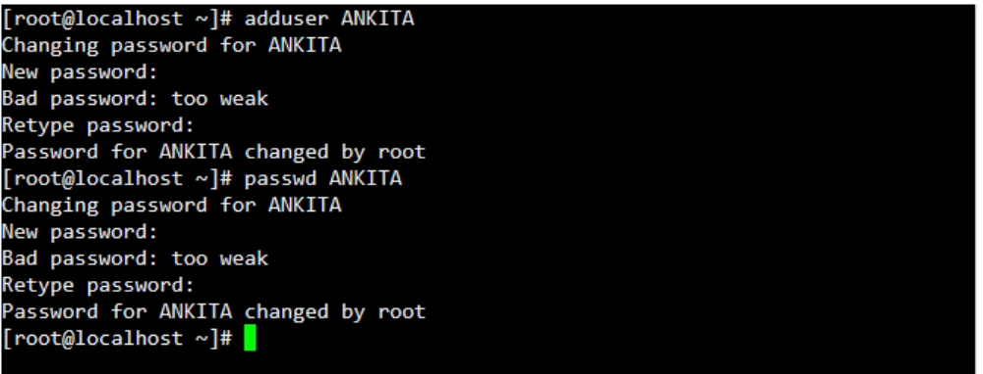

QUESTION NO- 6

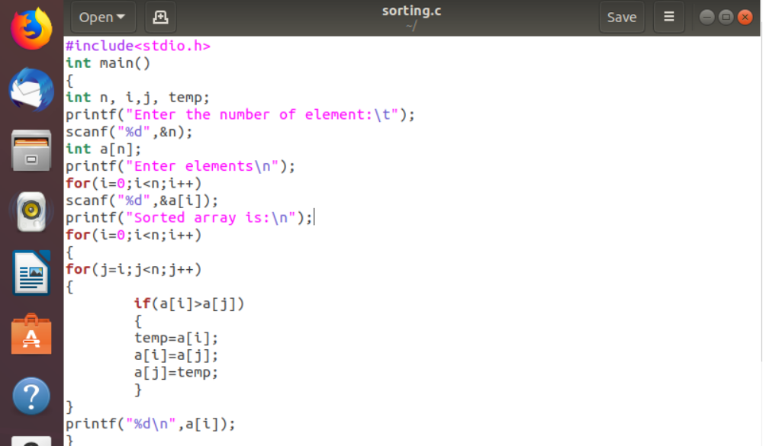

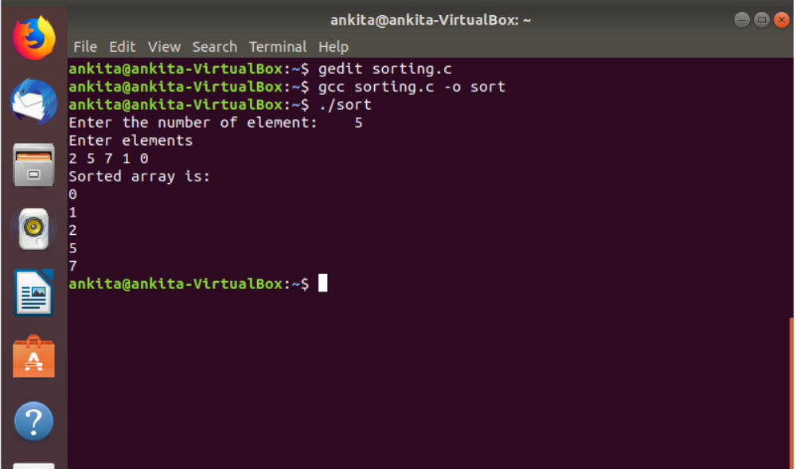
QUESTION NO- 7

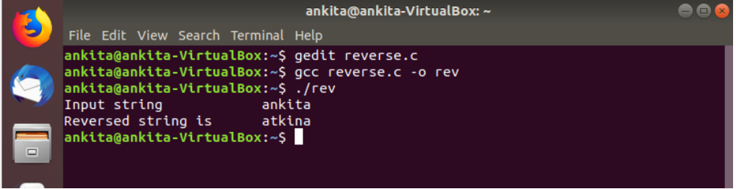
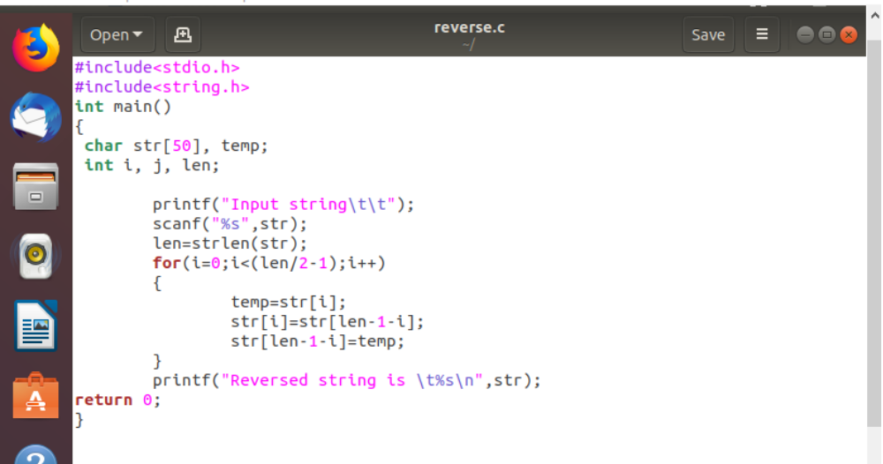
QUESTION NO-9

Commit - committing is the process which records changes in the repository. Think of it as a snapshot of the current status of the project. Commits are done locally.
Push - pushing sends the recent commit history from your local repository up to GitHub. If you're the only one working on a repository, pushing is fairly simple. If there are others accessing the repository, you may need to pull before you can push.
Pull - a pull grabs any changes from the GitHub repository and merges them into your local repository.

QUESTION NO-10

Stashing
Often, when you’ve been working on part of your project, things are in a messy state and you want to switch branches for a bit to work on something else. The problem is, you don’t want to do a commit of half-done work just so you can get back to this point later. The answer to this issue is the git stash command.
Stashing takes the dirty state of your working directory — that is, your modified tracked files and staged changes — and saves it on a stack of unfinished changes that you can reapply at any time.

