CASE STUDY: CLOUD INFRASTRUCTURE AUTOMATION & MONITORING SUITE
Built with Node.js and AWS SDK v3Built with Node.js and AWS SDK v3

1. Executive Summary
This project is a custom-built, end-to-end AWS infrastructure monitoring console. Designed to replace heavy web frameworks with a lightning-fast terminal dashboard, it automatically provisions EC2 instances, establishes CloudWatch metric streams, and configures SNS threat alerting entirely through code using the modern AWS SDK v3 for Node.js.

2. Tech Stack & Architecture
- • Core Language: Node.js
- • Cloud Provider: Amazon Web Services (AWS)
- • SDK: @aws-sdk (v3) modular clients (EC2, CloudWatch, SNS, SSM)
- • Interface: Terminal User Interface (TUI) via blessed & blessed-contrib

3. Engineering Implementation

Phase 1: Dynamic EC2 Provisioning & Network Fallbacks
Instead of relying on hardcoded variables, the system queries the AWS SSM Parameter Store to dynamically resolve the latest Amazon Linux 2023 AMI. Furthermore, a robust network-fallback logic was implemented: if an account lacks a Default VPC, the script intercepts the failure, auto-generates a Default VPC via the SDK, and seamlessly retries the t3.micro server launch.

Phase 2: CloudWatch Metrics & SNS Alert Pipelines
For infrastructure health, the suite fetches 1-hour timelines of CPU, Memory, and Disk networking data. It simultaneously registers an SNS Topic and attaches a programmatic CloudWatch Metric Alarm. If compute load exceeds 80% for 5 minutes, email alerts are dispatched to the operations team.

Phase 3: The Terminal Dashboard (TUI)
The entire system is visualized in the terminal grid layout featuring live EC2 Instance status tables, an animated CPU line chart, and real-time backend action logs to monitor the asynchronous AWS interactions.

4. Project Results & Visuals
The screenshots below demonstrate the application compiling successfully on Windows, successfully making authenticated API requests to AWS, and rendering the TUI matrix.
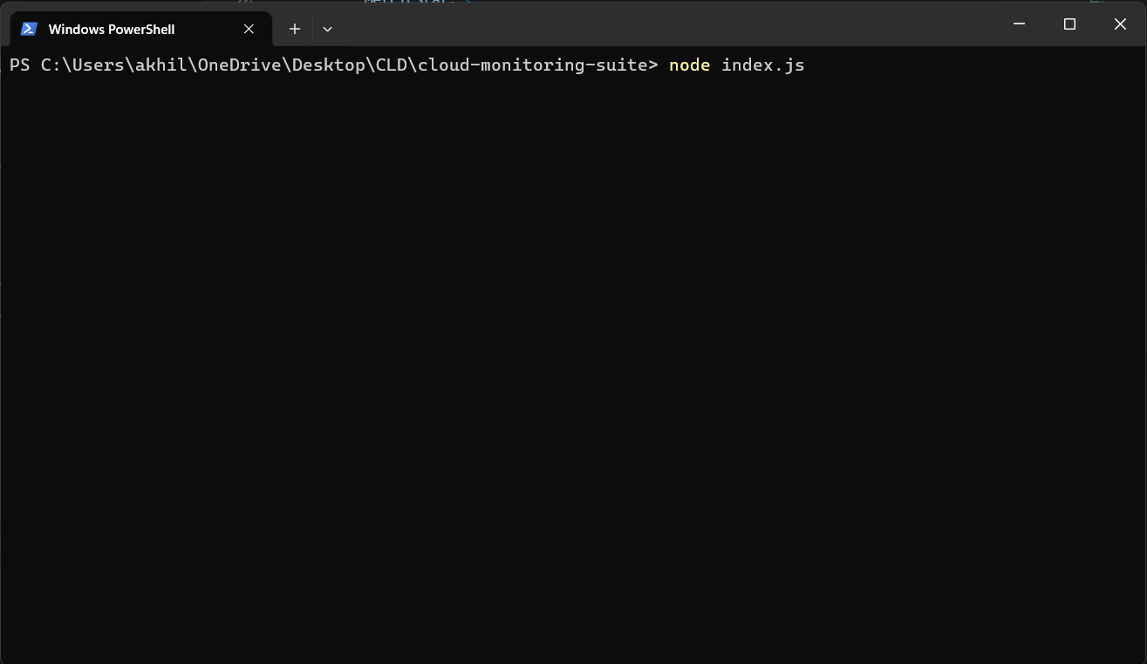
Figure 1: The Initial Dashboard Matrix connecting to the AWS Region.Figure 1: The Initial Dashboard Matrix connecting to the AWS Region.
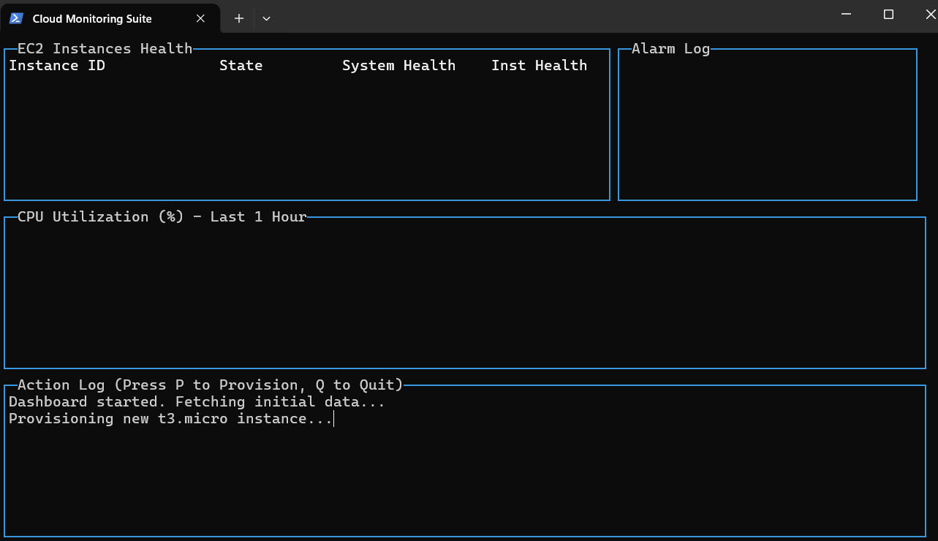
Figure 2: Execution Log showing the provisioning of the t3.micro EC2 Instance.Figure 2: Active execution trace auto-provisioning the t3.micro server.

