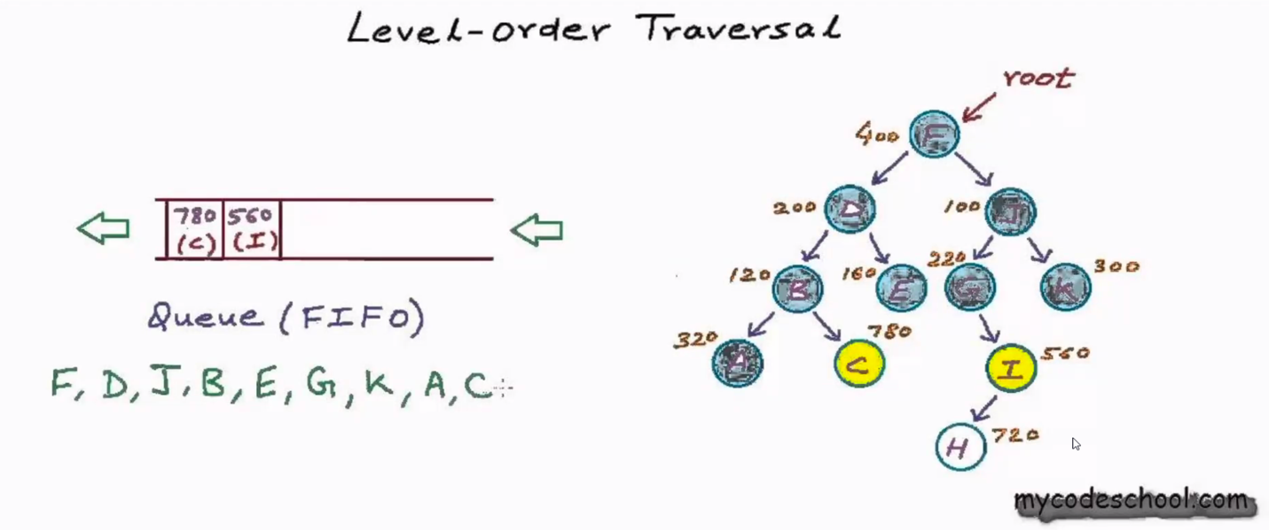

Symmetric Tree:



