**PROJECT PROPOSAL**

Arduino Solar and Soil Sensor

**Alexander Korsunsky**

**Sam Gandolfo-Lucia**

**Tony Tran**

**Jimson Whiskeyman**

[**https://github.com/cis3296s23/05-arduino-light-and-water-sensor**](https://github.com/cis3296s23/05-arduino-light-and-water-sensor)

Table of Contents

Project Proposal 3

Project Abstract 3

High Level Requirement 3

Conceptual Design 3

Proof of Concept 3

Background 3

Required Resources 3

Projet Design 4

Vision 4

Persona Jack, a primary school teacher 4

Persona Emma, a history teacher 4

Class Diagram 5

Project Progress 6

Week 2 Progress 6

## Project Proposal

### Project Abstract

The purpose of this device is to improve community garden’s efficiency by giving average sunlight and soil moisture in a local 1m3 dirt patch. The device utilizes an Arduino chip sensor and will utilize Arduino base code. The unit will be connected to a small metal rod and have two sensors attached for sunlight and moisture. The light sensor is the BH1750 and the moisture sensor is the FC-28 Moisture sensor. All input is serial, and the output will be written to a file that will either be read directly from the COM port or via Wi-Fi.

### High Level Requirement

### Sensors can be placed in various areas in the soil where a user wants to know how much sunlight and moisture is received by plants. The Arduino will log information about the soil moisture and light received at a fixed interval. The user can either plug a device into the Arduino to read the information directly or read it over Wi-Fi.

### Conceptual Design

The COM3 Port in the Arduino chip will take the sensor information and log it inside of a serial file. The sensor Bh1750 and FC28 will report through voltage differentiation for the FC28 or through the BH1750 the ambient light that the sensor reads. The MoistureSensor class will take the information and write the data to the COM port. The LuxSensor class will do the same. The interface for the sensor reader (either a physical connection or connection over Wi-Fi) will take the information and write it to a file.

### Proof of Concept

<https://maker.pro/arduino/projects/arduino-soil-moisture-sensor>

<https://maker.pro/arduino/projects/arduino-soil-moisture-sensor>

### Background

The goal of this project is to be able to provide an organized data package that is able to be sent through a text file to the COM3 port on the Arduino. The data package will contain lux sensor information and moisture sensor information. Later intent of this project is to be able to create a GUI that is easy to read for users, and also implement functionality for sending the data over Wi-Fi.

The Arduino source code are from a tutorial on the websites linked above. They dictate the open source code and all that is required to compile the code is the Arduino software. The websites are shown accredited to an alias of a2 to MakerPro for the moisture sensor, and Christopher Laws’s git repository for the BH1750 Library from also MakerPro. The two tutorials do discuss how they are able to take the readings from both sensors and send them to a serial file.

### Required Resources

* Arduino Uno
* BH1750 Light Sensor
* Adafruit Soil Sensor

## Projet Design

### Vision

The Arduino Solar and Water sensor is for gardeners at every skill level who want the ability to easily and accurately measure the amount of sunlight and water their crops are receiving. It is a soil and sunlight condition monitoring tool that regularly logs data about the amount of moisture in the soil and the amount of sunlight plants in the surrounding area are receiving. Unlike other options, our Solar and Water sensor is highly modular, which means it can be customized to only have sensors in a single area, for beginner gardeners, or be customized to have a whole network of sensors to provide data from a variety of places.

### Persona Alexander, community garden supervisor (written by Alex, week 1)

Alexander, 42, is a community garden supervisor that lives in a borough of Fishtown in Philadelphia, PA. They’ve been raised off of poor options for food quality in their borough. This incentivized themselves to start a community garden in their neighborhood later in life. This is however only their part time job, where their main job takes a large part of their day so they do not have as much time to maintain and administer the garden. They’re technical skills with computers are of the average person, where they can easily browse the web for new crops and manipulate microsoft documents to be able to analyze their spreadsheets of the garden. They are interested in the product of the Arduino Light and Soil Moisture Sensor because it provides them a means to be able to display whether what crops require tending in an easy to display manner. That way, any of the volunteers or other gardeners that come to tend crops are able to do so without asking whether that task has been taken care of for the day or not. There is also further implementation where this could help set a possibility of automated sprinklers in the future for them.

### Persona Melody, professional farmer (written by Sam, week 1)

Melody is a 34 year old farmer who farms both commercially and for self-subsistence. She has been farming for 20 years, but has only been running her own farm for five years. In recent years, the commercial aspects of her farming have taken off, which has caused the amount of crops that she cares for to skyrocket in order to keep up with the demands. Melody has a 35 year old husband and a 2 year old son, and she and her husband are having at least two more children, which means that she will need to allocate more space for the crops dedicated to feeding her family. To ensure high quality, Melody estimates that she spends around two hours every day sampling soil from various areas on her farm to check that the soil is getting the right amount of water, and spends an additional hour or so examining various crops to gauge how much sunlight crops in that general area are receiving.

Melody is not averse to technology, but her technological knowledge is low since she does not have much need for it outside of a phone for everyday use and a laptop for writing and making spreadsheets. Melody would like to obtain several Arduino Water and Solar sensors to place in various areas throughout her farm to cut down on the amount of time she has to spend manually checking how much water and sunlight plants are getting. She likes this option because the technological knowledge needed to use the Water and Solar sensor is low, and the sensors are also unobtrusive, so she will not need to rearrange her crops to accommodate them.

### Persona Jane, community gardener (written by Tony, week 1)

Jane is a long-time resident of the community and an avid gardener. She started volunteering at the community garden three years ago and has been heavily involved ever since. She enjoys growing vegetables and fruits, and she also loves teaching others about gardening.

Jane’s main goal is to help the community garden grow and thrive. She wants to create a welcoming and inclusive environment for everyone to enjoy, regardless of their gardening experience. She also wants to increase the yield of the garden and donate more produce to local food banks and shelters. She also wants to provide an easy and useful way to determine the soil quality and light for each plant.

Jane struggles with the lack of resources and funding for the garden. She also finds it difficult to determine how the soil is for the garden. Plants require different types of soil and lighting to fully fertilize it. Sometimes she feels overwhelmed trying to understand what type of soil and light each plant needs and struggles to relay that information for other people to understand.

Jane is very passionate about gardening and spends a lot of her time at the community garden. She wants to spread knowledge about farming to other people so they can also have gardens of their own at home.

### Persona Charles, exotic plant enthusiast (written by Jimson, week 1)

Charles, 27, is a horticulturist with a background in biology, who specializes in growing exotic flowers. Because of the difficulty of growing foreign plants outside of their natural environment, he is always looking for new ways to make his job easier.

Charles’ main goal is to cultivate an exotic garden, with flowers and shrubs from all over the world. His dream is to be inundated by the scents of the world whenever he strolls through the lush cutaneous growth of his blossoms. He’s got goals for days.

Raising exotic plants is hard. Different genera require different things, and plants are very particular about their environment. Light levels and soil moisture have to be just right, and keeping on top of that is a lot of work.

Charley just wants to help his garden thrive.

**Feature List**

* Reading From light sensor
* Reading from soil sensor
* Reading Arduino COM port and logging sensor data to a text file
* Java GUI for representing the sensor data
* Analyze button that presents averages of each value reported by the sensors in the Java GUI
* Sending data from Arduino over Wi-Fi

### Updated Class Diagram

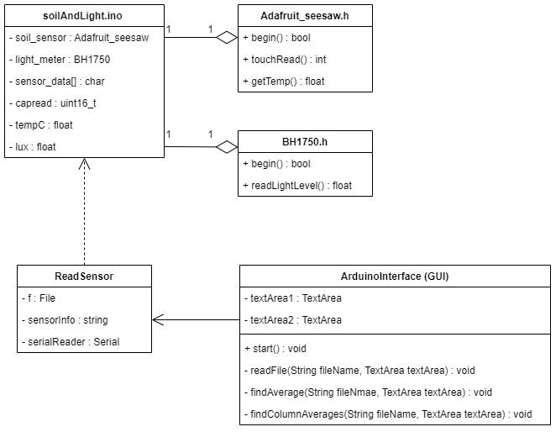

**Description**

This class diagram represents the three main pieces of the program, plus the two libraries required for getting data from the sensors used by the Arduino. soilAndLight.ino is the file that reads data directly from the sensors using the Adafruit_seesaw and BH1750 data types provided by their respective libraries. It then converts the data to a string and sends it to be read by another program

ReadSensor is a small script that reads sensor data from the Arduino and outputs it to a file, which is then read by ArduinoInterface.

ArduinoInterface is a GUI that reads the data logged by ReadSensor and finds the averages for each respective data type logged, which are the soil temperature (in celsius), the soil moisture (a value from 200 to 2000 with higher being more moist), and the light received (a value from 1 to 65535 with higher meaning there is more light). ArduinoInteface provides access to this information by the user through an Analyze button.

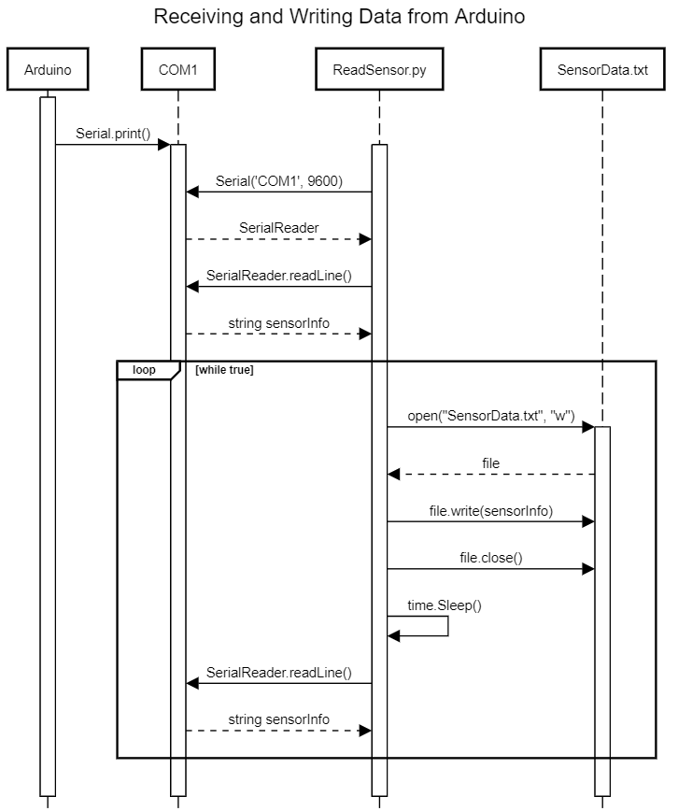

**Description:** This diagram shows the sequence of events that occurs once a user starts the Arduino and runs the ReadSensor.py script. Once started, the Arduino immediately begins sending serial data to the COM port, but none of it is logged until ReadSensor.py starts and begins reading the COM port. When ReadSensor.py starts, it will begin by opening the COM port with a specified baud rate of 9600, then it reads the serial output and converts it into a string that can be written to the log file. After this, the script loops indefinitely reading the output from the Arduino and writing it to the file. However, since the file is closed while the process is sleeping, the logged sensor data can freely be checked by the user.

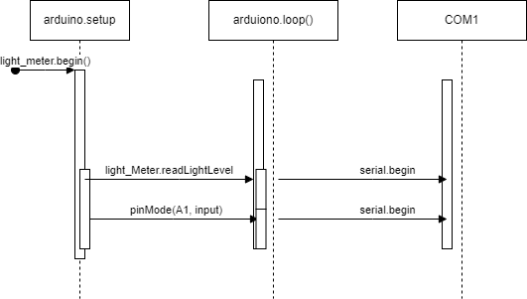

**Description:** This diagram displays the Arduino IDE sending a signal request to the Arduino for serial.begin() at the 9600 baud rate. The loop takes a reading of lux from the sensor and sends the signal to the com4 port connected to the Arduino.

## Project Progress

### Week 2 Progress

**Sprint Goal:** Acquire sensors and an Arduino and work on the skeleton code for reading information from the sensors using the COM port.

**Backlog Features**

* Create Java GUI for the data read by the sensors.
* Send data from the Arduino over Wi-Fi.
* Acquire breadboard and other miscellaneous connectors for the Arduino.
* Combine soil sensor and light sensor reading/writing

**Tasks in Sprint Task Status at end of Sprint Assigned To**

|  |  |  |
| --- | --- | --- |
| Research and acquire light sensor | Complete | Alex |
| Create class diagram | Complete | Alex |
| Write code to read solar sensor | Complete | Alex/Jimson |
| Run demo of solar sensor | Complete | Alex/Jimson |
| Research and acquire soil sensor | Complete | Sam/Jimson |
| Write code to read soil sensor | Complete | Sam |
| Update proposal | Complete | Sam |
| Research and acquire Wi-Fi module | In Progress | Jimson |
| Wire solar sensor to the Arduino | Complete | Jimson |
| Assign tasks on project board | Complete | Tony |
| Keep track of progress during sprint using project board | Complete | Tony |

### Week 3 Progress

**Sprint Goal:** The goal for this sprint was to achieve functionality with the soil moisture sensor, and research/implement a system for converting the serial output from the arduino to a text file. Another goal was to create a graphic interface for displaying the contents of the file containing sensor data.

**Backlog Features**

* Java GUI sensor analysis
* Simultaneous reading/writing from sensors
* Sending data over Wi-Fi

**Tasks in Sprint Task Status at end of Sprint Assigned To**

|  |  |  |
| --- | --- | --- |
| Acquire breadboard -size 2 | Complete | Alex |
| Create Java GUI - size 8 | Complete | Tony |
| Create sequence diagrams - size 3 | Complete | Sam and Alex |
| Test soil sensor - size 3 | Complete | Jimson |
| Write script for reading serial Arduino output and logging it to a file - size 3 | Complete | Sam |
| Create example presentation test case - size 3 | In Progresss | Alex |
| Test simultaneous sensor functionality - size 5 | In Progress | Jimson |
| Writing for scrum progress - size 3 | Complete | Alex and Sam |
| Send data from the Arduino over Wi-Fi. - 8 | In Progress | Jimson and Sam |

**Estimated velocity:** (2 + 8 + 3 + 3 + 3 + 5 + 3 + 8) / 7 = 35/7 = 5

**Actual velocity:** (2 + 8 + 3 + 3 + 3 + 5 + 3) / 7 = 27/7 = 3.86

### Week 4 Progress

**Sprint Goal:** The main goal for this sprint is to get everything we have done up to this point working together cohesively. This means getting both sensors connected to the Arduino reading data simultaneously and sending the data as a single unit, as well as getting the Java GUI to properly analyze and display the information.

For the most part all of this was accomplished, though a few small fixes are still needed in soilAndLight.ino to optimize how the data is processed and sent.

**Backlog Features**

**Tasks in Sprint Task Status at end of Sprint Assigned To**

|  |  |  |
| --- | --- | --- |
| Write new code for reading both sensors at the same time - size 5 | In Progress (small fixes still required) | Sam |
| Java GUI data Analysis - size 5 | Complete | Tony |
| Create new UML class diagram - size 2 | Complete | Sam |
| Test simultaneous sensor functionality with ReadSensor.py - size 5 | Complete | Alex/Sam/Jimson |
| Convert float values read by sensors into strings to be read by ReadSensor.py - size 2 | Complete | Alex |
| Write test cases and generate report - size 2 | Complete | Tony |
| Fix error reporting temperature value - size 3 | Complete | Alex |
| Writing for scrum progress - size 3 | Complete | Sam |
| Send data from the Arduino over Wi-Fi. - 8 | In Progress | Jimson and Sam |
| Physical wiring and setup of both sensors to the Arduino - size 3 | Complete | Jimson |

**Estimated velocity:** (5 + 5 + 2 + 5 + 2 + 2 + 3 + 3 + 8 + 3) / 7 = 38/7 = 5.43

**Actual velocity:** (5 + 2 + 5 + 2 + 2 + 3 + 3) / 7 = 21/7 = 3

**Test Results**

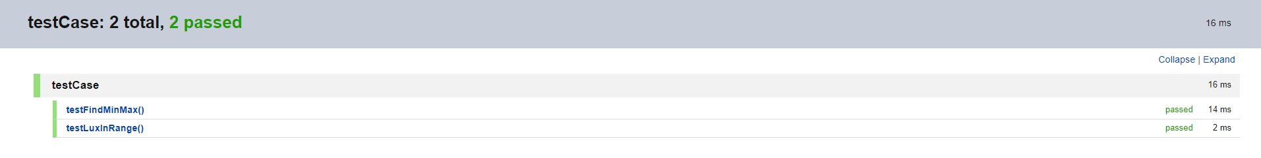

We only have two tests at this time because there is not a lot to test with the Arduino. The purpose of these tests is to verify that the sensors are working properly by ensuring that they are not reading values that are outside of the range of possible values. For example, if the lux sensor reads a value that is less than 1 or greater than 65535 the testLuxInRage() test will fail, otherwise it will pass.

**Final Class Diagram**

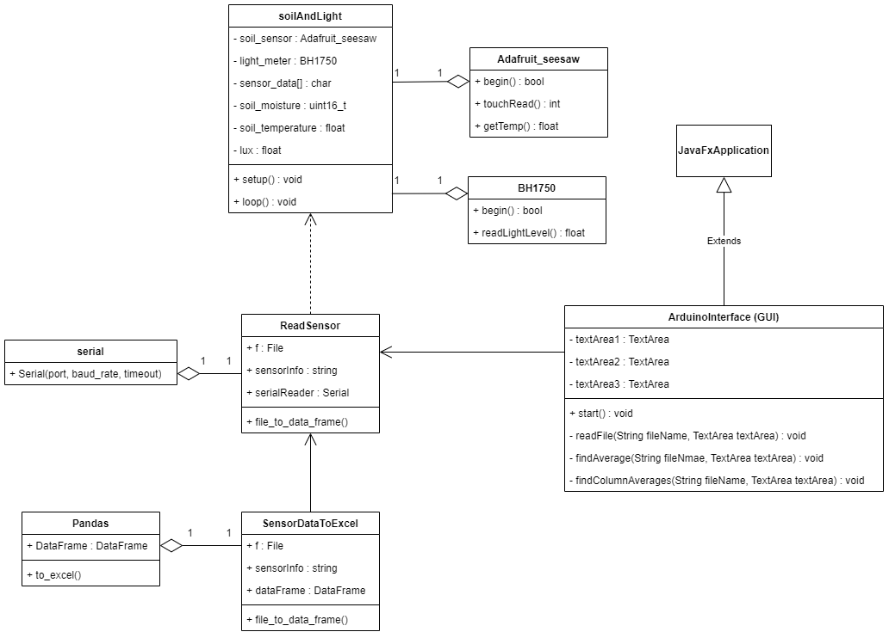

**Detailed Design API**

