TANAY SHRIVAS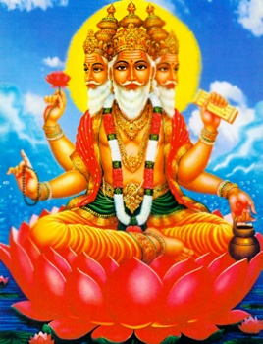TAVA IS MY NAME