Project2501

2023-04-28

## R Markdown

This is an R Markdown document. Markdown is a simple formatting syntax for authoring HTML, PDF, and MS Word documents. For more details on using R Markdown see <http://rmarkdown.rstudio.com>.

When you click the **Knit** button a document will be generated that includes both content as well as the output of any embedded R code chunks within the document. You can embed an R code chunk like this:

library(dplyr)

##   
## Attaching package: 'dplyr'

## The following objects are masked from 'package:stats':  
##   
## filter, lag

## The following objects are masked from 'package:base':  
##   
## intersect, setdiff, setequal, union

library(ggplot2)

## Warning: package 'ggplot2' was built under R version 4.2.3

library(coinmarketcapr)

## Warning: package 'coinmarketcapr' was built under R version 4.2.3

library(purrr)  
library(ggthemes)  
  
# Set API key for CoinMarketCap  
apikey <- "ed1842ab-58c3-4cc1-a11c-8b3fa6e10b80"  
coinmarketcapr::setup(apikey)  
  
# Get top 20 cryptocurrencies by market cap  
crypto_list <- get_crypto_listings(limit = 20)  
  
# Calculate market dominance percentages for the top 3 cryptocurrencies  
top3_dominance <- crypto_list %>%   
 slice(1:3) %>%   
 mutate(market_cap_percentage = USD_market_cap_dominance / sum(USD_market_cap_dominance) * 100) %>%   
 select(symbol, market_cap_percentage)  
  
# Calculate market dominance percentages for all other cryptocurrencies  
others_dominance <- crypto_list %>%   
 slice(4:n()) %>%   
 summarize(market_cap_percentage = sum(USD_market_cap_dominance) / sum(crypto_list$USD_market_cap_dominance) * 100) %>%   
 mutate(symbol = "Others")  
  
# Combine the top 3 and "Others" data  
market_dominance <- bind_rows(top3_dominance, others_dominance)  
  
# Create a pie chart of the market dominance data  
ggplot(market_dominance, aes(x = "", y = market_cap_percentage, fill = symbol)) +  
 geom_bar(stat = "identity", width = 1, color = "white", size = 0.5) +  
 coord_polar(theta = "y") +  
 theme_void() +  
 scale_fill_manual(values = c("#F7931A", "darkblue", "darkred", "darkgreen")) +  
 labs(title = "Market Dominance of Cryptocurrencies",  
 fill = "Cryptocurrency",  
 x = NULL,  
 y = NULL) +  
 geom_text(aes(label = paste(round(market_cap_percentage, 1), "%")),   
 position = position_stack(vjust = 0.5),   
 color = "white", size = 3, fontface = "italic")

## Warning: Using `size` aesthetic for lines was deprecated in ggplot2 3.4.0.  
## ℹ Please use `linewidth` instead.  
## This warning is displayed once every 8 hours.  
## Call `lifecycle::last_lifecycle_warnings()` to see where this warning was  
## generated.

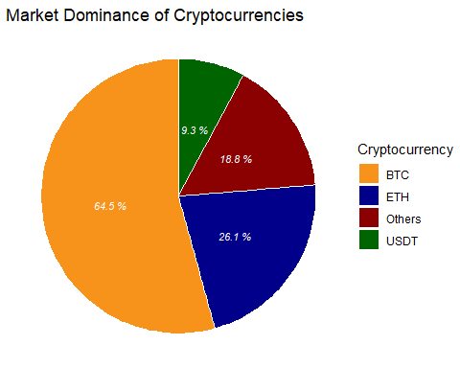

## Including Plots

You can also embed plots, for example:

# Load crypto2 library  
library(crypto2)  
  
  
  
# Get historical data for BTC, ETH, DOGE and XRP  
#coins <- c("BTC", "ETH", "DOGE", "XRP")  
coins <- crypto_list(only_active=TRUE) |> filter(symbol %in% c("BTC", "ETH", "XRP", "DOGE"))  
coin_hist <- crypto_history(coins, limit=4, start_date="20220101", end_date="20230331", finalWait=FALSE) #15months

## ❯ Scraping historical crypto data

##

## ❯ Processing historical crypto data

##

coin_hist$date <- as.Date(coin_hist$timestamp)  
  
  
  
# View data  
head(coin_hist)

## # A tibble: 6 × 17  
## timestamp id slug name symbol ref_cur open high low  
## <dttm> <int> <chr> <chr> <chr> <chr> <dbl> <dbl> <dbl>  
## 1 2022-01-01 23:59:59 1 bitcoin Bitcoin BTC USD 46312. 47827. 46288.  
## 2 2022-01-02 23:59:59 1 bitcoin Bitcoin BTC USD 47681. 47881. 46857.  
## 3 2022-01-03 23:59:59 1 bitcoin Bitcoin BTC USD 47344. 47511. 45836.  
## 4 2022-01-04 23:59:59 1 bitcoin Bitcoin BTC USD 46459. 47407. 45752.  
## 5 2022-01-05 23:59:59 1 bitcoin Bitcoin BTC USD 45899. 46929. 42798.  
## 6 2022-01-06 23:59:59 1 bitcoin Bitcoin BTC USD 43566. 43749. 42646.  
## # ℹ 8 more variables: close <dbl>, volume <dbl>, market_cap <dbl>,  
## # time_open <dttm>, time_close <dttm>, time_high <dttm>, time_low <dttm>,  
## # date <date>

Note that the echo = FALSE parameter was added to the code chunk to prevent printing of the R code that generated the plot.

# Load crypto2 library  
  
BTC_hist <- filter(coin_hist, id == 1)  
ETH_hist <- filter(coin_hist, id == 1027)  
XRP_hist <- filter(coin_hist, id == 52)  
DOGE_hist <- filter(coin_hist, id == 74)  
  
  
  
ggplot(coin_hist, aes(x = date, y = close, color = name)) +  
 geom_line(size = 0.5) + # set line thickness to 1.5  
 scale_y_log10() + # set y-axis to log scale  
 ggtitle("Historical Prices of BTC, ETH, and XRP (LOG Scale)") +  
 labs(x = "Date", y = "Closing Price (USD) [log]") +  
 theme_minimal() + # apply a minimalist theme  
 theme(plot.title = element_text(size = 18, face = "bold", hjust = 0.5),  
 axis.text = element_text(size = 12),  
 axis.title = element_text(size = 14))

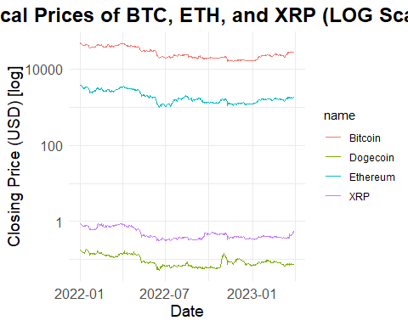

# Create line graph of closing prices over time for Bitcoin  
ggplot(BTC_hist, aes(x = date, y = close)) +  
 geom_line(size = 0.5, color = "orange") +  
 ggtitle("Historical Prices of Bitcoin") +  
 xlab("Date") +  
 ylab("Closing Price (USD)") +  
 theme_minimal()

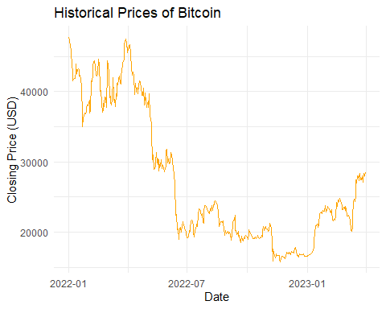

# Create line graph of closing prices over time for Ethereum  
ggplot(ETH_hist, aes(x = date, y = close)) +  
 geom_line(size = 0.5, color = "blue") +  
 ggtitle("Historical Prices of Ethereum") +  
 xlab("Date") +  
 ylab("Closing Price (USD)") +  
 theme_minimal()

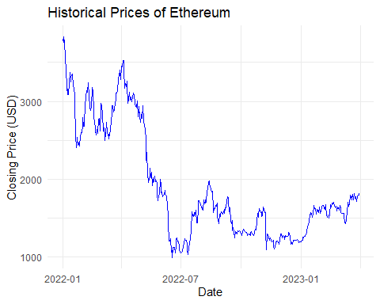

# Create line graph of closing prices over time for Ripple  
ggplot(XRP_hist, aes(x = date, y = close)) +  
 geom_line(size = 0.5, color = "darkgreen") +  
 ggtitle("Historical Prices of Ripple") +  
 xlab("Date") +  
 ylab("Closing Price (USD)") +  
 theme_minimal()

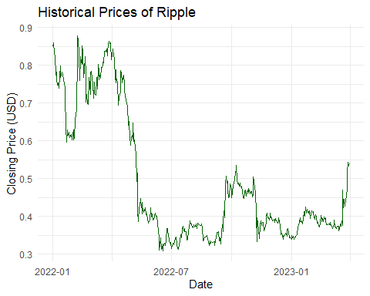

# Create line graph of closing prices over time for Dogecoin  
ggplot(DOGE_hist, aes(x = date, y = close)) +  
 geom_line(size = 0.5, color = "red") +  
 ggtitle("Historical Prices of Dogecoin") +  
 xlab("Date") +  
 ylab("Closing Price (USD)") +  
 theme_minimal()

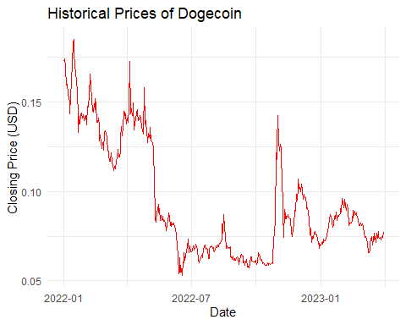

# Combine the four boxplots into one  
library(tidyr)  
# Calculate daily percentage change in closing prices for each coin  
BTC_pct_change <- c(NA, diff(BTC_hist$close)/BTC_hist$close[-nrow(BTC_hist)])  
ETH_pct_change <- c(NA, diff(ETH_hist$close)/ETH_hist$close[-nrow(ETH_hist)])  
XRP_pct_change <- c(NA, diff(XRP_hist$close)/XRP_hist$close[-nrow(XRP_hist)])  
DOGE_pct_change <- c(NA, diff(DOGE_hist$close)/DOGE_hist$close[-nrow(DOGE_hist)])  
  
# Combine percentage change data into a single data frame  
pct_change <- data.frame(date = BTC_hist$date,  
 BTC = BTC_pct_change,  
 ETH = ETH_pct_change,  
 XRP = XRP_pct_change,  
 DOGE = DOGE_pct_change)  
  
# Reshape the data frame from wide to long format  
pct_change_long <- pivot_longer(pct_change, cols = -date, names_to = "coin", values_to = "pct_change")  
  
# Create a single boxplot of daily percentage change in closing prices for each coin  
ggplot(pct_change_long, aes(x = coin, y = pct_change, fill = coin)) +  
 geom_boxplot() +  
 ggtitle("Volatility of Cryptocurrencies(Daily Closing prices)") +  
 xlab("Coin") +  
 ylab("Daily Percentage Change") +  
 scale_fill_manual(values = c("orange", "blue", "green", "red")) +  
 theme_minimal() + coord_flip()

## Warning: Removed 4 rows containing non-finite values (`stat_boxplot()`).

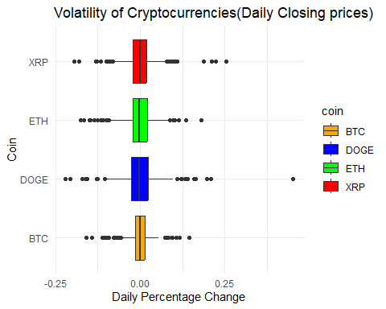 …………………………………………………………………………………………….

# Calculate daily volatility using high and low prices for each coin  
BTC_volatility <- (BTC_hist$high - BTC_hist$low) / BTC_hist$low  
ETH_volatility <- (ETH_hist$high - ETH_hist$low) / ETH_hist$low  
XRP_volatility <- (XRP_hist$high - XRP_hist$low) / XRP_hist$low  
DOGE_volatility <- (DOGE_hist$high - DOGE_hist$low) / DOGE_hist$low  
  
# Combine volatility data into a single data frame  
volatility <- data.frame(date = BTC_hist$date,  
 BTC = BTC_volatility,  
 ETH = ETH_volatility,  
 XRP = XRP_volatility,  
 DOGE = DOGE_volatility)  
  
# Reshape data for plotting  
volatility_long <- pivot_longer(volatility, cols = -date, names_to = "coin", values_to = "volatility")  
  
# Create a single plot with separate panels for each coin  
ggplot(volatility_long, aes(x = date, y = volatility, color = coin)) +  
 geom_line(size = 0.5) +  
 facet_wrap(~coin, ncol = 2) +  
 xlab("Date") +  
 ylab("Daily Volatility") +  
 ggtitle("Daily Volatility of Cryptocurrencies (Using daily Highs and Lows)") +  
 theme_minimal() +  
 scale_color_manual(values = c("orange", "blue", "green", "red"))

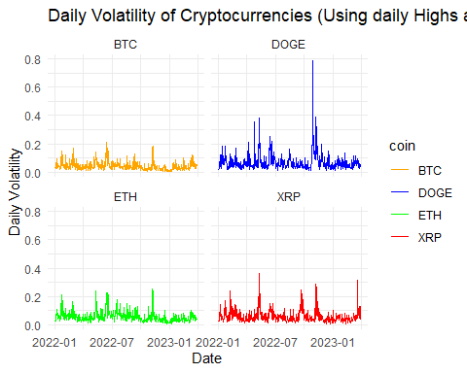 ……………………………………………………………………..

# Join the data by timestamp  
coin_join <- full_join(BTC_hist, ETH_hist, by = "timestamp", suffix = c("_BTC", "_ETH")) %>%  
 full_join(XRP_hist, by = "timestamp") %>%  
 full_join(DOGE_hist, by = "timestamp", suffix = c("_XRP", "_DOGE"))  
  
# Select only the closing prices and rename the columns  
coin_close <- coin_join %>%  
 select(timestamp, close_BTC, close_ETH, close_XRP, close_DOGE) %>%  
 rename(BTC = close_BTC, ETH = close_ETH, XRP = close_XRP, DOGE = close_DOGE)  
  
# Calculate the correlation matrix  
coin_corr <- cor(coin_close[-1])  
  
# Print the correlation matrix  
print(coin_corr)

## BTC ETH XRP DOGE  
## BTC 1.0000000 0.9756381 0.9152283 0.8592428  
## ETH 0.9756381 1.0000000 0.9206926 0.8957089  
## XRP 0.9152283 0.9206926 1.0000000 0.8739963  
## DOGE 0.8592428 0.8957089 0.8739963 1.0000000

library(reshape2)

## Warning: package 'reshape2' was built under R version 4.2.3

##   
## Attaching package: 'reshape2'

## The following object is masked from 'package:tidyr':  
##   
## smiths

# Melt the correlation matrix for ggplot  
coin_corr_melt <- melt(coin_corr)  
  
# Plot the heatmap  
ggplot(coin_corr_melt, aes(x = Var1, y = Var2, fill = value)) +  
 geom_tile() +  
 scale_fill_gradient2(low = "darkgreen", mid = "yellow", high = "darkred", midpoint = 0.9) +  
 theme_minimal() +  
 theme(axis.text.x = element_text(angle = 45, vjust = 1, hjust = 1),  
 panel.grid = element_blank()) +  
 labs(title = "Cryptocurrency Correlations (Daily Closing Price)",  
 x = "Cryptocurrency",  
 y = "Cryptocurrency",  
 fill = "Correlation") +  
 coord_fixed()

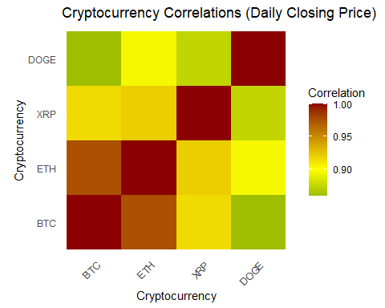 …………………………………………………………………………………

library(prophet)

## Warning: package 'prophet' was built under R version 4.2.3

## Loading required package: Rcpp

## Loading required package: rlang

## Warning: package 'rlang' was built under R version 4.2.3

##   
## Attaching package: 'rlang'

## The following objects are masked from 'package:purrr':  
##   
## %@%, flatten, flatten_chr, flatten_dbl, flatten_int, flatten_lgl,  
## flatten_raw, invoke, splice

# Filter the training data from 20220101 to 20221231  
BTC_train <- BTC_hist %>% filter(date >= as.Date("2022-01-01") & date <= as.Date("2022-12-31"))  
  
# Filter the test data from 20230101 to 20230331  
BTC_test <- BTC_hist %>% filter(date >= as.Date("2023-01-01") & date <= as.Date("2023-03-31"))  
  
# Prepare the dataset for Prophet (rename columns to 'ds' and 'y')  
BTC_prophet <- BTC_train %>% select(date, close) %>% rename(ds = date, y = close)  
  
# Create a Prophet model  
model <- prophet(BTC_prophet)

## Disabling yearly seasonality. Run prophet with yearly.seasonality=TRUE to override this.

## Disabling daily seasonality. Run prophet with daily.seasonality=TRUE to override this.

# Make predictions for the next 90 days (3 months)  
future_dates <- make_future_dataframe(model, periods = 90)  
forecast <- predict(model, future_dates)  
  
# Combine the test data with the predictions  
BTC_test_pred <- BTC_test %>% select(date, close) %>% left_join(forecast %>% select(ds, yhat), by = c("date" = "ds"))  
  
# Calculate the Mean Absolute Percentage Error (MAPE)  
MAPE <- mean(abs((BTC_test_pred$close - BTC_test_pred$yhat) / BTC_test_pred$close)) * 100  
print(paste("MAPE:", MAPE))

## [1] "MAPE: 32.7284017202559"

# Convert the date column to POSIXct format  
BTC_test_pred$date <- as.POSIXct(BTC_test_pred$date)  
  
# Plot the actual data and forecast  
plot(model, forecast) +  
 geom_point(aes(x = date, y = close), data = BTC_test_pred, color = "red") +  
 theme_minimal() +  
 labs(title = "Bitcoin Price Forecast with Prophet 2022-2023",  
 subtitle = paste("MAPE =", round(MAPE, 2), "%"))

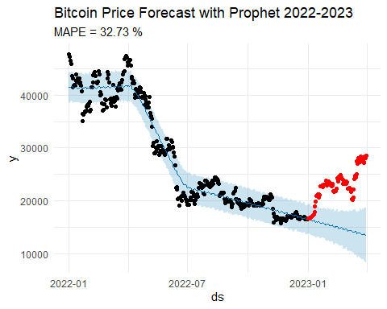

# Plot the forecast components  
prophet_plot_components(model, forecast)

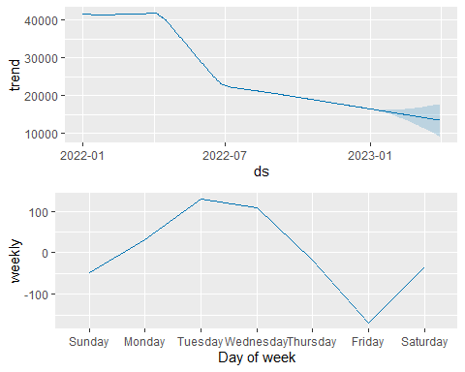 …………………………………..

coins2 <- crypto_list(only_active=TRUE) |> filter(symbol %in% c("BTC"))  
BTC_histPro <- crypto_history(coins2, limit=1, start_date="20140101", end_date="20230331", finalWait=FALSE) #15months

## ❯ Scraping historical crypto data

##

## ❯ Processing historical crypto data

##

BTC_histPro$date <- as.Date(BTC_histPro$timestamp)  
  
# Filter the training data from 20220101 to 20221231  
BTC_train2 <- BTC_histPro %>% filter(date >= as.Date("2014-01-01") & date <= as.Date("2020-12-31"))  
  
# Filter the test data from 20230101 to 20230331  
BTC_test2 <- BTC_histPro %>% filter(date >= as.Date("2021-01-01") & date <= as.Date("2023-03-31"))  
  
# Prepare the dataset for Prophet (rename columns to 'ds' and 'y')  
BTC_prophet2 <- BTC_train2 %>% select(date, close) %>% rename(ds = date, y = close)  
  
# Create a Prophet model  
model2 <- prophet(BTC_prophet2)

## Disabling daily seasonality. Run prophet with daily.seasonality=TRUE to override this.

# Make predictions for the next 365 days  
future_dates2 <- make_future_dataframe(model2, periods = 820)  
forecast2 <- predict(model2, future_dates2)  
  
# Combine the test data with the predictions  
BTC_test_pred2 <- BTC_test2 %>% select(date, close) %>% left_join(forecast2 %>% select(ds, yhat), by = c("date" = "ds"))  
  
# Calculate the Mean Absolute Percentage Error (MAPE)  
MAPE2 <- mean(abs((BTC_test_pred2$close - BTC_test_pred2$yhat) / BTC_test_pred2$close)) * 100  
print(paste("MAPE:", MAPE2))

## [1] "MAPE: 43.8876376453523"

# Convert the date column to POSIXct format  
BTC_test_pred2$date <- as.POSIXct(BTC_test_pred2$date)  
  
# Plot the actual data and forecast  
plot(model2, forecast2) +  
 geom_point(aes(x = date, y = close), data = BTC_test_pred2, color = "red") +  
 theme_minimal() +  
 labs(title = "Bitcoin Price Forecast with Prophet 2014-2023",  
 subtitle = paste("MAPE =", round(MAPE2, 2), "%"))

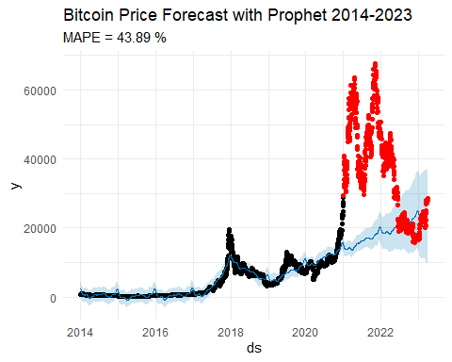

# Plot the forecast components  
prophet_plot_components(model2, forecast2)

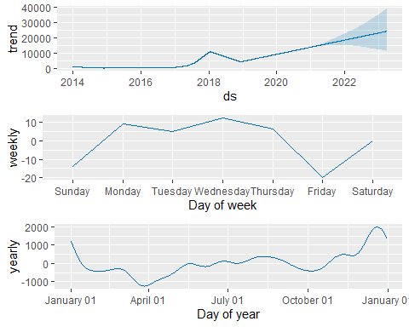 ………………………………………………..

library(prophet)  
  
# Get the Dogecoin price data  
coins3 <- crypto_list(only_active = TRUE) |> filter(symbol %in% c("DOGE"))  
DOGE_histPro <- crypto_history(coins3, limit = 1, start_date = "20140101", end_date = "20230331", finalWait = FALSE)

## ❯ Scraping historical crypto data

##

## ❯ Processing historical crypto data

##

DOGE_histPro$date <- as.Date(DOGE_histPro$timestamp)  
  
# Filter the training data from 2014-01-01 to 2022-03-31  
DOGE_train <- DOGE_histPro %>% filter(date >= as.Date("2014-01-01") & date <= as.Date("2020-12-31"))  
  
# Filter the test data from 2022-04-01 to 2023-03-31  
DOGE_test <- DOGE_histPro %>% filter(date >= as.Date("2021-01-01") & date <= as.Date("2023-03-31"))  
  
# Prepare the dataset for Prophet (rename columns to 'ds' and 'y')  
DOGE_prophet <- DOGE_train %>% select(date, close) %>% rename(ds = date, y = close)  
  
# Create a Prophet model  
model <- prophet(DOGE_prophet)

## Disabling daily seasonality. Run prophet with daily.seasonality=TRUE to override this.

# Make predictions for the next 365 days  
future_dates <- make_future_dataframe(model, periods = 820)  
forecast <- predict(model, future_dates)  
  
# Combine the test data with the predictions  
DOGE_test_pred <- DOGE_test %>% select(date, close) %>% left_join(forecast %>% select(ds, yhat), by = c("date" = "ds"))  
  
# Calculate the Mean Absolute Percentage Error (MAPE)  
MAPE <- mean(abs((DOGE_test_pred$close - DOGE_test_pred$yhat) / DOGE_test_pred$close)) * 100  
print(paste("MAPE:", MAPE))

## [1] "MAPE: 95.4760913763684"

# Convert the date column to POSIXct format  
DOGE_test_pred$date <- as.POSIXct(DOGE_test_pred$date)  
  
# Plot the actual data and forecast  
plot(model, forecast) +  
 geom_point(aes(x = date, y = close), data = DOGE_test_pred, color = "red") +  
 theme_minimal() +  
 labs(title = "Dogecoin Price Forecast with Prophet 2014-2023",  
 subtitle = paste("MAPE =", round(MAPE, 2), "%"))

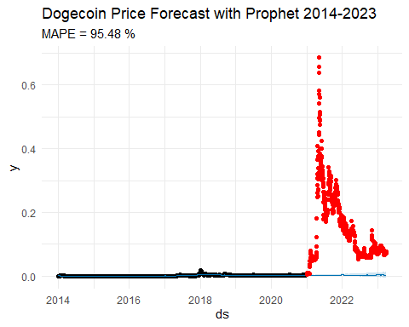

# Plot the forecast components  
prophet_plot_components(model, forecast)

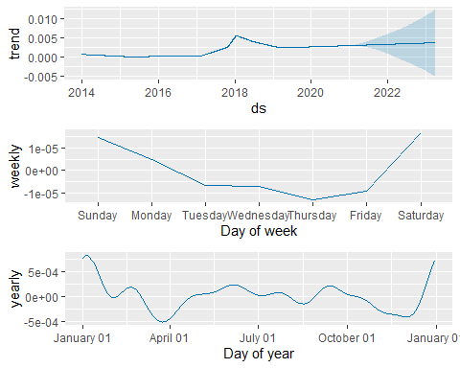

library(prophet)  
  
# Get the Dogecoin price data  
coins3 <- crypto_list(only_active = TRUE) |> filter(symbol %in% c("DOGE"))  
DOGE_histPro <- crypto_history(coins3, limit = 1, start_date = "20140101", end_date = "20230331", finalWait = FALSE)

## ❯ Scraping historical crypto data

##

## ❯ Processing historical crypto data

##

DOGE_histPro$date <- as.Date(DOGE_histPro$timestamp)  
  
# Filter the training data from 2014-01-01 to 2022-03-31  
DOGE_train <- DOGE_histPro %>% filter(date >= as.Date("2022-01-01") & date <= as.Date("2022-12-31"))  
  
# Filter the test data from 2022-04-01 to 2023-03-31  
DOGE_test <- DOGE_histPro %>% filter(date >= as.Date("2023-01-01") & date <= as.Date("2023-03-31"))  
  
# Prepare the dataset for Prophet (rename columns to 'ds' and 'y')  
DOGE_prophet <- DOGE_train %>% select(date, close) %>% rename(ds = date, y = close)  
  
# Create a Prophet model  
model <- prophet(DOGE_prophet)

## Disabling yearly seasonality. Run prophet with yearly.seasonality=TRUE to override this.

## Disabling daily seasonality. Run prophet with daily.seasonality=TRUE to override this.

# Make predictions for the next 365 days  
future_dates <- make_future_dataframe(model, periods = 90)  
forecast <- predict(model, future_dates)  
  
# Combine the test data with the predictions  
DOGE_test_pred <- DOGE_test %>% select(date, close) %>% left_join(forecast %>% select(ds, yhat), by = c("date" = "ds"))  
  
# Calculate the Mean Absolute Percentage Error (MAPE)  
MAPE <- mean(abs((DOGE_test_pred$close - DOGE_test_pred$yhat) / DOGE_test_pred$close)) * 100  
print(paste("MAPE:", MAPE))

## [1] "MAPE: 24.2884677557298"

# Convert the date column to POSIXct format  
DOGE_test_pred$date <- as.POSIXct(DOGE_test_pred$date)  
  
# Plot the actual data and forecast  
plot(model, forecast) +  
 geom_point(aes(x = date, y = close), data = DOGE_test_pred, color = "red") +  
 theme_minimal() +  
 labs(title = "Dogecoin Price Forecast with Prophet 2022-2023",  
 subtitle = paste("MAPE =", round(MAPE, 2), "%"))

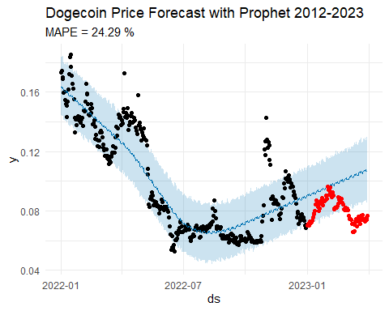

# Plot the forecast components  
prophet_plot_components(model, forecast)

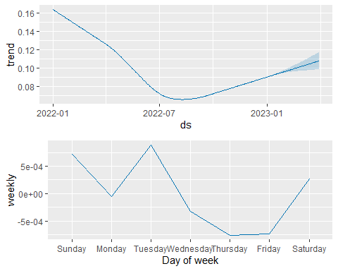

library(randomForest)

## Warning: package 'randomForest' was built under R version 4.2.3

## randomForest 4.7-1.1

## Type rfNews() to see new features/changes/bug fixes.

##   
## Attaching package: 'randomForest'

## The following object is masked from 'package:ggplot2':  
##   
## margin

## The following object is masked from 'package:dplyr':  
##   
## combine

# Get the Bitcoin price data  
coins <- crypto_list(only_active = TRUE) %>% filter(symbol == "BTC")  
BTC_hist <- crypto_history(coins, limit = 1, start_date = "20140101", end_date = "20230331", finalWait = FALSE)

## ❯ Scraping historical crypto data

##

## ❯ Processing historical crypto data

##

BTC_hist$date <- as.Date(BTC_hist$timestamp)  
  
# Filter the training data from 2014-01-01 to 2020-12-31  
BTC_train <- BTC_hist %>% filter(date >= as.Date("2014-01-01") & date <= as.Date("2020-12-31"))  
  
# Filter the test data from 2021-01-01 to 2023-03-31  
BTC_test <- BTC_hist %>% filter(date >= as.Date("2021-01-01") & date <= as.Date("2023-03-31"))  
  
# Prepare the training data  
BTC_train_rf <- BTC_train %>% select(date, close)  
BTC_train_rf$date <- as.numeric(BTC_train_rf$date)  
  
# Train the random forest model  
model_rf <- randomForest(close ~ date, data = BTC_train_rf)  
  
# Prepare the test data  
BTC_test_rf <- BTC_test %>% select(date, close)  
BTC_test_rf$date <- as.numeric(BTC_test_rf$date)  
  
# Make predictions for the test data  
BTC_test_pred_rf <- predict(model_rf, newdata = BTC_test_rf)  
  
# Calculate the Mean Absolute Percentage Error (MAPE)  
MAPE_rf <- mean(abs((BTC_test_rf$close - BTC_test_pred_rf) / BTC_test_rf$close)) * 100  
print(paste("MAPE:", MAPE_rf))

## [1] "MAPE: 35.6854563528149"

# Combine the training and test data  
BTC_all <- rbind(BTC_train_rf, BTC_test_rf)  
BTC_all$date <- as.Date(BTC_all$date, origin = "1970-01-01")  
  
# Add a column to indicate whether the data is training or test data  
BTC_all$type <- ifelse(BTC_all$date %in% BTC_train_rf$date, "Training", "Test")  
  
# Add a column for the predicted values  
BTC_all$forecast <- ifelse(BTC_all$type == "Training", NA, BTC_test_pred_rf)  
  
# Plot the actual data and forecast  
forecast_plot_rf <- ggplot(BTC_all, aes(x = date, y = close)) +  
 geom_line(aes(color = type), size = 1) +  
 geom_line(aes(x = date, y = forecast, color = "Forecast"), size = 1) +  
 xlab("Date") +  
 ylab("Price") +  
 ggtitle("Bitcoin Price Forecast with Random Forests 2014-2023") +  
 labs(caption = paste("MAPE =", round(MAPE_rf, 2), "%")) +  
 scale_color_manual(values = c("Training" = "black", "Test" = "red", "Forecast" = "blue")) + theme_minimal()  
  
print(forecast_plot_rf)

## Warning: Removed 2557 rows containing missing values (`geom_line()`).

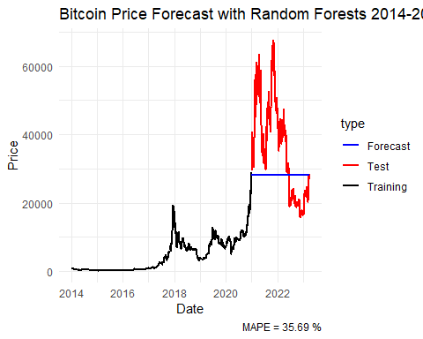

# Load the forecast package  
library(forecast)

## Warning: package 'forecast' was built under R version 4.2.3

## Registered S3 method overwritten by 'quantmod':  
## method from  
## as.zoo.data.frame zoo

library(xts)

## Warning: package 'xts' was built under R version 4.2.3

## Loading required package: zoo

## Warning: package 'zoo' was built under R version 4.2.3

##   
## Attaching package: 'zoo'

## The following objects are masked from 'package:base':  
##   
## as.Date, as.Date.numeric

##   
## ######################### Warning from 'xts' package ##########################  
## # #  
## # The dplyr lag() function breaks how base R's lag() function is supposed to #  
## # work, which breaks lag(my_xts). Calls to lag(my_xts) that you type or #  
## # source() into this session won't work correctly. #  
## # #  
## # Use stats::lag() to make sure you're not using dplyr::lag(), or you can add #  
## # conflictRules('dplyr', exclude = 'lag') to your .Rprofile to stop #  
## # dplyr from breaking base R's lag() function. #  
## # #  
## # Code in packages is not affected. It's protected by R's namespace mechanism #  
## # Set `options(xts.warn_dplyr_breaks_lag = FALSE)` to suppress this warning. #  
## # #  
## ###############################################################################

##   
## Attaching package: 'xts'

## The following objects are masked from 'package:dplyr':  
##   
## first, last

# Obtain the Bitcoin price data  
coins <- crypto_list(only_active = TRUE) %>% filter(symbol == "BTC")  
BTC_hist <- crypto_history(coins, limit = 1, start_date = "20140101", end_date = "20230331", finalWait = FALSE)

## ❯ Scraping historical crypto data

##

## ❯ Processing historical crypto data

##

BTC_hist$date <- as.Date(BTC_hist$timestamp)  
  
# Split the data into training and test sets  
BTC_train <- BTC_hist %>% filter(date >= as.Date("2014-01-01") & date <= as.Date("2020-12-31"))  
BTC_test <- BTC_hist %>% filter(date >= as.Date("2021-01-01") & date <= as.Date("2023-03-31"))  
  
# Extract the closing prices for the training set  
BTC_train_ets <- BTC_train %>% select(date, close)  
BTC_train_ets <- xts(BTC_train_ets$close, order.by = BTC_train_ets$date)  
  
# Build an ETS model on the training set  
model_ets <- ets(BTC_train_ets)  
  
# Predict the closing prices for the test set  
BTC_test_ets <- BTC_test %>% select(date, close)  
BTC_test_ets <- xts(BTC_test_ets$close, order.by = BTC_test_ets$date)  
BTC_test_pred_ets <- forecast(model_ets, h = nrow(BTC_test_ets))  
  
# Compute the Mean Absolute Percentage Error (MAPE)  
MAPE_ets <- mean(abs((BTC_test_ets - BTC_test_pred_ets$mean) / BTC_test_ets)) * 100

## Warning in mean(abs((BTC_test_ets - BTC_test_pred_ets$mean)/BTC_test_ets)):  
## Incompatible methods ("Ops.xts", "Ops.ts") for "-"

## Warning in mean(abs((BTC_test_ets - BTC_test_pred_ets$mean)/BTC_test_ets)):  
## Incompatible methods ("Ops.ts", "Ops.xts") for "/"

print(paste("MAPE:", MAPE_ets))

## [1] "MAPE: 35.88835785846"

# Plot the actual and predicted prices  
BTC_test_pred_ets_df <- data.frame(date = index(BTC_test_ets), close = coredata(BTC_test_ets), forecast = coredata(BTC_test_pred_ets$mean))  
  
forecast_plot_ets <- ggplot() +  
 geom_line(aes(x = date, y = close, color = "Actual"), data = BTC_test_pred_ets_df) +  
 geom_line(aes(x = date, y = forecast, color = "Forecast"), data = BTC_test_pred_ets_df) +  
 xlab("Date") +  
 ylab("Price") +  
 ggtitle("Bitcoin Price Forecast with ETS 2014-2023") +  
 labs(caption = paste("MAPE =", round(MAPE_ets, 2), "%")) +  
 scale_color_manual(values = c("Actual" = "red", "Forecast" = "blue"))+ theme_minimal()  
  
# Add the training data to the plot  
forecast_plot_ets <- forecast_plot_ets +  
 geom_line(aes(x = date, y = close, color = "Training"), data = BTC_train)  
  
print(forecast_plot_ets)

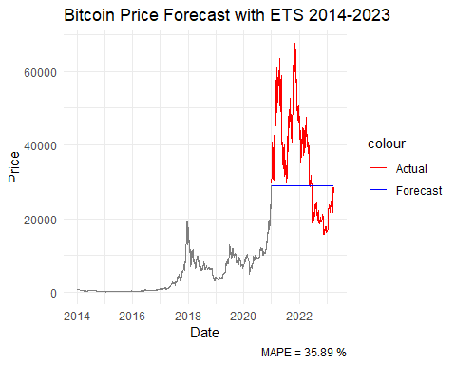

library(forecast)  
library(tidyverse)

## ── Attaching core tidyverse packages ──────────────────────── tidyverse 2.0.0 ──  
## ✔ forcats 1.0.0 ✔ stringr 1.5.0  
## ✔ lubridate 1.9.2 ✔ tibble 3.1.8  
## ✔ readr 2.1.4   
## ── Conflicts ────────────────────────────────────────── tidyverse_conflicts() ──  
## ✖ rlang::%@%() masks purrr::%@%()  
## ✖ randomForest::combine() masks dplyr::combine()  
## ✖ dplyr::filter() masks stats::filter()  
## ✖ xts::first() masks dplyr::first()  
## ✖ rlang::flatten() masks purrr::flatten()  
## ✖ rlang::flatten_chr() masks purrr::flatten_chr()  
## ✖ rlang::flatten_dbl() masks purrr::flatten_dbl()  
## ✖ rlang::flatten_int() masks purrr::flatten_int()  
## ✖ rlang::flatten_lgl() masks purrr::flatten_lgl()  
## ✖ rlang::flatten_raw() masks purrr::flatten_raw()  
## ✖ rlang::invoke() masks purrr::invoke()  
## ✖ dplyr::lag() masks stats::lag()  
## ✖ xts::last() masks dplyr::last()  
## ✖ randomForest::margin() masks ggplot2::margin()  
## ✖ rlang::splice() masks purrr::splice()  
## ℹ Use the ]8;;http://conflicted.r-lib.org/conflicted package]8;; to force all conflicts to become errors

#Get the Bitcoin price data  
coins2 <- crypto_list(only_active=TRUE) %>%  
filter(symbol %in% c("BTC"))  
BTC_hist <- crypto_history(coins2, limit=1, start_date="20140101", end_date="20230331", finalWait=FALSE) #15months

## ❯ Scraping historical crypto data

##

## ❯ Processing historical crypto data

##

BTC_hist$date <- as.Date(BTC_hist$timestamp)  
  
#Filter the training data from 2014-01-01 to 2020-12-31  
BTC_train <- BTC_hist %>% filter(date >= as.Date("2014-01-01") & date <= as.Date("2020-12-31"))  
  
#Filter the test data from 2021-01-01 to 2023-03-31  
BTC_test <- BTC_hist %>% filter(date >= as.Date("2021-01-01") & date <= as.Date("2023-03-31"))  
  
#Prepare the training dataset for ARIMA (select 'close' column and convert to time series)  
BTC_train_ts <- ts(BTC_train$close)  
  
#Fit an ARIMA model to the training data  
model <- auto.arima(BTC_train_ts)  
  
#Make predictions for the next 820 days  
forecast <- forecast(model, h = 820)  
  
#Combine the test data with the predictions  
BTC_test_pred <- BTC_test %>% select(date, close) %>% mutate(forecast = forecast$mean)  
BTC_test_pred <- as.data.frame(BTC_test_pred) # convert to data frame  
  
#Calculate the Mean Absolute Percentage Error (MAPE)  
MAPE <- mean(abs((BTC_test_pred$close - BTC_test_pred$forecast) / BTC_test_pred$close)) * 100  
print(paste("MAPE:", MAPE))

## [1] "MAPE: 279.459614892151"

#Plot the actual data, training data and forecast  
forecast_plot <- ggplot() +  
geom_line(aes(x = date, y = close, color = "Training"), data = BTC_train) +  
geom_line(aes(x = date, y = close, color = "Actual"), data = BTC_test_pred) +  
geom_line(aes(x = date, y = forecast, color = "Forecast"), data = BTC_test_pred) +  
xlab("Date") +  
ylab("Price") +  
ggtitle("Bitcoin Price Forecast with ARIMA 2014-2023") +  
labs(caption = paste("MAPE =", round(MAPE, 2), "%")) +  
scale_color_manual(values = c("Training" = "black", "Actual" = "red", "Forecast" = "blue")) + theme_minimal()  
  
print(forecast_plot)

