RETAIL SALES ANALYSIS REPORT
Fiscal Year 2023 | Comprehensive Sales Intelligence
Prepared by: Retail Analytics Team | Dataset: retail_sales_dataset.csv

Table of Contents
- 1. Executive Summary
- 2. Key Performance Indicators (KPIs)
- 3. Revenue Analysis by Product Category
- 4. Monthly & Quarterly Revenue Trends
- 5. Customer Demographics
- 6. Transaction Deep-Dive
- 7. Key Findings & Recommendations
- 8. Conclusion

1. Executive Summary
This report presents a comprehensive analysis of retail sales data for fiscal year 2023. The dataset covers 1,000 unique customer transactions across three product categories — Electronics, Clothing, and Beauty — generating total revenue of $456,000. The analysis covers revenue trends, customer demographics, product performance, and transactional distributions to provide actionable insights for strategic decision-making.
Key highlights: Q4 2023 was the strongest quarter ($126,190). Electronics led category revenue at $156,905 (34.4%). Female customers contributed 51.1% of total revenue. The 46–60 age group is the highest-value segment at $147,875. Average order value stood at a healthy $456 per transaction.

2. Key Performance Indicators (KPIs)
Top-level KPIs for the full reporting period:
KPI Metric | Value | Notes
Total Revenue | $456,000 | Full fiscal year 2023
Total Transactions | 1,000 | All unique purchases
Unique Customers | 1,000 | 100% unique purchase rate
Average Order Value | $456.00 | Premium retail positioning
Avg Quantity per Order | 2.51 units | Moderate basket size
Top Revenue Quarter | Q4 — $126,190 | Oct – Dec 2023
Leading Product Category | Electronics — $156,905 | 34.4% revenue share
Top Customer Segment (Age) | 46–60 — $147,875 | Highest-value age group

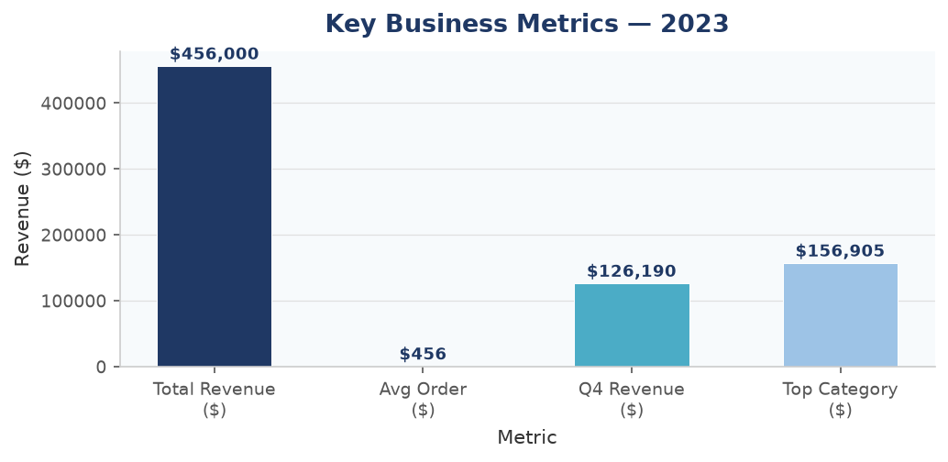
Figure: Key Business Metrics Overview

3. Revenue Analysis by Product Category
Three product categories drive all revenue. Electronics leads at 34.4%, followed by Clothing (34.1%) and Beauty (31.5%). This near-equal distribution signals a well-diversified product strategy with no single-category dependency risk.
Category | Revenue ($) | Share (%) | Units Sold | Transactions | Avg Price ($)
Electronics | $156,905 | 34.4% | 849 | 342 | $181.90
Clothing | $155,580 | 34.1% | 894 | 351 | $174.29
Beauty | $143,515 | 31.5% | 771 | 307 | $184.06
TOTAL | $456,000 | 100% | 2,514 | 1,000 | $180.08

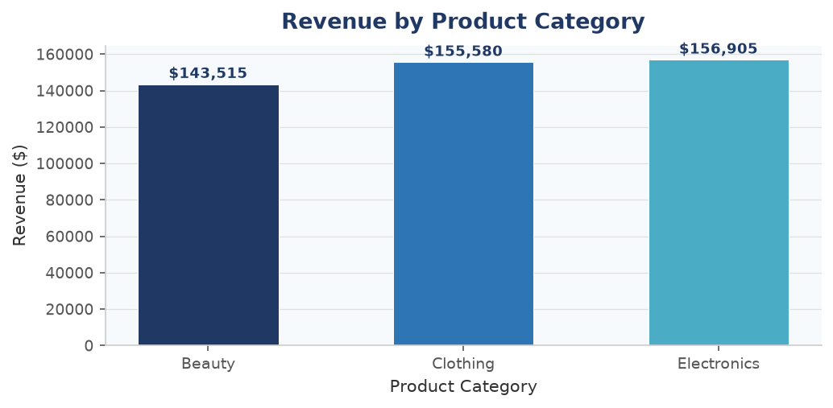
Figure: Revenue by Product Category (Bar Chart)
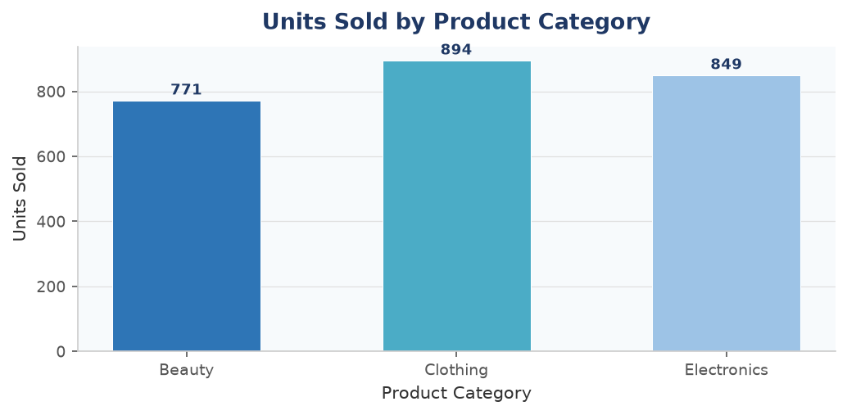
Figure: Units Sold by Product Category (Bar Chart)
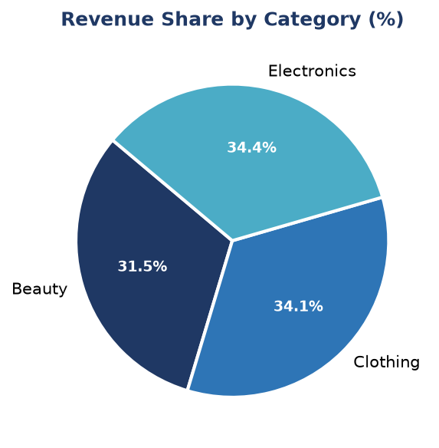
Figure: Revenue Share by Product Category (Pie Chart)

4. Monthly & Quarterly Revenue Trends
Monthly revenue fluctuated throughout the year with May being the peak month ($53,150). Q4 was the strongest quarter at $126,190, driven by October and December performance. Q3 showed the weakest performance at $96,045, indicating potential for targeted campaigns during the July–September period.
Quarter | Revenue ($) | % of Annual | Strongest Month
Q1 (Jan–Mar) | $110,030 | 24.1% | Feb — $44,060
Q2 (Apr–Jun) | $123,735 | 27.1% | May — $53,150
Q3 (Jul–Sep) | $96,045 | 21.1% | Aug — $36,960
Q4 (Oct–Dec) | $126,190 | 27.7% | Dec — $44,690
TOTAL | $456,000 | 100% | May 2023

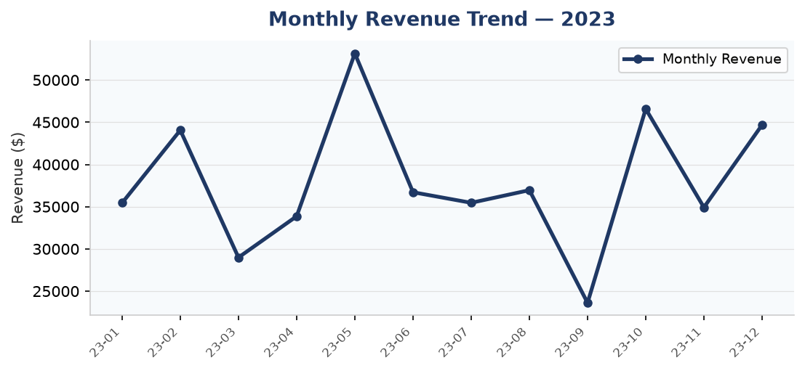
Figure: Monthly Revenue Trend — January to December 2023 (Line Chart)
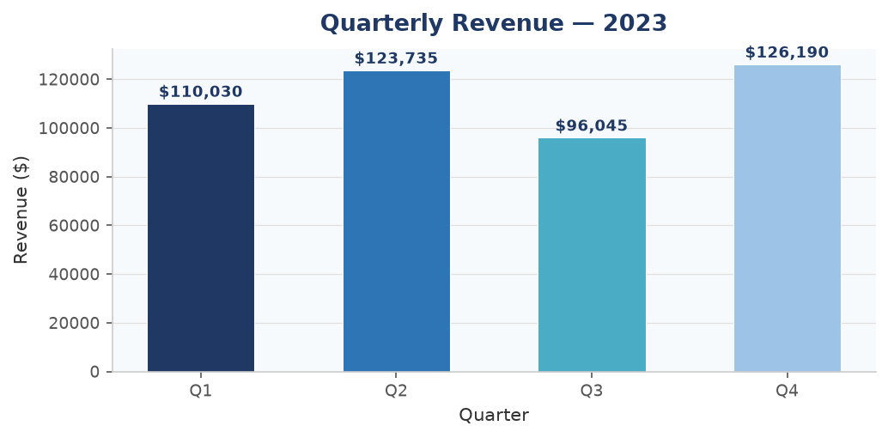
Figure: Quarterly Revenue Breakdown (Bar Chart)

5. Customer Demographics

5.1 Gender Analysis
The customer base is nearly evenly split by gender. Female customers hold a marginal lead at 51.1% of total revenue ($232,840), while Male customers contributed 48.9% ($223,160). Both segments show similar transaction counts and average order values.
Gender | Revenue ($) | Revenue Share (%) | Transactions
Female | $232,840 | 51.1% | 496
Male | $223,160 | 48.9% | 504
TOTAL | $456,000 | 100% | 1,000

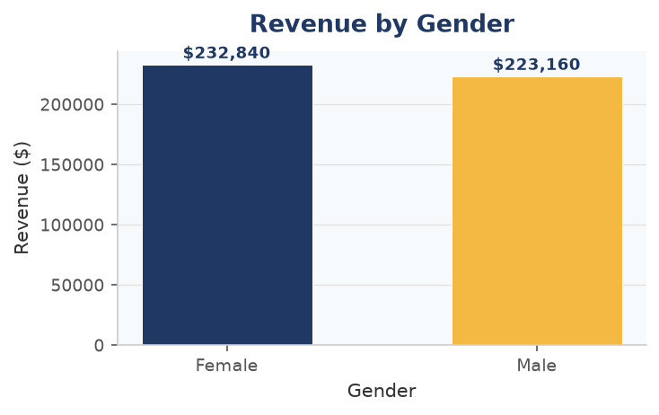
Figure: Revenue by Gender (Bar Chart)
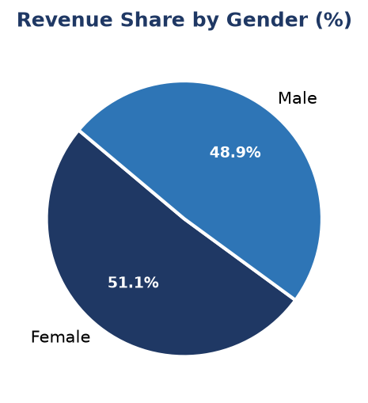
Figure: Revenue Share by Gender (Pie Chart)

5.2 Age Group Analysis
The 46–60 age group is the most valuable segment with $147,875 revenue (32.4% share). The 26–35 group is second at $98,480. The 60+ segment is the smallest at $33,225, presenting a growth opportunity through targeted outreach to senior demographics.
Age Group | Revenue ($) | Share (%)
18-25 | $84,550 | 18.5%
26-35 | $98,480 | 21.6%
36-45 | $91,870 | 20.1%
46-60 | $147,875 | 32.4%
60+ | $33,225 | 7.3%
TOTAL | $456,000 | 100%

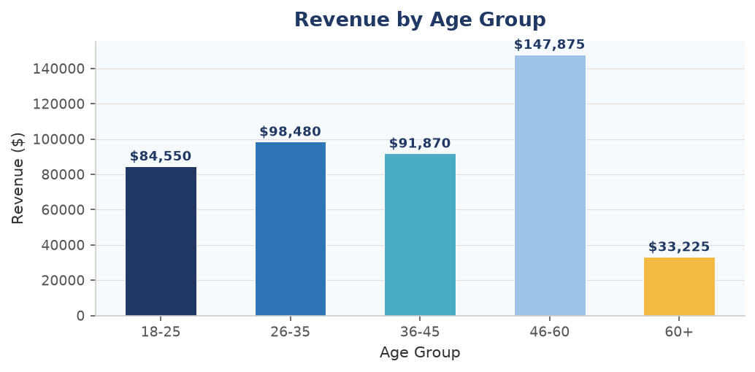
Figure: Revenue by Customer Age Group (Bar Chart)

6. Transaction Deep-Dive
Transaction-level analysis reveals that total order amounts range from $25 to $2,000. The median order value is $135, while the average is $456 — the gap indicating a right-skewed distribution driven by high-value Electronics purchases. Most customers purchase 1–4 units per transaction.
Statistic | Value ($)
Minimum | $25
Maximum | $2,000
Mean | $456.00
Median | $135
Std Deviation | $560.00
25th Percentile | $60
75th Percentile | $900

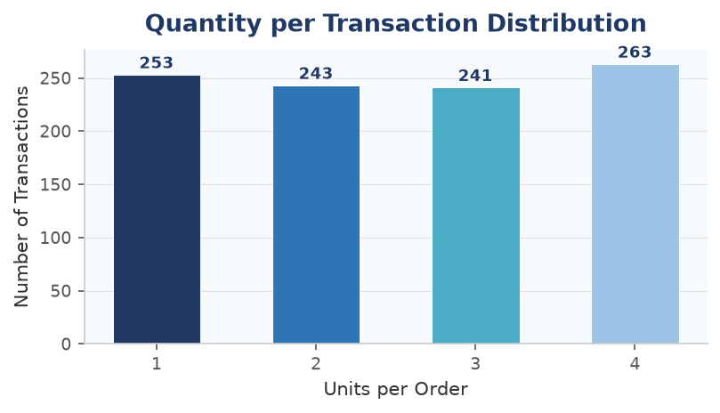
Figure: Quantity per Transaction Distribution (Bar Chart)
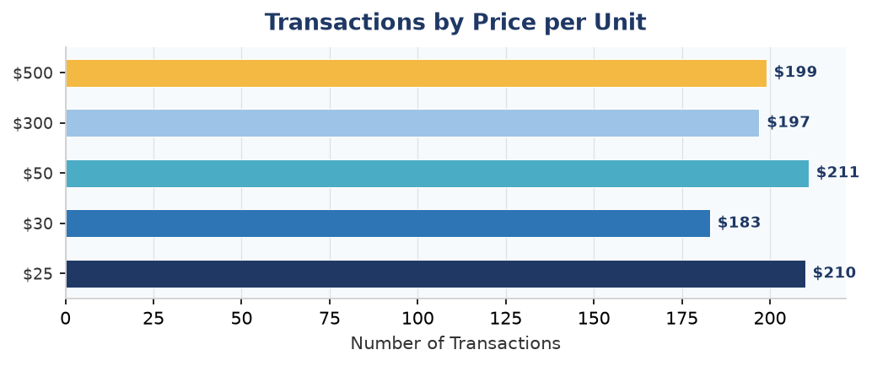
Figure: Transaction Count by Price per Unit (Horizontal Bar Chart)

7. Key Findings & Recommendations

7.1 Key Findings
- Q4 Dominance: Q4 was the strongest quarter with $126,190 in revenue — 27.7% of annual total. Seasonal demand peaks in October and December.
- Electronics Leads: Electronics generated the highest category revenue ($156,905) driven by high price-per-unit ($181.90 average).
- Balanced Categories: Revenue spread across categories is tight (34.4% / 34.1% / 31.5%), reducing concentration risk.
- Female Customer Edge: Female customers contribute marginally more revenue (51.1%) with near-equal transaction counts.
- Mid-Age Segment is Key: The 46–60 age bracket contributes 32.4% of total revenue, far exceeding any other age group.
- Q3 Underperformance: Q3 revenue ($96,045) lags other quarters by 9–24%, suggesting a potential seasonal dip requiring attention.
- High AOV: Average order value of $456 reflects a premium retail proposition and strong per-visit monetisation.

7.2 Strategic Recommendations
- Boost Q3 Sales: Launch mid-year promotions (July–September) — flash sales, bundles, or loyalty rewards — to address the Q3 revenue gap.
- Target 46–60 Segment: Expand product lines and personalised campaigns aligned with mid-age consumer preferences, the highest-revenue demographic.
- Grow 60+ Segment: The 60+ age group generates only 7.3% of revenue despite being a growing demographic. Introduce senior-friendly offerings and communication channels.
- Electronics Upsell: Leverage Electronics' premium AOV by promoting accessories and warranties at point-of-sale.
- Beauty Category Investment: Beauty trails other categories by ~$13K. Invest in product range expansion and influencer marketing to close the gap.
- Gender-Neutral Strategy: The near-equal revenue split by gender validates inclusive product curation — continue to expand unisex categories.

8. Conclusion
The retail business demonstrated solid performance in 2023, achieving $456,000 in total revenue across 1,000 transactions. The balanced category distribution, premium average order value, and broad customer demographic reach indicate a healthy and diversified retail operation.
Key opportunities lie in addressing Q3 seasonal weakness, cultivating the under-served 60+ demographic, and deepening Electronics upsell programmes. With targeted interventions in these areas, a 10–15% revenue uplift in the next fiscal year is a realistic and achievable target.
This analysis was powered by Python (Pandas, Matplotlib) and covers the full retail_sales_dataset.csv of 1,000 transactions. All figures are sourced directly from the dataset.

Retail Sales Analysis Report 2023 | Retail Analytics Team | Confidential

