<https://www.youtube.com/watch?v=Ao-oM57PnJY&list=PLSw2mlMYG5MJd7UUZmH0T87_VmjT-qpEy&index=5&ab_channel=ProgrammingAndrew>

可以用npm run lint檢查有無錯誤

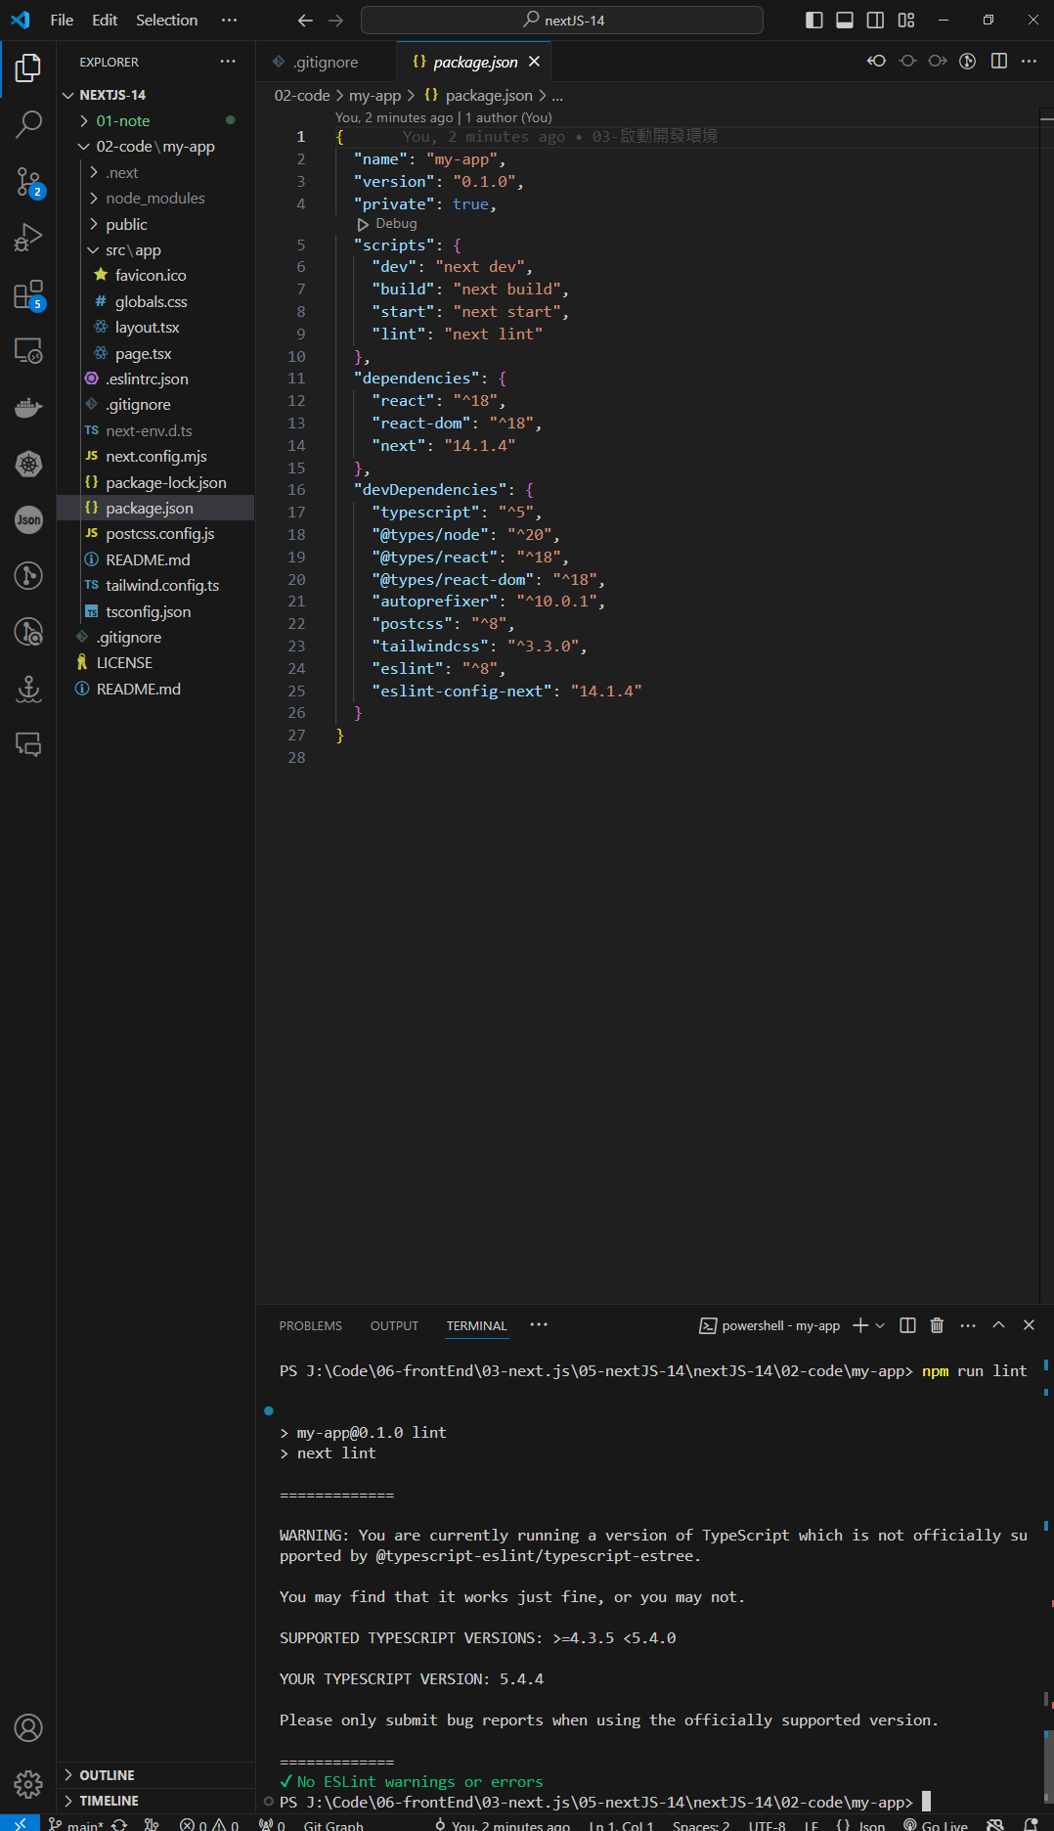

Trouble shooting

<https://stackoverflow.com/questions/71491493/error-eisdir-illegal-operation-on-a-directory-readlink-d-study-noobinjs-pag>

# [Error: EISDIR: illegal operation on a directory, readlink 'D:\study\noobinjs\pages\_app.tsx' when trying to run 'npm run build' for next js app](https://stackoverflow.com/questions/71491493/error-eisdir-illegal-operation-on-a-directory-readlink-d-study-noobinjs-pag)

4

4

Try to put the file of project in C drive not in the D. Example => C:\Users\Mahmoud\Desktop\next-damo

Then try to run npm run build.

[Share](https://stackoverflow.com/a/72594016)

[Improve this answer](https://stackoverflow.com/posts/72594016/edit)

Follow

[edited Jun 14, 2022 at 11:56](https://stackoverflow.com/posts/72594016/revisions)

[[](https://stackoverflow.com/users/1870780/juliomalves)](https://stackoverflow.com/users/1870780/juliomalves)

[juliomalves](https://stackoverflow.com/users/1870780/juliomalves)

**46.9k**2121 gold badges166166 silver badges157157 bronze badges

answered Jun 12, 2022 at 16:30

[[](https://stackoverflow.com/users/16710837/mahmoud-kandel)](https://stackoverflow.com/users/16710837/mahmoud-kandel)

[Mahmoud Kandel](https://stackoverflow.com/users/16710837/mahmoud-kandel)

**158**11 silver badge55 bronze badges

* 3

I absolutely hate this answer, but then I had to try it because nothing else worked and, unfortunately, it worked for me. Is Next.js something that only works properly on the C:? I tried several of the projects in the examples/ and they also only worked on my C:, so it's not *anything* in the folder. How am I supposed to process this?

– [Mark Stouffer](https://stackoverflow.com/users/927008/mark-stouffer)

[Aug 17, 2022 at 1:41](https://stackoverflow.com/questions/71491493/error-eisdir-illegal-operation-on-a-directory-readlink-d-study-noobinjs-pag#comment129592526_72594016)

[Add a comment](https://stackoverflow.com/questions/71491493/error-eisdir-illegal-operation-on-a-directory-readlink-d-study-noobinjs-pag)

0

This problem may be related to whether the symbolic link can be created or not. I also encountered the same problem, but solved it by changing the filesystem from exFAT to NTFS. As you know exFAT can't create symlink.

所以放C槽可以解決這個問題

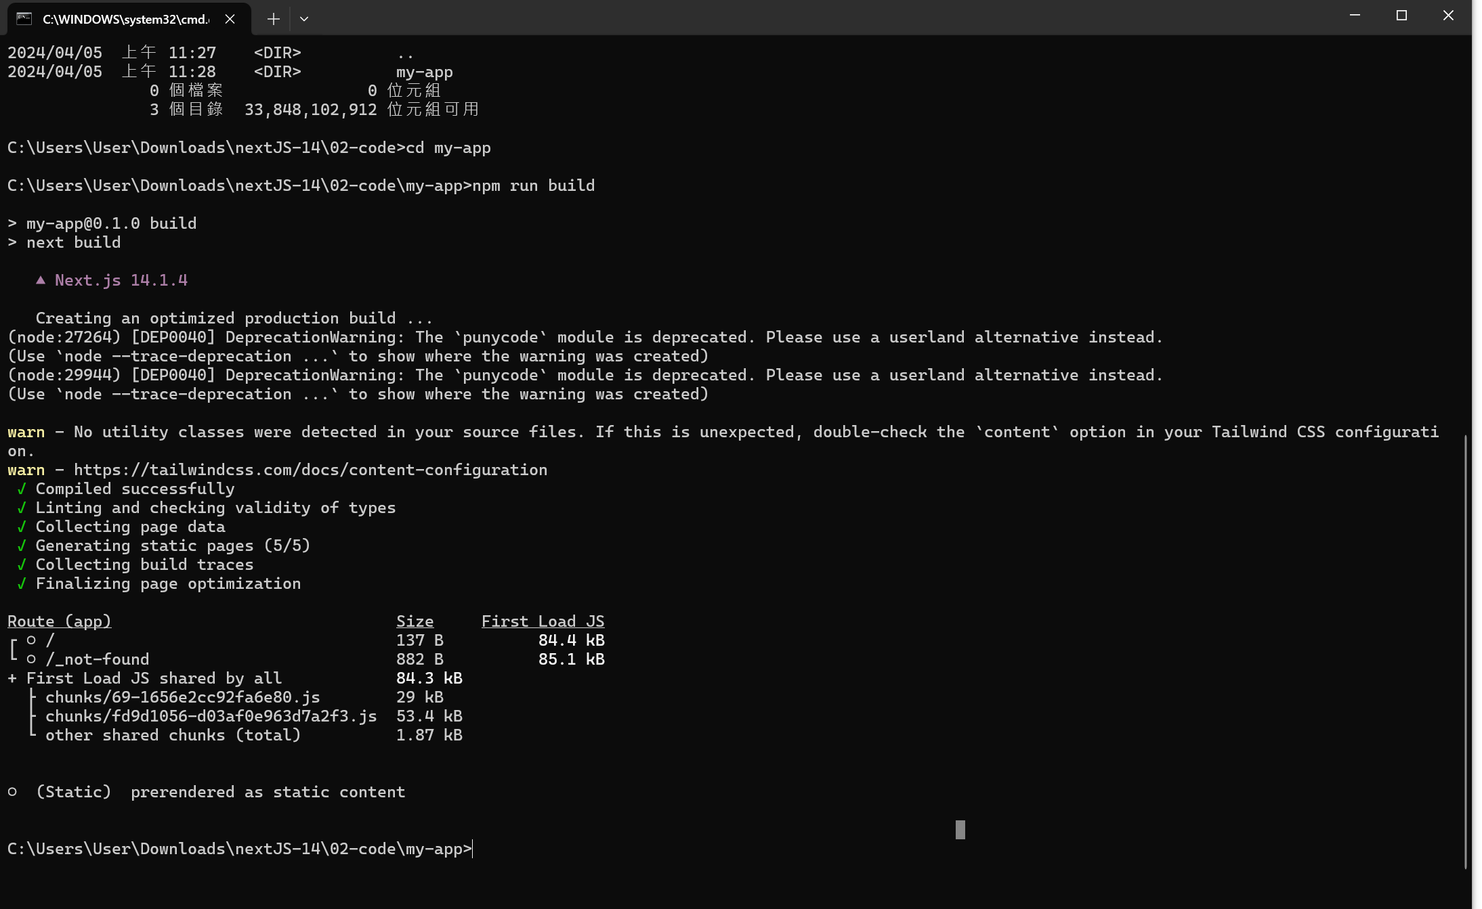

Production版編譯完後用npm run start可以啟動起來

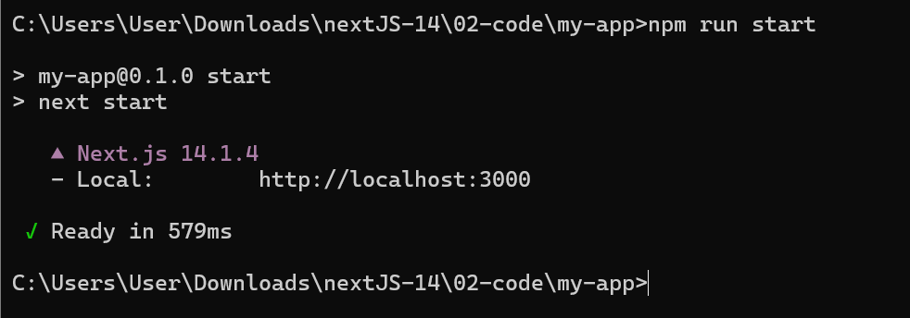

速度會快很多