**Digestive System Answer Key**

**Vocabulary:** absorption, amino acid, carbohydrate, chemical digestion, chyme, complex carbohydrate, digestion, digestive system, elimination, enzyme, fat, fatty acid, fiber, food calorie, mechanical digestion, monoglyceride, nutrient, peristalsis, protein, starch, sugar, villus

**Prior Knowledge Questions** (Do these BEFORE using the Gizmo.)

*[Note: The purpose of these questions is to activate prior knowledge and get students thinking. Students are not expected to know the answers to the Prior Knowledge Questions.]*

1. Why do we need to eat food?

*Answers will vary. Sample answer: Food provides a source of energy and raw materials for growth and development.*

1. How do you think our bodies break food down into useful **nutrients**?

*Answers will vary. Sample answer: Teeth chew food into small pieces, which are swallowed and transported to the stomach. Chemicals in the stomach and intestines further break down food into simple nutrients, which are absorbed into blood.*

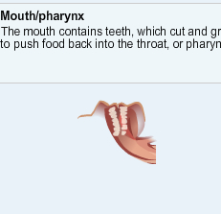

**Gizmo Warm-up**

The **digestive system** is a group of organs that does three things:

* First, the digestive system breaks food down into useful nutrients, a process called **digestion**.
* Next, the nutrients move into the bloodstream, a process called **absorption**.
* Finally, the leftover waste is removed from the body, a process called **elimination**.

With the *Digestive System* Gizmo™, you can arrange the organs of the digestive system any way you like. To begin, look at the organs on the **Large Organs** tab. Place your cursor over each organ to learn more about it.

1. Which organs allow nutrients to be absorbed? *Small intestine and large intestine*
2. Which organ stores and compacts waste before it is eliminated? *Rectum*
3. Which *two* organs help to break food down mechanically? *Mouth, stomach*

|  |  |  |
| --- | --- | --- |
| **Activity A:**  **Build a digestive system** | Get the Gizmo ready:   * If necessary, click **Clear screen**. | DigestiveSystemSE2 |

**Goal: Design your own digestive system.**

1. Explore: Read the descriptions of the large organs, as well as those of the **Small Organs** on the next tab. Fill in the names of the organs that serve the functions listed below:

*Large intestine* This organ absorbs water and vitamin K from digested food.

*Pancreas* This organ produces **enzymes** that break down nutrients.

*Capillaries* These tiny blood vessels transport absorbed nutrients.

*Parietal cells* These cells produce hydrochloric acid (HCl).

*Chief cells* These cells produce *pepsin*, which breaks down proteins.

1. Build: Now it is time to design and build your own digestive system! Start with the **Large Organs** tab to build a basic system, starting with the **Mouth/pharynx**. Next, attach organs from the **Small organs** tab to the large organs to complete your system. Draw a picture of your system below. (If you like, you can click the **Screen shot** icon to take a snapshot, and then paste the image into a blank document to hand in with this worksheet.)

*Sketches will vary. [For purposes of comparison, the image below is as close as you can get to the actual human digestive system with this Gizmo.]*

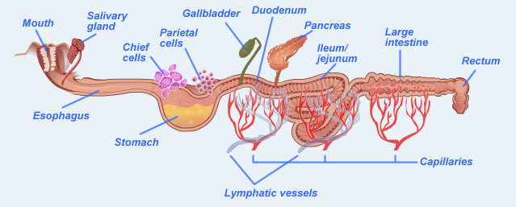

1. Predict: How well do you think your system will digest food? Explain your reasoning.

*Predictions will vary.*

**(Activity A continued on next page)Activity A (continued from previous page)**

1. Prepare: Select the **Food** tab. The energy we get from food is measured in **food calories** (Calories). Each Calorie is equal to 4,184 joules of energy. Calories are found in the three main nutrients in food: **carbohydrates** (**sugars** and **starches**), **proteins**, and **fats**.

Drag the **Cheeseburger** above the mouth in your digestive system. How many Calories in the cheeseburger come from carbohydrates, proteins, and fats?

Carbohydrate Calories: *226 Cal* Protein Calories: *140 Cal* Fat Calories: *361 Cal*

1. Run the Gizmo: Click **Play** (play), and observe the food moving through the digestive system. The muscular contractions that push food through the system are called **peristalsis**. When food has finished passing through the system, you will see a message.
2. What percentage of Calories were absorbed by your system? *Results will vary.*
3. What percentage of water was absorbed? *Results will vary.*
4. Based on these results, how well do you think this digestive system worked? Explain.

*Answers will vary.*

1. Revise: Click **Reset** (reset). Rearrange the organs of your system to try to improve your results. Describe how you changed your system below.

*Answers will vary.*

1. Test: Click **Play**. List the results below. Did the system improve? *Answers will vary.*

Percentage of Calories absorbed: *Results will vary.*

Percentage of water absorbed: *Results will vary.*

1. Explain: If your system improved, why do you think this was so? *Answers will vary.*

|  |  |  |
| --- | --- | --- |
| **Activity B:**  **Mechanical and chemical digestion** | Get the Gizmo ready:   * Click **Reset** and **Clear screen**. * Build a system with a **Mouth**, **Salivary gland**, **Esophagus**, **Pancreas**, and **Rectum**. | DigestiveSystemSE3 |

**Introduction:** Before nutrients are absorbed, they must be broken down to their simplest components. Teeth and muscular contractions in the stomach break food down into smaller particles, a process called **mechanical digestion**. In the meantime, powerful chemicals break down food in a process called **chemical digestion**.

**Question: How are nutrients broken down in your digestive system?**

1. Set up the Gizmo: Check that the current digestive system has a mouth, salivary gland, esophagus, pancreas, and rectum, as shown above. From the **Food** tab, drag the **Baked potato** to the mouth. A potato mostly consists of **complex carbohydrates**, such as starch.
2. Select the **Analysis** tab. What is the initial value of complex carbohydrates? *236 Cal*
3. Click **Play**. What is the ending value of complex carbohydrates? *204.68 Cal*
4. How many Calories of complex carbohydrates were converted to sugars? *31.32 Cal*

Explain how you know: *The complex carbohydrates decreased by 31.32 Cal and the sugars increased by the same amount.*

The pancreas produces three digestive enzymes: *Amylase* breaks down complex carbohydrates into simple carbohydrates (sugars), *trypsin* breaks down proteins into **amino acids**, and *lipase*breaks down fats into **fatty acids** and **monoglycerides**.

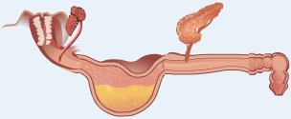

1. Experiment: Click **Reset**. Move the **Rectum**, **Esophagus**, and **Pancreas** to the right and insert the **Stomach** so that the system looks like the image at right. Click **Play**.
2. After digestion is complete, what is the value of complex carbohydrates? *30.26 Cal*
3. How many Calories of complex carbohydrates were converted to sugars? *205.74 Cal*
4. Why do you think the results were different?

*Answers will vary. [The churning action of the stomach breaks up food chunks and exposes complex carbohydrates inside to the action of enzymes.]*

The muscular walls of the stomach churn food, transforming food chunks into a thick liquid called **chyme**. The nutrients in chyme break down more easily because they are exposed to digestive enzymes rather than hidden in food chunks.

**(Activity B continued on next page)Activity B (continued from previous page)**

1. Observe: Click **Reset**. Drag the **Steamed tofu** above the mouth. The Calories in tofu mostly come from proteins and fat. We will look at fat digestion first.
2. What is the initial number of fat Calories? *90 Cal*
3. Click **Play**. How many fat Calories were converted to fatty acids? *27 Cal*
4. Experiment: Click **Reset**. Move the **Pancreas** one space to the right (still attached to the esophagus). Place the **Gallbladder** on the esophagus to the left of the pancreas. Click **Play**.
5. How many fat Calories were converted to fatty acids in this situation? *86.36 Cal*
6. How did adding the gallbladder affect fat digestion? *Fat digestion improved.*

Fat molecules can be difficult to break down because large fat droplets do not mix well with water-based enzymes such as lipase. For lipase to work, it helps if the fat is *emulsified* into tiny droplets. This is done with the help of *bile*, which is stored in the gallbladder.

1. Observe: Now look at the results for proteins. (Do not press **Reset** yet.) Proteins are complex molecules formed from long chains of amino acids.

How many of the original 72 protein Calories were converted to amino acids? *1.44 Cal*

1. Experiment: Click **Reset**. The process of protein digestion is helped by the enzyme *pepsin*.
2. Look at the remaining small organs. Which ones produce pepsin? *Chief cells*

Add these cells to the stomach.

1. Click **Play**. How much protein is converted to amino acids now? *29.09 Cal*
2. Click **Reset**. Pepsin works best in an acidic environment. Which of the remaining small organs produces an acid? *Parietal cells* Add these to the stomach.
3. Click **Play**. How much protein is converted to amino acids now? *69.87 Cal*
4. Explain: How do mechanical and chemical digestion work together to break down food?

*Sample answer: Mechanical digestion by the mouth, stomach, and bile break up large chunks of food into smaller pieces. This increases the surface area for enzymes to act to chemically break down carbohydrates, fats, and proteins into sugars, fatty acids, and amino acids.*

|  |  |  |
| --- | --- | --- |
| **Activity C:**  **Absorption** | Get the Gizmo ready:   * Click **Reset** and **Clear screen**. | DigestiveSystemSE5 |

**Introduction:** Digesting nutrients into simple carbohydrates, amino acids, and fatty acids is important, but it doesn’t matter unless the nutrients get into the bloodstream to feed body cells. This process is called absorption.

**Question: How are nutrients absorbed?**

1. Observe: Look through the descriptions of the large and small organs.
2. Which of the large organs allow nutrients and water to pass through their walls?

*The small intestine and large intestine allow nutrients to pass through their walls.*

1. Which of the small organs transport absorbed nutrients to the bloodstream?

*The capillaries and lymphatic vessels transport absorbed nutrients.*

1. Set up the Gizmo: Create the digestive system shown. The small intestine has three parts: the *duodenum* (attached to the stomach), the *jejunum* (the middle portion), and the *ilium* (attached to the large intestine)*.* Drag the **Pecan pie** to the mouth.

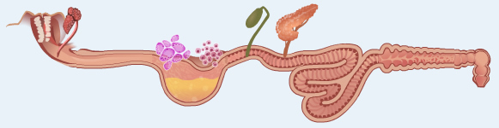

Test each of the scenarios below. For each setup, record the nutrients that are *absorbed* by the system. (Be sure to look at the “Absorbed” row of the **Analysis** table.)

|  |  |  |  |  |
| --- | --- | --- | --- | --- |
| **Scenario** | **Sugars** | **Amino acids** | **Fatty acids** | **Water** |
| Capillaries attached to the small intestine segments only | *272.16 Cal* | *21.43 Cal* | *0 Cal* | *18.9 g* |
| Capillaries attached to the large intestine only | *7.2 Cal* | *0 Cal* | *0 Cal* | *3.83 g* |
| Lymphatic vessels attached to the small intestine segments only (no capillaries) | *0 Cal* | *0 Cal* | *174.8 Cal* | *0 g* |
| Lymphatic vessels attached to the large intestine only (no capillaries) | *0 Cal* | *0 Cal* | *0 Cal* | *0 g* |

**(Activity C continued on next page)Activity C (continued from previous page)**

1. Analyze: Examine the results of your four experiments.
2. Which nutrients were absorbed by capillaries in the small intestine?

*Sugars, amino acids, and water*

1. Which nutrients were absorbed by capillaries in the large intestine?

*Sugars and water*

Bacteria in the large intestine break down some types of **fiber**—a difficult to digest complex carbohydrate—into sugars and other nutrients.

1. Which nutrient was absorbed by small intestine lymphatic vessels? *Fatty acids*
2. Did lymphatic vessels absorb anything from the large intestine? *No*
3. Draw conclusions: Based on your experiments, where should the capillaries and lymphatic vessels be placed to maximize the absorption of nutrients from food?

Capillaries: *Capillaries should be placed on the small and large intestines.*

Lymphatic vessels: ­­­­­­­­­­­­­*Lymphatic vessels should be placed on the small intestine only.*

1. Investigate: Click **Reset**. From the **Food** tab, drag the **Apple** to the work area to view its **Nutritional Facts**. What nutrient makes up most of an apple’s Calories? *Sugars*
2. Challenge: Using a total of only *five* organs, design a digestive system that can absorb the maximum number of Calories from the apple. Describe your system below.

*Sample answer: I created a system with a mouth, stomach, and small intestine (jejunum/ileum) with a pancreas and capillaries attached.*

1. Test: Click **Play**. What percentage of Calories did your system absorb? *Results will vary.*

*[The system described above will absorb 73.91% of the apple’s Calories.]*

1. Explore: Use the Gizmo to determine how absorption of water affects the texture of the stool (poop) that is produced by the digestive system. What do you conclude?

*Sample answer: The texture of the stool depends on how much water was removed from the food. If most of the water is removed and the waste is compacted in the rectum, the stool is solid. If very little water is absorbed, the stool will be loose or liquid.*

|  |  |  |
| --- | --- | --- |
| **Activity D:**  **Human digestion** | Get the Gizmo ready:   * Click **Reset** and **Clear screen**. | DigestiveSystemSE7 |

**Introduction:** Now that you have explored a model of human digestion, it is time to apply what you have learned to the real human digestive system.

**Goal: Describe the human digestive system.**

1. Label: Based on what you have learned, identify the organs of the human digestive system.

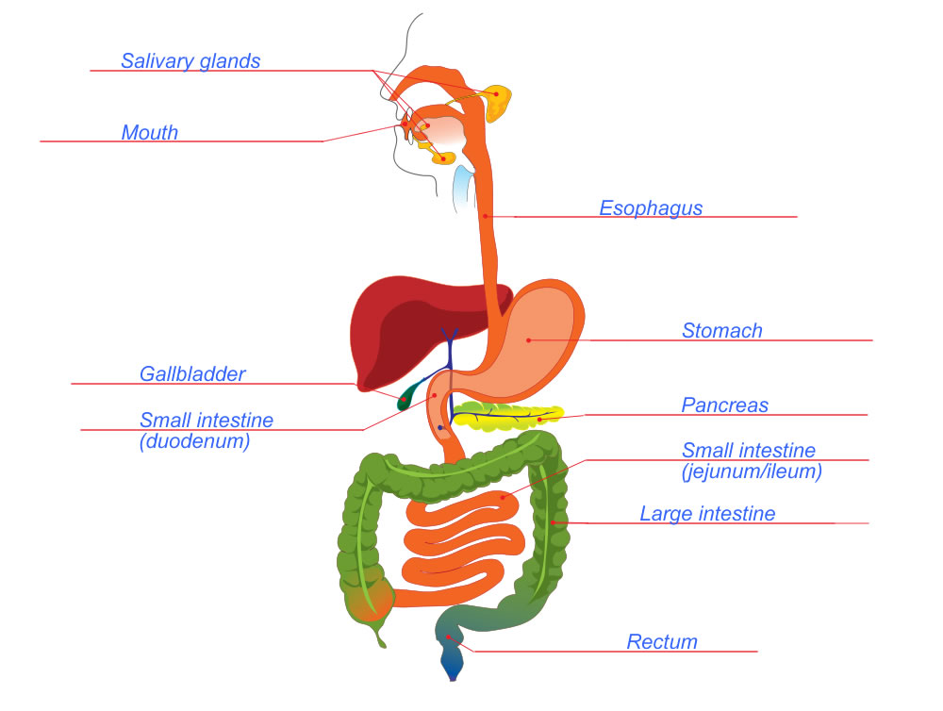

1. Think and discuss: Why is it important that the mouth and stomach are near the start of the digestive system?

*The mouth and stomach account for most mechanical digestion. It is important for food to be broken up into tiny pieces so nutrients can be exposed to the action of digestive enzymes.*

**(Activity D continued on next page)Activity D (continued from previous page)**

1. Match: Match each structure, chemical, or process to its function.

*K* Amylase A. Upper section of the small intestine

*E* Peristalsis B. Muscular tube connecting the throat and stomach

*A* Duodenum C. Organ that produces a variety of digestive enzymes

*I* Lymphatic vessel D. Chemical that breaks up large fat droplets

*G* Anus E. Muscular contractions that push food through the digestive system

*J* Large intestine F. Enzyme that starts to digest proteins in the stomach

*B* Esophagus G. Opening through which wastes are eliminated

*F* Pepsin H. Produces hydrochloric acid in the stomach

*C* Pancreas I. Transports absorbed fatty acids to the bloodstream

*H* Parietal cell J. Organ that absorbs water and vitamin K

*D* Bile K. Enzyme that breaks down starches into simple carbohydrates

1. Infer: The diagram at right shows part of a **villus**. A villus is a tiny, fingerlike projection in the wall of the small intestine. The small intestine contains millions of villi.

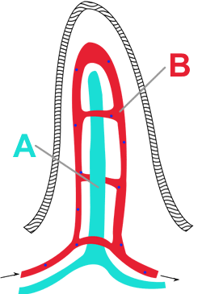

1. What are the names of the vessels labeled A and B in the diagram?

*Lymphatic vessel and capillaries [Students do not need to know this, but (A) represents the lymphatic vessel and (B) represents capillaries.]*

1. What do you think is the function of a villus?

*The villus absorbs nutrients in the small intestine.*

1. Evaluate: In humans, the small intestine can be over 8 meters (26 feet) long. Why do you think this organ is so long?

*Most nutrient absorption takes place in the small intestine. The great length of the small intestine maximizes nutrient absorption.*