Classification and Clustering on the Breast Cancer and Wine Datasets
Name: Abdülhakim Yavuz

1. Loading the Datasets
We use two datasets from scikit-learn. Breast Cancer has 569 samples, 30 numerical features and two classes: malignant (class 0, 212 samples) and benign (class 1, 357 samples). Wine has 178 samples, 13 numerical features and three classes (59, 71 and 48 samples). In both notebooks the features are in a DataFrame X and the labels are in a Series y.
Library versions: Notebooks used Python 3.11.9, numpy 2.4.6, pandas 3.1.1 and scikit-learn 1.9.1. 1.

2. Dataset Quality Checks
Neither dataset has missing values or duplicate rows, and all features are numerical (float64), so no cleaning or encoding is needed.
We counted potential outliers with the IQR rule (below Q1 - 1.5 x IQR or above Q3 + 1.5 x IQR). We did not remove any value. In Breast Cancer the largest counts are area error (65), radius error (38) and perimeter error (38). In Wine, at most 4 of 178 samples are flagged in any feature (magnesium, alcalinity_of_ash and color_intensity).

3. Exploratory Data Analysis (EDA)

3.1 Descriptive statistics
The full tables with mean, median, min, max, standard deviation, Q1 and Q3 are in Appendix A. The features have very different scales. In Breast Cancer, mean area has a mean of 654.9 and radius error has a mean of 0.405. In Wine, proline has a mean of 746.9 and hue has a mean of 0.96. A distance-based model on raw values would be dominated by the large-scale features, so we also test a scaled representation.

3.2 Class distribution and correlations
Breast Cancer is not balanced (37% malignant, 63% benign) but the imbalance is not extreme. Wine classes are 33%, 40% and 27%. The strongest correlated pairs (absolute Pearson) are mean radius - mean perimeter (0.998), worst radius - worst perimeter (0.994) and mean radius - mean area (0.987) for Breast Cancer, and total_phenols - flavanoids (0.865), flavanoids - od280/od315 (0.787) and total_phenols - od280/od315 (0.700) for Wine. We did not remove any feature.
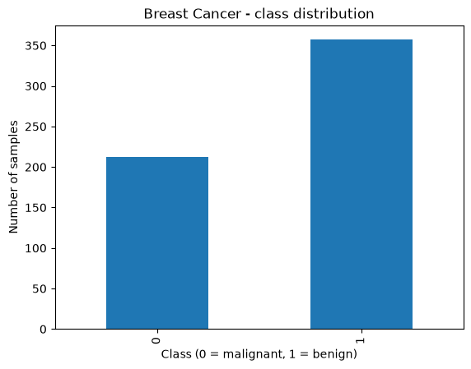  Figure 1. Breast Cancer class distribution. | 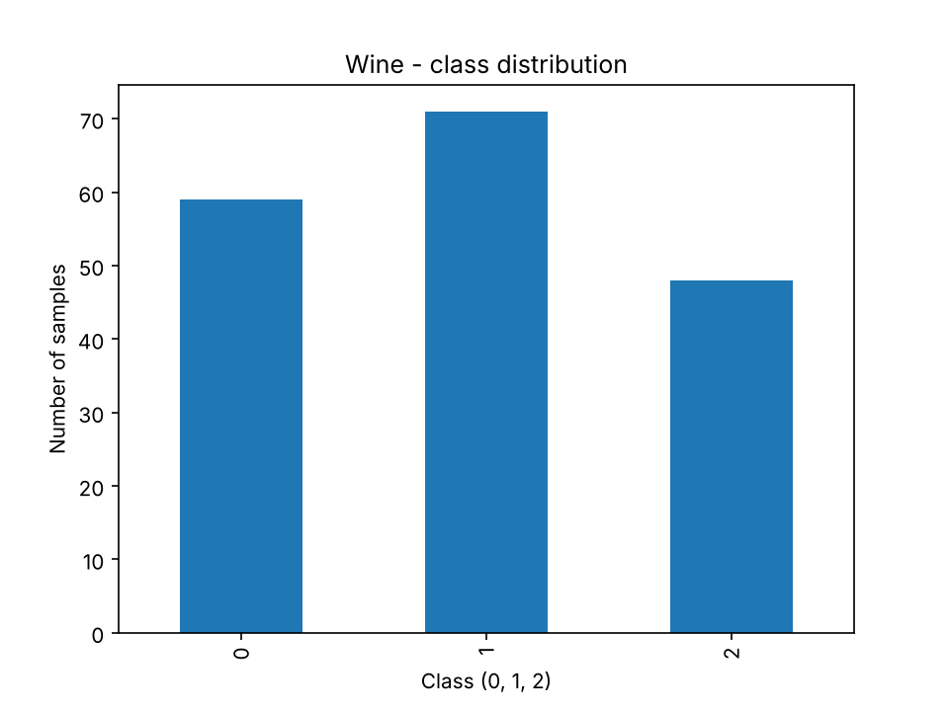  Figure 2. Wine class distribution.
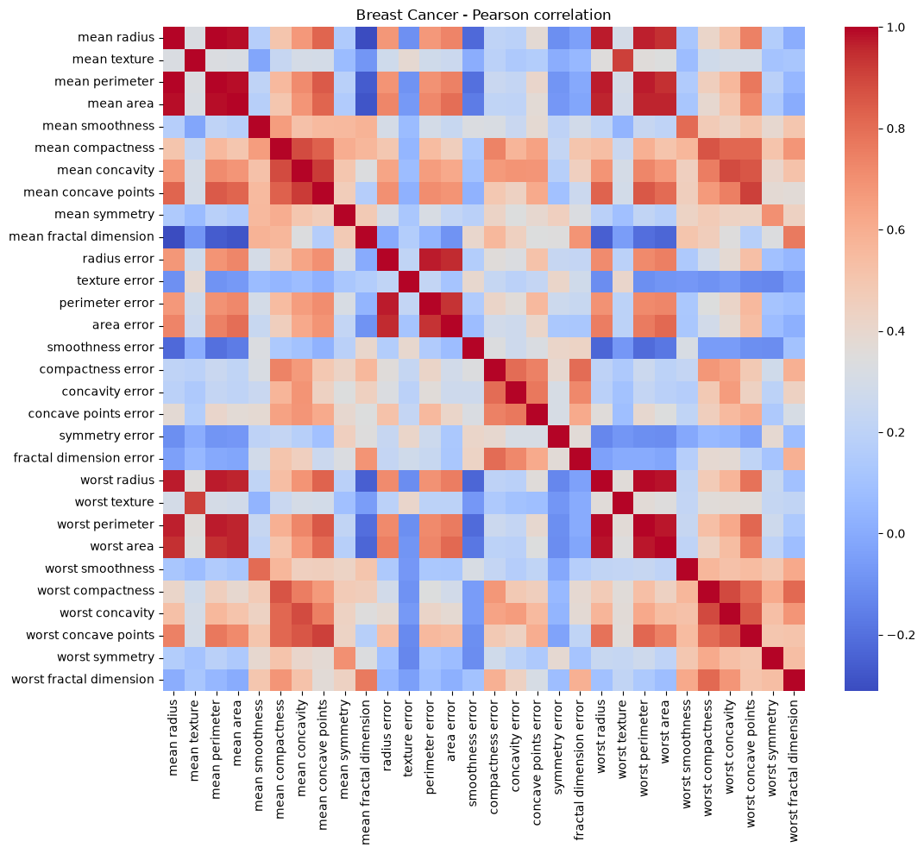  Figure 3. Breast Cancer correlation heatmap. | 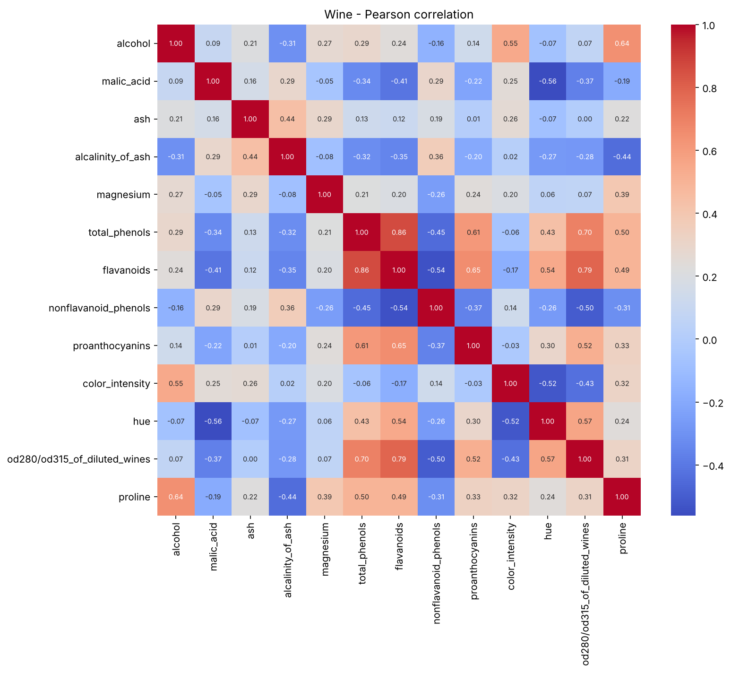  Figure 4. Wine correlation heatmap.

3.3 Boxplots
Every feature has its own small boxplot because the scales are very different. The boxplots are in Appendix B (Figures B1 to B5).

4. Splitting the Datasets
We first split off a fixed test set of 20% with random_state=42 and stratification. The remaining 80% is split again for each seed (42, 52, 62) with test_size=0.125, which gives 70% train, 10% validation and 20% test. We use stratification so the class proportions stay similar in every subset. All checks passed for all seeds: no overlap between subsets, sizes add up to the full dataset, and the test set is the same for every seed.
Table 1. Subset sizes (the same for every seed).
Dataset | Train | Validation | Test | Total
Breast Cancer | 398 (69.9%) | 57 (10.0%) | 114 (20.0%) | 569
Wine | 124 (69.7%) | 18 (10.1%) | 36 (20.2%) | 178

Limitation: the Wine validation set has only 18 samples, so one wrong prediction changes accuracy by about 5.6%. The three validation sets come from the same 80% pool, so they overlap and are not independent.

5. Data Preprocessing and Scaling
There are no missing values, so no imputation is needed. We use StandardScaler, because MinMaxScaler is more sensitive to outliers. For each seed, the scaler is fitted on the training set only and then applied to the training and validation sets. The test set is transformed once with the seed-42 scaler, because the final evaluation uses the seed-42 model. This avoids data leakage from validation and test data.

6. Preparing the Two Data Representations
We have two representations: unscaled (original values) and scaled (StandardScaler). For every seed, the shapes and row indices are identical in both (for example Breast Cancer seed 42: 398 x 30 in both, Wine seed 42: 124 x 13 in both), so the same samples are used. Only the scaling is different.

7. Training the Classification Models
For each dataset we train three algorithms: Decision Tree (max_depth = 2, 3, 5, 10, None), KNN (n_neighbors = 1, 3, 5, 7, 11, uniform weights, Euclidean distance) and GaussianNB (defaults). With 2 representations, 11 settings and 3 seeds, this gives 66 fits per dataset (132 in total). All models are fitted on the training data only. Each run has an ID in the form dataset_algorithm_representation_parameter_seed. The raw run tables (66 rows per dataset) are in the notebooks and in classifier_runs.csv. In all 132 runs no precision or recall was undefined.

8. Measuring Validation Performance

8.1 Metrics
We report accuracy and macro precision, recall and F1 (the classes have equal weight). For Breast Cancer, ROC-AUC treats malignant as the positive class. For Wine, ROC-AUC is one-vs-rest for each class with macro average.

8.2 Comparison tables and model selection
The 66 runs of each dataset are summarised into 22 configurations (mean over 3 seeds). Tables 2 and 3 show them. The selection rule uses validation columns only: highest mean validation macro-F1, then highest mean validation accuracy, then lowest macro-F1 standard deviation, then alphabetical configuration ID. The selected row is in bold.

Table 2. Breast Cancer: 22 configurations, mean over 3 seeds (F1 = macro F1, AUC = malignant vs benign).
Configuration | Train Acc | Train F1 | Val Acc | Val Prec | Val Rec | Val F1 | Val F1 std | Val AUC
DT unscaled depth=2 | 0.956 | 0.953 | 0.918 | 0.913 | 0.912 | 0.912 | 0.024 | 0.922
DT unscaled depth=3 | 0.976 | 0.974 | 0.924 | 0.920 | 0.917 | 0.918 | 0.030 | 0.941
DT unscaled depth=5 | 0.995 | 0.995 | 0.924 | 0.917 | 0.923 | 0.919 | 0.023 | 0.930
DT unscaled depth=10 | 1.000 | 1.000 | 0.924 | 0.916 | 0.927 | 0.919 | 0.011 | 0.927
DT unscaled depth=None | 1.000 | 1.000 | 0.924 | 0.916 | 0.927 | 0.919 | 0.011 | 0.927
DT scaled depth=2 | 0.956 | 0.953 | 0.918 | 0.913 | 0.912 | 0.912 | 0.024 | 0.922
DT scaled depth=3 | 0.976 | 0.974 | 0.924 | 0.920 | 0.917 | 0.918 | 0.030 | 0.941
DT scaled depth=5 | 0.995 | 0.995 | 0.924 | 0.917 | 0.923 | 0.919 | 0.023 | 0.930
DT scaled depth=10 | 1.000 | 1.000 | 0.924 | 0.916 | 0.927 | 0.919 | 0.011 | 0.927
DT scaled depth=None | 1.000 | 1.000 | 0.924 | 0.916 | 0.927 | 0.919 | 0.011 | 0.927
KNN unscaled k=1 | 1.000 | 1.000 | 0.889 | 0.884 | 0.876 | 0.879 | 0.057 | 0.876
KNN unscaled k=3 | 0.959 | 0.956 | 0.901 | 0.900 | 0.885 | 0.891 | 0.045 | 0.930
KNN unscaled k=5 | 0.951 | 0.947 | 0.918 | 0.917 | 0.905 | 0.911 | 0.030 | 0.948
KNN unscaled k=7 | 0.948 | 0.944 | 0.912 | 0.913 | 0.897 | 0.904 | 0.001 | 0.958
KNN unscaled k=11 | 0.945 | 0.940 | 0.924 | 0.935 | 0.903 | 0.916 | 0.011 | 0.961
KNN scaled k=1 | 1.000 | 1.000 | 0.942 | 0.941 | 0.934 | 0.937 | 0.021 | 0.934
KNN scaled k=3 | 0.981 | 0.979 | 0.959 | 0.970 | 0.944 | 0.955 | 0.023 | 0.979
KNN scaled k=5 | 0.974 | 0.972 | 0.959 | 0.970 | 0.944 | 0.955 | 0.023 | 0.979
KNN scaled k=7 | 0.972 | 0.970 | 0.971 | 0.978 | 0.960 | 0.968 | 0.030 | 0.978
KNN scaled k=11 | 0.972 | 0.969 | 0.965 | 0.975 | 0.952 | 0.961 | 0.039 | 0.994
GaussianNB unscaled | 0.937 | 0.932 | 0.942 | 0.938 | 0.937 | 0.937 | 0.023 | 0.980
GaussianNB scaled | 0.936 | 0.931 | 0.930 | 0.924 | 0.928 | 0.925 | 0.020 | 0.976

Table 3. Wine: 22 configurations, mean over 3 seeds (F1 = macro F1, AUC = one-vs-rest macro).
Configuration | Train Acc | Train F1 | Val Acc | Val Prec | Val Rec | Val F1 | Val F1 std | Val AUC
DT unscaled depth=2 | 0.935 | 0.936 | 0.852 | 0.872 | 0.849 | 0.848 | 0.036 | 0.905
DT unscaled depth=3 | 0.992 | 0.993 | 0.944 | 0.961 | 0.941 | 0.946 | 0.055 | 0.961
DT unscaled depth=5 | 1.000 | 1.000 | 0.944 | 0.961 | 0.941 | 0.946 | 0.055 | 0.955
DT unscaled depth=10 | 1.000 | 1.000 | 0.944 | 0.961 | 0.941 | 0.946 | 0.055 | 0.955
DT unscaled depth=None | 1.000 | 1.000 | 0.944 | 0.961 | 0.941 | 0.946 | 0.055 | 0.955
DT scaled depth=2 | 0.935 | 0.936 | 0.852 | 0.872 | 0.849 | 0.848 | 0.036 | 0.905
DT scaled depth=3 | 0.992 | 0.993 | 0.944 | 0.961 | 0.941 | 0.946 | 0.055 | 0.961
DT scaled depth=5 | 1.000 | 1.000 | 0.944 | 0.961 | 0.941 | 0.946 | 0.055 | 0.955
DT scaled depth=10 | 1.000 | 1.000 | 0.944 | 0.961 | 0.941 | 0.946 | 0.055 | 0.955
DT scaled depth=None | 1.000 | 1.000 | 0.944 | 0.961 | 0.941 | 0.946 | 0.055 | 0.955
KNN unscaled k=1 | 1.000 | 1.000 | 0.704 | 0.689 | 0.684 | 0.671 | 0.023 | 0.765
KNN unscaled k=3 | 0.836 | 0.829 | 0.667 | 0.661 | 0.652 | 0.646 | 0.043 | 0.833
KNN unscaled k=5 | 0.788 | 0.774 | 0.704 | 0.728 | 0.686 | 0.667 | 0.040 | 0.864
KNN unscaled k=7 | 0.790 | 0.780 | 0.667 | 0.647 | 0.654 | 0.636 | 0.032 | 0.846
KNN unscaled k=11 | 0.739 | 0.731 | 0.630 | 0.615 | 0.614 | 0.600 | 0.001 | 0.822
KNN scaled k=1 | 1.000 | 1.000 | 0.963 | 0.968 | 0.968 | 0.966 | 0.030 | 0.975
KNN scaled k=3 | 0.968 | 0.969 | 0.944 | 0.950 | 0.952 | 0.946 | 0.056 | 1.000
KNN scaled k=5 | 0.976 | 0.976 | 0.981 | 0.981 | 0.984 | 0.981 | 0.032 | 1.000
KNN scaled k=7 | 0.960 | 0.960 | 0.981 | 0.981 | 0.984 | 0.981 | 0.032 | 1.000
KNN scaled k=11 | 0.965 | 0.966 | 0.981 | 0.981 | 0.984 | 0.981 | 0.032 | 1.000
GaussianNB unscaled | 0.984 | 0.984 | 0.963 | 0.968 | 0.966 | 0.964 | 0.031 | 1.000
GaussianNB scaled | 0.984 | 0.984 | 0.963 | 0.968 | 0.966 | 0.964 | 0.031 | 1.000

Breast Cancer: the selected configuration is KNN, scaled, k=7 (mean validation macro-F1 0.968, accuracy 0.971, F1 std 0.030). The next best is KNN scaled k=11 (0.961).
Wine: KNN scaled with k=5, k=7 and k=11 have exactly the same mean macro-F1 (0.981), accuracy (0.981) and standard deviation (0.032). The alphabetical rule puts k=11 first, so KNN scaled k=11 is selected because of the tie-break rule, not because k=11 is really better than k=5 or k=7.

Parameter figures
Figures 5 to 8 show training and validation macro-F1 against max_depth and k, with error bars for the standard deviation over 3 seeds. The Decision Tree lines for scaled and unscaled data are on top of each other.
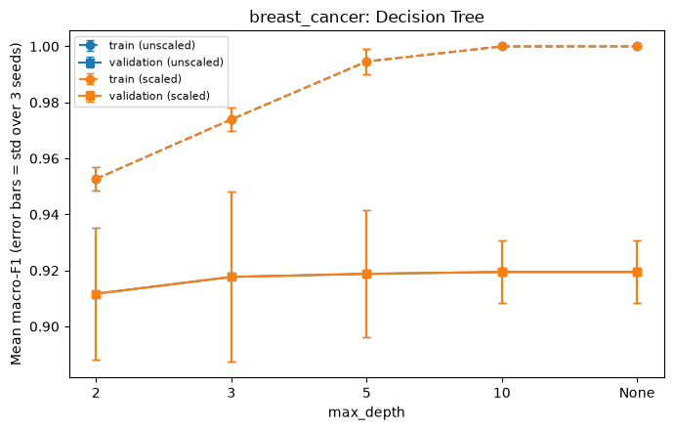  Figure 5. Breast Cancer: Decision Tree. | 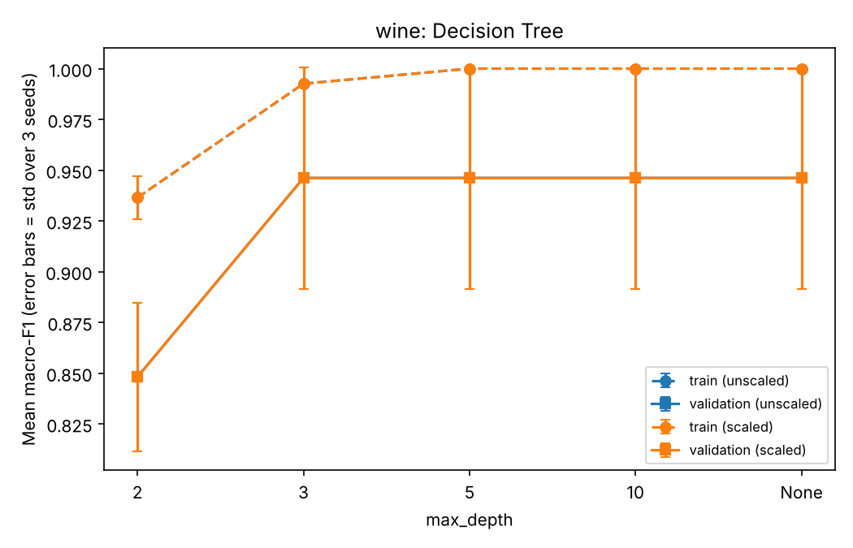  Figure 6. Wine: Decision Tree.
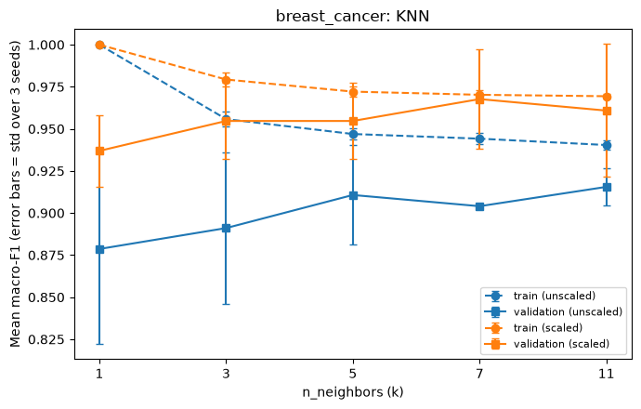  Figure 7. Breast Cancer: KNN. | 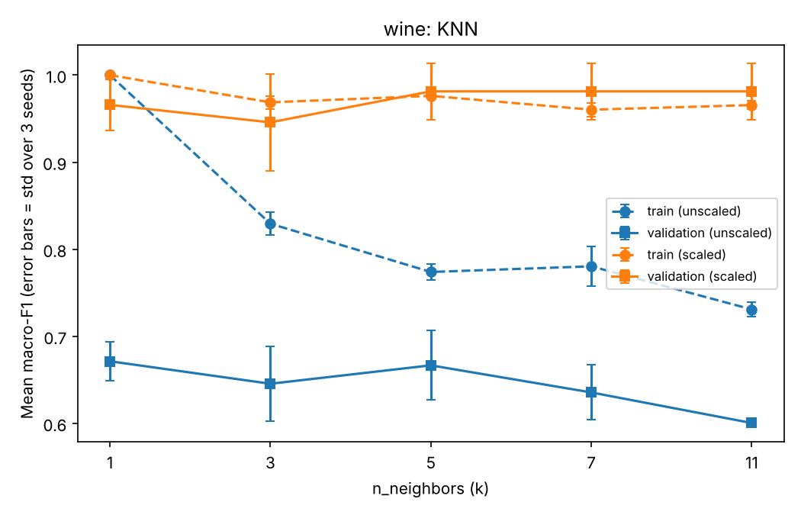  Figure 8. Wine: KNN.

9. Evaluating the Selected Models on the Test Sets

9.1 Final performance metrics
Each selected model (seed-42 model with seed-42 scaling) was evaluated once on its fixed test set. The test set was not used for any choice.
Table 4. Classifier test results.
Dataset | Selected model | Val F1 (mean ± std) | Test Acc | Test Prec | Test Rec | Test F1 | Test AUC
Breast Cancer | KNN scaled k=7 | 0.968 ± 0.030 | 0.974 | 0.980 | 0.964 | 0.971 | 0.989
Wine | KNN scaled k=11 | 0.981 ± 0.032 | 1.000 | 1.000 | 1.000 | 1.000 | 1.000

Breast Cancer, per class (test set, 114 samples): malignant has precision 1.00, recall 0.93 and F1 0.96 (42 samples); benign has precision 0.96, recall 1.00 and F1 0.98 (72 samples). Wine: precision, recall and F1 are 1.00 for all three classes (12, 14 and 10 samples).
The Wine test score (1.0) is a little higher than the mean validation score (0.981). We do not read this as the model being better on test, because both sets are small and the test score comes from one split.

9.2 Confusion matrices
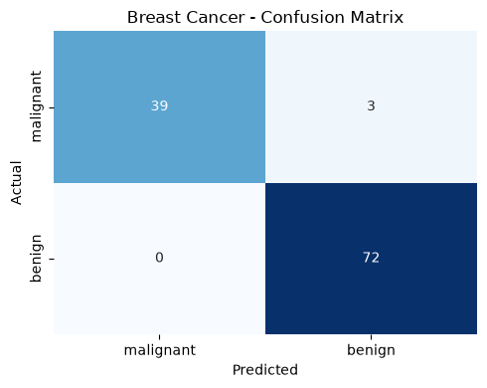  Figure 9. Breast Cancer test confusion matrix. | 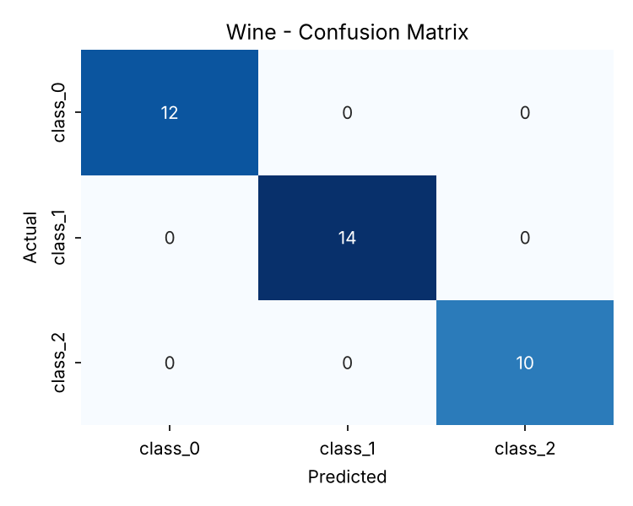  Figure 10. Wine test confusion matrix.
Breast Cancer (malignant as positive): TP=39, FP=0, FN=3, TN=72. Manual precision (1.000), recall (0.929) and F1 (0.963) match the classification report. Wine: only the diagonal has values (12, 14, 10). For class_1 versus the rest, TP=14, FP=0, FN=0, TN=22, so precision, recall and F1 are all 1.0.

9.3 ROC curves
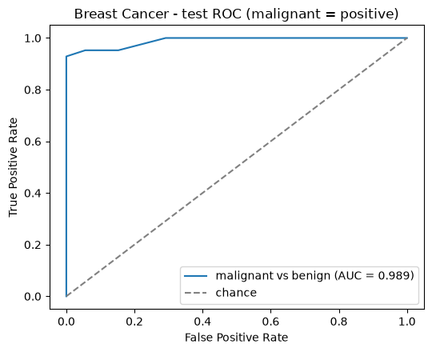  Figure 11. Breast Cancer test ROC. | 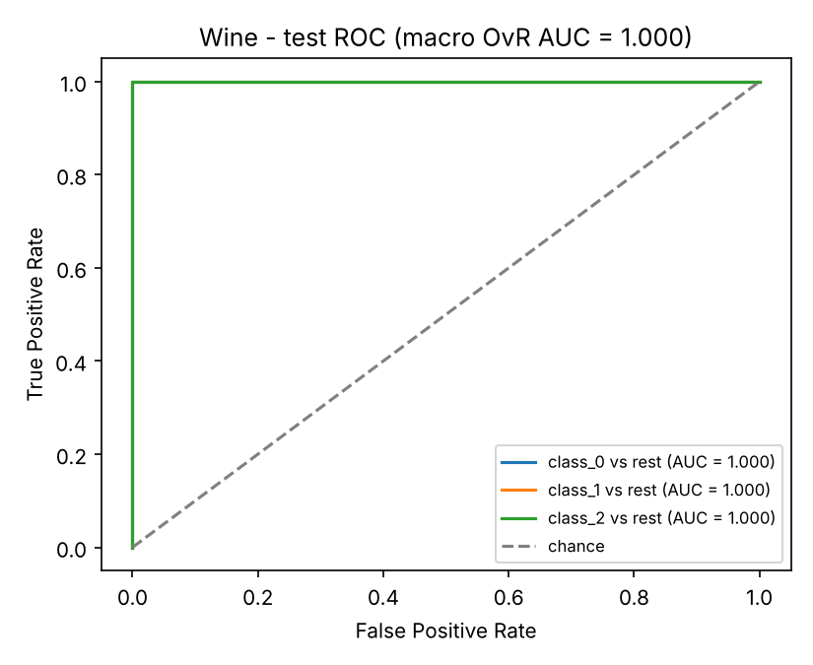  Figure 12. Wine test ROC (one-vs-rest).
The Breast Cancer test AUC is 0.989. In Wine, all three one-vs-rest AUC values are 1.0, so the macro AUC is 1.0. The ROC curve shows all thresholds. We do not choose a new threshold from the test set.

9.4 Error interpretation
Breast Cancer has 3 errors out of 114 (samples 41, 73 and 205). All three are malignant tumors predicted as benign. Wine has no errors on the test set. One error-free result on 36 samples is not enough to say that the model will generalise perfectly.

10. K-Means Clustering

10.1 Fit the clustering model
K-Means is fitted on the training features only (no labels), with n_init=10 and random_state equal to the seed. We use 2 clusters for Breast Cancer and 3 clusters for Wine, the same as the number of classes. The labels are only used afterwards to measure the agreement with the classes. Validation results are in Table 5.
Table 5. K-Means validation summary (mean ± std over 3 seeds).
Dataset | Representation | Train inertia (mean) | Val ARI | Val silhouette
Breast Cancer | unscaled | 5.13e7 | 0.504 ± 0.106 | 0.677 ± 0.033
Breast Cancer | scaled | 7948 | 0.581 ± 0.142 | 0.312 ± 0.055
Wine | unscaled | 1.35e6 | 0.361 ± 0.068 | 0.577 ± 0.101
Wine | scaled | 879 | 1.000 ± 0.000 | 0.275 ± 0.025

ARI (adjusted Rand index) measures agreement between clusters and classes: 1.0 is perfect agreement and values near 0 are random. It is not an accuracy percentage. Inertia values of scaled and unscaled data cannot be compared because the units are different. A higher silhouette for the unscaled data does not mean a better result: in the unscaled data, large-scale features (mean area for Breast Cancer, proline for Wine) dominate the distances, so the clusters look compact but do not match the classes.

10.2 Final cluster evaluation on the test sets
The seed-42 K-Means models are applied to the fixed test sets without refitting. Cluster numbers are arbitrary.
Table 6. K-Means test evaluation (seed 42).
Dataset | Representation | Test ARI | Test silhouette | Cluster counts
Breast Cancer | unscaled | 0.558 | 0.712 | 0:86; 1:28
Breast Cancer | scaled | 0.735 | 0.325 | 0:74; 1:40
Wine | unscaled | 0.373 | 0.493 | 0:14; 1:10; 2:12
Wine | scaled | 0.909 | 0.271 | 0:13; 1:13; 2:10

Table 7. Class versus cluster counts on the test sets.
Breast Cancer, unscaled
Class | Cluster 0 | Cluster 1
benign | 72 | 0
malignant | 14 | 28

Breast Cancer, scaled
Class | Cluster 0 | Cluster 1
benign | 69 | 3
malignant | 5 | 37

Wine, unscaled
Class | Cluster 0 | Cluster 1 | Cluster 2
class_0 | 2 | 10 | 0
class_1 | 5 | 0 | 9
class_2 | 7 | 0 | 3

Wine, scaled
Class | Cluster 0 | Cluster 1 | Cluster 2
class_0 | 12 | 0 | 0
class_1 | 1 | 13 | 0
class_2 | 0 | 0 | 10

Breast Cancer: with scaling, 3 benign and 5 malignant samples are in the other cluster. Without scaling, all benign samples are in cluster 0, but 14 of 42 malignant samples are in cluster 0 too. Wine: with scaling, all class_0 and class_2 samples are in their own clusters and 13 of 14 class_1 samples are in cluster 1. Without scaling, class_1 and class_2 are mixed. K-Means does not use labels, so its ARI cannot be compared with the classifier metrics: it solves a different task.

10.3 Visualise and interpret the clusters
We plot the two features with the highest absolute correlation with the class in the seed-42 training data: worst concave points and mean concave points for Breast Cancer, and flavanoids and od280/od315_of_diluted_wines for Wine. The left panel shows the true classes and the right panel shows the clusters. Colours do not have to match between panels.
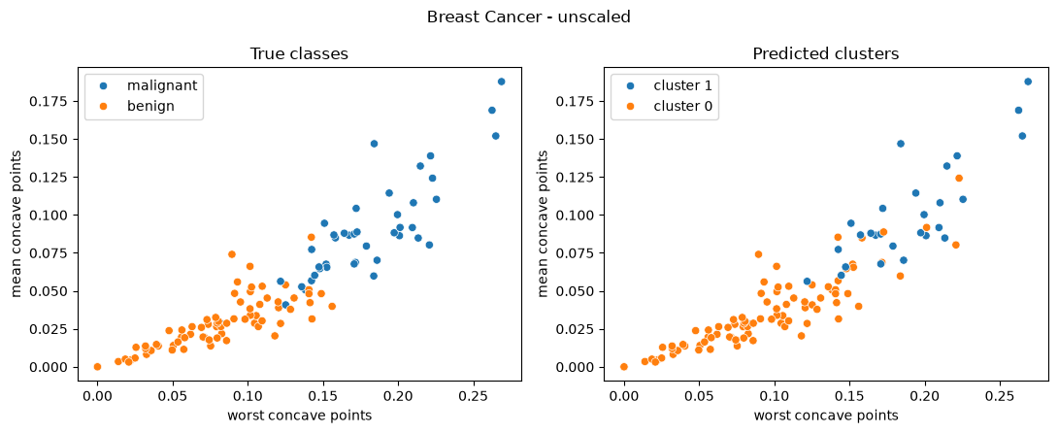
Figure 13. Breast Cancer K-Means, unscaled (test set).
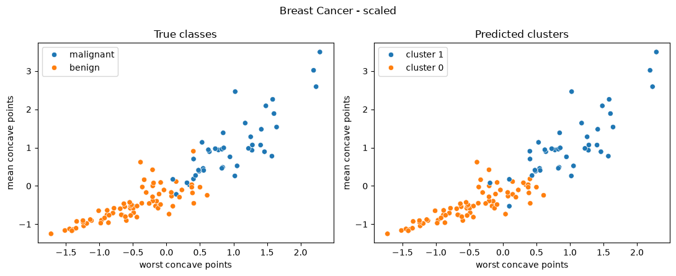
Figure 14. Breast Cancer K-Means, scaled (test set).
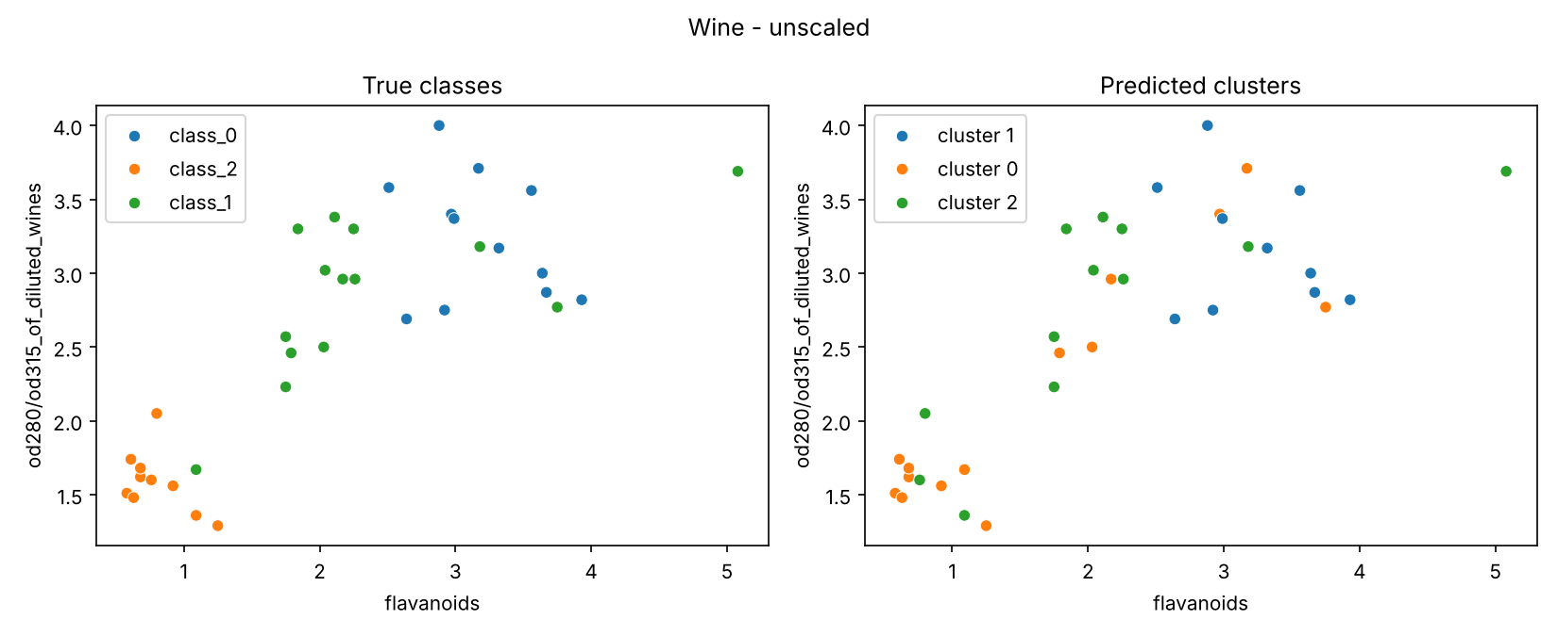
Figure 15. Wine K-Means, unscaled (test set).
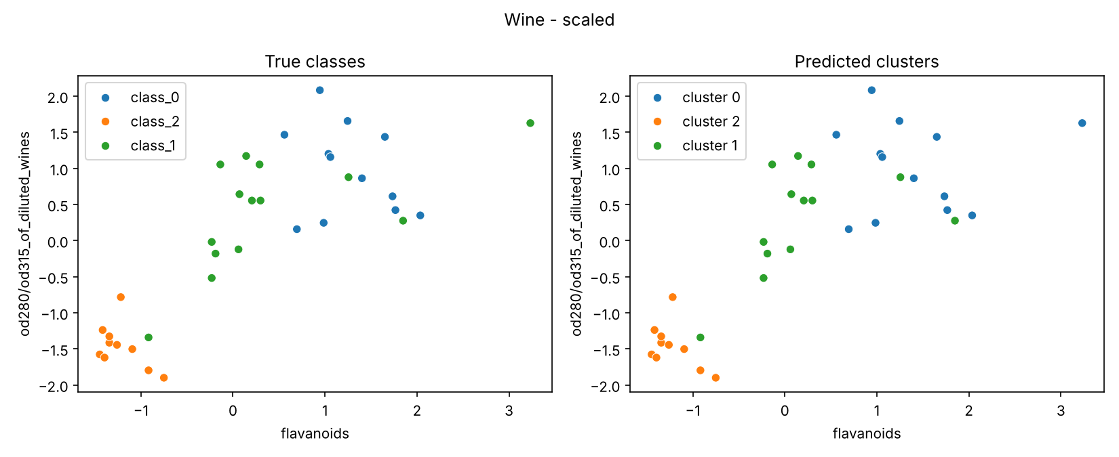
Figure 16. Wine K-Means, scaled (test set).
For Wine, the scaled clusters follow the class groups in this 2D view, and the unscaled clusters are mixed. This is because the unscaled clusters were found mostly by proline, which is not one of the two plotted features. This is only a 2D view of a higher dimensional space.

11. Results Across the Two Datasets
1. Was the same classifier and representation best on both datasets?
The algorithm and representation were the same, but the parameter was not. On validation, scaled KNN was best on both datasets: k=7 for Breast Cancer (macro-F1 0.968) and k=11 for Wine (0.981, tied with k=5 and k=7 and selected by the tie-break rule).
On test, only the selected model of each dataset was evaluated, so we cannot say that it was best on test. It performed well on both: Breast Cancer accuracy 0.974 and macro-F1 0.971, Wine 1.000 on all metrics. These test results agree with the validation choice but do not prove that other models would be worse.
2. Which algorithm was most affected by scaling?
KNN. In Breast Cancer, validation macro-F1 rose from 0.904 to 0.968 for k=7 (+0.064) and from 0.879 to 0.937 for k=1 (+0.058). In Wine the effect was much larger: k=11 rose from 0.600 to 0.981 (+0.381) and k=5 from 0.667 to 0.981 (+0.314). Wine is affected more because like proline (range 278 to 1680) are big numbers so its dominates when unscaled.
The Decision Tree was not affected: all 10 scaled and unscaled pairs have identical values (for example depth 3 gives 0.918 in Breast Cancer and 0.946 in Wine in both representations), because tree splits depend only on the order of values. GaussianNB changed very little: Wine was identical (0.964) and Breast Cancer changed from 0.937 to 0.925.
3. Did deeper trees or larger k always improve validation performance?
No. Decision Tree, Breast Cancer: validation macro-F1 is 0.912 (depth 2), 0.918 (depth 3) and 0.919 for depth 5, 10 and None, while training macro-F1 goes from 0.953 to 1.0. So the gain stops after depth 3 and the train-validation gap grows. Wine: 0.848 at depth 2, 0.946 at depth 3, and the same 0.946 for all deeper trees (Figures 5 and 6).
KNN, scaled: Breast Cancer goes 0.937 (k=1), 0.955 (k=3), 0.955 (k=5), 0.968 (k=7) and then falls to 0.961 (k=11). Wine goes 0.966 (k=1), falls to 0.946 (k=3), then 0.981 for k=5, 7 and 11. For unscaled Wine, larger k is worse (0.671 at k=1 and 0.600 at k=11) (Figures 7 and 8).
Variation between seeds (std of validation macro-F1): Breast Cancer 0.011 to 0.030 for trees and 0.021 to 0.039 for scaled KNN; Wine 0.036 to 0.055 for trees and 0.030 to 0.056 for scaled KNN. Many differences between neighbouring settings are smaller than these values, especially in Wine where the validation set has 18 samples, so they should not be over-interpreted.
4. How were the main classification errors different?
Breast Cancer had 3 errors in 114 test samples, and all were malignant tumors predicted as benign (FN=3, FP=0). Malignant precision is 1.00 and recall is 0.93. Wine had no errors: the confusion matrix has only the diagonal (12, 14, 10), so nothing to say.
5. How was K-Means agreement with the true classes different?
Agreement was clearly higher in Wine. With scaling, Wine had validation ARI 1.000 (std 0.000) and test ARI 0.909, while Breast Cancer had validation ARI 0.581 (std 0.142) and test ARI 0.735. Without scaling, both were lower: Wine 0.361 (validation) and 0.373 (test), Breast Cancer 0.504 and 0.558.
The contingency tables show the same pattern. In scaled Wine only 1 of 36 test samples is outside its main cluster. In scaled Breast Cancer, 3 benign and 5 malignant samples are in the other cluster, and in unscaled Breast Cancer 14 of 42 malignant samples are in the benign cluster. ARI is not classification accuracy, so 0.735 does not mean 73.5% correct. Silhouette was higher for unscaled data in both datasets, but this does not mean better agreement with the classes.
6. What change would we investigate next?
Future work: we would repeat the train/validation split with more seeds (for example 10 instead of 3) and check whether the same models are selected. The reason is that the validation sets are small (57 samples for Breast Cancer and 18 for Wine). More seeds would give a more stable mean and standard deviation for each configuration. We have not done this, so we do not know the result.

12. Exported Results and Files
The code is in two notebooks (breast_cancer.ipynb and wine.ipynb) that use the shared file helpers.py. Each notebook saves its tables to results/parts, and the combined files are in the results folder: classifier_runs.csv (132 rows), classifier_summary.csv (44 rows), classifier_test.csv (2 rows), kmeans_runs.csv (12 rows), kmeans_summary.csv (4 rows) and kmeans_test.csv (4 rows). The figures are in the figures folder.
Video: https://youtu.be/GOql-7WvIyo

Appendix A. Descriptive Statistics
Table A1. Breast Cancer descriptive statistics.
Feature | Mean | Median | Min | Max | Std | Q1 | Q3
mean radius | 14.13 | 13.37 | 6.981 | 28.11 | 3.524 | 11.7 | 15.78
mean texture | 19.29 | 18.84 | 9.71 | 39.28 | 4.301 | 16.17 | 21.8
mean perimeter | 91.97 | 86.24 | 43.79 | 188.5 | 24.3 | 75.17 | 104.1
mean area | 654.9 | 551.1 | 143.5 | 2501.0 | 351.9 | 420.3 | 782.7
mean smoothness | 0.09636 | 0.09587 | 0.05263 | 0.1634 | 0.01406 | 0.08637 | 0.1053
mean compactness | 0.1043 | 0.09263 | 0.01938 | 0.3454 | 0.05281 | 0.06492 | 0.1304
mean concavity | 0.0888 | 0.06154 | 0 | 0.4268 | 0.07972 | 0.02956 | 0.1307
mean concave points | 0.04892 | 0.0335 | 0 | 0.2012 | 0.0388 | 0.02031 | 0.074
mean symmetry | 0.1812 | 0.1792 | 0.106 | 0.304 | 0.02741 | 0.1619 | 0.1957
mean fractal dimension | 0.0628 | 0.06154 | 0.04996 | 0.09744 | 0.00706 | 0.0577 | 0.06612
radius error | 0.4052 | 0.3242 | 0.1115 | 2.873 | 0.2773 | 0.2324 | 0.4789
texture error | 1.217 | 1.108 | 0.3602 | 4.885 | 0.5516 | 0.8339 | 1.474
perimeter error | 2.866 | 2.287 | 0.757 | 21.98 | 2.022 | 1.606 | 3.357
area error | 40.34 | 24.53 | 6.802 | 542.2 | 45.49 | 17.85 | 45.19
smoothness error | 0.007041 | 0.00638 | 0.001713 | 0.03113 | 0.003003 | 0.005169 | 0.008146
compactness error | 0.02548 | 0.02045 | 0.002252 | 0.1354 | 0.01791 | 0.01308 | 0.03245
concavity error | 0.03189 | 0.02589 | 0 | 0.396 | 0.03019 | 0.01509 | 0.04205
concave points error | 0.0118 | 0.01093 | 0 | 0.05279 | 0.00617 | 0.007638 | 0.01471
symmetry error | 0.02054 | 0.01873 | 0.007882 | 0.07895 | 0.008266 | 0.01516 | 0.02348
fractal dimension error | 0.003795 | 0.003187 | 0.0008948 | 0.02984 | 0.002646 | 0.002248 | 0.004558
worst radius | 16.27 | 14.97 | 7.93 | 36.04 | 4.833 | 13.01 | 18.79
worst texture | 25.68 | 25.41 | 12.02 | 49.54 | 6.146 | 21.08 | 29.72
worst perimeter | 107.3 | 97.66 | 50.41 | 251.2 | 33.6 | 84.11 | 125.4
worst area | 880.6 | 686.5 | 185.2 | 4254.0 | 569.4 | 515.3 | 1084.0
worst smoothness | 0.1324 | 0.1313 | 0.07117 | 0.2226 | 0.02283 | 0.1166 | 0.146
worst compactness | 0.2543 | 0.2119 | 0.02729 | 1.058 | 0.1573 | 0.1472 | 0.3391
worst concavity | 0.2722 | 0.2267 | 0 | 1.252 | 0.2086 | 0.1145 | 0.3829
worst concave points | 0.1146 | 0.09993 | 0 | 0.291 | 0.06573 | 0.06493 | 0.1614
worst symmetry | 0.2901 | 0.2822 | 0.1565 | 0.6638 | 0.06187 | 0.2504 | 0.3179
worst fractal dimension | 0.08395 | 0.08004 | 0.05504 | 0.2075 | 0.01806 | 0.07146 | 0.09208

Table A2. Wine descriptive statistics.
Feature | Mean | Median | Min | Max | Std | Q1 | Q3
alcohol | 13 | 13.05 | 11.03 | 14.83 | 0.8118 | 12.36 | 13.68
malic_acid | 2.336 | 1.865 | 0.74 | 5.8 | 1.117 | 1.603 | 3.083
ash | 2.367 | 2.36 | 1.36 | 3.23 | 0.2743 | 2.21 | 2.558
alcalinity_of_ash | 19.49 | 19.5 | 10.6 | 30 | 3.34 | 17.2 | 21.5
magnesium | 99.74 | 98 | 70 | 162 | 14.28 | 88 | 107
total_phenols | 2.295 | 2.355 | 0.98 | 3.88 | 0.6259 | 1.742 | 2.8
flavanoids | 2.029 | 2.135 | 0.34 | 5.08 | 0.9989 | 1.205 | 2.875
nonflavanoid_phenols | 0.3619 | 0.34 | 0.13 | 0.66 | 0.1245 | 0.27 | 0.4375
proanthocyanins | 1.591 | 1.555 | 0.41 | 3.58 | 0.5724 | 1.25 | 1.95
color_intensity | 5.058 | 4.69 | 1.28 | 13 | 2.318 | 3.22 | 6.2
hue | 0.9574 | 0.965 | 0.48 | 1.71 | 0.2286 | 0.7825 | 1.12
od280/od315_of_diluted_wines | 2.612 | 2.78 | 1.27 | 4 | 0.71 | 1.938 | 3.17
proline | 746.9 | 673.5 | 278 | 1680.0 | 314.9 | 500.5 | 985

Appendix B. Boxplots
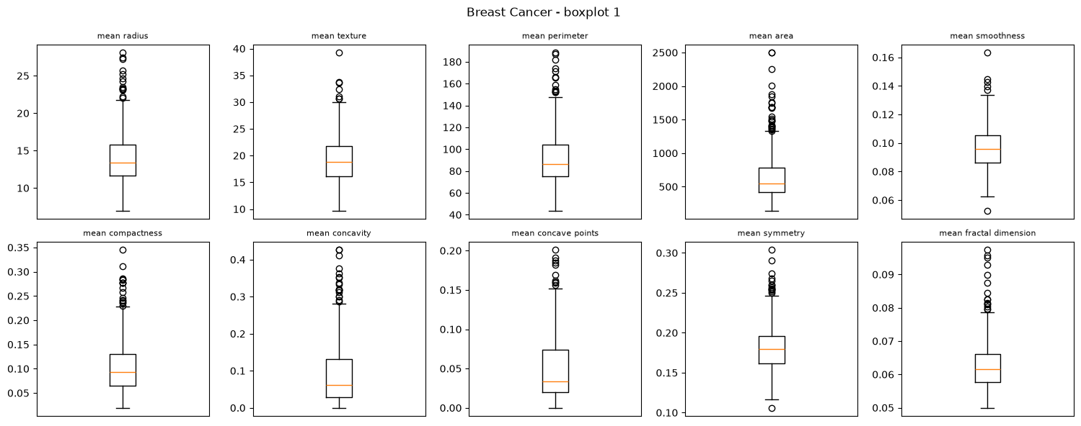
Figure B1. Breast Cancer boxplots, features 1 to 10.
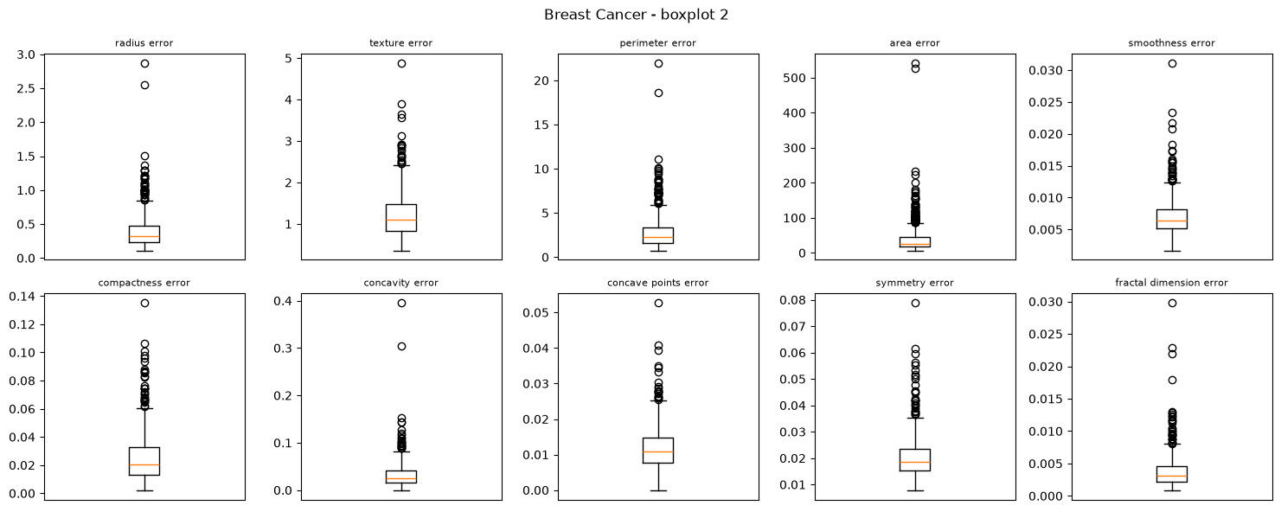
Figure B2. Breast Cancer boxplots, features 11 to 20.
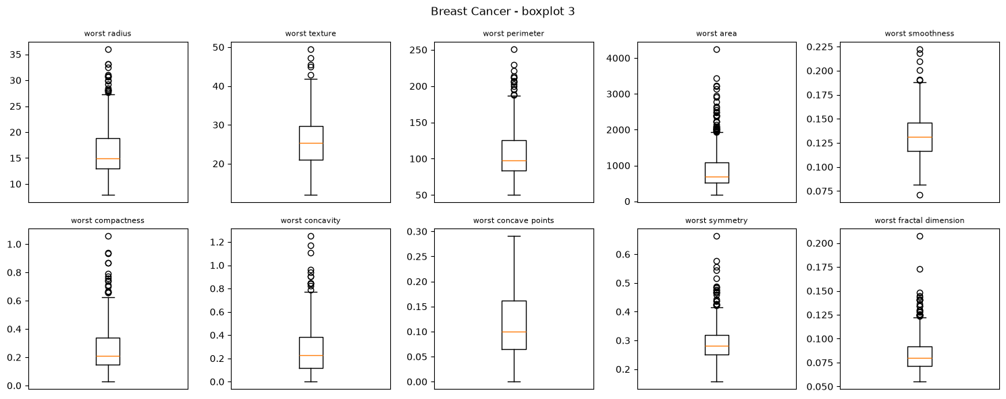
Figure B3. Breast Cancer boxplots, features 21 to 30.
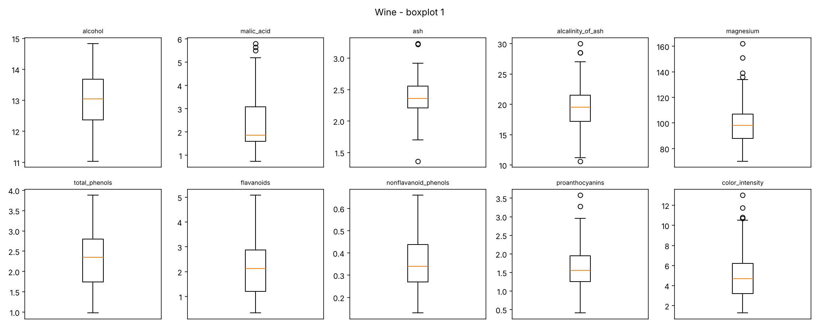
Figure B4. Wine boxplots, features 1 to 10.
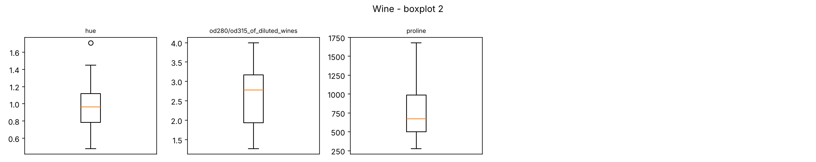
Figure B5. Wine boxplots, features 11 to 13.

