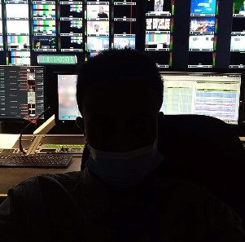

**Personal Information**

Name: Sharif

**Profile**

- Graphic designer and illustrator.

- Strong background in graphic design, illustration, photography, and computer texturing, with very good experience in Animation.

- Good teamwork skills and individual ones.

|  |  |  |
| --- | --- | --- |
| **Education**  2014 -2016 | Graphic and Digital Design, HND | University of Greenwich |
|  |  | London |
| 2009 -2011 | BTEC National Diploma in Engineering | City of Westminster College, London |
| 2008 – 2009 | BTEC First diploma in Engineering | City of Westminster College, London |
| 2006 – 2008 | GCSE in IT(C), Math(C), and Science (C) | Whitefield secondary school London |

**Experience**

*Dec 2 0 22 – Apr 2023*

Danhouse LTD, London

***Schedules*** (Responsible for scheduling and

organizing schedules for various projects and events.

This includes ensuring that deadlines are met,

resources are allocated efficiently,

and plans are executed effectively

*M a y 2 0 1 9– Oct 2022*

Alaraby TV”, London

***Ingest operator*** ( responsible for monitoring and

ensuring the quality standards of all video material processed.

Ensures that all media files conform to established standards,

assessing for any potential errors,

and addressing them if necessary to ensure the highest level of quality.

*Jan 2 0 17 – Jan 2019*

Horn cable TV, London

***Video and Motion Graphic Designer***

*2 0 23 - P r e s e n t*

Freelance Jobs

***Logo Design & Identity****:Web* Digital & Print Designs, Logos, Business Cards, Corporate

Identities, Book Covers and Designs for various clients.

**Software Skills**

Adobe Photoshop

Adobe Illustrator

Adobe InDesign

Adobe Premiere

Adobe AfterEffect

Microsoft Office

**Artistic Skills** Computer Modeling Character Design

Illustration

Scene Layout Design Storyboarding Computer texturing

Product & People Photography

# Skills & Interests

I enjoy learning languages in my spare time. I also enjoy learning about history and different cultures. Another hobby of mine is to design and edit videos. I have a keen interest in software development

**Language,**

English (Fluent; written and spoken) Somali (Mother language)

Amhara

Arabic

And Suomi

**Contact Information**

Phone number: +447467064303 E-mail: [kacfariiso@gmail.com](mailto:kacfariiso@gmail.com)