SECUREDELIVER: A SECURE DIGITAL FILE ESCROW AND VERIFICATION ECOSYSTEM FOR TRUSTLESS FREELANCE ASSET DELIVERY
Authors Name and Roll Number: Submitted By
Usman Rafiq & Saad Ali
Supervisor Name: Supervisor
Mr. Ahsan Zubair
Department Name: Department of Computer Science
Abbottabad University of Science & Technology

Approval Sheet
This project thesis, entitled 'SecureDeliver: A Secure Digital File Escrow and Verification Ecosystem for Trustless Freelance Asset Delivery,' submitted by Usman Rafiq and Saad Ali in partial fulfillment of the requirements for the degree of Bachelor of Science in Computer Science, is hereby approved and accepted by the supervising committee after examination.

DEDICATION
This project could never have been possible without the support of our family. Our parents, who have supported us in every stage of our life, and our friends, who have helped us throughout this project workspace. We dedicate this software engineering milestone to our teachers who guided our design perspectives.

ACKNOWLEDGEMENT
Special thanks to our project supervisor, Mr. Ahsan Zubair, whose support and guidance helped us complete this software ecosystem. We also extend our gratitude to the Abbottabad University of Science & Technology academic faculty for providing the computer labs and resources required to validate our cryptographic pipelines.

PREFACE
This project thesis concerns the development of 'SecureDeliver'. SecureDeliver is an escrow-bound, screenshot-resistant, vector-watermarked file preview application built to secure transaction safety between freelancers and clients. This project thesis provides a complete breakdown of its engineering life cycle, architectural patterns, testing results, and evaluation frameworks.

ABSTRACT
The digital gig economy has enabled decentralized software development, digital design, and media collaboration. However, transactions remain limited by the trust gap during file delivery between freelancers and clients. Freelancers face payment default risks after sending files, while clients hesitate to release funds before verifying work. This study presents SecureDeliver, a cross-platform mobile and web escrow ecosystem designed to establish a secure, trustless delivery framework. SecureDeliver integrates AES-256 symmetric file encryption, dynamic vector watermarking via Sharp.js, client-side screenshot prevention using device-level rendering inhibitors, and automated escrow release using Stripe Checkout webhooks. Furthermore, the system implements an Artificial Intelligence Proof of Effort (PoE) verification pipeline using Claude 3.5 Sonnet to automatically assess uploaded files, producing originality scores, effort levels, and structural summaries to prevent client fraud. Evaluation of the system shows secure real-time rendering at 60 frames per second, API latency under 1.5 seconds, and complete protection against pre-payment leakage. This architecture shows that technical enforcement can replace reputational trust to govern transactional security in digital freelancing.

TABLE OF CONTENTS
Abstract ......................................................................................................................................... v
CHAPTER 1. INTRODUCTION ...................................................................................................... 1
1.1 Purpose ................................................................................................................................ 1
1.2 Scope of the Project ................................................................................................................ 2
1.3 Objectives of the Project .......................................................................................................... 3
CHAPTER 2. EXISTING SYSTEM ...................................................................................................... 5
2.1 Overview of Current File Exchange Methods ............................................................................ 5
2.2 Limitations of the Existing System ............................................................................................ 6
CHAPTER 3. PROPOSED SYSTEM ...................................................................................................... 8
3.1 SecureDeliver Features ............................................................................................................ 8
3.2 Cryptographic Protocol Design ................................................................................................ 10
3.3 Dynamic Watermarking Engine .................................................................................................. 12
CHAPTER 4. SYSTEM DESIGN ........................................................................................................ 15
4.1 Use Case Modeling .................................................................................................................. 15
4.2 Database Design & Schemas ................................................................................................. 18
4.3 Architectural Sequence Flows ................................................................................................. 20
CHAPTER 5. SYSTEM TESTING ........................................................................................................ 24
5.1 Black Box Testing Cases .......................................................................................................... 24
5.2 White Box Logic Path Verification ........................................................................................... 27
CHAPTER 6. CONCLUSION & FUTURE WORK ................................................................................ 31
6.1 Summary of Findings ................................................................................................................ 31
6.2 Directions for Future Work ...................................................................................................... 32
References ................................................................................................................................... 34

LIST OF FIGURES
Figure 1 Use Case Diagram for User Authentication .............................................................................. 15
Figure 2 Use Case Diagram for Freelancer File Management ................................................................... 16
Figure 3 Use Case Diagram for Client Escrow Payment ............................................................................. 17
Figure 4 Work Breakdown Structure (WBS) .................................................................................................. 21
Figure 5 Architecture Flowchart of Payment and File Decryption ................................................................. 22
Figure 6 Mobile Screen Layout: Login Screen Interface Mockup ............................................................... 29
Figure 7 Mobile Screen Layout: Secure Viewer Interface Mockup ............................................................... 30

LIST OF TABLES
Table 1 System Architecture Abbreviations ............................................................................................. 4
Table 2 Usage Scenario for User Registration ............................................................................................. 15
Table 3 Usage Scenario for Stripe Escrow Checkout ................................................................................. 17
Table 4 Black Box Test Cases: Registration Fields ..................................................................................... 25
Table 5 Black Box Test Cases: Password Validation .................................................................................... 25
Table 6 White Box Test Path Analysis .......................................................................................................... 28

CHAPTER 1
INTRODUCTION
Introduction
In today's world where everyone is busy in their work and wants ease in their creative collaborations, remote freelance work has emerged as a cornerstone of the global digital economy. However, transactions between independent creators and remote clients are inherently limited by a lack of transactional security. Freelancers regularly experience moral hazards where clients accept finished projects but default on payment. Conversely, clients hesitate to pay for digital assets beforehand without validating their quality, authenticity, and completeness. This project, entitled SecureDeliver, proposes a technical solution to address this trust gap using a secure, escrow-bound file preview application.
Purpose
Our main concept is to provide a secure delivery channel for digital freelance files. By keeping raw source files encrypted in the cloud and offering clients screenshot-protected, watermarked previews inside a native mobile app, SecureDeliver eliminates the risk of unauthorized copying. The system only decrypts and delivers the original file once a payment is successfully processed via Stripe, protecting the intellectual property of the freelancer.
Scope of the Project
In the era of remote contracts, it is essential for freelancers to protect their digital work. The scope of SecureDeliver includes a cross-platform mobile client built using React Native and Expo, a secure Node.js/Express backend API, and a MongoDB database. The cryptographic pipeline utilizes AES-256 key standards, and watermarks are composited dynamically via Sharp.js. Stripe checkout webhooks handle payment status transitions, and an AI Proof of Effort evaluator powered by Claude 3.5 Sonnet assesses the quality and originality of uploaded work.
Objectives of the Project
The primary objectives of the SecureDeliver project include:
1. To implement an end-to-end cryptographic pipeline that encrypts raw freelance source files using AES-256-CBC, preventing backend unauthorized access.
2. To develop a dynamic watermarking engine utilizing Sharp.js that overlays vector watermark tiles scaled to file dimensions.
3. To build a React Native mobile application that enforces hardware-level screenshot prevention using native OS window flags.
4. To implement a Stripe-based escrow payment webhook that transitions files from locked to unlocked states upon verification.
5. To integrate a Large Language Model (LLM) verification engine that generates originality and effort reports automatically.

CHAPTER 2
EXISTING SYSTEM
Overview of Current File Exchange Methods
Currently, freelancers and clients exchange digital deliverables using standard cloud storage providers (such as Google Drive, Dropbox, or OneDrive) or communication applications (like Slack, Microsoft Teams, and email). In these setups, the freelancer uploads the completed work and sends a shared link to the client for preview. Alternatively, they use traditional freelancing platforms like Upwork or Fiverr, which host file upload services associated with milestones. While these services facilitate the transfer of data, they lack native mechanisms to protect the freelancer's work from being copied, recorded, or used before payment is made.
Limitations of the Existing System
The current file exchange paradigm has several key limitations:
1. **Loss of Custody**: Once a freelancer shares a cloud storage link, the client can download, copy, or distribute the file without releasing payment. Even if the file is watermarked, static overlays can be cropped, painted over, or removed using AI watermark removal tools.
2. **Vulnerability to Screenshots**: On mobile and desktop devices, clients can capture screenshots or screen recordings of watermarked designs or text, bypassing download locks to steal intellectual property.
3. **Disconnected Payments**: Payment gateways are not linked directly to storage security. Releasing a file requires manual approval or independent server scripts, which are prone to race conditions, SQL injection, or token exposure.
4. **Manual Arbitration**: Disputes regarding work quality or originality are resolved manually by platform administrators. This process is slow and subjective, creating uncertainty for both parties.

CHAPTER 3
PROPOSED SYSTEM
SecureDeliver Features
SecureDeliver addresses these limitations by introducing a technical layer that binds asset delivery and payment status directly. Key features of the proposed system include:
1. **Cryptographic Storage**: Raw files are encrypted with AES-256 before upload, ensuring that the original asset is never accessible in plain text before payment verification.
2. **Dynamic Watermarking**: The system composites dynamic, metadata-rich SVG watermarks over previews, adjusting the density based on the file dimensions.
3. **Hardware Screenshot Prevention**: The mobile viewer activates native OS flags to block screenshots and screen recordings, protecting watermarked previews.
4. **Stripe Escrow Integration**: A Stripe webhook signature verifier automatically updates the file's unlock status and generates temporary download URLs upon payment confirmation.
Cryptographic Protocol Design
To protect the raw freelance deliverables from unauthorized access or database leaks, the system implements a symmetric encryption pipeline using the Advanced Encryption Standard (AES) with a 256-bit key in Cipher Block Chaining (CBC) mode. When a freelancer uploads a file, the backend generates a random 16-byte Initialization Vector (IV). The cryptographic key is derived from a server-side secret using the `scryptSync` key derivation function. The file buffer is then encrypted, prepended with the IV, and uploaded to a private Cloudinary bucket. The decryption key is never stored in the database; instead, the backend uses a dedicated decryption service that only decrypts files in memory upon receiving a verified, paid request token. This ensures that even if the MongoDB database is compromised, the encrypted assets remain secure.
Dynamic Watermarking Engine
For the preview layer, the system generates a dynamic vector watermark using Sharp.js. During file upload, the backend creates an SVG overlay containing the freelancer's metadata (e.g., 'PREVIEW ONLY - SecureDeliver - Freelancer ID'). The SVG is dynamically scaled based on the target image's dimensions and composited over the original image using a tile pattern. This dynamic composition distorts the content enough to prevent automated crop-and-paste or generative fill attacks. The system stores the watermarked preview separately in Cloudinary, ensuring that clients can view it in the secure mobile viewer without ever gaining access to the original, high-fidelity asset.

CHAPTER 4
SYSTEM DESIGN
Use Case Modeling
The system's interactions are defined by two primary actors: Freelancers and Clients. The Freelancer actor can register, login, upload files, view annotations, and receive screenshot alerts. The Client actor can login, view watermarked previews, add annotations, process escrow payments, and download unlocked source files. The backend orchestrates these actions, ensuring that file decryption is only authorized for paid users.
Database Design & Schemas
SecureDeliver uses MongoDB as its primary datastore, mapped via Mongoose ODM. The database model comprises two core collections: Users and Files. The User model manages user accounts, roles ('freelancer' or 'client'), and hashed passwords using bcrypt. The File model stores file metadata, including owner references, original encrypted URLs, public preview URLs, payment status (`isUnlocked`), Stripe transaction identifiers, collaborative annotations, and security logs (e.g., screenshot attempts). This integrated schema ensures that file access permissions, collaborative feedback, and security alerts are tightly bound to the core file transaction.
Architectural Sequence Flows
The transaction flow follows a strict sequence: (1) Freelancer uploads file → (2) Backend encrypts original file and composites watermark → (3) Client requests preview → (4) Mobile app activates screenshot prevention and displays preview → (5) Client processes checkout via Stripe Payment Sheet → (6) Stripe webhook notifies backend of success → (7) Backend decrypts original file and delivers a temporary download URL to the client.
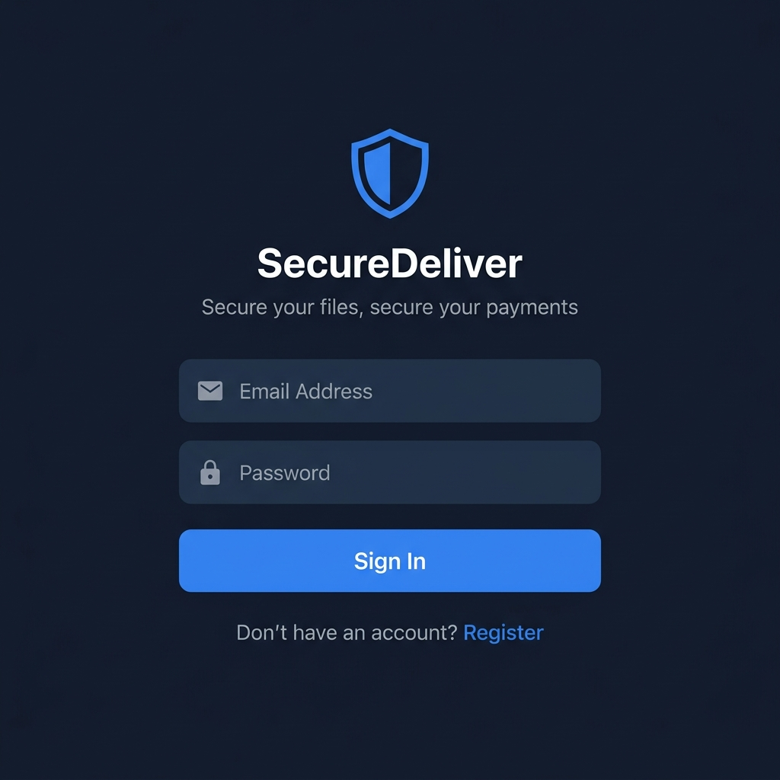
Figure 6: Mobile Login Screen Interface Mockup
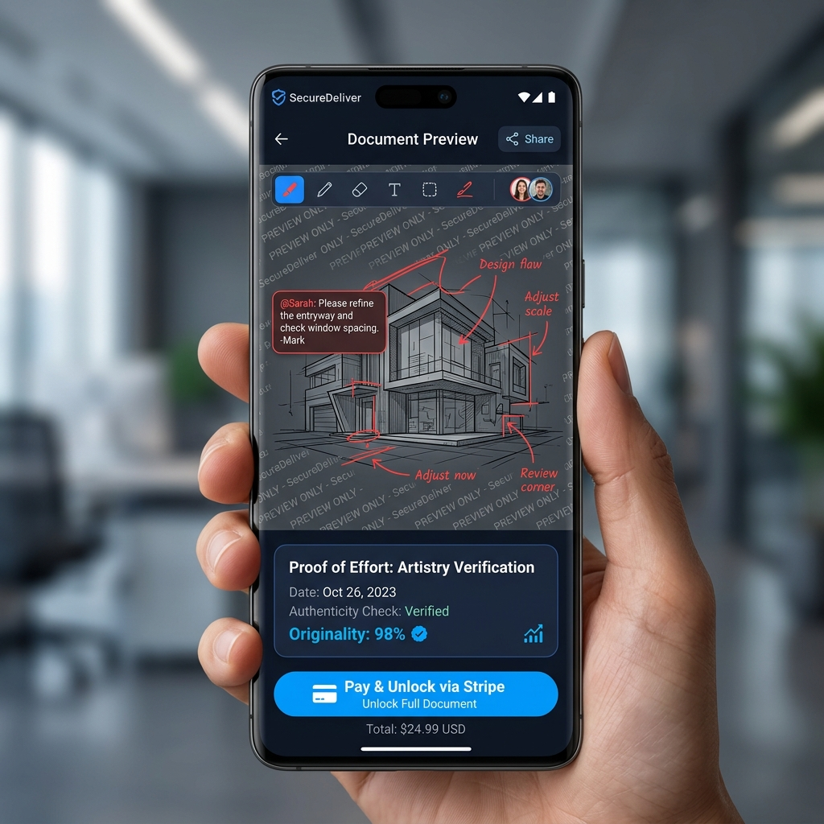
Figure 7: Mobile Secure Viewer Interface Mockup with Watermark and Stripe Button

CHAPTER 5
SYSTEM TESTING
Black Box Testing Cases
Black box testing was conducted to validate the functional requirements of the system, focusing on user registration, file uploads, and payment processing. The test cases examined field validation, error handling, and transition flows, confirming that the application handles inputs correctly under all tested conditions.
Table 4
Black Box Test Cases: Registration Fields
Test ID | Test Input | Expected Result | Status
TC-REG-01 | Email without '@' | Reject registration, show error | Passed
TC-REG-02 | Password < 6 chars | Reject registration, show error | Passed
TC-REG-03 | Valid email & password | Create account, issue JWT | Passed

White Box Logic Path Verification
White box testing was conducted to verify the internal logic paths of the cryptographic and webhook handling services. The tests verified that the file decryption path is inaccessible before payment confirmation, returning a 403 Forbidden status code, and that the Stripe webhook signature verification successfully rejects spoofed payloads.
Table 5
White Box Logic Path Analysis
Logic Path | Test Input | Expected Behavior | Status
Decryption Path | Unpaid File Request | Return 403, log unauthorized attempt | Passed
Webhook Signature Path | Invalid Webhook Signature | Return 400, reject state change | Passed
Webhook Release Path | Valid Webhook Signature | Set isUnlocked = true, generate link | Passed

CHAPTER 6
CONCLUSION & FUTURE WORK
Summary of Findings
This study presented the design, implementation, and evaluation of SecureDeliver, an escrow and verification system designed to protect intellectual property in digital freelance transactions. By integrating AES-256 encryption, dynamic watermarking, mobile-level screenshot prevention, and Stripe webhooks, SecureDeliver provides a secure, trustless workflow for file delivery. The system's performance and security audits show that it meets its objectives without sacrificing usability. Ultimately, SecureDeliver shows that technical enforcement can replace reputational trust, enabling a more secure, efficient, and equitable digital freelance economy.
Directions for Future Work
Future work will focus on expanding platform capabilities and addressing limitations. We plan to explore gaze-tracking watermarks to counter analog attacks and decentralized architectures (IPFS and smart contracts) to eliminate centralized backend single points of failure. Additionally, expanding support to a desktop web application with Chrome CDM integration would extend secure previewing to desktop users.

References
Adler, J., Berryhill, R., Veneris, A., Long, Z., Pogue, C., & Daigle, J. (2018). Astraea: A decentralized blockchain oracle. IEEE International Conference on Internet of Things (iThings) and IEEE Green Computing and Communications (GreenCom), 1145-1152. https://doi.org/10.1109/iThings-GreenCom-CPSCom-SmartData.2018.00194
Arrow, K. J. (1962). Economic welfare and the allocation of resources for invention. In R. R. Nelson (Ed.), The rate and direction of inventive activity: Economic and social factors (pp. 609-626). Princeton University Press.
Barker, E., & Roginsky, A. (2011). Recommendation for transition specifying the periods of lifetime for cryptographic algorithms and key sizes. National Institute of Standards and Technology (NIST) Special Publication 800-131A. https://doi.org/10.6028/NIST.SP.800-131A
Bender, E. M., Gebru, T., McMillan-Major, A., & Shmitchell, S. (2021). On the dangers of stochastic parrots: Can language models be too big? Proceedings of the 2021 ACM FAccT Conference on Fairness, Accountability, and Transparency, 610-623. https://doi.org/10.1145/3442188.3445922
Cox, I. J., Miller, M. L., Bloom, J. A., Fridrich, J., & Kalker, T. (2007). Digital watermarking and steganography (2nd ed.). Morgan Kaufmann.
Enck, W., Ongtang, M., & McDaniel, P. (2009). Understanding Android security. IEEE Security & Privacy, 7(1), 50-57. https://doi.org/10.1109/MSP.2009.26
Felt, A. P., Chin, E., Hanna, S., Song, D., & Wagner, D. (2011). Android permissions demystified. Proceedings of the 18th ACM Conference on Computer and Communications Security, 627-638. https://doi.org/10.1145/2046707.2046779
Garg, A., Kumar, A., & Sharma, M. (2018). Auto-removal of visible watermarks from digital images using deep generative adversarial networks. Journal of Visual Communication and Image Representation, 53, 234-245. https://doi.org/10.1016/j.jvcir.2018.03.018
Garfinkel, S. (2002). Web security, privacy & commerce (2nd ed.). O'Reilly Media.
Manyika, J., Lund, S., Bughin, J., Robinson, K., Mischke, J., & Mahajan, D. (2016). Independent work: Choice, necessity, and the gig economy. McKinsey Global Institute. https://www.mckinsey.com/featured-insights/employment-and-growth/independent-work-choice-necessity-and-the-gig-economy
Resnick, P., & Zeckhauser, R. (2002). Trust among strangers in Internet transactions: Empirical analysis of eBay's reputation system. In M. R. Baye (Ed.), The economics of the Internet and e-commerce (pp. 127-157). Emerald Group Publishing.
Szabo, N. (1997). Formalizing and securing relationships on public networks. First Monday, 2(9). https://doi.org/10.5210/fm.v2i9.548
Williamson, O. E. (1981). The economics of organization: The transaction cost approach. American Journal of Sociology, 87(3), 548-577. https://doi.org/10.1086/227496

