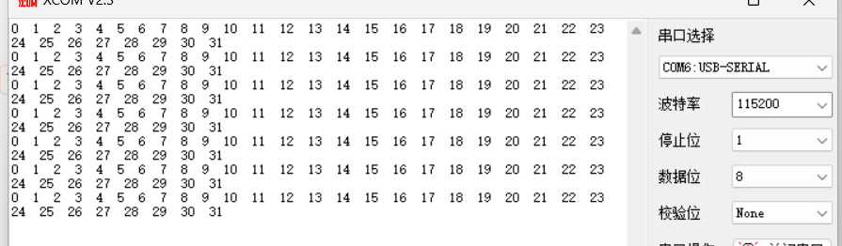
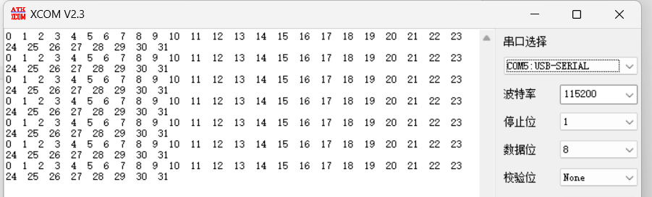
volatile static uint8_t is_packet_prepared = 0;
volatile static uint8_t buffer_sent_cnt=0;加上后会运行函数中代码
is_packet_prepared 可能始终为0，所以整个if块被删除
