# Input 1

$$T=1000$$

$$M=2$$

$$λ=μ=20$$

$$P_{0}…P_{N}=[1, 0.8, 0.5, 0.1, 0]$$

## Question 1.

The State diagram for a single test station looks in the following way. Provided that the arrival rate is distributed among all the test stations equally, the arrival rate for a single test station is then $\frac{λ}{M}$, where M is the number of test stations. The state diagram is finite, since it is given to us that the last probability of a visitor to stay is 0 ($P_{N}=0$)

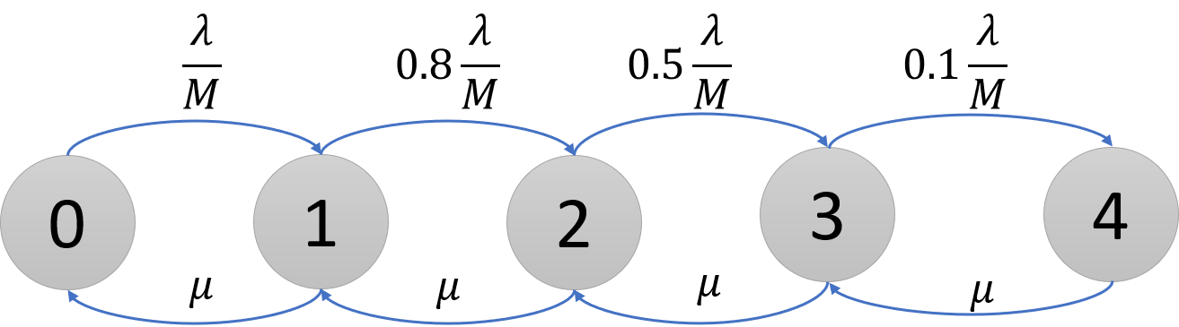

## Question 2.

The system is stable because it’s finite.

## Question 3.

Let us define $ρ$ in a bit different way to ease the calculations: $ρ=\frac{λ}{M μ}=\frac{20}{20⋅2}=0.5$

Then, the system of equations are:

$P_{1}=ρ⋅P_{0}=0.5⋅P_{0}$

$P_{2}=0.8 ρ⋅P_{1}=0.4⋅P_{1}$

$P_{3}=0.5 ρ⋅P_{2}=0.25⋅P_{2}$

$P_{4}=0.1 ρ⋅P_{3}=0.05⋅P_{3}$

$\sum_{0}^{4}{P_{n}}=1$

The answers are:

$$P_{0}≈0.57 ;P_{1}≈0.285 ;P_{2}≈0.114 ; P_{3}≈0.0285 ;P_{4}≈0.00143$$

## Question 4.

The mean arrival rate is calculated:

$$\overline{λ}= \sum_{n=0}^{4}{λ⋅P_{n} }=P_{0}⋅\frac{λ}{M}+P_{1}⋅\frac{λ}{M}⋅0.8+ P_{2}⋅\frac{λ}{M}⋅0.5+P_{3}⋅\frac{λ}{M}⋅0.1+P_{4}⋅0$$

$$\frac{λ}{M}=20$$

$$\overline{λ}= \frac{λ}{M}\left(P_{0}+0.8 P_{1}+0.5 P_{2}+0.1 P_{3}\right)≈8.5785$$

## Question 5.

Due to the Little law:

$$\overline{N}=\overline{λ}⋅\overline{T}$$

We have to calculate the $\overline{N}$ in order to use it:

$$\overline{N}= \sum_{N=0}^{4}{N⋅P_{N} }=0⋅P_{0}+1⋅P_{1}+.. +4⋅P_{4}≈0.604$$

Thus:

$$\overline{T}=\frac{\overline{N}}{\overline{λ}}=\frac{0.604}{8.5785}≈0.07$$

## Question 6.

The mean for the wait time can be calculated using:

$$T_{Q}=\overline{T}-\frac{1}{μ}=0.07-0.05≈0.02$$

## Question 7.

The simulation results are the following: