## Question 1.

### Part a.

We develop the equations to calculate the throughput following the examples in the lectures.

The protocol used in simple ALOHA. We divide the time into slot as in the lecture.

Given 2 groups of stations, we can calculate the throughput for each station:

The transmissions are distributed in the Poisson distribution:

Thus,

In the similar way, we can calculate the throughput for the group B. In fact, everything is almost similar:

The requirement:

### Part b.

The calculation for the reservation ALOHA is similar to CSMA/CD. The collisions may occur during the reservation slot, where multiple stations may try to reserve a slot. If only 1 station sends the reservation request, it will be granted a collision-free window of T slots.

We define:

* Group 1: stations which want to transmit at probability
* Group 2: stations which want to transmit at probability
* Probability of error white sending request:

The throughput is calculated in a similar to CSMA/CD:

Where the contention interval includes the reservation, and all the re-transmissions of the reservation. It will include AT LEAST 1 interval where the reservation will take place.

We can calculate the probability of a successful reservation by a certain station:

Remembering the definition for the Euler’s number:

We can rewrite:

And obtain:

We define to be the smallest interval.

Thus, the contention interval:

Which fits, meaning we need only 1 reservation slot before message transmit.

Since the time units here are given in units of 1,

So, we obtain:

Sanity check:

Which is logical, we need 1 reservation slot.

Which is logical, if we can’t succeed to send reservation, throughput is 0.

The expression for was found before. Inserting:

## Question 2.

Using the illustrations from the lecture to answer this question.

### 

ALOHA will send the frame at any time.

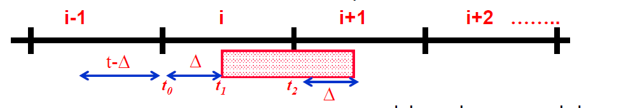

Accounting only for the group A of stations (which operate at ALOHA), the probability of successful transmission is:

Where the interval is divided into 2:

And the total length of interval is length of 1 slot.

We have to account for the group B of stations, which operate at Slotted ALOHA, specifically add the term:

Because a transmission during any of those slots will interrupt the current transmission.

### 

Accounting only for slotted ALOHA, we require that only 1 appearance will be at slot i, other slots don’t have effect:

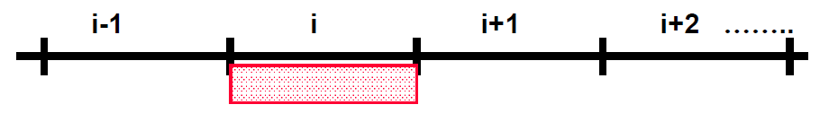

Now, when we also have ALOHA operating, we put further restrictions:

1. No frame should be transmitted during i-1
2. No frame should be transmitted during i

Thus we expect 0 transmission from group A for 2 slots.

Putting this all together:

### 

We wish both success chances to be equal. Thus:

## Question 3.

### 

The groups of stations are not synced. This may look like this:





The packets transmission is distributed via Poisson distribution

Given 2 groups of stations, and their sizes, we can calculate their rate.

1. Group 1 of size will transmit at rate
2. Group 2 of size will transmit at rate

A frame from Group 1 will succeed in slot i if :

1. only 1 frame from Group 1 will be in this slot
2. and no frame from Group 2 will be in slots which intersect this slot (on the picture above – those are i-1 and i in the bottom timeline)

Thus:

### 

In the same way, calculating the success probability for a slot for group 2:

As expected, the probability for success in a certain slot for Group 2 is higher, since more stations obey to the same protocol rules and will not interrupt the message in the middle.